**Field Papers Walk Through**

Field Papers is a tool for creating a printable map atlas of anywhere in the world. The idea is that you use it to print the map, you go out into the field, sketch what you see, then come back, take a picture of your map or scan it, and update OpenStreetMap. This walk through will only focus on creating your atlas.

**Make yourself an atlas –** this walk through focuses on creating your atlas. Using it in the field, and updating OpenStreetMap will be covered in other guides.

Go to <http://fieldpapers.org/> and click on the ‘Make yourself an atlas’ link.

Enter your location in the search box and hit ‘Start There’.

You should now see the location you entered in OpenStreetMap.

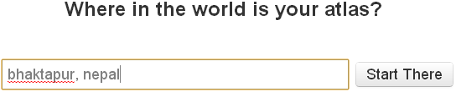



Now, you can see a zoomed out view of Bhaktapur, but we want to focus on a smaller area. Click on the + button in the top left corner to zoom in.

Each of the rectangles you see represent a page of your atlas. As you zoom in, you’ll want to move your atlas…

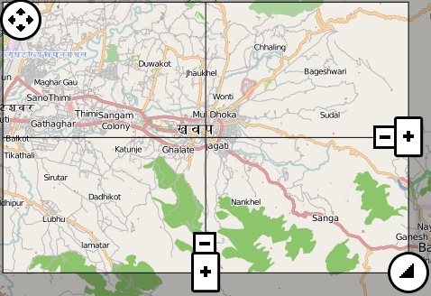

...and you’ll want to resize your atlas accordingly.

If you want to add or remove pages, use the +/- buttons

Choose landscape or portrait Choose the characteristics of your base map



In the toolbar near the top of the page, you can customize your map.

Once you are happy with the area and structure of your atlas, click the ‘Next’ button.

In the Name/Description page, give your atlas a name.

For example, if your atlas focuses on a neighbourhood you could name it after that neighbourhood.

…and you can choose to make your atlas private.

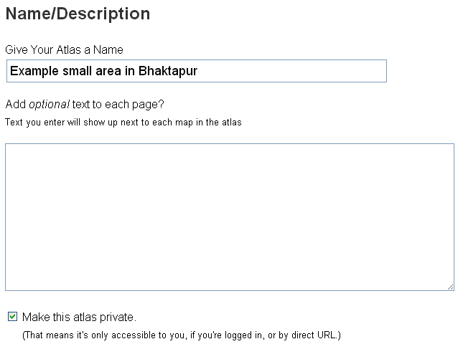

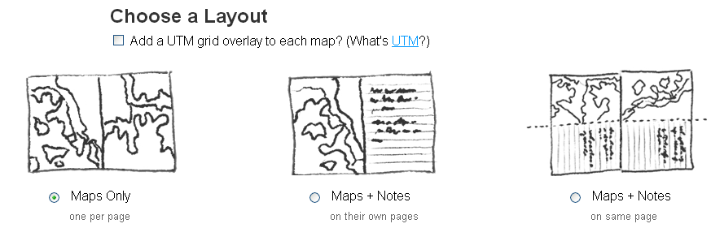

Next, let’s choose a layout for our atlas.

Do you want…

Just Maps filling your atlas pages? Maps and pages for notes? Or Maps and a space for notes on the same page?

Once you have picked a layout, click the button, and your atlas will be generated!

Bear in mind that this will take a few minutes, and you need a reasonable internet connection as well.

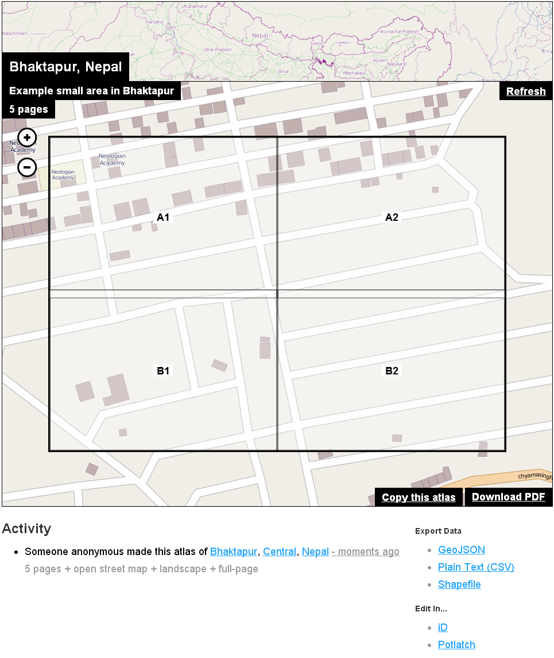

On the left is a preview of an example atlas.

The rectangles A1, A2, B1, B2 will all be separate pages. The fifth page will be an overview of the whole area, similar to the preview page on the left.

Download as PDF and then you are ready to print and use your atlas in the field.