***Nebraska Business Training Inc.***

***Executive Summary***

Nebraska Business Training was started by two corporate trainers who decided to provide value quality training to employees of small and large firms. They provide onsite and online training depending on the convenience of the employee. The topics of training range from technical MS office products to non-technical training such as team building, avoiding workplace harassment. Every employee in a workplace should not only have technical knowledge but should also know basic workplace ethics. These training classes were managed by two office assistants and were mostly managed manually. But as the company grew and more customers started to flow in the manual management of all the training classes were getting hectic and the customers also preferred having a self-service option which would help them save time and energy. The two assistants enter the details like training description, cost for training and the schedule of the training manually into the website. To make the tasks simpler Nebraska Business Training has contacted the Trustworthy Computing Services.

The goal of the project is to provide a self-service option to customers (employee’s and Managers) and to reduce the work load of the assistants. This can be done by allowing clients to review all the classes and type of classes that are being offered and giving them an option to sign up for classes. They should also be able to make a payment through the new website. The new website should have some extra features such as alerting the customers if the classes are full, the customers should also be notified that they would not be charged until the class begins. The system will store only a code for each transactions and should not store the credit card details thereby making it more secure. The teachers should not only be able to register as instructors but should also be able to download class material, send surveys to students and receive feedbacks from the students. As it can be seen that the project mainly focuses on automating a few tasks and providing more flexibility to the clients. Labor costs can be saved as they do not need to increase the number of assistants as the business grows and also helps save of the clients.

***GitHub Repository:***

<https://github.com/Amersha/ISQA3420.git>

***Use Case Diagram***

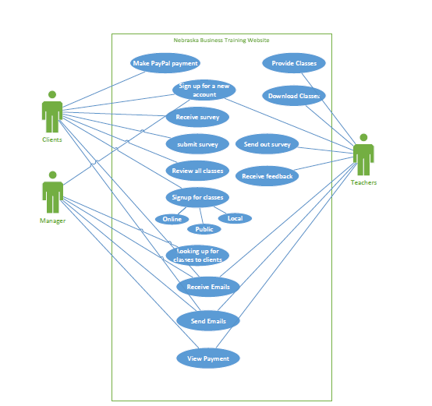

***Data Model***

