Mary Barrett

WEB 320

Exercise 9.2

**Steps to Change Right-Column Colors in Google Chrome:**

1. Open the webpage or code in Google Chrome
2. Press the **F12** key to open Google Chrome’s DevTools
3. Make sure that you have the **‘Elements’** tab open in DevTools
4. On the left side of the DevTools window, click the arrow next to the word **<body>**
5. On the left side of the DevTools window, click the word **<div class=”right-column”>…</div>**
6. On the right side of the DevTools window, click on the **‘+’** sign near the top of the column
7. A new section will open called **‘.right-column { } inspector-stylesheet: a number’**
8. Click on the blank space next after the first **‘{‘** to open a typing curser
9. Type the following: **background-color: steelblue;**
10. Press the **‘Enter’** key
11. Type the following: **color: white;**
12. Press the **‘Enter’** key
13. Click anywhere on the white space to get rid of the typing curser
14. The screen should look like the following screenshot when finished.

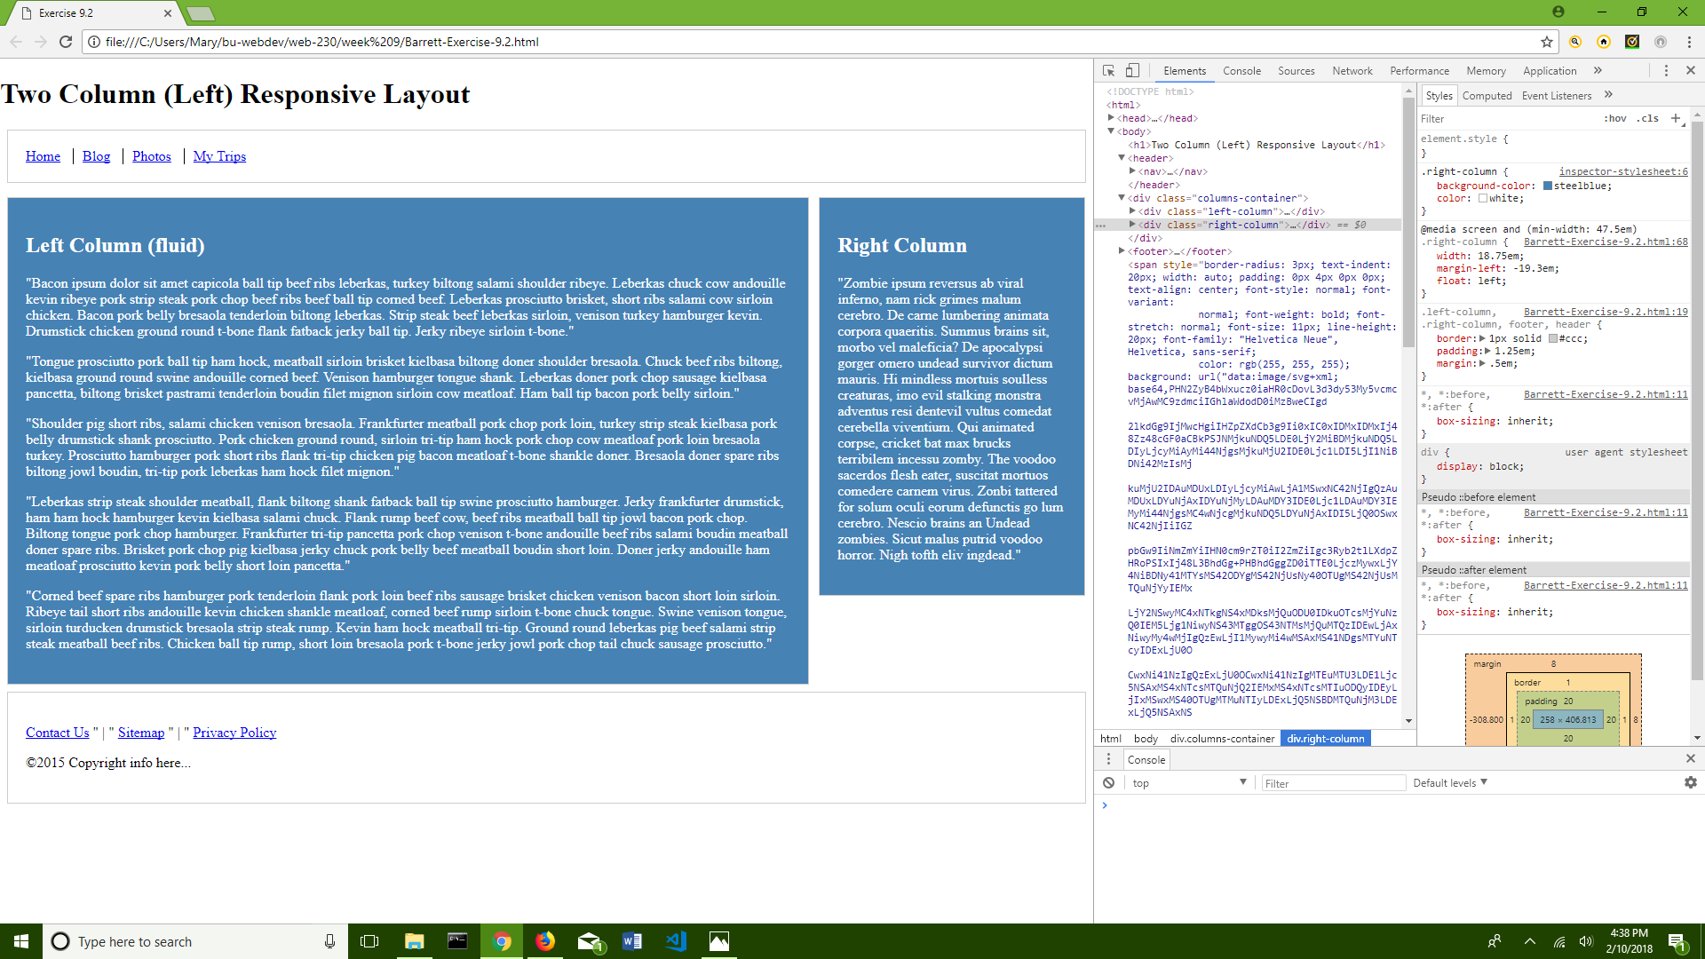

**Steps to Change Left-Column Colors in Google Chrome:**

1. Open the webpage or code in Google Chrome
2. Press the **F12** key to open Google Chrome’s DevTools
3. Make sure that you have the **‘Elements’** tab open in DevTools
4. On the left side of the DevTools window, click the arrow next to the word **<body>**
5. On the left side of the DevTools window, click the word **<div class=”left-column”>…</div>**
6. On the right side of the DevTools window, click on the **‘+’** sign near the top of the column
7. A new section will open called **‘.left-column { } inspector-stylesheet: a number’**
8. Click on the blank space next after the first **‘{‘** to open a typing curser
9. Type the following: **background-color: steelblue;**
10. Press the **‘Enter’** key
11. Type the following: **color: white;**
12. Press the **‘Enter**’ key
13. Click anywhere on the white space to get rid of the typing curser
14. The screen should look like the following screenshot when finished.

