Mary Barrett

WEB 230

Exercise 9.3

**Steps to Change Header and Footer Menu Colors in Firefox:**

1. Open the webpage or code in Firefox
2. Press the **F12** key to open Firefox’s DevTools
3. Make sure that you have the **‘Rules’** tab open in DevTools
4. On the left side of the DevTools window, click the arrow next to the word **<body>**
5. On the left side of the DevTools window, click the word **<header>**
6. On the right side of the DevTools window, click blank space after the first **‘{‘** of the words  **‘footer, header { } inline: 12’** to open a typing curser
7. Type the following: **background-color: steelblue;**
8. Press the **‘Enter’** key
9. Type the following: **color: white;**
10. Press the **‘Enter’** key
11. Click anywhere on the white space to get rid of the typing curser
12. The screen should look like the following screenshot when finished.

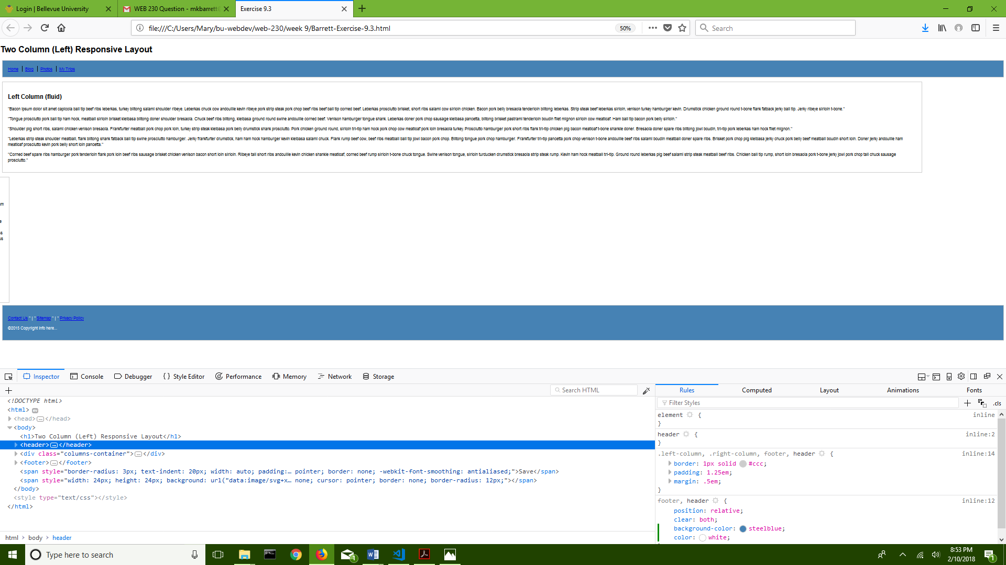

**Steps to Change Header and Footer Links Color in Firefox:**

1. Complete the steps listed above
2. On the right side of the DevTools window, click on the **‘+’** sign near the top of the column
3. A new section will open called **‘header’**
4. Click on the **‘header’** word and erase it, replacing it with the letter **‘a’**
5. Click on the blank space next after the first **‘{‘** to open a typing curser
6. Type the following: **color: white;**
7. Press the **‘Enter’** key
8. Click anywhere on the white space to get rid of the typing curser
9. The screen should look like the following screenshot when finished.

