EXE1:

Convert code to Python

def func1(a, b):

     if(a > b):

          while(a >= b):

               a -= 1

               b += 1

     else:

          b += a

     return b

Control Flow:

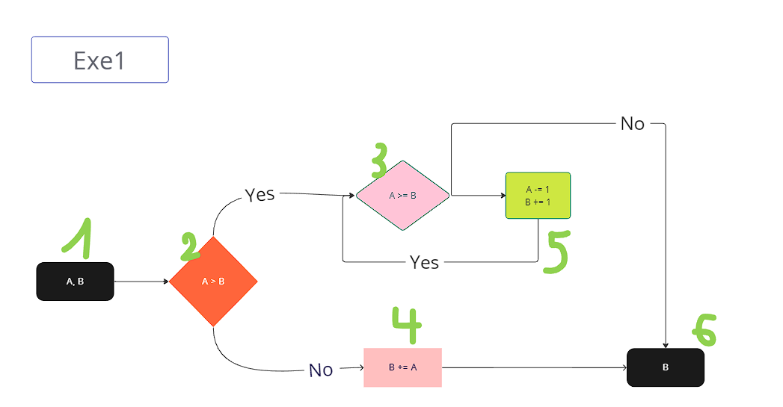

* TC1: (3,2)

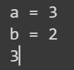

* Statement coverage: line 1,2,3,4,5,8 -> 6/8 = 75%
* Decision coverage: 1/2 = 50%
* TC2: (3,4)

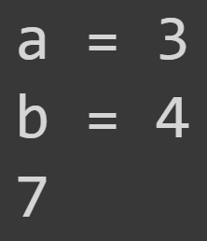

* Statement coverage: line 1,2,6,7,8 -> 5/8 = 62,5%
* Decision coverage: 1/2 = 50%

To get 100% decision coverage, I choose TC1(3,2) and TC2(3,4)

EXE 2

def func2(x,y):

     if((1 > x > 0) and (y < 0)):

          return x + y

     elif(x > 1):

          return x*y

     else:

          return x-y

Control Flow:

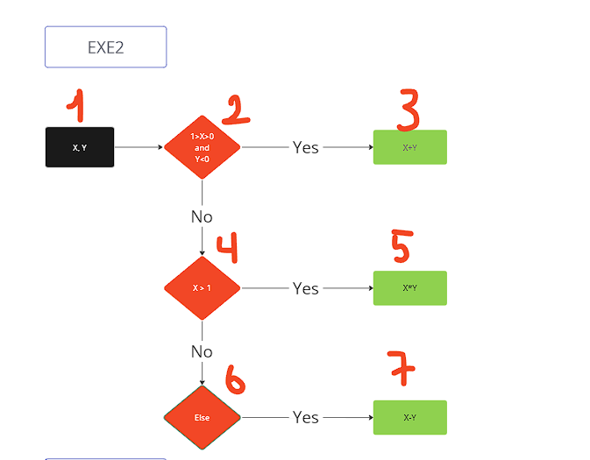

Test case:

* TC1: (0.5,-4)

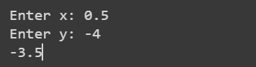

* Statement coverage: line 1,2,3 -> 3/7 = 42,9%
* Decision coverage: 1/3 = 33.3%
* TC2: (5,10)

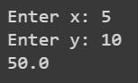

* Statement coverage: line 1,2,4,5 -> 4/7 = 57,1%
* Decision coverage: 1/3 = 33.3%

To get 100% decision coverage, I choose TC1(0.5,-4); TC2(5,10); TC3(-4,1)

EXE 3

def funct(x,y):

     if((0 < x <= 1) and (y < 0)):

          return x + y

     elif((x > 1) and (0 < y <= 5)):

          return x * y

     else:

          return x - y

Control flow:

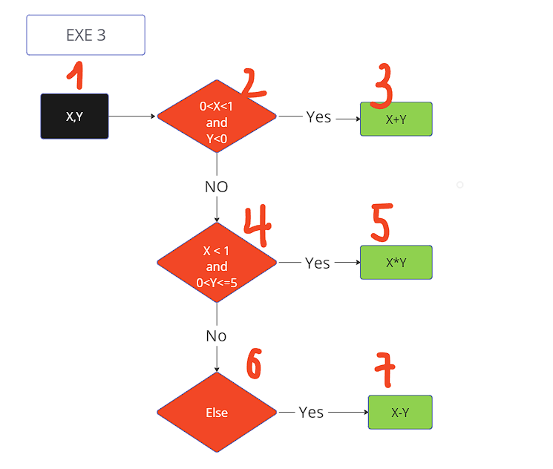

Test case:

* TC1(0.5, -1):

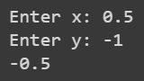

* Statement coverage: line 1,2,3 -> 3/7 = 42,9%
* Decision coverage: 1/3 = 33.3%
* TC2(6,3):

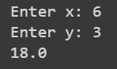

* Statement coverage: line 1,2,4,5 -> 4/7= 57,1%
* Decision coverage: 1/3 = 33.3%

To get 100% decision coverage, I choose TC1(0.5,-1); TC2(6,3); TC3(-4,1)

EXE 4:

def funct(x,y):

     if((-1<x<1) and (-1<y<1)):

          return x-y-1

     elif((x>=1) and (y>=1)):

          return x+y-1

     elif((x < -1) and (y>0)):

          return x*y-1

     else:

          return x-1

Control flow

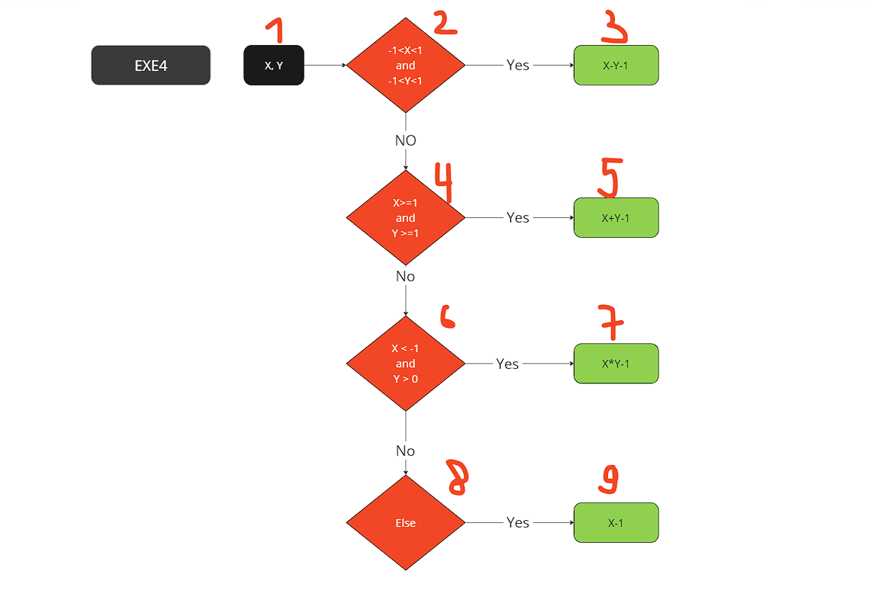

Test case:

* TC1(0,0):

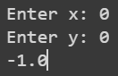

* Statement coverage: line 1,2,3 -> 3/9 = 33.3%
* Decision coverage: 1/4 = 25%
* TC2(5,6):

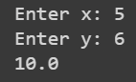

* Statement coverage: line 1,2,4,5 -> 4/9 = 44.4%
* Decision coverage: 1/4 = 25%

To get 100% decision coverage, I choose TC1(0,0); TC2(5,6); TC3(-4,4); TC4(-5,-1)

EXE 5

def calculate_price_Tdque(baseprice, specialprice, extraprice, extras, discount):

     addon_discount = 0

     result = 0

     if extras <= 3:

          addon_discount = 10

     elif extras >= 5:

          addon_discount = 15

     else:

          addon_discount = 13

     if discount > addon_discount:

          addon_discount = discount

     result = baseprice/100.0*(100-discount) + specialprice + extraprice/100.0*(100-addon_discount)

     return result

Control flow:

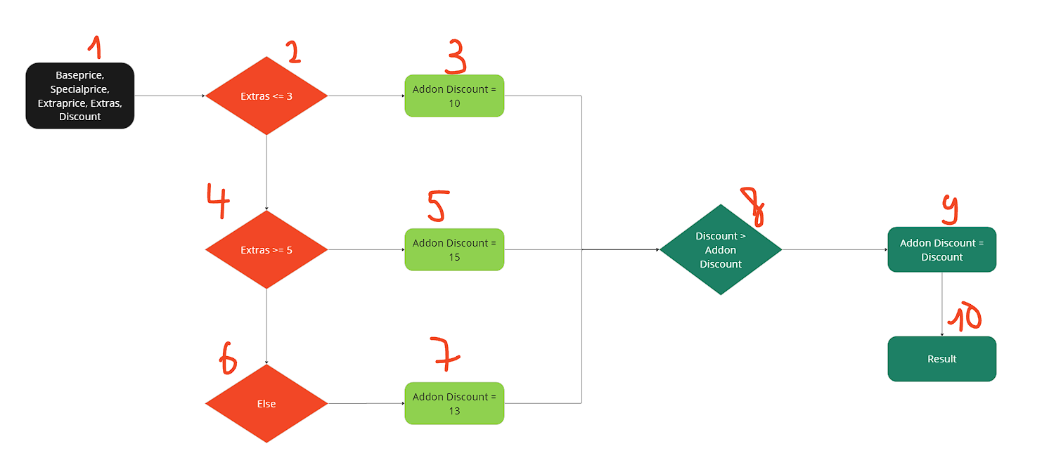

Test case:

* TC1(50,50,100,4,15):

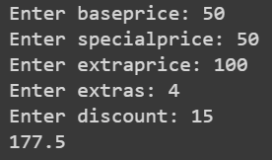

* Statement coverage: line 1,2,3,4,5,8,9,10,11 -> 9/11 = 81.82%
* Decision coverage: 1/6 = 16.67%
* TC2(100,90,80,10,10):

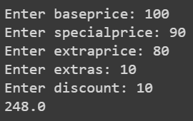

* Statement coverage: line 1,2,3,4,6,7,8,10,11 -> 9/11 = 81.82%
* Decision coverage: 1/6 = 16.67%

To get 100% decision coverage, I choose TC1(50,50,100,4,15); TC2(100,90,80,10,10); TC3(50,50,100,4,8), TC4(100,90,80,10,20); TC5(100,90,80,1,20); TC6(100,90,80,2,0)

EXE 6:

def calculate_price(color, bill):

     discount = 0

     if(200 <= bill <= 300):

          if(color == "yellow"):

               discount = 0.3

          elif(color == "white"):

               discount = 0

          else:

               discount = 0

     elif(300 < bill <= 500):

          if(color == "yellow"):

               discount = 0.4

          elif(color == "white"):

               discount = 0.3

          else:

               discount = 0

     elif(bill > 500):

          if(color == "yellow"):

               discount = 0.6

          elif(color == "white"):

               discount = 0.5

          else:

               discount = 0

     else:

          discount = 0

     return discount

Control Flow

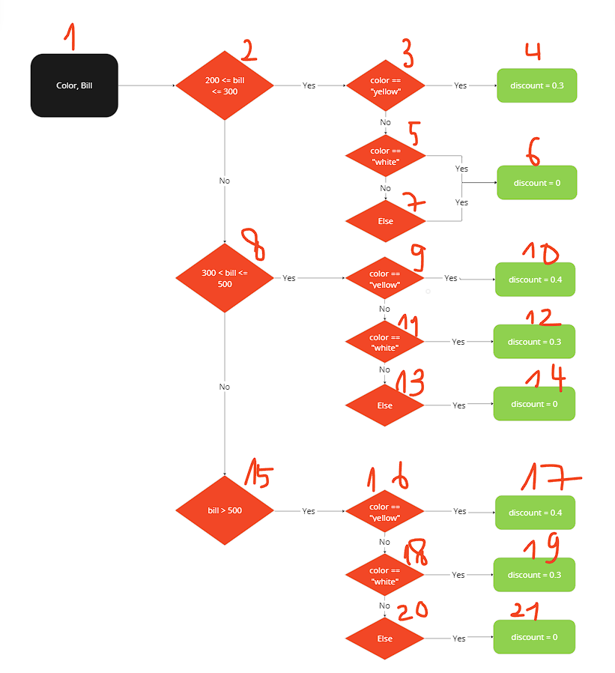

Test:

* TC1(250,yellow):

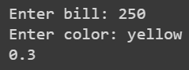

* Statement coverage: line 1,2,3,4,5,26 -> 6/26 = 23.07%
* Decision coverage: 1/10 = 10%
* TC2(400,white):

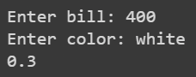

* Statement coverage: line 1,2,3,10,11,13,14,26 -> 8/26 = 30.76%
* Decision coverage: 1/10 = 10%

To get 100% decision coverage, I choose TC1(250,yellow); TC2(400,white); TC3(250,white); TC4(250,black); TC5(400,yellow); TC6(400,black); TC7(600,yellow); TC8(600,white); TC9(600,red); TC10(100,red).

EXE 7:

def identify_class(ticket, card):

     notify = ""

     if(ticket == "economy"):

          if(card == "gold"):

              notify = "You may get upgraded to business class"

          else:

               notify = "You may delay"

     else:

          notify = "You may delay"

     return notify

Control Flow

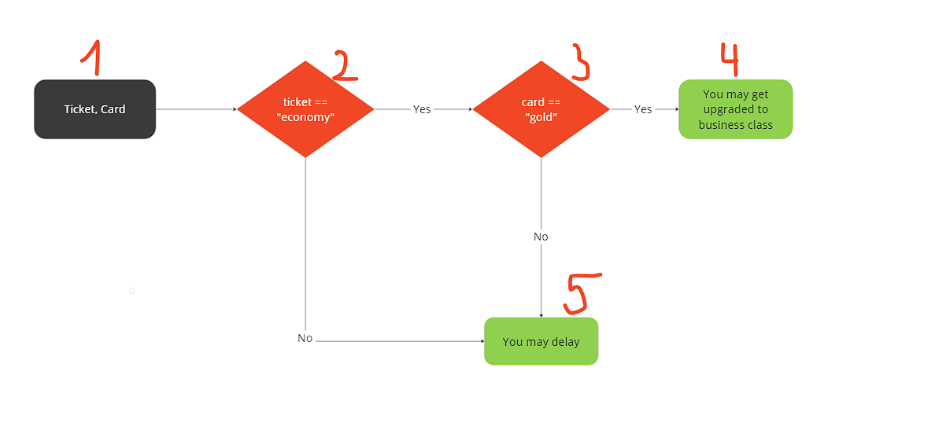

Test:

* TC1(economy,gold):

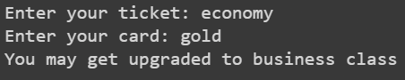

* Statement coverage: line 1,2,3,4,5,10 -> 6/10 = 60%
* Decision coverage: 1/3 = 33.3%
* TC2(economy,sliver):

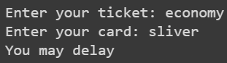

* Statement coverage: line 1,2,3,4,6,7,10 -> 7/10 = 70%
* Decision coverage: 1/3 = 33.3%

To get 100% decision coverage, I choose TC1(economy,gold); TC2(economy,sliver); TC3(cheap economy, sliver)