SECURECORP
Security Assessment Engagement
FINAL SECURITY ASSESSMENT REPORT
Junior Cybersecurity Consultant Capstone
Client: SecureCorp Inc.
Consultant: Neil
Assessment environment: Controlled libvirt laboratory
Final report date: 15 August 2026
Classification: CONFIDENTIAL — FOR ASSESSMENT / ACADEMIC USE
Evidence basis: direct screenshots, terminal records and working evidence retained in the SecureCorp repository.

2. Executive Summary
SecureCorp's controlled assessment identified four material weaknesses in the DVWA representation of the customer-facing web environment: brute-force authentication, SQL injection, reflected cross-site scripting and command injection. The command-injection finding is the highest-risk application weakness because successful input manipulation reached operating-system command execution in the web-server process context.
The assessment also established centralized monitoring through Wazuh. The Arch Linux physical/libvirt host operates the Wazuh Manager and Dashboard, while the Kali and Ubuntu virtual machines provide monitored endpoints. The current repository contains direct evidence of active agents, SSH authentication detection, reflected-XSS web-log detection, a SQL-injection search with no matching alert, and endpoint audit telemetry.
The defensive conclusion is therefore two-part: the application weaknesses are demonstrated by direct testing evidence, while detection effectiveness varies by attack class. SSH brute-force and reflected XSS are supported by Wazuh evidence. SQL injection is not demonstrated as detected in the retained dashboard search, and command-injection evidence demonstrates endpoint telemetry availability but does not prove that the malicious command itself generated a privileged-execution alert.
Overall posture: HIGH RISK. Immediate remediation should focus on eliminating shell-based command execution and SQL injection, strengthening authentication controls, improving XSS defenses, and validating Wazuh detections against replayed attack traffic.

3. Scope & Rules of Engagement
The engagement was restricted to the controlled SecureCorp laboratory. Testing was performed only against personally controlled virtual machines and deliberately vulnerable application components. Public systems, unrelated networks and other students' systems were out of scope.
Rule | Application
Authorized targets | Ubuntu VM hosting DVWA and associated services; controlled Kali/Arch lab systems.
Attacker environment | Kali Linux libvirt VM used for authorized security testing and analyst activity.
Central monitoring | Wazuh Manager and Dashboard hosted on the Arch Linux physical/libvirt host.
Credential testing | Restricted to deliberately created laboratory credentials and DVWA test accounts.
Network boundary | Testing remained within the controlled libvirt laboratory.
Evidence standard | Findings are supported by retained screenshots, terminal records or log evidence; unsupported event claims are not presented as fact.

The assessment follows the handbook requirement that findings must be evidence-backed and that Week 3 investigation must relate directly to the attack simulations performed during the assessment. The current repository evidence is treated as authoritative for screenshots and retained records.

4. Asset Inventory & CIA Analysis

4.1 Asset Inventory
Asset | Type | Owner / affected function | Why it matters
Customer portal / DVWA | Software | Customer-facing service | Represents the primary attack surface and handles application interactions.
Ubuntu web server | Hardware / software platform | Engineering / service operations | Hosts DVWA, Apache, MariaDB, PHP, SSH and auditd.
Customer / employee database | Data | Engineering / business operations | Contains information whose disclosure or alteration would affect confidentiality and integrity.
Employee accounts and credentials | Identity | All departments | Compromise can provide unauthorized access to business systems.
Employee laptops / Windows workstations | Endpoint | Employees | Support business operations and may hold credentials or sensitive information.
Internal company website | Software | Internal users | Provides internal information and requires integrity and availability.
Internet-facing connection | Connectivity | IT / service operations | Provides required customer access but increases attack surface.
Arch Linux Wazuh host | Infrastructure | Security monitoring | Provides centralized Wazuh management, dashboard and monitoring for the lab.

4.2 CIA Analysis
Asset | Confidentiality | Integrity | Availability
Customer portal | Customer and account data must not be disclosed. | Requests and application data must not be manipulated. | Customers must be able to use the portal.
Ubuntu web server | Logs, credentials and service data must be protected. | System and application configuration must not be altered without authorization. | Web services must remain operational.
Customer / employee database | Records must remain private. | Records must not be modified by unauthorized users. | Applications and staff must be able to access required data.
Employee accounts | Credentials must remain secret. | Account permissions and identity state must remain trustworthy. | Authorized users require reliable access.
Wazuh monitoring platform | Security telemetry should be protected from unauthorized access. | Alerts and logs must retain evidential integrity. | Monitoring must remain available for investigation.

5. Risk Assessment
Asset / area | Threat / weakness | Business impact | Risk | Primary control
Ubuntu web server | Command injection | Unauthorized OS command execution and potential server compromise. | Critical | Remove shell execution; use safe APIs, strict allowlists and least privilege.
Customer portal | SQL injection | Unauthorized disclosure or manipulation of application data. | High | Parameterized queries, server-side validation and least-privilege DB access.
Customer portal | Reflected XSS | Browser-side script execution and possible session/data exposure. | High | Context-aware output encoding, validation and CSP.
Customer portal / SSH | Brute-force authentication | Credential compromise and unauthorized access. | High | Strong passwords, rate limiting, lockout/anti-automation controls and MFA.
Employee accounts | Phishing / credential theft | Unauthorized access to business systems and data. | High | MFA, phishing-resistant authentication where practical and awareness controls.
Endpoints / server | Malware | Data loss, disruption or credential compromise. | High | Endpoint protection, patching, least privilege and centralized logging.
Business data | Insider misuse | Unauthorized disclosure or alteration. | Medium–High | Least privilege, access reviews and audit logging.
Internet-facing connection | Unauthorized scanning / exploitation | Expanded attack surface and service compromise. | High | Minimize exposed services, segment systems and monitor external activity.

6. Methodology
The assessment followed the handbook lifecycle: understand the environment, identify assets and risk, perform controlled attack simulations, collect application and endpoint telemetry, investigate through Wazuh, correlate evidence, and convert findings into prioritized remediation.

6.1 Lab and Monitoring Architecture
Role | System | Address / network | Function
Central Wazuh manager | Arch Linux physical/libvirt host | 192.168.1.8 | Wazuh Manager, Wazuh Dashboard and centralized monitoring.
Authorized attacker / analyst | Kali Linux libvirt VM | 192.168.122.139/24 | Controlled security testing and analyst activity.
Target / monitored endpoint | Ubuntu libvirt VM | 192.168.122.138/24 | DVWA target; Apache, MariaDB, PHP, SSH and auditd; Wazuh agent.
Lab gateway | Libvirt network | 192.168.122.1 | Gateway for the VM network.
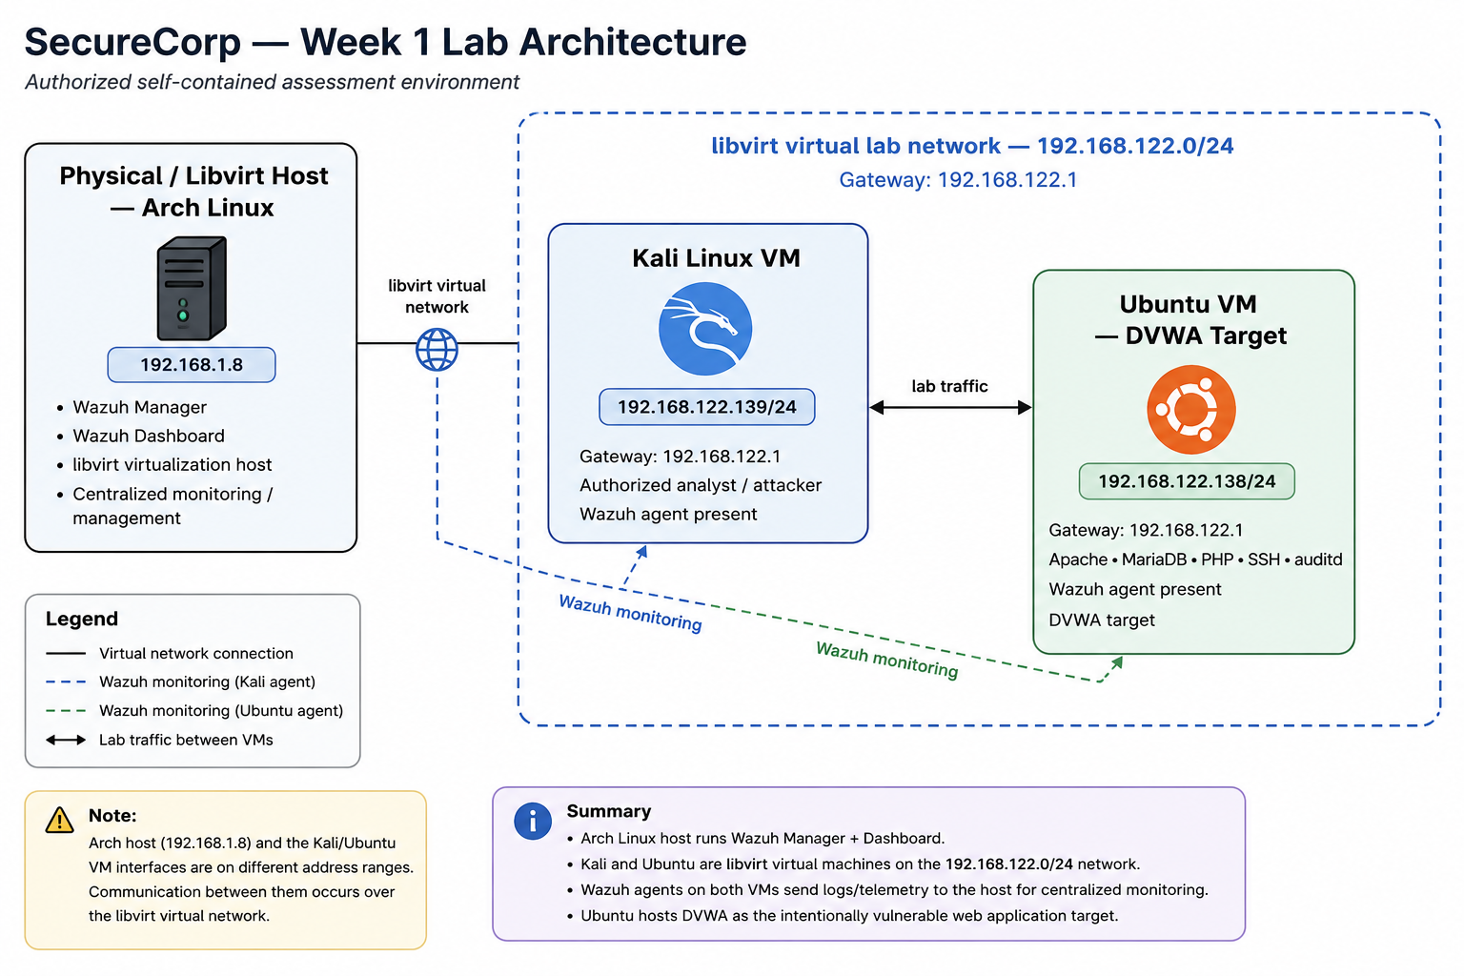
Figure 6-1. Repository network diagram showing the Arch Linux host, Kali VM, Ubuntu/DVWA target and Wazuh monitoring paths.

6.2 Wazuh Deployment
The Arch Linux host provides centralized Wazuh management and dashboard access. The repository's current Wazuh agent view shows two active agents: the Arch host and the Ubuntu endpoint. The Ubuntu endpoint also retains direct evidence of the Wazuh agent running.
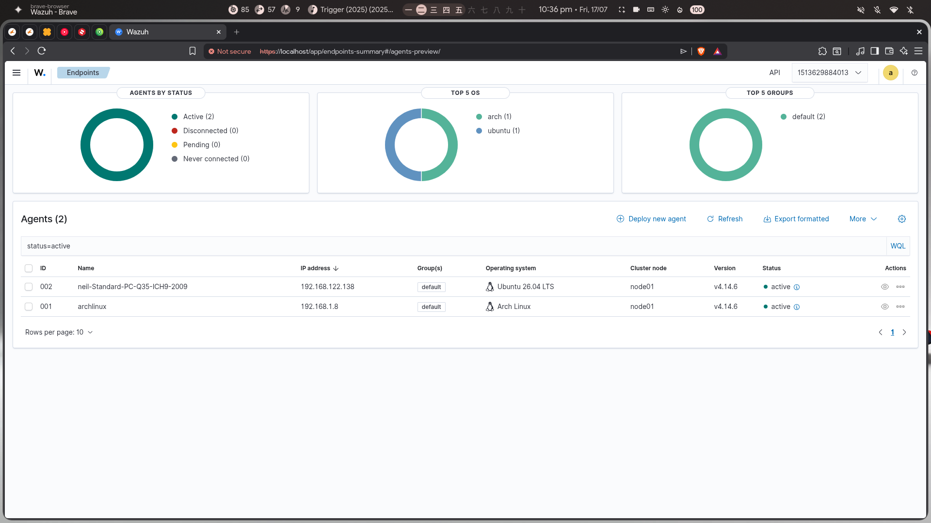
Figure 6-2. Direct Wazuh screenshot showing both documented agents active, including the Arch Linux host and Ubuntu endpoint.

6.3 Assessment Workflow
- Validate host identities, IP addressing, services, DVWA availability and Wazuh connectivity.
- Execute the four required controlled attack simulations against the DVWA target and controlled SSH service.
- Record direct application results and timestamps where available.
- Review Wazuh authentication, web-access-log and endpoint/audit telemetry.
- Separate exploitation evidence from detection evidence; a successful attack does not automatically constitute a confirmed SIEM alert.
- Prioritize remediation according to technical impact and business consequence.

7. Attack Simulation Findings
The four required simulations are summarized below. Dates and times are stated only where supported by retained evidence. Where a direct screenshot lacks a timestamp, the corresponding retained terminal record is used and identified as such.
Attack | Evidence timestamp | Result | Detection status | Risk
Brute-force authentication | 13 Aug 2026, 07:57:06 -0400 (access log evidence) | Controlled repeated authentication activity and successful lab authentication were demonstrated. | Confirmed Wazuh SSH detection; rules 5710/related SSH telemetry retained. | High
SQL injection | 13 Aug 2026, 08:02:02 -0400 (access log evidence) | Boolean manipulation returned multiple records, demonstrating query alteration. | Not confirmed. Retained Wazuh search returned no matching results. | High
Reflected XSS | 13 Aug 2026, 08:11:44 -0400 (access log evidence) | Injected script executed in the browser and generated the expected alert behaviour. | Confirmed Wazuh web-access-log evidence; rule 31106 shown in retained event. | High
Command injection | 24 Jun 2026, 12:13:19–12:19:52 IST (terminal record) | Appended shell commands returned uid=33(www-data), whoami and working-directory output. | Endpoint audit telemetry is present; malicious privileged-execution alert not proven. | Critical

7.1 Brute Force
The DVWA brute-force module and controlled SSH authentication path were assessed. The retained evidence shows the vulnerable login area and access-log activity. The working attack record states that a valid laboratory credential was obtained and authenticated successfully.
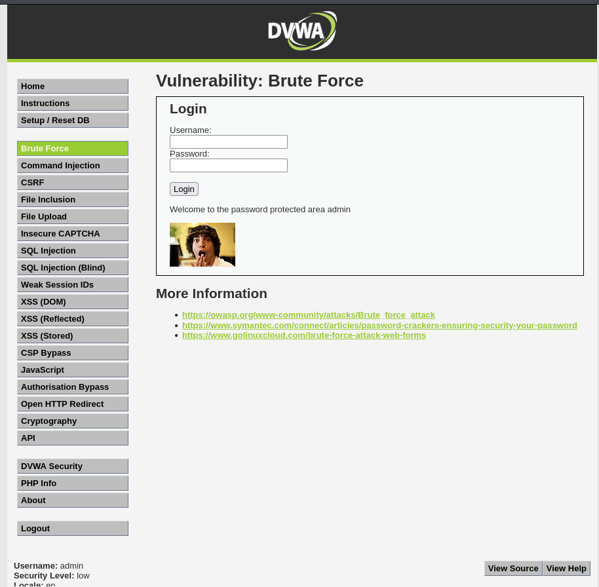
Figure 7-1. Direct DVWA brute-force evidence.
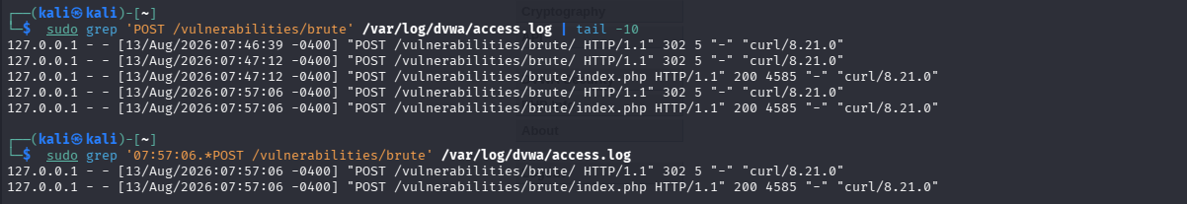
Figure 7-2. Direct access-log evidence with the retained brute-force request timestamps.

7.2 SQL Injection
The DVWA SQL Injection module accepted boolean-manipulation input and returned multiple records. This demonstrates unsafe query handling and a high confidentiality/integrity risk.
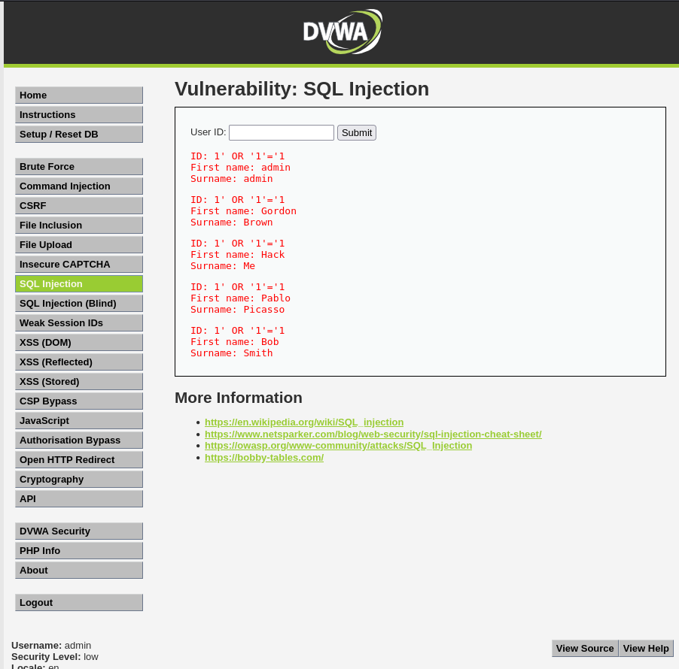
Figure 7-3. Direct DVWA SQL injection result.
Figure 7-4. Direct access-log evidence for the SQL injection request.

7.3 Reflected XSS
The reflected-XSS module rendered attacker-controlled script input in the browser. The retained Wazuh document shows the corresponding web-access-log event and rule 31106.
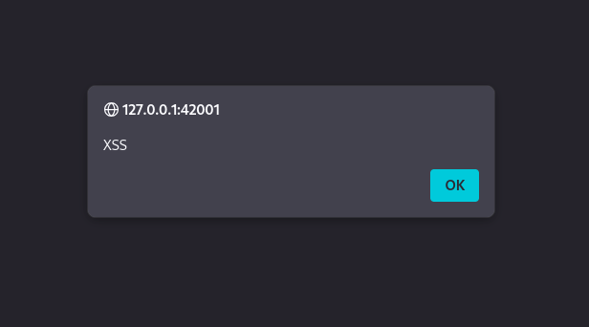
Figure 7-5. Direct browser evidence of reflected XSS execution.
Figure 7-6. Direct access-log evidence with the retained XSS timestamp.

7.4 Command Injection
The command-injection module accepted appended shell commands. The retained terminal record demonstrates execution as www-data and exposes the application's working directory. This is the highest-risk application finding because the attack crosses from the web layer into operating-system execution.
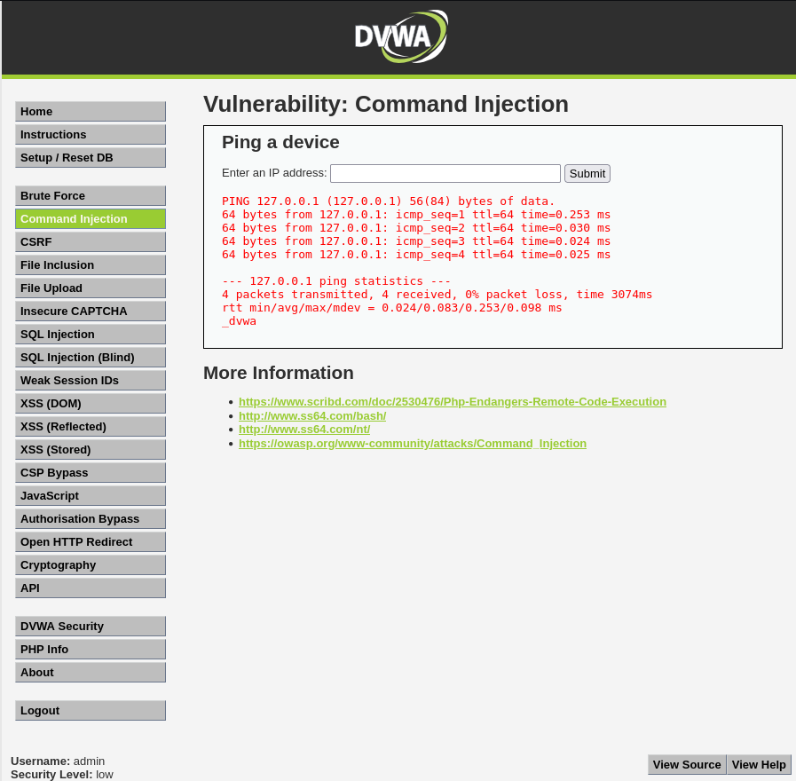
Figure 7-7. Direct DVWA command-injection execution evidence.

8. Detection Notes & Incident Timeline

8.1 Detection Notes
Attack | Wazuh / telemetry mapping | Evidence conclusion
Brute-force authentication | SSH/authentication rules including 5710 and supporting 5720/5716 context. | Confirmed detection evidence retained.
SQL injection | Web-access-log investigation; retained dashboard search for the SQLi path. | No matching result in retained dashboard evidence; detection not confirmed.
Reflected XSS | Web-access-log rule 31106; document details show /vulnerabilities/xss_r/ and HTTP 200. | Confirmed detection evidence retained.
Command injection | Web-layer investigation plus auditd endpoint telemetry; 80792 is relevant when its documented privileged condition is present. | Telemetry is present, but retained evidence does not prove a malicious privileged-execution alert.

8.2 Incident Timeline
Evidence time | Activity | Source | Assessment
13 Aug 2026 07:57:06 -0400 | Brute-force web authentication activity | DVWA access log screenshot | Attack activity recorded.
13 Aug 2026 08:02:02 -0400 | SQL injection request | DVWA access log screenshot | Attack request recorded; Wazuh search did not return a matching result.
13 Aug 2026 08:11:44 -0400 | Reflected XSS request | DVWA access log + Wazuh document | Attack and web-log detection corroborated.
13 Aug 2026 08:18:15–08:18:21 | SSH authentication failures / invalid-user attempts | Wazuh SSH events | Wazuh rule 5710 evidence retained.
13 Aug 2026 13:30:09 | Endpoint audit search command executed through sudo | Wazuh endpoint document | Telemetry collection is functioning; this is analyst activity, not malicious command proof.

8.3 Investigation Conclusion
The monitoring architecture provides useful coverage across authentication, web access logs and endpoint telemetry. The evidence demonstrates confirmed Wazuh visibility for SSH brute-force and reflected XSS, while SQL injection and command-injection detection require further rule validation. The distinction is important: application compromise findings remain valid even when the defensive detection control does not fire.
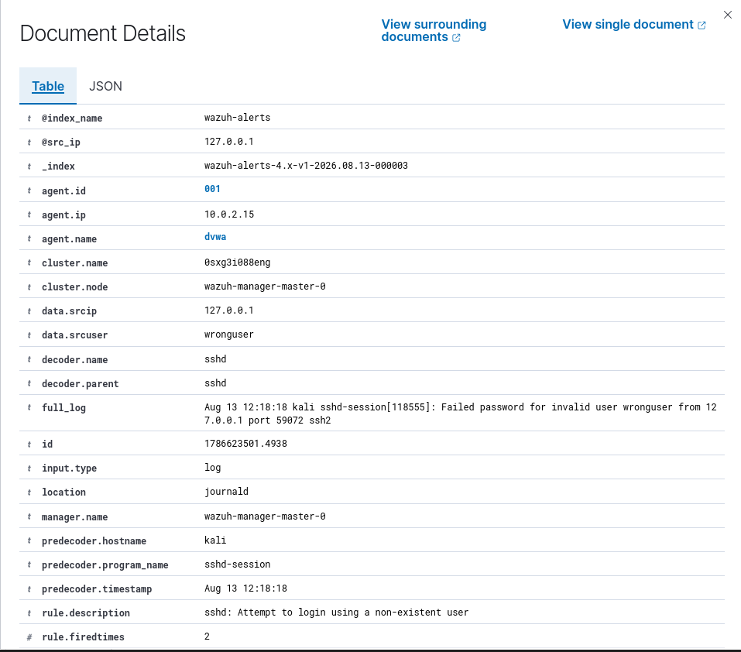
Figure 8-1. Wazuh document showing SSH invalid-user authentication activity.
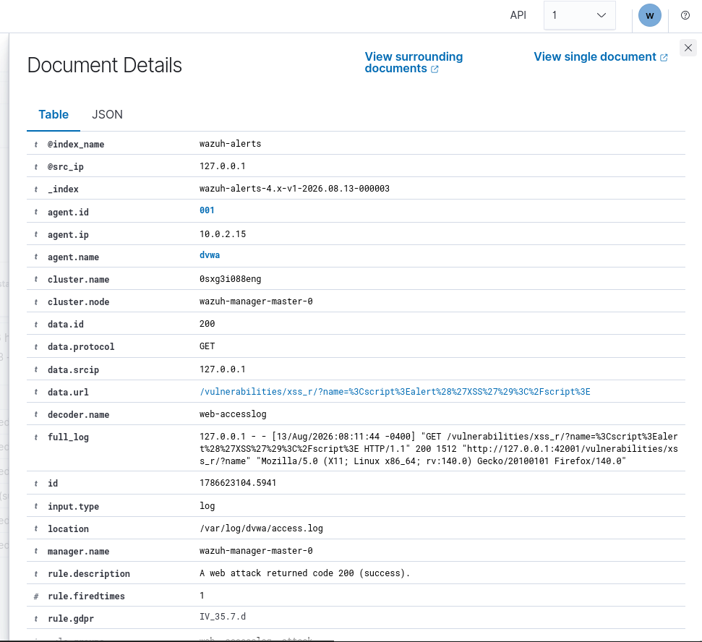
Figure 8-2. Wazuh document showing the reflected-XSS web-access event and rule 31106.
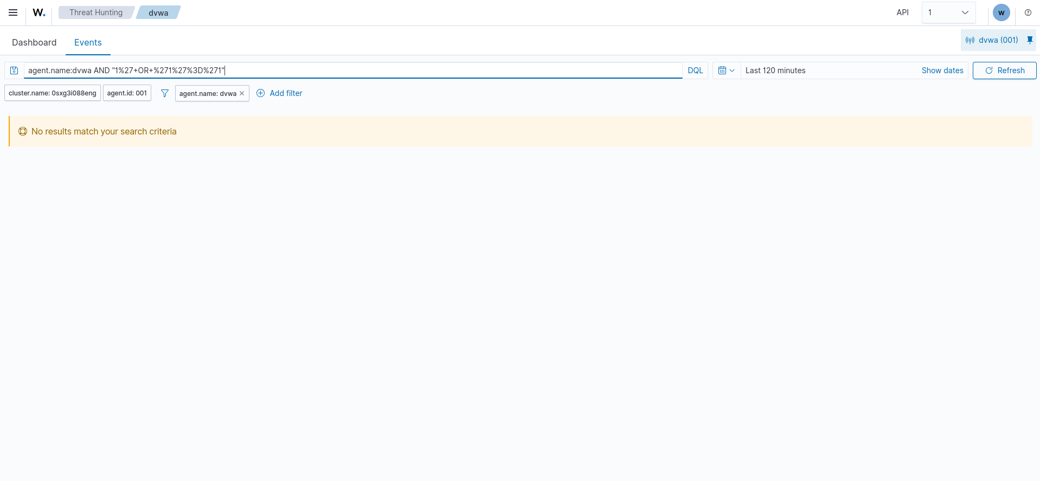
Figure 8-3. Retained Wazuh search showing no results for the SQL injection query.
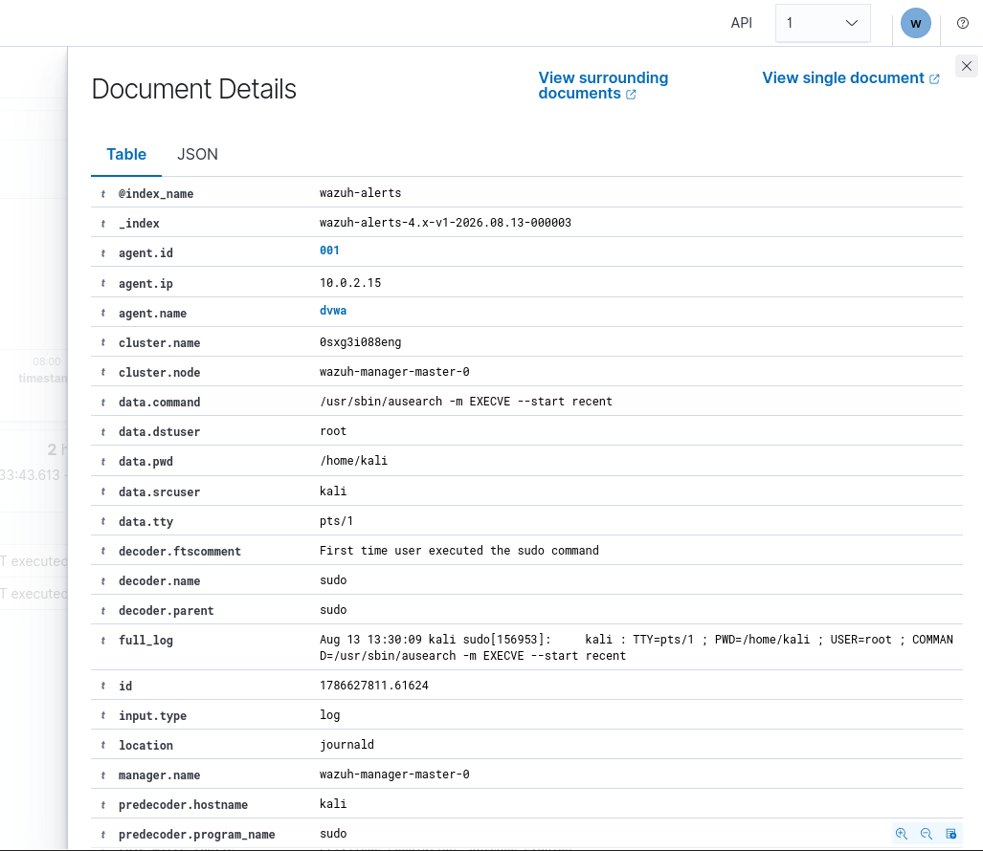
Figure 8-4. Wazuh endpoint telemetry showing audit/ausearch activity; this does not prove malicious privileged execution.

9. Recommendations
Priority | Area | Recommendation | Success measure
Critical | OS command execution | Remove shell execution from web input. Use safe APIs, strict allowlists, validation and least-privilege service accounts. | Command-injection test no longer produces OS command output.
Critical | SQL injection | Use parameterized queries, server-side validation and least-privilege database permissions. | SQLi payloads fail safely and do not alter query logic.
High | Authentication | Use strong unique credentials, rate limiting, lockout/anti-automation controls and MFA for sensitive access. | Repeated authentication attempts are throttled and protected accounts resist credential guessing.
High | XSS | Apply context-aware output encoding, input validation and an appropriate Content Security Policy. | Injected script is rendered inert and CSP violations are controlled.
High | Wazuh detection engineering | Validate and tune rules against replayed SQLi, XSS, command-injection and SSH attack traffic. | Each required attack produces a predictable, actionable detection where intended.
High | Privileged access | Minimize sudo/su access and retain privileged-command auditing. | Unexpected privileged execution is attributable to a user/process and investigation can reconstruct the sequence.
High | Patch management | Keep the OS, web server, PHP, database and application components supported and patched. | Critical security updates are applied within an agreed maintenance window.
Medium–High | Network exposure | Expose only required services and restrict management access to trusted paths. | External attack surface is minimized and management interfaces are not publicly reachable.
Medium–High | Backup and recovery | Maintain protected backups and periodically test restoration. | Recovery objectives are met during a controlled restore test.
Recommended implementation order: eliminate command execution and SQL injection first; harden authentication and XSS controls next; then validate Wazuh coverage and privileged-activity monitoring against repeatable test cases.

10. Appendices

Appendix A — Evidence Repository
The repository is the authoritative evidence location. The final report embeds selected direct screenshots; the complete evidence set remains available in the project repository.
Evidence | Repository location
Network diagram | SecureCorp/workingevidence/week1/03_Network_Diagram/final_network_diagram.png
Arch/Wazuh screenshots | SecureCorp/Screenshots/arch-host/
Kali attack screenshots | SecureCorp/Screenshots/kali/
Ubuntu service / agent screenshots | SecureCorp/Screenshots/ubuntu/
Attack logs | SecureCorp/workingevidence/week2/03_Attack_Logs/
Terminal transcripts | SecureCorp/workingevidence/week2/02_Terminal_Transcripts/
Detection notes / Wazuh investigation | SecureCorp/workingevidence/week3/
Recommendations / final working material | SecureCorp/workingevidence/week4/
Repository: github.com/Amevrynx/aenexz/tree/master/SecureCorp

Appendix B — Environment Network Diagram

Figure B-1. Final repository network diagram. Source retained in the project evidence set.

Appendix C — Evidential Screenshots
The following figures are the key direct screenshots required to demonstrate the assessment. Full supporting evidence remains in the repository.

Figure C-1. Wazuh agents active.

Figure C-2. SSH authentication detection.

Figure C-3. SQL injection detection gap.

Figure C-4. Reflected-XSS detection.

Figure C-5. Endpoint audit telemetry.

Appendix D — Supporting Logs and Evidence Notes
- The direct application screenshots demonstrate the four required attack outcomes.
- The retained access-log screenshots provide evidence timestamps for brute force, SQL injection and XSS.
- The command-injection terminal transcript records the controlled test window and the returned OS-level command output.
- Wazuh evidence is reported separately from exploitation evidence.
- The SQL injection dashboard screenshot is retained as evidence of a detection gap, not as evidence of a successful alert.
- The endpoint audit screenshot demonstrates telemetry availability but is not interpreted as proof of malicious privileged execution.
- Historical or unsupported system-specific values are not presented as verified current facts.

Appendix E — Submission Checklist
- ☐ Network Diagram / Application Map — included.
- ☐ Asset Inventory — included.
- ☐ CIA Analysis — included.
- ☐ Risk Assessment — included.
- ☐ Wazuh dashboard screenshot with active agents — included.
- ☐ Attack Log covering brute force, SQL injection, XSS and command injection with evidence/timestamps where supported — included.
- ☐ Detection notes for all four attack classes — included.
- ☐ Incident timeline with retained evidence times — included.
- ☐ Security Recommendations — included.
- ☐ Executive Summary — included.
- ☐ Evidence files organized in the SecureCorp repository — referenced.

