SECURECORP INC.
SECURITY ASSESSMENT ENGAGEMENT
Week 1 — Understanding the Environment
Scoping & Discovery
Prepared by: Neil
Assessment environment: self-contained authorized lab
CONFIDENTIAL — FOR ASSESSMENT / ACADEMIC USE

1. Week 1 Deliverables
Week 1 is the scoping and discovery stage. The handbook calls for lab deployment, asset identification, CIA analysis, threat/risk assessment and centralized Wazuh logging. Appendix E consolidates the submission requirements into the Network Diagram / Application Map, Asset Inventory, CIA Analysis, Risk Assessment and Wazuh dashboard evidence.
2. Lab Architecture and Network Details
The actual implementation differs slightly from the handbook's example architecture. The Wazuh manager/dashboard are running on the Arch Linux host, while the Ubuntu VM is the DVWA target and has Wazuh agent 002. Kali is the authorized attacker/analyst VM.
Component | Role | Address | Relevant services / function
Arch Linux host | Central monitoring host | 192.168.1.8 | Wazuh Manager + Dashboard; host monitoring
Kali Linux VM | Authorized attacker / analyst | 192.168.122.139 | Assessment traffic; Wazuh agent present in Week 1
Ubuntu VM | DVWA target | 192.168.122.138 | DVWA, Apache, MariaDB, PHP, SSH, auditd, Wazuh agent 002
Kali/Ubuntu lab network | Target/attacker segment | 192.168.122.0/24 | Gateway 192.168.122.1
3. Network Diagram / Application Map
At the Week 1 baseline, Kali can reach the Ubuntu target, DVWA is accessible through Apache, and centralized monitoring is provided through Wazuh.
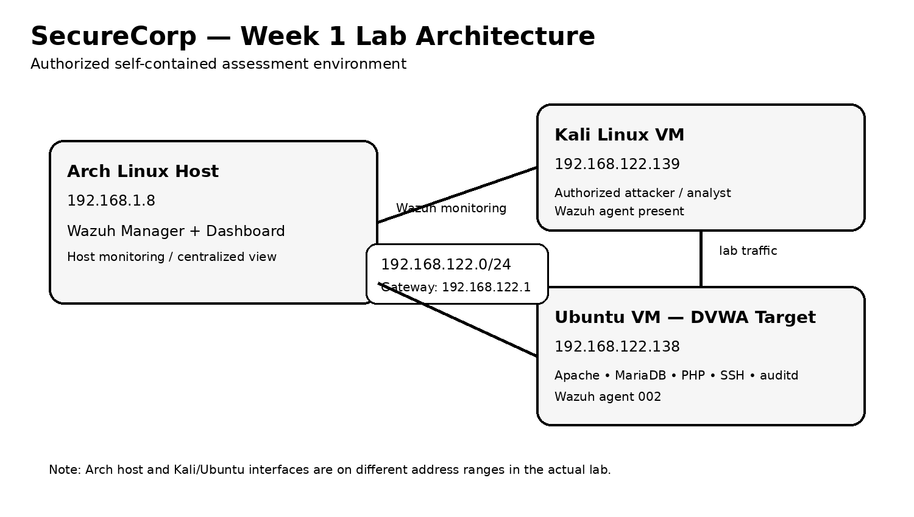
4. Asset Inventory
The inventory follows the SecureCorp company background in the handbook. No additional business assets are introduced.
Asset | Type | Owner / Department | Why It Matters
Employee laptops / Windows workstations | Hardware | All departments / IT responsibility | Primary endpoints used by employees; compromise could expose credentials, business data and internal access.
Ubuntu web server | Hardware / Software | Engineering / IT | Hosts the customer-facing portal in the production model and is a critical service platform.
Customer portal web application | Software | Engineering / Customer Support | Handles customer logins, customer data and support tickets and is directly exposed to application-layer attacks.
Internal company website | Software | Engineering / Corporate | Provides internal company information and business functionality.
Customer and employee database | Data | Engineering / Finance / HR / Customer Support | Contains business and personal information whose disclosure or manipulation could cause operational and reputational harm.
Employee accounts and credentials | Data / Identity | HR / IT / All departments | Provide access to business systems; compromise could enable unauthorized access and lateral movement.
Internet-facing connection | Connectivity | IT / Engineering | Provides external access to customer-facing services and therefore expands the attack surface.
5. CIA Analysis
The handbook requires coverage of at least five major assets. Seven are included here.
Asset | Confidentiality | Integrity | Availability
Customer portal | Customer information and account data must not be disclosed to unauthorized users. | Portal logic, authentication and transactions must not be altered by unauthorized parties. | Customers and support staff need reliable access to the portal and its functions.
Customer and employee database | Sensitive customer and employee records must remain private. | Unauthorized modification could corrupt records, permissions or business data. | Business functions relying on records must remain operational.
Ubuntu web server | System configuration, credentials and application data should not be exposed. | Unauthorized changes could alter services or enable compromise. | The server must remain available to serve the customer portal.
Employee accounts and credentials | Passwords and authentication material must remain secret. | Accounts and privileges must not be altered without authorization. | Employees need dependable access to required systems.
Employee workstations | Local business data and authentication material must be protected. | Unauthorized modification can affect business operations and endpoint trust. | Employees need functioning endpoints to perform their work.
Internal company website | Internal information should only be available to intended users. | Content must not be altered by unauthorized users. | Employees must be able to access required internal information.
Internet-facing connection | Exposure should not unintentionally disclose internal services. | Network exposure and routing should not be manipulated. | Connectivity is required for customer-facing services and remote work.
6. Threat and Risk Assessment
These are qualitative pre-assessment risks based on the assets and threat examples in the handbook. They are not being presented as confirmed Week 2 findings.
Asset | Threat | Vulnerability / Exposure | Business Impact | Risk | Recommended Control
Customer portal | SQL injection | Unsanitized application input may allow attacker-controlled SQL expressions. | Unauthorized data disclosure or manipulation. | High | Use parameterized queries, server-side input validation and least-privilege database access.
Customer portal | Brute-force attack | Repeated authentication attempts against weak credentials. | Account compromise and unauthorized customer access. | High | Enforce strong passwords, rate limiting, lockout controls and MFA where appropriate.
Customer portal | Cross-site scripting | Untrusted input may be rendered without adequate output encoding. | Script execution in a user's browser and possible session/data compromise. | High | Apply context-aware output encoding, input validation and an appropriate Content Security Policy.
Ubuntu web server | Command injection | Application input may reach operating-system commands without safe handling. | Unauthorized command execution and potential server compromise. | Critical | Avoid shell execution where possible; use allowlists, safe APIs, strict validation and least privilege.
Employee accounts | Phishing / credential theft | Human-targeted attacks can expose authentication material. | Unauthorized access to business systems and data. | High | Deploy MFA, phishing-resistant authentication where practical, security awareness and email protections.
Endpoints / server | Malware | Malicious software could execute on business systems. | Data loss, service disruption or credential compromise. | High | Use endpoint protection, patching, least privilege, centralized logging and tested backups.
Business data | Insider threat | Legitimate access can be abused or misused. | Unauthorized disclosure or alteration of business information. | Medium–High | Apply least privilege, access reviews, audit logging and separation of duties.
Internet-facing connection | Unauthorized scanning / exploitation | Externally reachable services increase attack surface. | Service compromise or disruption. | High | Minimize exposed services, segment systems, patch regularly and monitor external-facing activity.
7. Centralized Logging — Wazuh
Centralized monitoring was established using the Wazuh manager and dashboard on the Arch Linux host. The Arch host is agent 001 and the Ubuntu target is agent 002. The Week 1 setup also included a Wazuh agent on Kali. The available dashboard evidence confirms active enrolled agents, while the Ubuntu service status screenshot confirms the target agent is running.
Evidence | What it supports
14-wazuh-dashboard.png | Wazuh dashboard is operational.
15-wazuh-agent-running.png | Wazuh agent service is active on Ubuntu.
16-wazuh-agents-connected.png | Wazuh dashboard shows enrolled/connected agents.
8. Week 1 Evidence Register
File | Evidence
01-hostnamectl.png | Ubuntu hostname and operating-system identification
02-ipaddr.png | Ubuntu network addressing
03-storage.png | Disk/storage information
04-memory.png | Memory information
05-apache-running.png | Apache service status
06-mariadb-running.png | MariaDB service status
07-ssh-running.png | SSH service status
08-auditd-running.png | auditd service status
09-agent-active.png | Wazuh agent service status
10-kali-ping.png | Kali-to-Ubuntu connectivity
11-ubuntu-ping.png | Ubuntu-to-Kali connectivity
12-dvwa-login.png | DVWA login page
13-dvwa-home.png | DVWA home page after login
14-wazuh-dashboard.png | Wazuh dashboard
15-wazuh-agent-running.png | Wazuh agent running on Ubuntu
16-wazuh-agents-connected.png | Wazuh agents enrolled/connected
17-dvwa-security-low.png | DVWA configured at Low security
18-dvwa-db-created.png | DVWA database creation/setup evidence

9. Week 1 Completion Statement
The Week 1 environment was established and the baseline required for later testing is in place. The Ubuntu DVWA target is operational, the supporting services are running, Kali-to-Ubuntu connectivity was confirmed, DVWA was initialized and configured at Low security, and Wazuh monitoring was established. The asset inventory, CIA analysis and qualitative risk assessment are based on the SecureCorp company background. No Week 2 attack outcomes are included in this baseline.
Topology basis: Arch Linux is the physical/libvirt host at 192.168.1.8. Kali and Ubuntu are both libvirt guest VMs on 192.168.122.0/24. Kali is 192.168.122.139 and Ubuntu is 192.168.122.138, with 192.168.122.1 as the stated lab gateway.

