📘 Band-Pass Filter
A band-pass filter allows a specific range of frequencies to pass while attenuating frequencies below and above this range.
It is formed by cascading:
- a high-pass filter (HPF) → removes low frequencies
- a low-pass filter (LPF) → removes high frequencies
🔑 Key Idea
- Lower cutoff frequency → set by HPF
- Upper cutoff frequency → set by LPF
$$f_{L}=\text{HPF cutoff},f_{H}=\text{LPF cutoff}$$
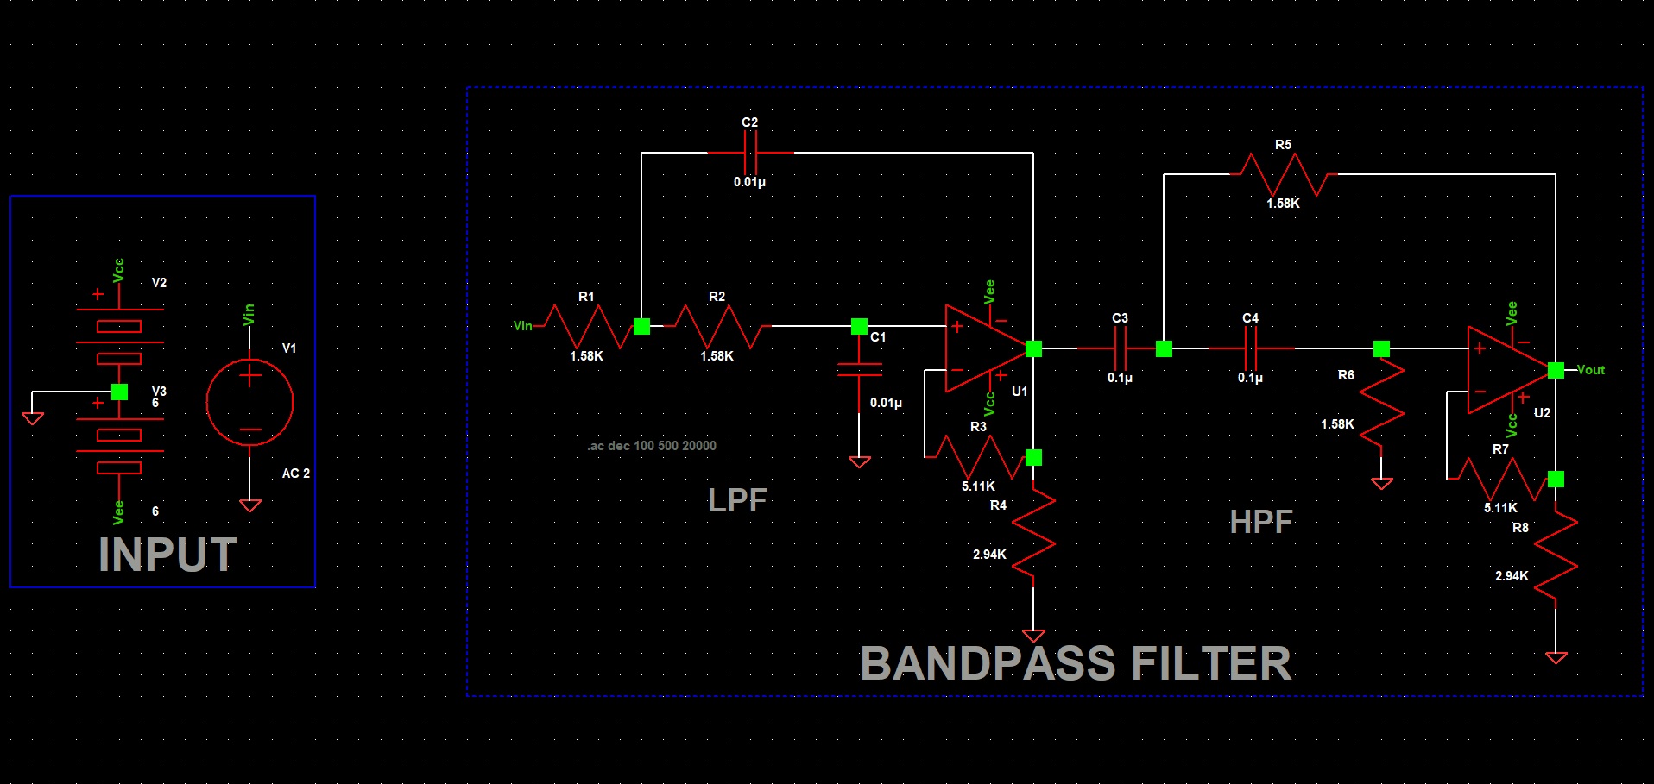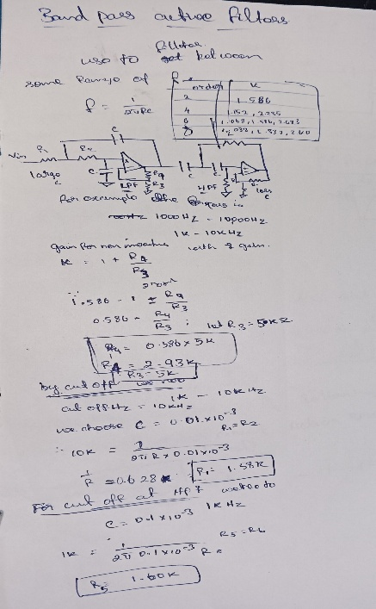0