## Convertian

A project report submitted in partial fulfillment of the requirements for the

### Second Year of Artificial Intelligence & Data Science

by

#### Vinit Dave (Roll No. 9362)

#### Jonathan Joseph (Roll No. 9377)

#### Amey Managute (Roll No. 9384)

#### Jacob Mire (Roll No. 9386)

Under the guidance of

#### Prof. Prajakta Dhamanskar



DEPARTMENT OF ARTIFICIAL INTELLIGENCE & DATA SCIENCE.

#### Fr. Conceicao Rodrigues College of Engineering, Bandra (W), Mumbai - 400050

University of Mumbai 2020-21

*This work is dedicated to my family.*

*I am very thankful for their motivation and support.*

## Internal Approval Sheet

**CERTIFICATE**

This is to certify that the project entitled **"Convertian"** is a bonafide work of **Vinit Dave (Roll No. 9362)Jonathan Joseph (Roll No. 9377)Amey Managute (Roll No. 9384)Jacob Mire (Roll No. 9386)** submitted to the University of Mumbai in partial fulfillment of the requirement for term work submission of Mini Project 1- A Second year Artificial Intelligence & Data Science**.**

(Name and sign) Supervisor/Guide

(Name and sign) Head of Department

(Name and sign) Principal

## Approval Sheet

**Project Report Approval**

This project report entitled **Convertian** by **Vinit Dave, Jonathan Joseph, Amey Managute, Jacob Mire** is approved for the Term work submission of Mini Project –1 A, Second year Artificial Intelligence & Data Science**.**

Examiners 1.————————————–

2.————————————–

Date:

Place:

# Declaration

We declare that this written submission represents our ideas in our own words and where others’ ideas or words have been included, we have adequately cited and referenced the original sources. We also declare that we have adhered to all principles of academic honesty and integrity and have not misrepresented or fabricated or falsified any idea/data/fact/source in my submission. We understand that any violation of the above will be cause for disciplinary action by the Institute and can also evoke penal action from the sources which have thus not been properly cited or from whom proper permission has not been taken when needed.

Vinit Dave (Roll No. 9362) **(sign)**

Jonathan Joseph (Roll No. 9377) **(sign)**

Amey Managute (Roll No. 9362) **(sign)**

Jacob Mire (Roll No. 9386) **(sign)**

Date: April 10, 2016

## Abstract

A mobile ad-hoc network is a self configuring network connected by wireless links. No infrastructure or central base station is needed for these types of networks. Therefore they are only suitable for temporary communication links. An important issue in a network is to design the network in such a way to cope up with the speed required today. The task of routing packets from a source to the particular destination is hard in ad-hoc networks because there is no central control over the network elements. In any network the data packets have to be routed to the destination with minimum data loss, minimum delay and maximum packet delivery ratio. Therefore there must be an efficient algorithm which satisfies all these quality of service (QoS) requirements. In this thesis we propose a biology-inspired ant routing protocol based on Ant Colony Optimization (ACO) called as OANTGPS (Optimized Antnet GPS) which is based on GPS (Global Positioning System) and mobile software agents modeled on ants for routing in ad-hoc networks. This technique uses range difference technique in GPS to compare the distance between two nodes in relation with destination node. Due to this technique, the packets are transmitted to the destination using optimum route. Our simulation result shows that our proposed algorithm outperforms Antnet in terms of average. throughput and route cost. Our simulation results also shows that OANTGPS outperforms Ad-hoc On Demand Distance Vector (AODV), Ad-hoc On Demand Multipath Distance Vector Routing (AOMDV) and Dynamic Source Routing (DSR) protocols in terms of average end to end delay, average throughput, packet delivery ratio and route cost.

## Acknowledgments

We have great pleasure in presenting the report on **"Project Title With Every First Letter in Upper Case"**. I take this opportunity to express my sincere thanks towards the guide [Name of the guide], C.R.C.E, Bandra (W), Mumbai, for providing the technical guidelines, and the suggestions regarding the line of this work. We enjoyed discussing the work progress with him during our visits to department.

We thank Dr. Jagruti Save, Head of Artificial Intelligence & Data Science Department, Principal and the management of C.R.C.E., Mumbai for encouragement and providing necessary infrastructure for pursuing the project.

We also thank all non-teaching staff for their valuable support, to complete our project.

Date: April 10, 2016

Vinit Dave (Roll No. 9362)

Jonathan Joseph (Roll No. 9377)

Amey Managute (Roll No. 9362)

Jacob Mire (Roll No. 9386)

# Chapter 1

## Introduction

### In today's online era where everyone is working and studying at home, there is a constant need of converting various things such as pdfs, word files, image files from one format to another.

### At the same time, students also require unit /measurement converters, currency converters , weight converters , area converters ,volume converters ,file converters and much more

### We at synergetiks have come up with a solution to all this and we present to you convertian ,convertian is a website that converts all units; from temperature to currencies and everything in between.

# Chapter 2

## Literature Review

What is conversion?

A conversion is defined as an exchange from one unit of measure to another. An example of conversion is exchanging dollars for euros. An example of conversion is figuring out how many cups are in a liter etc. A change in the form of a quantity, a unit, or an expression without a change in the value.

In today's online era where everyone is working and studying at home ,there is a constant need of converting various things such as pdfs ,word files ,image files from one format to another.

At the same time, students also require unit /measurement converters , currency converters , weight converters , area converters ,volume converters ,file converters and much more

We have observed a lack of number of conversions in certain websites ,they are very subject limited or very specific to a particular scenario .Some websites didn’t have universally compatible resolution, resulting in website/browser crashes and inefficiencies. These old websites don’t work on new and popular browsers. They had Complex and Outdated UIs and their contents were very unorganized, which made them hard to use

# Chapter 3

**Report on the proposed system**

Our objective is make a convenient website that converts all types of quantities and units at one place.the following are the list of all the conversions possible through convertian:-

* **Length converter**(mm,cm,m,km,miles,yards ,ft,inches, lightyears)
* **Weight converter**(mg,g,kg,tons,pounds,quintal)
* **Area converter**(mm²,cm²,km²,acres,hectares)
* **Volume converter**(mm,cm,m,litres,kilo litres)
* **Image to pdf conversion** (vice versa)
* **Pdf to word doc conversion**
* **Temperature converter**(f°,c°,k)
* **Pressure**(psi,pa,kpa,barr,atm,tor)
* **Currency**(rupees,dollars,british pounds,dirhams and many more……)
* **Number system conversion**(binary,decimal,octal,hexadecimal)
* **Power conversion**(mw,watts,mw,gw,hp)
* **Angle conversions**(degrees,radian)

**Analysis**

Our Objective is create an updated and organized website which is not subject limited, presentable , easy and convenient to use as well as having an integrated chatbot all in one place.

We have observed a lack of number of conversions in certain websites ,they are very subject limited or very specific to a particular scenario .Some websites didn’t have universally compatible resolution, resulting in website/browser crashes and inefficiencies. These old websites don’t work on new and popular browsers. They had Complex and Outdated UIs and their contents were very unorganized, which made them hard to use .

Our website covers all domains of conversions from financial,scientifical,mathematical all the way to document conversions.

**Design/Architecture**

We are using Spring MVC as a Framework of our project.

Spring MVC is a library within the Spring framework that simplifies handling HTTP requests and responses.

The Model-View-Controller (MVC) is an architectural pattern that separates an application into three main logical components: the model, the view, and the controller.

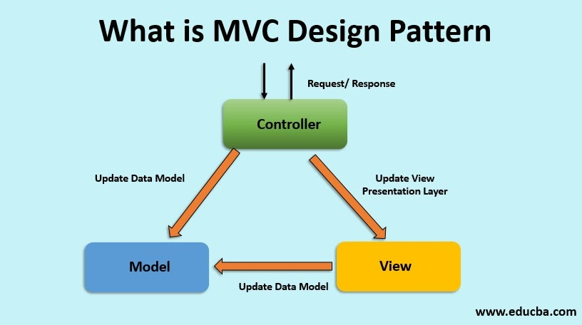

**DispatcherServlet**

DispatcherServlet - is the front controller. Front controller is a typical design pattern in the web applications development.A single servlet receives all requests and transfers them to all other components of the application.

The task of the DispatcherServlet is to send request to the specific Spring MVC controller.

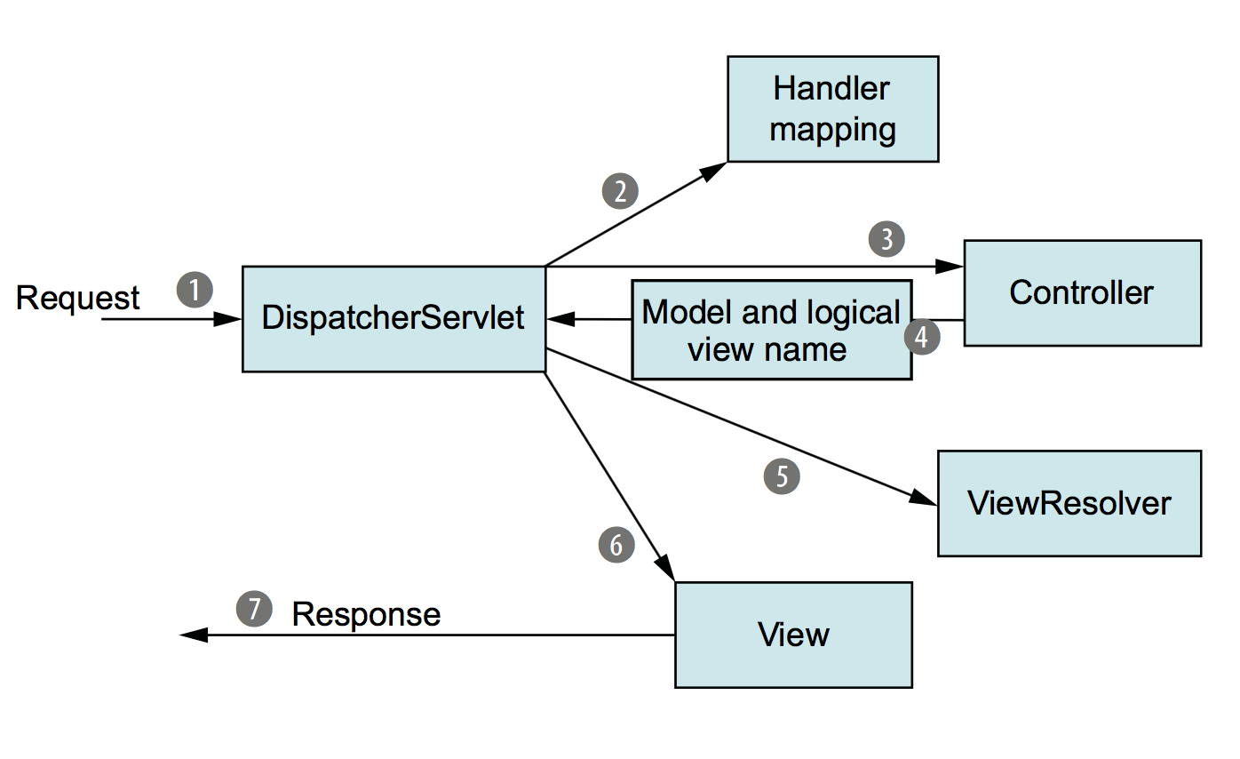

# Class Diagram

# 

# Block Diagram

# 

|  |  |  |  |  |  |
| --- | --- | --- | --- | --- | --- |
| **NAME** | **universally compatible resolution** | | **ease of usage** | **chatbot** | **quantity of conversions** |
| <https://www.onlineconversion.com/> | | 🗶 | 🗶 | 🗶 | ✔ |
| <https://www.everythingconverter.com/> | | ✔ | ✔ | 🗶 | 🗶 |
| <https://www.calculatorsoup.com/calculators/conversions/index.php> | | ✔ | 🗶 | 🗶 | subject limited |
| <https://www.metric-conversions.org/time-conversion.htm> | | ✔ | 🗶 | 🗶 | 🗶 |
| <https://www.digikey.com/en/resources/online-conversion-calculators> | | ✔ | 🗶 | 🗶 | subject limited |

# Chapter 4

**Software requirements**

* Frontend programming
  + Jsp for describing the structure of web pages.
  + Css for defining the styles for web pages.
  + Javascript to add dynamic behavior to the webpage and add special effects to the webpage.

* Backend programming
  + Java for  mobile application development, web development, database connectivity, networking
  + Firebase as database
  + Spring mvc as framework
  + Java for, web development, networking
  + Maven based project

* Dialogflow for chat bot

* Eclipse idea as an ide

**Implementation Plan for next semester**

In the Coming Semester, we are planning to integrate a chatbot to the website for further ease of usage also making it feature-rich

We are also planning to add firebase as Database for data handling/Management/saving of previous conversions.

Including Word to Pdf, Pdf to word, Image to Pdf.

## References

Documentation :

<https://getbootstrap.com/docs/5.1/getting-started/introduction>

<https://docs.spring.io/spring-framework/docs/4.0.x/spring-framework-reference/html/>

Videos:

<https://www.youtube.com/watch?v=y8zyPlIdTyE&list=PL0zysOflRCelAb51IrexpUSeB0dpr9p6g>

<https://www.youtube.com/playlist?list=PL0zysOflRCekeiERASkpi-crREVensZGS>

Websites:

<https://www.onlineconversion.com/>

<https://www.everythingconverter.com/>

https://www.digikey.com/en/resources/online-conversion-calculators