**Abstract:**

The marketing mix approach for the Apple iPhone SE is critically evaluated in this study. Following a quick introduction to the necessity of marketing mix strategy, a brief overview of the iPhone SE, including its pricing and features, is provided. Apple's iPhone SE is a high-end and mid-range mobile smartphone. The iPhone SE's product strategy, pricing plan, and promotion strategy all show that it is a cutting-edge product, with prices tailored to the needs of middle-class customers. The promotional activities for the iPhone SE suggest that it is marketed through television commercials, and marketing mix modification methods have also been recommended, indicating that the iPhone's pricing should be comparable to those of other similar mobile phones.

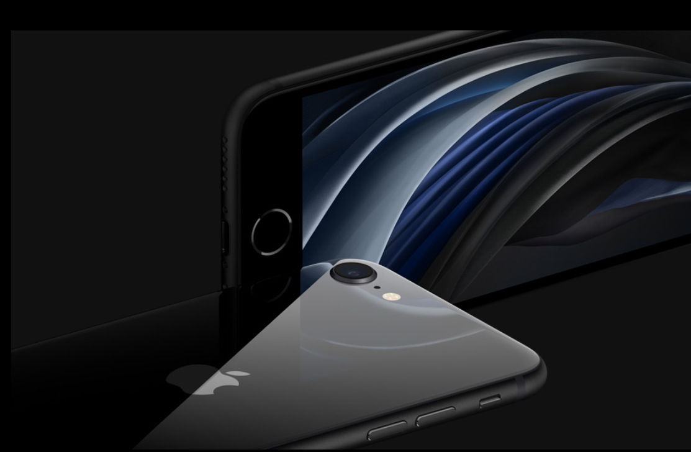

**Introduction:**

New goods are introduced into the market regularly, but the majority of them fail to make an impression in the market due to ineffective marketing mix tactics for their product. For a product to succeed, it has to have a strong marketing mix plan. The marketing mix plan demands the creation of an effective product, price, and promotion strategies for the product to have an impression on the target customers and, as a result, generate greater overall success for the product. This implies that a proper marketing mix plan is critical for a newly introduced product's market success. The company's product should be able to meet the demands of its consumers, and its prices should be such that the consumer who purchases it receives good value for money. Furthermore, it is necessary to design particular advertising plans for the product to make customers aware of it.

A study of the product, price, and advertising strategies for the product iPhone SE will be done in this report, along with a clear appraisal of its target market and the company's product characteristics. In addition, the promotional methods that were utilised to communicate the product to the market will be evaluated, followed by a review of the company's pricing strategy. Finally, the iPhone SE market mix adjustment plan will be assessed, and the product's entire findings will be presented in the report's conclusion section.

Cell phones have been around for a long time. Messages, calls, and a few other functions were all that phones could do when they first came out. However, there has been a significant advancement in the field of mobile phones during the previous decade. With the debut of the first-generation iPhone in 2007, Apple established a new category of phones known as "smartphones." It could accomplish a variety of activities, such as browse the internet, download apps, send emails, play games, and so on. Since then, a slew of businesses has released smartphones based on Google's "Android" operating system, alongside Apple's "iOS" operating system.

**History of iPhones:**

Since the first iPhone was introduced in 2007, Apple has announced new iPhones every year, generally in September in conjunction with some of their other products during their World Wide Developers Conference (WWDC). Every year at 9:41 a.m., they announce the phone, in honour of Steve Jobs' introduction of the original generation iPhone. Every year, a new version of iOS is released, with bug fixes, new features, and upgraded hardware such as improved cameras, a stunning all-new design, as well as new compatible accessories and other goodies.

**iPhone SE (2nd Generation):**

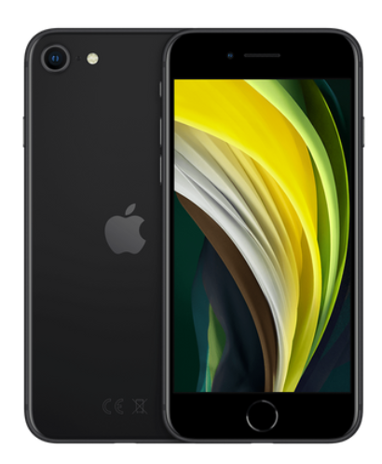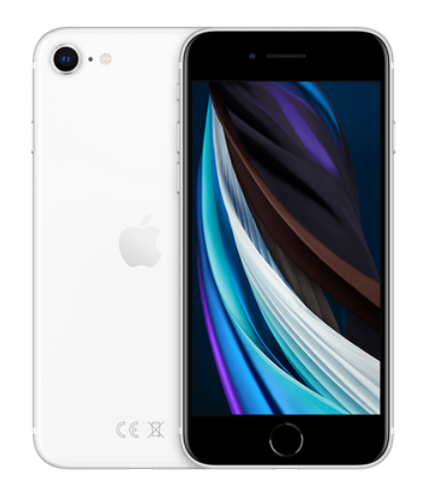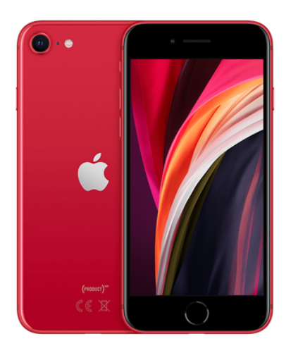

The iPhone SE is the iPhone's second generation. Because of the Corona Virus pandemic, it was unveiled on April 15, 2020, rather than September, as is customary, during an Apple Special Event at Apple Park in Cupertino, California.

It was the first time since the first-generation iPhone SE was introduced in 2016 that it was released with a fresh design. A redesigned aluminium frame and glass back body with eSim capabilities, a True-tone display with brightness up to 625 nits, a 65.4% screen-to-body ratio, and more are among the major changes. It has Apple's new A13 Bionic CPU (7 nm+), which is one of the world's most powerful mobile computers. It sports a Retina IPS LCD display with a size of 4.7 inches. It comes with 64GB, 128GB, and 256GB of storage. Apple claims that the new design incorporates a new "ceramic display," which is "the toughest smartphone display." There are four colour options for the iPhone SE (2nd generation): black, white, and red. It has IP67 water and dust resistance rating, which means it can be immersed for 30 minutes in water up to 1 metre deep.

**Product and Target Market Description:**

The iPhone SE has been chosen as the product to analyse its marketing mix methods, as previously stated. It is a product of Apple Inc, a global corporation located in the United States. Apple Inc. is recognised for developing revolutionary electrical equipment, with the iPhone being one such example. The business began making iPhones in 2005, and since then, it has introduced a variety of iPhone models to the market. The iPhone SE is the company's most recent mobile phone, and it has various functions and features to meet all of a consumer's needs from a phone.

The target market for a product is the group of people that the product is intended for. The selection of an acceptable target market is critical for the product to be introduced into the market with tactics that will lead to better product acceptability by the intended customers. In the case of the iPhone SE, the business's target demographic comprises mid-tier consumers, as the corporation prefers to target a big number of customers rather than a small number of high-end customers. It has taken every effort to maintain the cost of its iPhone SE within the grasp of middle-class customers to ensure that the device is acceptable to a larger client database (Apple iPhone SE pricing designed to widen its appeal, 2016). Apart from this, the target market for iPhone SE also includes the customers of previous versions of the iPhone who wish to upgrade their iPhone to iPhone SE (2nd Generation).

**Marketing Mix Adjustment Strategies:**

The evaluation of Apple iPhone SE marketing mix tactics resulted in the discovery of specific strengths as well as weaknesses in the approach. Based on the study, it can be concluded that price and promotion methods may be tweaked further to increase product recognition among the target market. For example, targeting techniques might be fine-tuned by identifying certain consumer categories that can be targeted for the iPhone SE, such as business professionals or young individuals with a penchant for high-end phones like the iPhone, Samsung Galaxy, and so on. Furthermore, by maintaining its price approach somewhat lower than its key competitors like Samsung and Motorola, the pricing plan may be made more inventive and acceptable to a larger portion of its target market group. Finally, there are a variety of promotional techniques available to make the iPhone extremely visible to its target consumers, such as public relations, where companies may provide discounts, or other offers, such as purchasing an iPhone SE with extra add-ons.

**Pricing Strategy used for Apple iPhone SE (2nd Generation):**

Another important determining element for the product's performance is the price plan. The product's price plan should help buyers to build a positive impression of the product as a good value for money purchase. Only by creating a successful price plan for the product based on the demands and budget of its target consumers can this be accomplished. As previously said, the company's Apple iPhone SE is aimed at middle- and higher-end users, and as a result, the pricing goal for the device has been to keep it affordable for middle-end consumers. The approach for the iPhone SE has been to charge varying rates for different capacities of 64 GB, 128 GB, and 256GB versions.

During the introduction phase, the perceptual map is used to outline the price plan for the iPhone SE, which is as follows:

The perceptual map for the Apple iPhone SE during the introductory phase is compared to phones in similar ranges from other companies such as Motorola, Samsung, Nokia, and others, and it has been determined that the quality of the Apple iPhone SE is at the top of the list, and the prices for the iPhone SE are also higher than other phones such as the Samsung Galaxy II, Motorola Droid RAZR, and others. The map also shows that while the quality of other phones is still adequate, the costs of all other phones are initially cheaper during the launch phase.

However, a significant shift in the pricing of the iPhone SE and other major mobile phones is predicted, but the quality of the Apple iPhone SE is likely to remain the same, as shown in the perceptual map below in the mature stage:

The perceptual map for Apple iPhone SE at the maturity stage shows that the phone's quality will remain the same, but costs will drop due to reduced significance for iPhone SE, as the firm plans to introduce iPhone SE (2nd Generation) with the most desirable features. Since a result, the capabilities offered in the iPhone SE will become less significant as most customers choose to purchase the most recent iPhone models. Other phones, on the other hand, are expected to see price reductions as well.

**Conclusion and Recommendation:**

Based on the analysis, it is recommended that the iPhone SE be priced slightly lower than its competitors, such as Samsung, Nokia, and Motorola phones in the same price range, and that more promotional tools, such as coupons, discounts, and additional add-on features, be used to promote the iPhone among its target audience.

Apple's most recent iPhone is the iPhone SE (2nd Generation). It's Apple's current entry-level iPhone. It exemplifies how far the smartphone industry has progressed since the first iPhone was released. It's a highly sophisticated and powerful gadget. Later this year, Apple is anticipated to unveil the next generation of iPhones, which will hopefully improve on this already competent smartphone. The Apple iPhone SE has been subjected to a rigorous examination, with particular attention paid to Apple Inc's marketing mix approach for its current iPhone model. The target market for Apple iPhone has been examined, and it has been determined that its target market comprises middle and high-end consumer groups, followed by an evaluation of its product, promotion, and price methods. The product strategy is evaluated, and it shows that the iPhone SE has all of the crucial characteristics that are required in a contemporary Android phone. The firm has also utilised promotional methods like television commercials to sell its product, and the pricing approach shows that the iPhone SE is priced differently depending on the capacity.