**Experiment No.03**

**A.1 Aim:** Implementation of OLAP operation in SQL Environment for the problem statement defined in the first experiment.

**PART B**

(PART B: TO BE COMPLETED BY STUDENTS)

***(Students must submit the soft copy as per the following segments within two hours of the practical. The soft copy must be uploaded on the Blackboard or emailed to the concerned lab in charge faculties at the end of the practical in case there is no Blackboard access available)***

|  |  |
| --- | --- |
| **Roll No.** 50 | **Name:** AMEY THAKUR |
| **Class:** Comps TE B | **Batch:** B3 |
| **Date of Experiment:** 23/03/2021 | **Date of Submission:** 23/03/2021 |
| **Grade:** |  |

**B.1 Software Code written by a student:**

***(Paste your problem statement related to your case study completed during the 2 hours of practice in the lab here)***

**OLAP TABLE**

CREATE TABLE OLAP

(CUST_ID NUMBER(3) PRIMARY KEY,

CUST_NAME VARCHAR2(20),

NO_OF_PRODUCTS NUMBER(3),

STORE_NAME VARCHAR2(54),

STORE_LOCATION VARCHAR2(25));

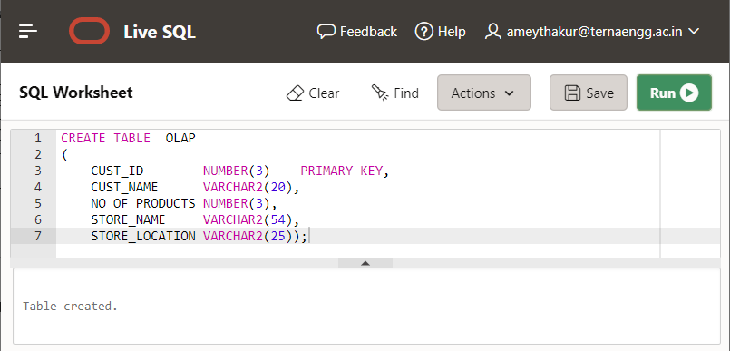

**INSERT VALUES**

INSERT INTO OLAP VALUES('1','ARCHIT KONDE','2','Star Bazzar','THANE');

INSERT INTO OLAP VALUES('2','SAAKSHI DEOKAR','1','DMart','GOREGAON');

INSERT INTO OLAP VALUES('3','HASAN RIZVI','4','DMart','THANE');

INSERT INTO OLAP VALUES('4','MEGA MODHA','3','Big Bazaar','GHATKOPAR');

INSERT INTO OLAP VALUES('5','MAYURESH PHANSIKAR','2','DMart','SEAWOODS');

INSERT INTO OLAP VALUES('6','INJILA HUSSAIN','1','Big Bazaar','KURLA');

INSERT INTO OLAP VALUES('7','SAURABH KILLEKAR','2','Hyper City','THANE');

INSERT INTO OLAP VALUES('8','SAKSHI KHARE','1',’Star Bazzar','GHATKOPAR');

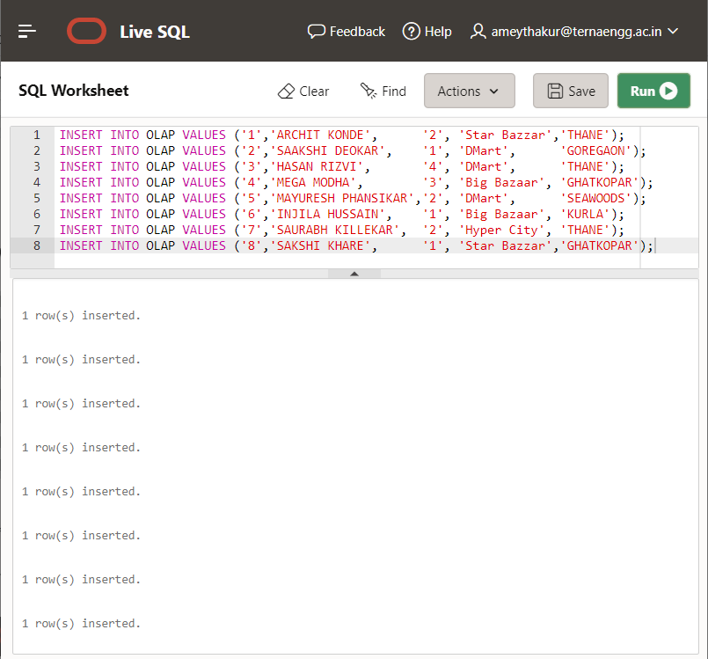

SELECT * FROM OLAP;

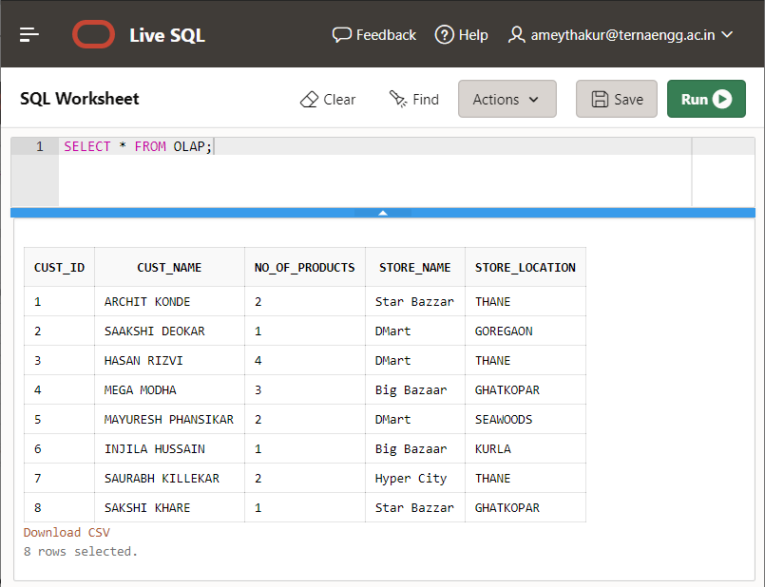

**Roll up:**

SELECT STORE_NAME, SUM(NO_OF_PRODUCTS) AS TOTALPRODUCT FROM OLAP GROUP BY STORE_NAME;

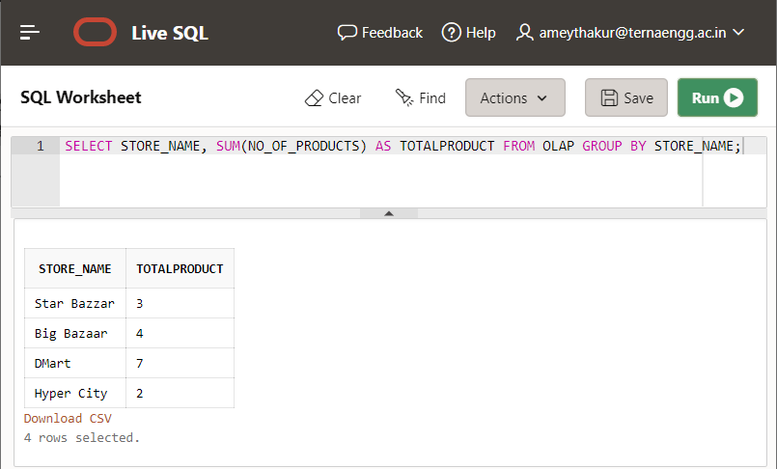

SELECT STORE_LOCATION, SUM(NO_OF_PRODUCTS) AS TOTALPRODUCT FROM OLAP GROUP BY STORE_LOCATION;

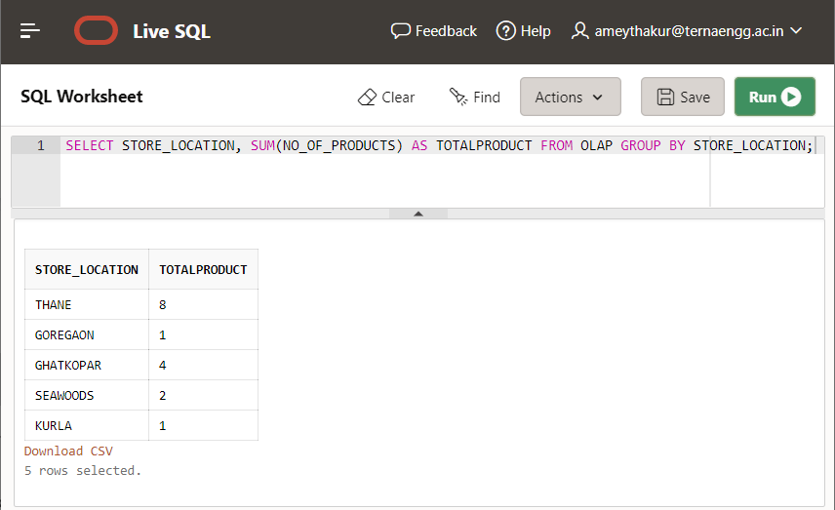

**Drill down**

SELECT CUST_ID,CUST_NAME,NO_OF_PRODUCTS, STORE_LOCATION FROM OLAP;

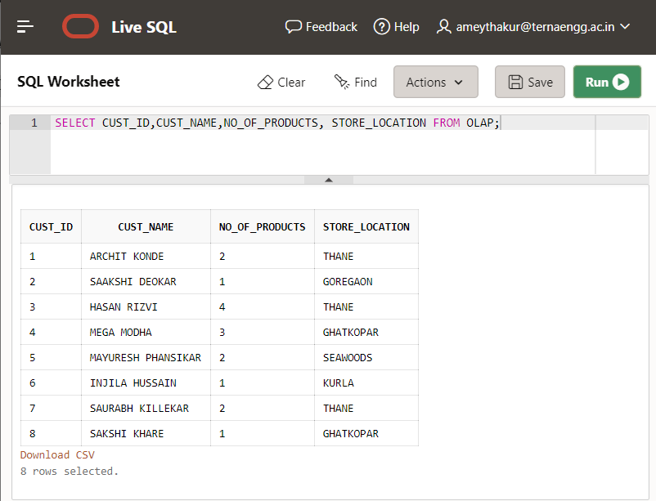

**Slice**

SELECT * FROM OLAP WHERE STORE_LOCATION='THANE';

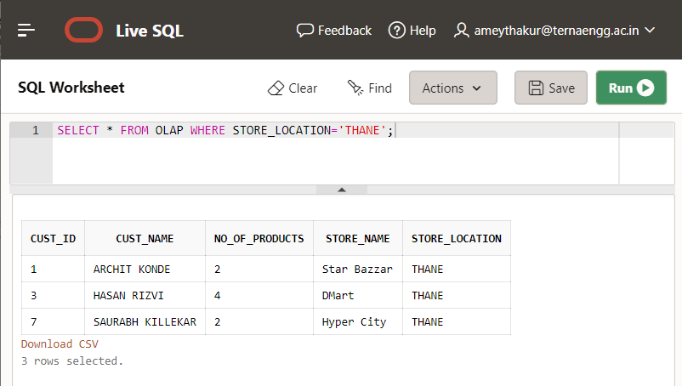

**Dice**

SELECT * FROM OLAP WHERE NO_OF_PRODUCTS=2 AND STORE_LOCATION='THANE';

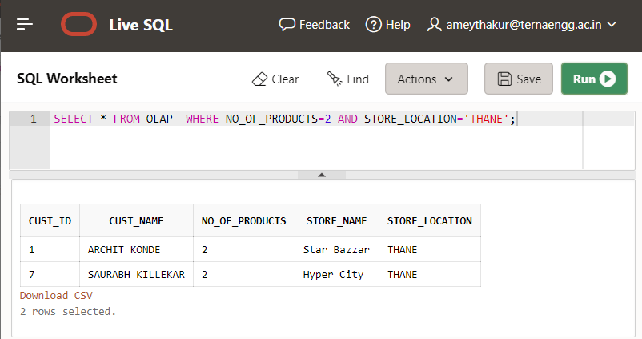

**B.2 Input and Output:**

***(Paste your program input and output in the following format, If there is an error then paste the specific error in the output part. In case of an error with the due permission of the faculty, an extension can be given to submit the error-free code with output in due course of time. Students will be graded accordingly.)***

**Note:** Input and Output are mentioned in section B.1

**Input :**

**SQL commands/script which satisfies Two different outcomes mentioned in Problem statements.**

**Output:**

1. **Dimensional Tables created after firing the above SQL commands.**
2. **The output satisfies 2 different outcomes mentioned in Problem statements**.

**B.3 Observations and learning:**

***(Students are expected to comment on the output obtained with clear observations and learning for each task/ subpart assigned)***

Hence, we have learnt about the different OLAP operations and observed the result of the respective operation queries.

**B.4 Conclusion:**

*(****Students must write the conclusion as per the attainment of individual outcome listed above and learning/observation noted in section B.3)***

We have successfully implemented the queries for different OLAP operations for the dimension and fact tables.

**B.5 Question of Curiosity**

***(To be answered by the student based on the practical performed and learning/observations)***

1. Explain the Need for Online Analytical Processing.

Ans:

* OLAP is a category of software that allows users to analyze information from multiple database systems at the same time. It is a technology that enables analysts to extract and view business data from different points of view. OLAP stands for Online Analytical Processing.
* Analysts frequently need to group, aggregate and join data. These operations in relational databases are resource-intensive. With OLAP data can be pre-calculated and pre-aggregated, making analysis faster.
* OLAP databases are divided into one or more cubes. The cubes are designed in such a way that creating and viewing reports become easy.

1. What is the difference between MOLAP and ROLAP?

Ans:

|  |  |  |
| --- | --- | --- |
| **BASIS FOR COMPARISON** | **ROLAP** | **MOLAP** |
| **Full-Form** | ROLAP stands for Relational Online Analytical Processing. | MOLAP stands for Multidimensional Online Analytical Processing. |
| **Storage & Fetched** | Data is stored and fetched from the main data warehouse. | Data is stored and fetched from the Proprietary database MDDBs. |
| **Data Form** | Data is stored in the form of relational tables. | Data is Stored in the large multidimensional array made of data cubes. |
| **Data volumes** | Large data volumes. | Limited summaries data is kept in MDDBs. |
| **Technology** | Uses Complex SQL queries to fetch data from the main warehouse. | MOLAP engine created a precalculated and prefabricated data cubes for multidimensional data views.  Sparse matrix technology is used to manage data sparsity. |
| **View** | ROLAP creates a multidimensional view of data dynamically. | MOLAP already stores the static multidimensional view of data in MDDBs. |
| **Access** | Slow access. | Faster access. |