**Experiment No.04**

**A.1 Aim:** Implementation of Decision Tree Algorithm using J-48 in WEKA tool.

**PART B**

(PART B: TO BE COMPLETED BY STUDENTS)

***(Students must submit the soft copy as per the following segments within two hours of the practical. The soft copy must be uploaded on the Blackboard or emailed to the concerned lab in charge faculties at the end of the practical in case there is no Blackboard access available)***

|  |  |
| --- | --- |
| **Roll No.** 50 | **Name:** AMEY THAKUR |
| **Class:** Comps TE B | **Batch:** B3 |
| **Date of Experiment:** 10/04/2021 | **Date of Submission:** 10/04/2021 |
| **Grade:** |  |

**B.1 Software Code written by a student:**

***(Paste your problem statement related to your case study completed during the 2 hours of practice in the lab here)***

@RELATION iris

@ATTRIBUTE sepallength REAL

@ATTRIBUTE sepalwidth REAL

@ATTRIBUTE petallength REAL

@ATTRIBUTE petalwidth REAL

@ATTRIBUTE class {Iris-setosa,Iris-versicolor,Iris-virginica}

@DATA

5.1,3.5,1.4,0.2,Iris-setosa

4.9,3.0,1.4,0.2,Iris-setosa

4.7,3.2,1.3,0.2,Iris-setosa

4.6,3.1,1.5,0.2,Iris-setosa

5.0,3.6,1.4,0.2,Iris-setosa

5.4,3.9,1.7,0.4,Iris-setosa

4.6,3.4,1.4,0.3,Iris-setosa

5.0,3.4,1.5,0.2,Iris-setosa

4.4,2.9,1.4,0.2,Iris-setosa

4.9,3.1,1.5,0.1,Iris-setosa

5.4,3.7,1.5,0.2,Iris-setosa

4.8,3.4,1.6,0.2,Iris-setosa

4.8,3.0,1.4,0.1,Iris-setosa

4.3,3.0,1.1,0.1,Iris-setosa

5.8,4.0,1.2,0.2,Iris-setosa

5.7,4.4,1.5,0.4,Iris-setosa

5.4,3.9,1.3,0.4,Iris-setosa

5.1,3.5,1.4,0.3,Iris-setosa

5.7,3.8,1.7,0.3,Iris-setosa

5.1,3.8,1.5,0.3,Iris-setosa

5.4,3.4,1.7,0.2,Iris-setosa

5.1,3.7,1.5,0.4,Iris-setosa

4.6,3.6,1.0,0.2,Iris-setosa

5.1,3.3,1.7,0.5,Iris-setosa

4.8,3.4,1.9,0.2,Iris-setosa

5.0,3.0,1.6,0.2,Iris-setosa

5.0,3.4,1.6,0.4,Iris-setosa

5.2,3.5,1.5,0.2,Iris-setosa

5.2,3.4,1.4,0.2,Iris-setosa

4.7,3.2,1.6,0.2,Iris-setosa

4.8,3.1,1.6,0.2,Iris-setosa

5.4,3.4,1.5,0.4,Iris-setosa

5.2,4.1,1.5,0.1,Iris-setosa

5.5,4.2,1.4,0.2,Iris-setosa

4.9,3.1,1.5,0.1,Iris-setosa

5.0,3.2,1.2,0.2,Iris-setosa

5.5,3.5,1.3,0.2,Iris-setosa

4.9,3.1,1.5,0.1,Iris-setosa

4.4,3.0,1.3,0.2,Iris-setosa

5.1,3.4,1.5,0.2,Iris-setosa

5.0,3.5,1.3,0.3,Iris-setosa

4.5,2.3,1.3,0.3,Iris-setosa

4.4,3.2,1.3,0.2,Iris-setosa

5.0,3.5,1.6,0.6,Iris-setosa

5.1,3.8,1.9,0.4,Iris-setosa

4.8,3.0,1.4,0.3,Iris-setosa

5.1,3.8,1.6,0.2,Iris-setosa

4.6,3.2,1.4,0.2,Iris-setosa

5.3,3.7,1.5,0.2,Iris-setosa

5.0,3.3,1.4,0.2,Iris-setosa

7.0,3.2,4.7,1.4,Iris-versicolor

6.4,3.2,4.5,1.5,Iris-versicolor

6.9,3.1,4.9,1.5,Iris-versicolor

5.5,2.3,4.0,1.3,Iris-versicolor

6.5,2.8,4.6,1.5,Iris-versicolor

5.7,2.8,4.5,1.3,Iris-versicolor

6.3,3.3,4.7,1.6,Iris-versicolor

4.9,2.4,3.3,1.0,Iris-versicolor

6.6,2.9,4.6,1.3,Iris-versicolor

5.2,2.7,3.9,1.4,Iris-versicolor

5.0,2.0,3.5,1.0,Iris-versicolor

5.9,3.0,4.2,1.5,Iris-versicolor

6.0,2.2,4.0,1.0,Iris-versicolor

6.1,2.9,4.7,1.4,Iris-versicolor

5.6,2.9,3.6,1.3,Iris-versicolor

6.7,3.1,4.4,1.4,Iris-versicolor

5.6,3.0,4.5,1.5,Iris-versicolor

5.8,2.7,4.1,1.0,Iris-versicolor

6.2,2.2,4.5,1.5,Iris-versicolor

5.6,2.5,3.9,1.1,Iris-versicolor

5.9,3.2,4.8,1.8,Iris-versicolor

6.1,2.8,4.0,1.3,Iris-versicolor

6.3,2.5,4.9,1.5,Iris-versicolor

6.1,2.8,4.7,1.2,Iris-versicolor

6.4,2.9,4.3,1.3,Iris-versicolor

6.6,3.0,4.4,1.4,Iris-versicolor

6.8,2.8,4.8,1.4,Iris-versicolor

6.7,3.0,5.0,1.7,Iris-versicolor

6.0,2.9,4.5,1.5,Iris-versicolor

5.7,2.6,3.5,1.0,Iris-versicolor

5.5,2.4,3.8,1.1,Iris-versicolor

5.5,2.4,3.7,1.0,Iris-versicolor

5.8,2.7,3.9,1.2,Iris-versicolor

6.0,2.7,5.1,1.6,Iris-versicolor

5.4,3.0,4.5,1.5,Iris-versicolor

6.0,3.4,4.5,1.6,Iris-versicolor

6.7,3.1,4.7,1.5,Iris-versicolor

6.3,2.3,4.4,1.3,Iris-versicolor

5.6,3.0,4.1,1.3,Iris-versicolor

5.5,2.5,4.0,1.3,Iris-versicolor

5.5,2.6,4.4,1.2,Iris-versicolor

6.1,3.0,4.6,1.4,Iris-versicolor

5.8,2.6,4.0,1.2,Iris-versicolor

5.0,2.3,3.3,1.0,Iris-versicolor

5.6,2.7,4.2,1.3,Iris-versicolor

5.7,3.0,4.2,1.2,Iris-versicolor

5.7,2.9,4.2,1.3,Iris-versicolor

6.2,2.9,4.3,1.3,Iris-versicolor

5.1,2.5,3.0,1.1,Iris-versicolor

5.7,2.8,4.1,1.3,Iris-versicolor

6.3,3.3,6.0,2.5,Iris-virginica

5.8,2.7,5.1,1.9,Iris-virginica

7.1,3.0,5.9,2.1,Iris-virginica

6.3,2.9,5.6,1.8,Iris-virginica

6.5,3.0,5.8,2.2,Iris-virginica

7.6,3.0,6.6,2.1,Iris-virginica

4.9,2.5,4.5,1.7,Iris-virginica

7.3,2.9,6.3,1.8,Iris-virginica

6.7,2.5,5.8,1.8,Iris-virginica

7.2,3.6,6.1,2.5,Iris-virginica

6.5,3.2,5.1,2.0,Iris-virginica

6.4,2.7,5.3,1.9,Iris-virginica

6.8,3.0,5.5,2.1,Iris-virginica

5.7,2.5,5.0,2.0,Iris-virginica

5.8,2.8,5.1,2.4,Iris-virginica

6.4,3.2,5.3,2.3,Iris-virginica

6.5,3.0,5.5,1.8,Iris-virginica

7.7,3.8,6.7,2.2,Iris-virginica

7.7,2.6,6.9,2.3,Iris-virginica

6.0,2.2,5.0,1.5,Iris-virginica

6.9,3.2,5.7,2.3,Iris-virginica

5.6,2.8,4.9,2.0,Iris-virginica

7.7,2.8,6.7,2.0,Iris-virginica

6.3,2.7,4.9,1.8,Iris-virginica

6.7,3.3,5.7,2.1,Iris-virginica

7.2,3.2,6.0,1.8,Iris-virginica

6.2,2.8,4.8,1.8,Iris-virginica

6.1,3.0,4.9,1.8,Iris-virginica

6.4,2.8,5.6,2.1,Iris-virginica

7.2,3.0,5.8,1.6,Iris-virginica

7.4,2.8,6.1,1.9,Iris-virginica

7.9,3.8,6.4,2.0,Iris-virginica

6.4,2.8,5.6,2.2,Iris-virginica

6.3,2.8,5.1,1.5,Iris-virginica

6.1,2.6,5.6,1.4,Iris-virginica

7.7,3.0,6.1,2.3,Iris-virginica

6.3,3.4,5.6,2.4,Iris-virginica

6.4,3.1,5.5,1.8,Iris-virginica

6.0,3.0,4.8,1.8,Iris-virginica

6.9,3.1,5.4,2.1,Iris-virginica

6.7,3.1,5.6,2.4,Iris-virginica

6.9,3.1,5.1,2.3,Iris-virginica

5.8,2.7,5.1,1.9,Iris-virginica

6.8,3.2,5.9,2.3,Iris-virginica

6.7,3.3,5.7,2.5,Iris-virginica

6.7,3.0,5.2,2.3,Iris-virginica

6.3,2.5,5.0,1.9,Iris-virginica

6.5,3.0,5.2,2.0,Iris-virginica

6.2,3.4,5.4,2.3,Iris-virginica

5.9,3.0,5.1,1.8,Iris-virginica

%

%

%

**B.2 Input and Output:**

***(Paste your program input and output in the following format, If there is an error then paste the specific error in the output part. In case of an error with the due permission of the faculty, an extension can be given to submit the error-free code with output in due course of time. Students will be graded accordingly.)***

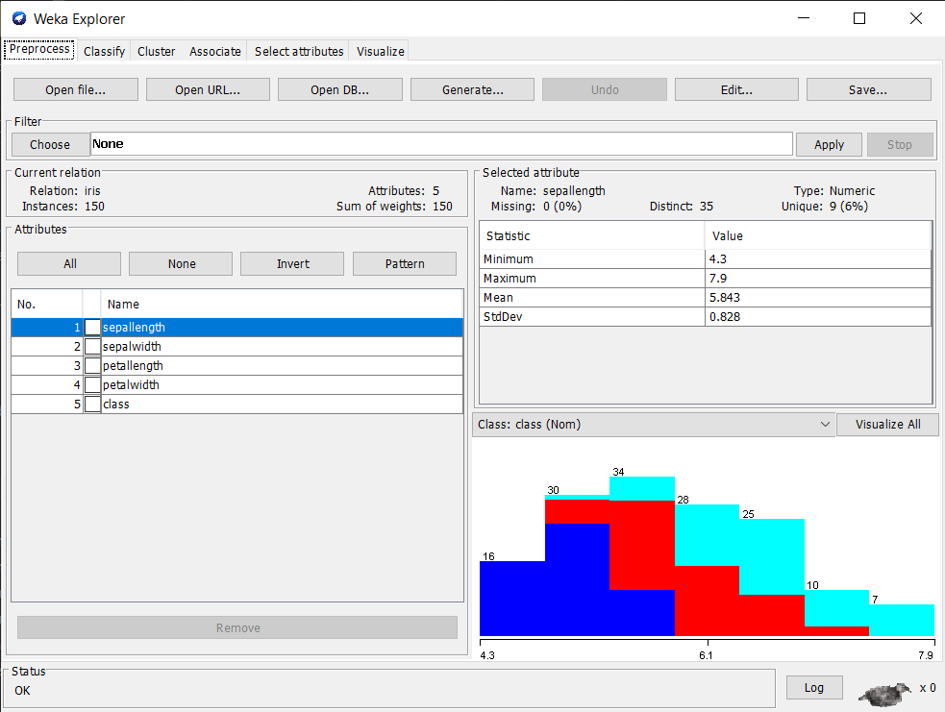

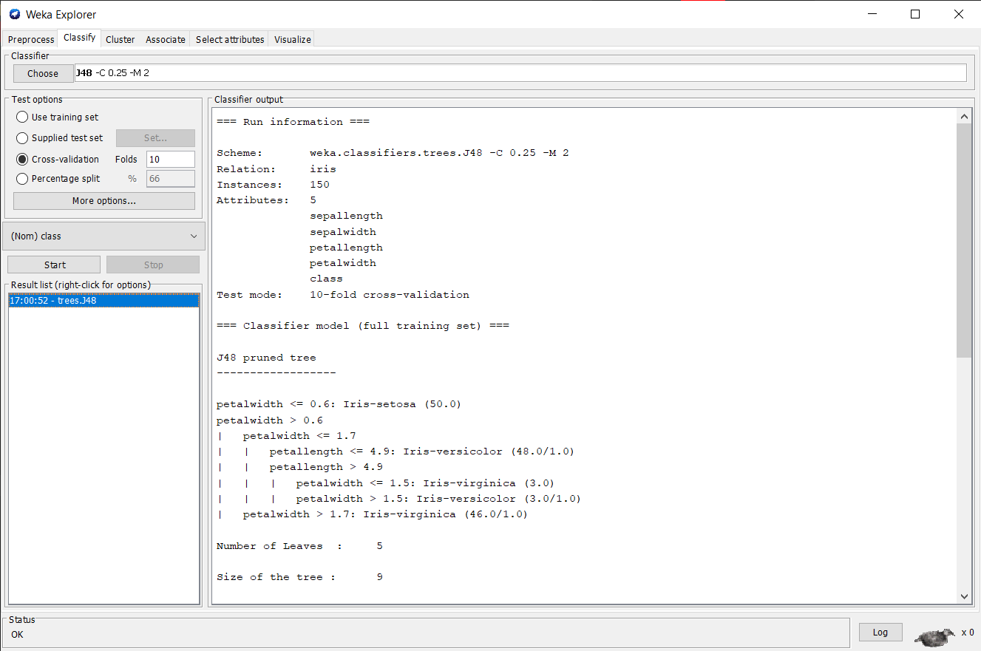

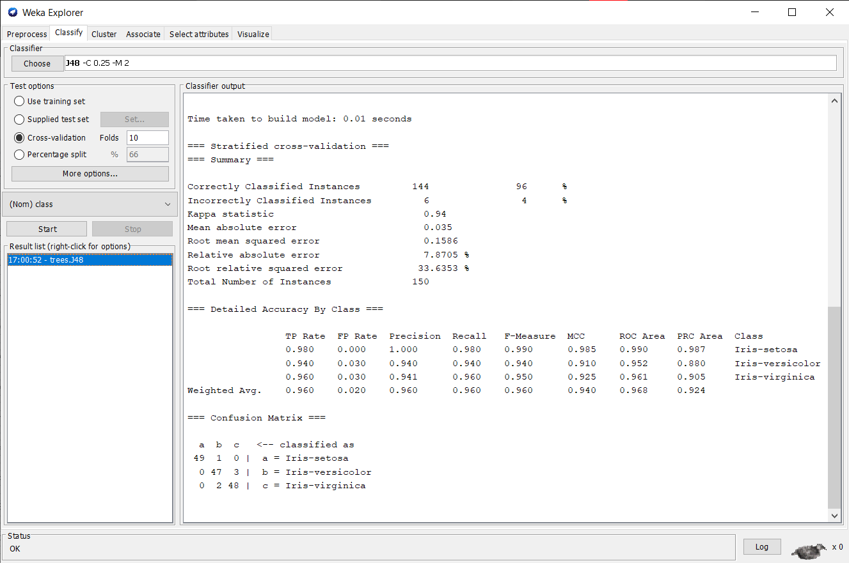

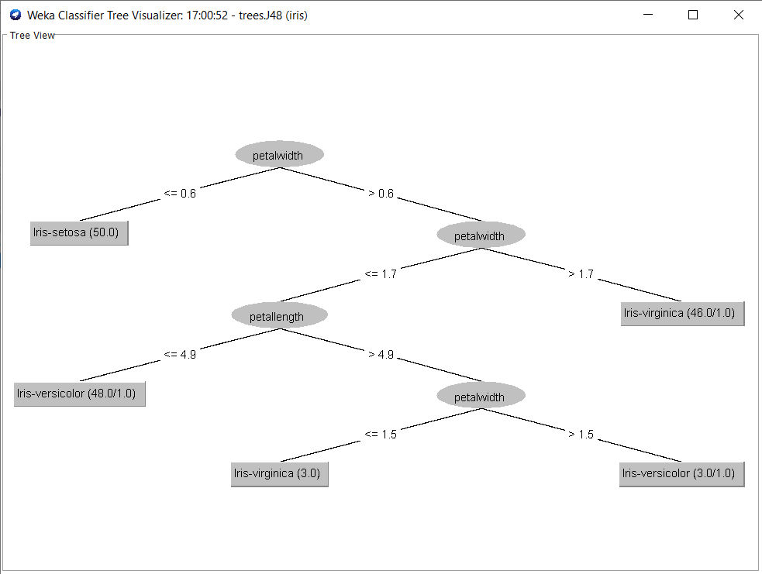

**B.3 Observations and learning:**

***(Students are expected to comment on the output obtained with clear observations and learning for each task/ subpart assigned)***

In this experiment, we use of j-48 classifier in the Weka tool. Data is already available in AIFF format. This document assumes that appropriate data preprocessing has been performed.

**B.4 Conclusion:**

*(****Students must write the conclusion as per the attainment of individual outcome listed above and learning/observation noted in section B.3)***

After completing this Experiment we can use the j-48 classifier in the Weka tool.

**B.5 Question of Curiosity**

***(To be answered by the student based on the practical performed and learning/observations)***

1. Draw the tree according to the classifier output and answers the following questions:
2. What is the depth of the tree?

Ans: 2

1. How many leaf nodes are there in the tree?

Ans: 4

1. How many tree nodes?

Ans: 5