**Experiment No.09**

**A.1 Aim:** Study and implementation of APRIORI algorithm using WEKA tool.

**PART B**

(PART B: TO BE COMPLETED BY STUDENTS)

***(Students must submit the soft copy as per the following segments within two hours of the practical. The soft copy must be uploaded on the Blackboard or emailed to the concerned lab in charge faculties at the end of the practical in case there is no Blackboard access available)***

|  |  |
| --- | --- |
| **Roll No.** 50 | **Name:** AMEY THAKUR |
| **Class:** Comps TE B | **Batch:** B3 |
| **Date of Experiment:** 28/04/2021 | **Date of Submission:** 28/04/2021 |
| **Grade:** |  |

**B.1 Software Code written by a student:**

***(Paste your problem statement related to your case study completed during the 2 hours of practice in the lab here)***

@relation car

@attribute Type {Subcompact, Compact, Sedan, Luxury}

@attribute Color {Red,Silver,Black}

@attribute Fuel {Petrol,Diesel,CNG,Electric}

@attribute Economic {Yes,No}

@data

Subcompact Red Petrol Yes

Compact Black Diesel Yes

Compact Silver Petrol Yes

Luxury Red Electric No

Subcompact Silver CNG Yes

Luxury Red Petrol No

Sedan Silver Electric No

Sedan Black Diesel Yes

Subcompact Black Electric Yes

Compact Red CNG Yes

Sedan Silver Petrol Yes

Luxury Red Diesel No

Luxury Silver Electric No

Sedan Black CNG Yes

Compact Black Diesel Yes

Compact Red Electric No

Subcompact Black Petrol Yes

Luxury Silver CNG No

Sedan Red Diesel Yes

Sedan Silver Electric No

Subcompact Red CNG Yes

Compact Black Petrol Yes

Subcompact Red Petrol Yes

Luxury Silver CNG No

Sedan Black Diesel Yes

Sedan Red Electric No

Subcompact Red Diesel Yes

Compact Silver Petrol Yes

Luxury Red Diesel No

Sedan Black Petrol Yes

Subcompact Black Petrol Yes

Subcompact Red Electric No

Compact Red Petrol Yes

Luxury Silver CNG No

Compact Black Diesel Yes

Luxury Silver Electric No

Subcompact Red CNG Yes

Luxury Red Diesel No

Sedan Black Electric No

Compact Black CNG Yes

Compact Red CNG Yes

Sedan Silver Petrol Yes

Luxury Black Diesel No

Subcompact Silver Electric No

Sedan Red CNG Yes

Compact Black Diesel Yes

Luxury Red Petrol No

Subcompact Black Electric No

Luxury Silver Diesel No

Compact Red Diesel Yes

**B.2 Input and Output:**

***(Paste your program input and output in the following format, If there is an error then paste the specific error in the output part. In case of an error with the due permission of the faculty, an extension can be given to submit the error-free code with output in the due course of time. Students will be graded accordingly.)***

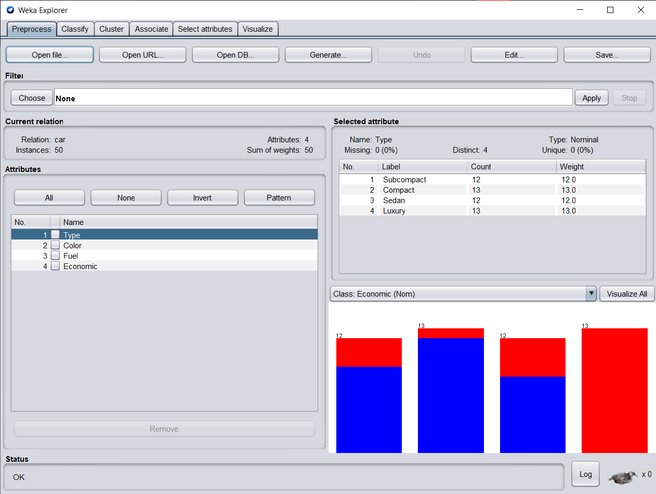

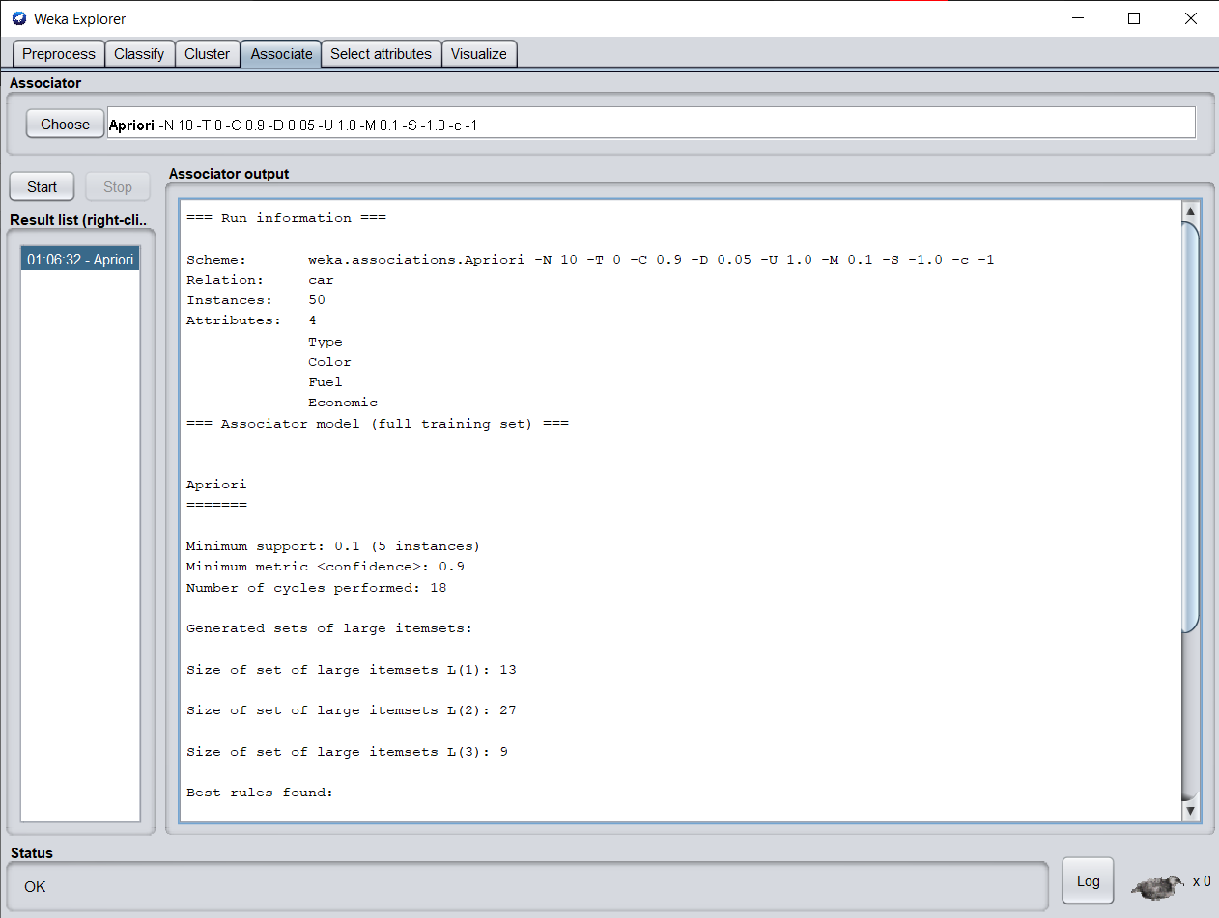

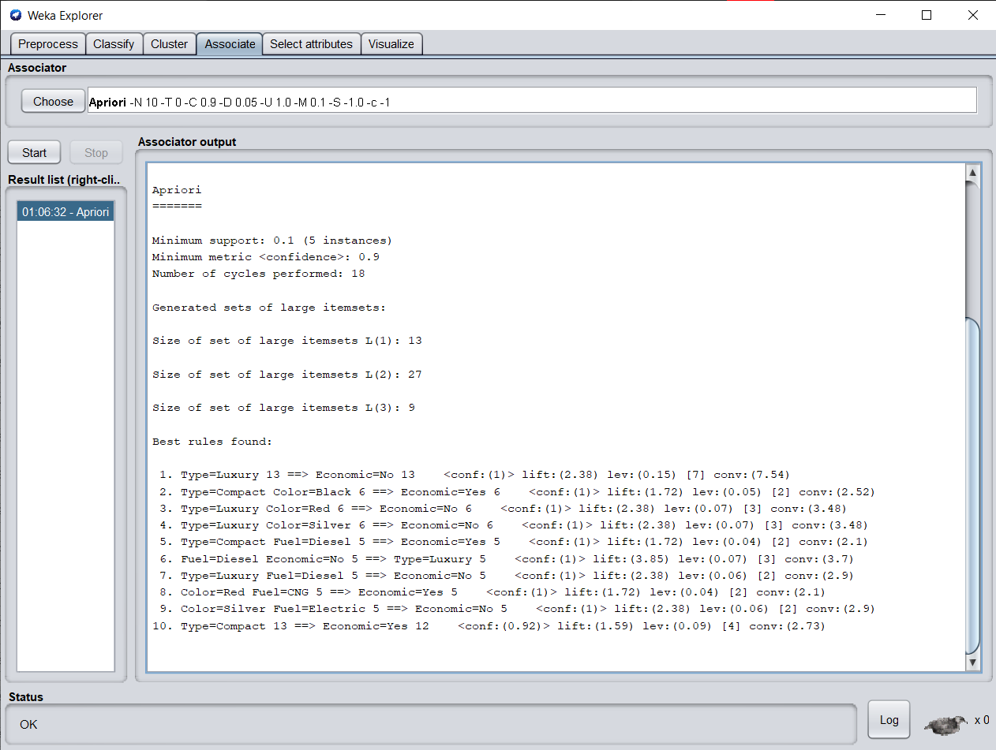

**B.3 Observations and learning:**

***(Students are expected to comment on the output obtained with clear observations and learning for each task/ subpart assigned)***

From the given supermarket dataset we have successfully implemented an apriori algorithm on it using the weka tool.

**B.4 Conclusion:**

*(****Students must write the conclusion as per the attainment of individual outcome listed above and learning/observation noted in section B.3)***

Hence we’ve successfully implemented the Apriori algorithm in Weka.

**B.5 Question of Curiosity**

***(To be answered by the student based on the practical performed and learning/observations)***

1. What is the use of the Apriori algorithm?

Ans:

Apriori is an algorithm for frequent itemset mining and association rule learning over relational databases. It proceeds by identifying the frequent individual items in the database and extending them to larger and larger item sets as long as those item sets appear sufficiently often in the database. The frequent itemsets determined by Apriori can be used to determine association rules which highlight general trends in the database, this has applications in many domains:

* In the business field: Market basket analysis, which is a technique that identifies the strength of association between pairs of products purchased together and identify patterns of co-occurrence
* In Education Field: Extracting association rules in data mining of admitted students through characteristics and specialities.
* In the Medical field: For example Analysis of the patient's database.
* In Forestry: Analysis of probability and intensity of forest fire with the forest fire data.
* Apriori is used by many companies like Amazon in the Recommender System and by Google for the auto-complete feature.

1. What is Support and Confidence in the Apriori algorithm?

Ans:

The parameters “support” and “confidence” are used in the apriori algorithm.

* Support refers to items’ frequency of occurrence.
* Confidence is a conditional probability. Items in a transaction form an item set.

The algorithm begins by identifying frequent, individual items (items with a frequency greater than or equal to the given support) in the database and continues to extend them to larger, frequent itemsets.

