Experiment No.09
A.1 Aim: Study and implementation of APRIORI algorithm using WEKA tool.

PART B
(PART B: TO BE COMPLETED BY STUDENTS)
(Students must submit the soft copy as per the following segments within two hours of the practical. The soft copy must be uploaded on the Blackboard or emailed to the concerned lab in charge faculties at the end of the practical in case there is no Blackboard access available)

Roll No. 50 | Name: AMEY THAKUR
Class: Comps TE B | Batch: B3
Date of Experiment: 28/04/2021 | Date of Submission: 28/04/2021
Grade:

B.1 Software Code written by a student:
(Paste your problem statement related to your case study completed during the 2 hours of practice in the lab here)

@relation car

@attribute Type {Subcompact, Compact, Sedan, Luxury}
@attribute Color {Red,Silver,Black}
@attribute Fuel {Petrol,Diesel,CNG,Electric}
@attribute Economic {Yes,No}

@data
Subcompact Red Petrol Yes
Compact Black Diesel Yes
Compact Silver Petrol Yes
Luxury Red Electric No
Subcompact Silver CNG Yes
Luxury Red Petrol No
Sedan Silver Electric No
Sedan Black Diesel Yes
Subcompact Black Electric Yes
Compact Red CNG Yes
Sedan Silver Petrol Yes
Luxury Red Diesel No
Luxury Silver Electric No
Sedan Black CNG Yes
Compact Black Diesel Yes
Compact Red Electric No
Subcompact Black Petrol Yes
Luxury Silver CNG No
Sedan Red Diesel Yes
Sedan Silver Electric No
Subcompact Red CNG Yes
Compact Black Petrol Yes
Subcompact Red Petrol Yes
Luxury Silver CNG No
Sedan Black Diesel Yes
Sedan Red Electric No
Subcompact Red Diesel Yes
Compact Silver Petrol Yes
Luxury Red Diesel No
Sedan Black Petrol Yes
Subcompact Black Petrol Yes
Subcompact Red Electric No
Compact Red Petrol Yes
Luxury Silver CNG No
Compact Black Diesel Yes
Luxury Silver Electric No
Subcompact Red CNG Yes
Luxury Red Diesel No
Sedan Black Electric No
Compact Black CNG Yes
Compact Red CNG Yes
Sedan Silver Petrol Yes
Luxury Black Diesel No
Subcompact Silver Electric No
Sedan Red CNG Yes
Compact Black Diesel Yes
Luxury Red Petrol No
Subcompact Black Electric No
Luxury Silver Diesel No
Compact Red Diesel Yes

B.2 Input and Output:
(Paste your program input and output in the following format, If there is an error then paste the specific error in the output part. In case of an error with the due permission of the faculty, an extension can be given to submit the error-free code with output in the due course of time. Students will be graded accordingly.)

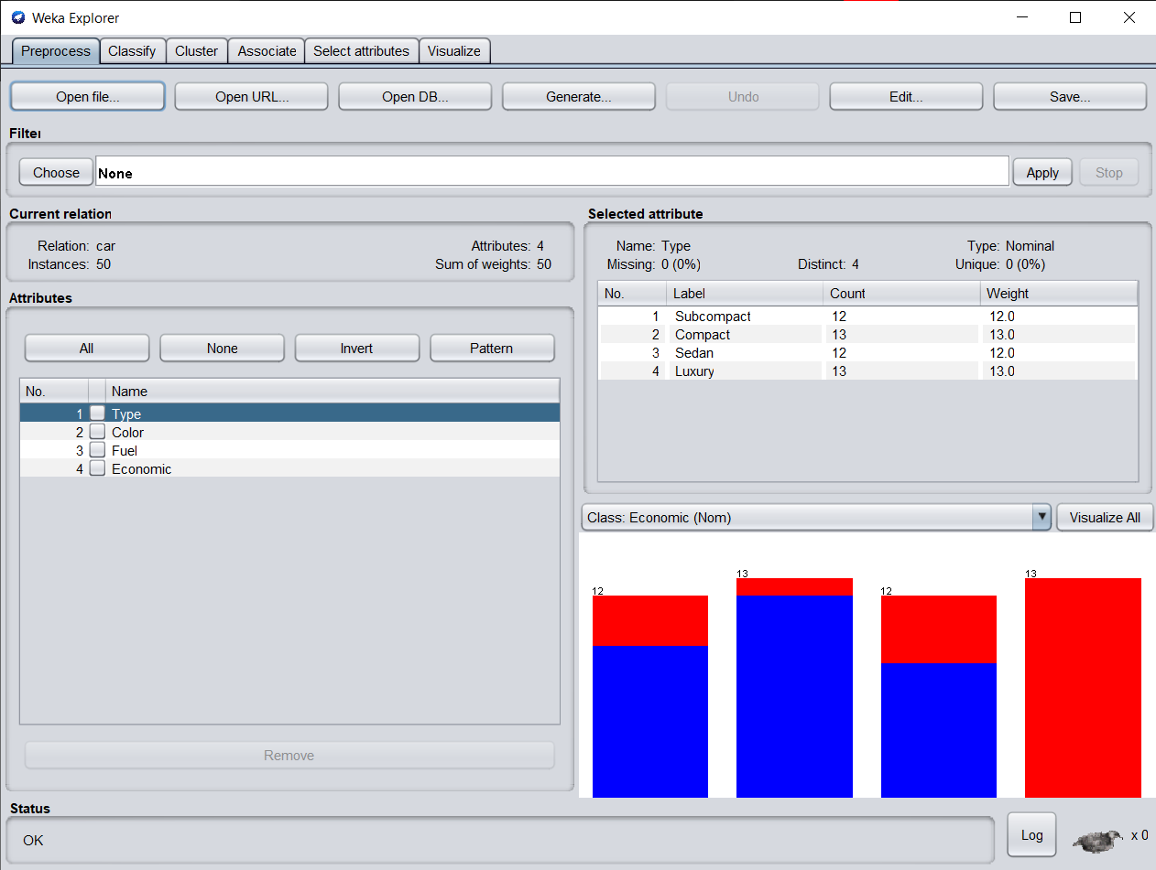

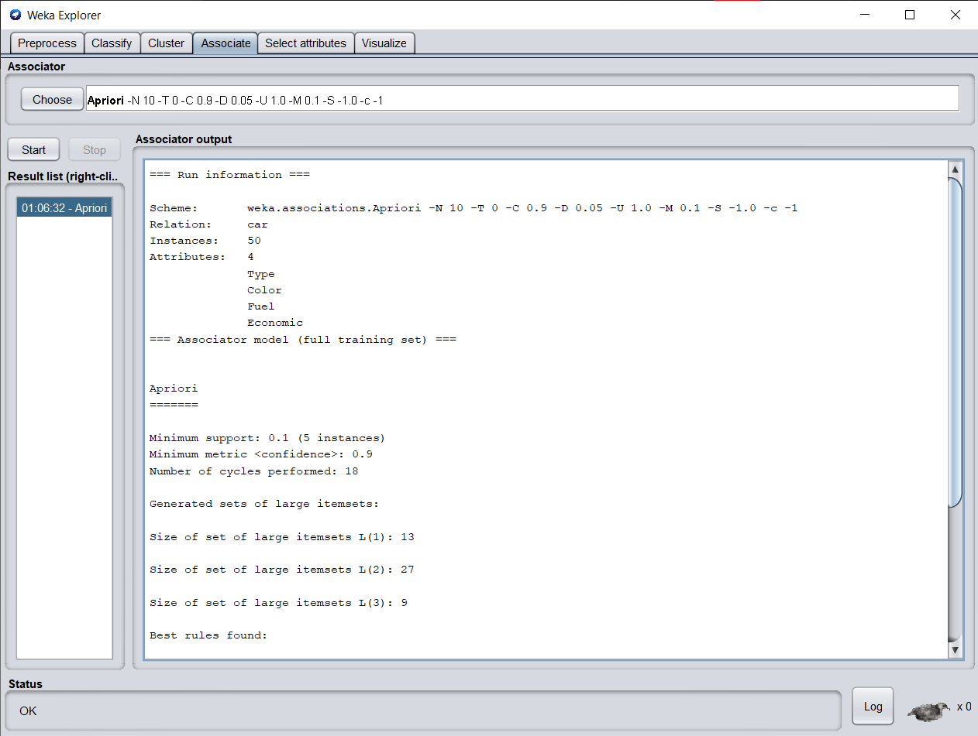
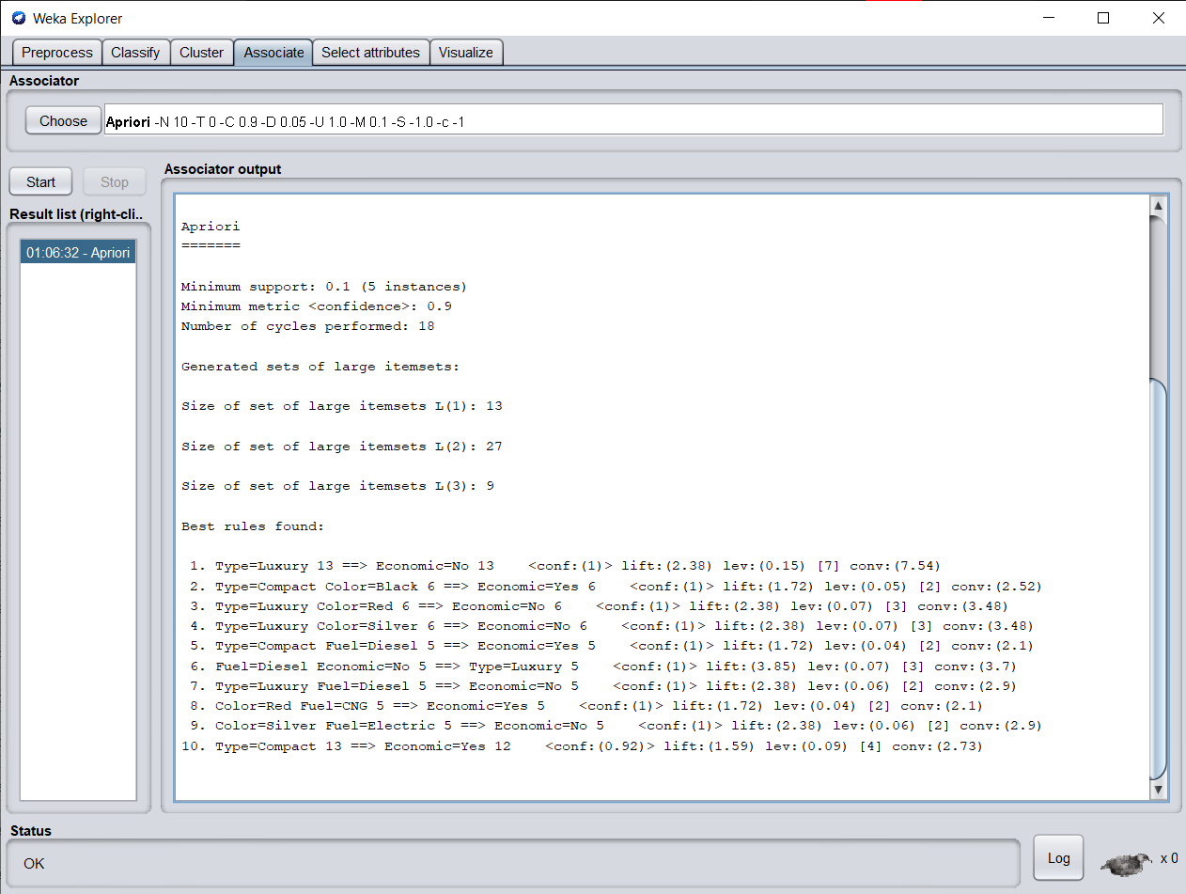
B.3 Observations and learning:
(Students are expected to comment on the output obtained with clear observations and learning for each task/ subpart assigned)

From the given supermarket dataset we have successfully implemented an apriori algorithm on it using the weka tool.

B.4 Conclusion:
(Students must write the conclusion as per the attainment of individual outcome listed above and learning/observation noted in section B.3)

Hence we’ve successfully implemented the Apriori algorithm in Weka.

B.5 Question of Curiosity
(To be answered by the student based on the practical performed and learning/observations)

- What is the use of the Apriori algorithm?
Ans:
Apriori is an algorithm for frequent itemset mining and association rule learning over relational databases. It proceeds by identifying the frequent individual items in the database and extending them to larger and larger item sets as long as those item sets appear sufficiently often in the database. The frequent itemsets determined by Apriori can be used to determine association rules which highlight general trends in the database, this has applications in many domains:
- In the business field: Market basket analysis, which is a technique that identifies the strength of association between pairs of products purchased together and identify patterns of co-occurrence
- In Education Field: Extracting association rules in data mining of admitted students through characteristics and specialities.
- In the Medical field: For example Analysis of the patient's database.
- In Forestry: Analysis of probability and intensity of forest fire with the forest fire data.
- Apriori is used by many companies like Amazon in the Recommender System and by Google for the auto-complete feature.

- What is Support and Confidence in the Apriori algorithm?
Ans:
The parameters “support” and “confidence” are used in the apriori algorithm.
- Support refers to items’ frequency of occurrence.
- Confidence is a conditional probability. Items in a transaction form an item set.
The algorithm begins by identifying frequent, individual items (items with a frequency greater than or equal to the given support) in the database and continues to extend them to larger, frequent itemsets.

