COMPUTER ENGINEERING DEPARTMENT

ASSIGNMENT NO-02
SUB: Machine Learning

COURSE: T.E. Year: 2020-2021 Semester: VI
DEPT: Computer Engineering
SUBJECT CODE: CSDLO6021 SUBMISSION DATE: 03/05/2021
=============================================================================================

Name: Amey Thakur | Roll No.: 50
Class: TE Comps B-50 | ID: TU3F1819127

Assignment No 2

Sr.  No. | Question | CO  mapping
1 | 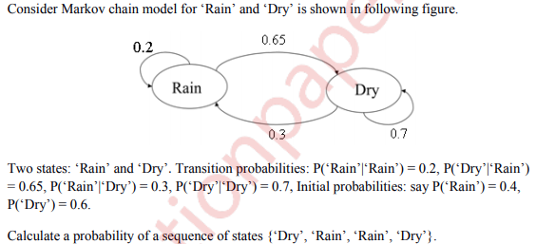 | CO5
2 | Discuss the following terms Initial hypothesis, Expectation step, Maximization step w.r.t EM algorithm and discuss how initial hypothesis converges to an optimal solution with suitable example. | CO5
3 | Discuss the structure of RBFN and how it can be used to solve non-linearly separable pattern? | CO5
4 | Describe the two methods for dimensionality reduction and how Principal Component Analysis is carried out to reduce the dimensionality of data. | CO6
5 | Why Dimensionality reduction is a very important step in Machine Learning? Use Principle component analysis (PCA) to arrive at the transformed matrix for the given matrix A.  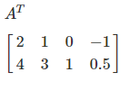 | CO6
6 | Describe the down Hill Simplex method. Why it is called the Derivative-Free method? | CO3
7 | Minimize f(x₁, x₂) =4x₁ -2x₂ +2x₁² ⁺ 2x₁x₂ +x₂²  With starting point X₁ = $\left\{0 0 \right\}$ using the steepest decent method. (Perform two iteration) | CO3
8 | Find the Singular value decomposition of A = $\left[2 2 1 -1 \right]$ and also List some advantages of derivative-based optimization techniques | CO3



