**Terna Engineering College**

**Computer Engineering Department**

Program: Sem VII

[**Course: MOBILE COMMUNICATION & COMPUTING AND MOBILE APPLICATION DEVELOPMENT LAB (MCC & MAD Lab)**](https://github.com/Amey-Thakur/MOBILE-COMMUNICATION-AND-COMPUTING-AND-MOBILE-APPLICATION-DEVELOPMENT-LAB)

**Experiment No. 01**

**PART B**

**(PART B: TO BE COMPLETED BY STUDENTS)**

***(Students must submit the soft copy as per the following segments within two hours of the practical. The soft copy must be uploaded on the Blackboard or emailed to the concerned lab in charge faculties at the end of the practical in case there is no Blackboard access available)***

| Roll No. 50 | Name: AMEY THAKUR |
| --- | --- |
| Class: BE-COMPS-50 | Batch: B3 |
| Date of Experiment: 06-08-2021 | Date of Submission: 06-08-2021 |
| Grade : |  |

**Aim:** To understand the path loss prediction formula.

**B.1 Input and Output:**

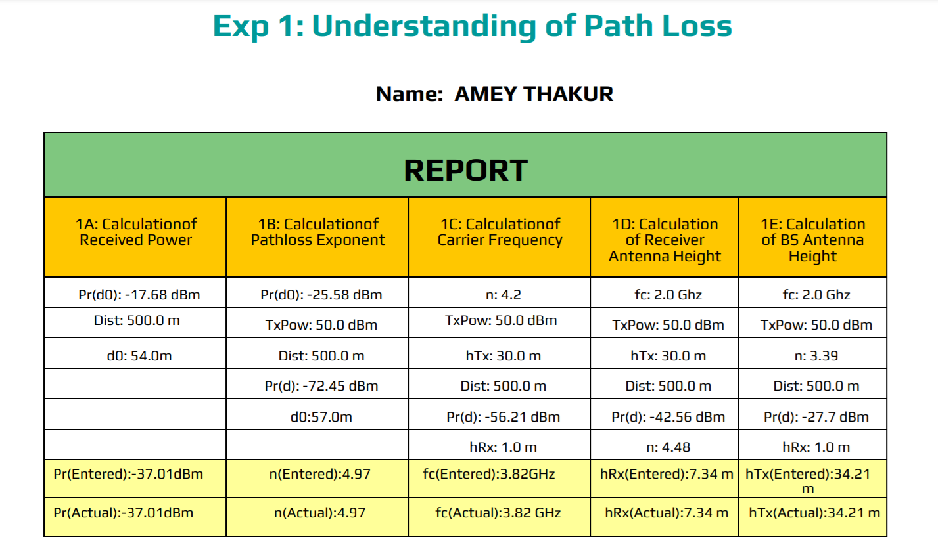

**DISCUSSION:**

The design of a communication system involves the selection of values for several parameters. With this experiment, we understood the impact of the following parameters on received signal strength.

* Transmitter Power
* Path Loss exponent
* Carrier frequency
* Receiver antenna height
* Transmitter antenna height

**B.2 Conclusion:**

Hence we’ve successfully performed and understood the concepts of Pathloss, Carrier Frequency, Transmitted Power, etc along with their working.

**B.3 Question of Curiosity:**

1. Explain signal propagation.

Ans:

Wireless communications systems are composed of one or more “Antenna Sites”, “Tower Sites”, or “Cell Sites”. Antennas mounted on these structures pump out wireless communications signals to devices in the field via electromagnetic waves. In addition to receiving these signals from the sites, user devices transmit similar types of signals back to the sites. This creates two-way communication. Wireless signal propagation is the movement of these radio waves (which move at the speed of light) to and from these sites and devices.

1. Explain the Path loss effect.

Ans:

Path loss, or path attenuation, is the reduction in power density (attenuation) of an electromagnetic wave as it propagates through space. Path loss is a major component in the analysis and design of the link budget of a telecommunication system. This term is commonly used in wireless communications and signal propagation. Path loss may be due to many effects, such as free-space loss, refraction, diffraction, reflection, aperture-medium coupling loss, and absorption. Path loss is also influenced by terrain contours, environment (urban or rural, vegetation and foliage), propagation medium (dry or moist air), the distance between the transmitter and the receiver, and the height and location of antennas.

**B.4 Attach the screenshot of the Quiz attempted after performing the experiment:**

