**Terna Engineering College**

**Computer Engineering Department**

Program: Sem VII

[**Course: MOBILE COMMUNICATION & COMPUTING AND MOBILE APPLICATION DEVELOPMENT LAB (MCC & MAD Lab)**](https://github.com/Amey-Thakur/MOBILE-COMMUNICATION-AND-COMPUTING-AND-MOBILE-APPLICATION-DEVELOPMENT-LAB)

**Experiment No. 10**

**PART B**

**(PART B: TO BE COMPLETED BY STUDENTS)**

***(Students must submit the soft copy as per the following segments within two hours of the practical. The soft copy must be uploaded on the Blackboard or emailed to the concerned lab in charge faculties at the end of the practical in case there is no Blackboard access available)***

| Roll No. 50 | Name: AMEY THAKUR |
| --- | --- |
| Class: BE-COMPS-50 | Batch: B3 |
| Date of Experiment: 08-10-2021 | Date of Submission: 08-10-2021 |
| Grade: |  |

**Aim:** Set up and configuration of wireless Access Points.

**B.1 Cisco Packet Tracer Installation:**

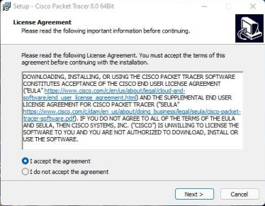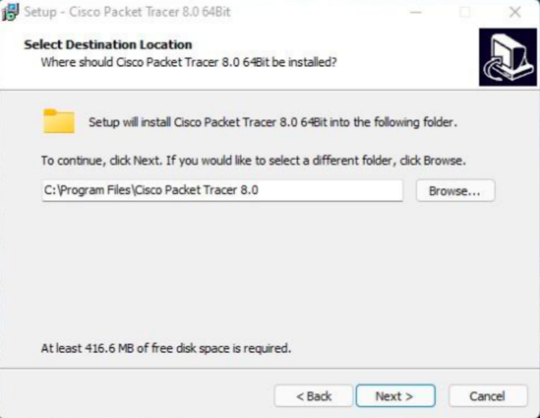

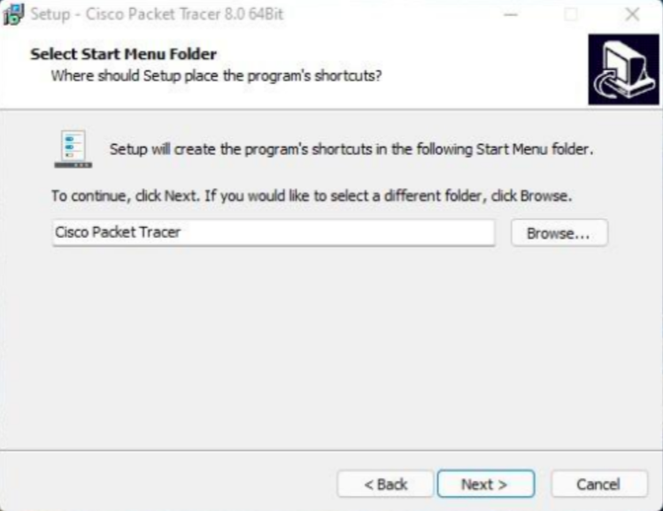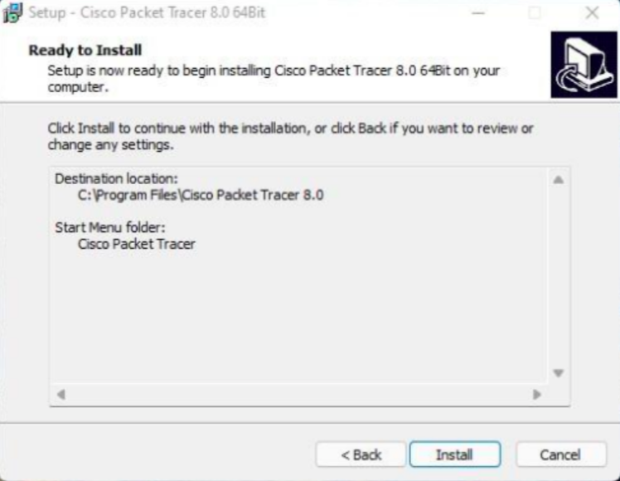

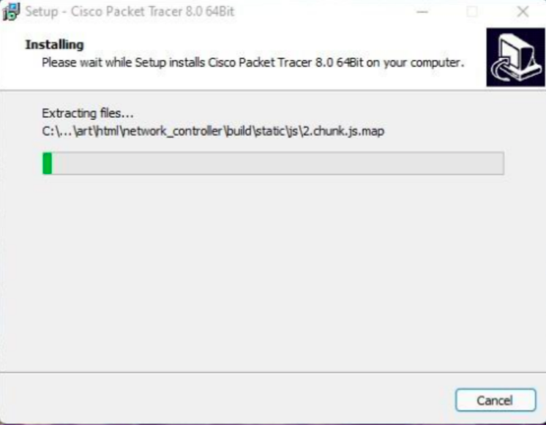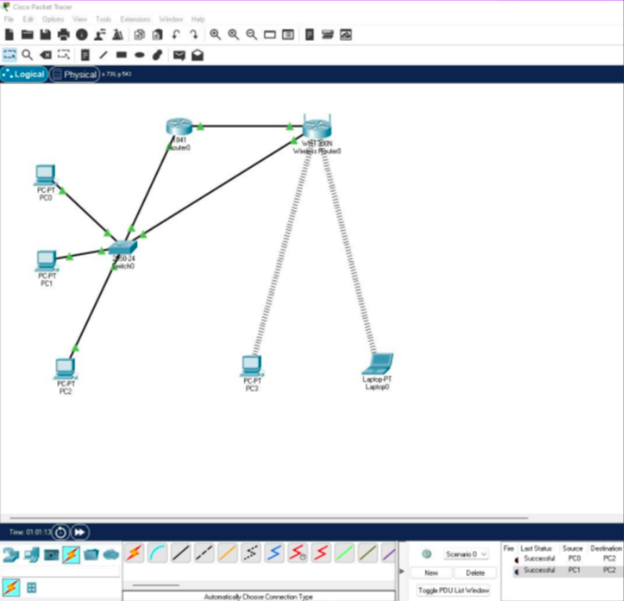

**B.3 Observations and learning:**

After successful completion of this experiment, we are able to Set up and configure access points and use them to access the internet using Cisco Packet Tracer.

**B.4 Conclusion:**

Hence we can Set up and configure wireless Access Point in Cisco Packet Tracer.

**B.5 Question of Curiosity**

1. How to Perform configuration of the wireless access points?

Ans:

* In order to configure the access point for your customer, you can connect a laptop or PC to the wireless access point's console port via a serial cable. Through the use of terminal software, you can view access point configuration screens and change specific settings, such as radio channel and transmit power.
* The problem is that this method of accessing the configuration screens is often character-based and not user-friendly. Plus, a serial cable limits how far you can move from the wireless access point when performing the configurations.
* If your laptop or PC is equipped with a radio card, then you can access the configuration screens through the use of a Web browser by typing the Internet Protocol (IP) address of the access point as the URL for the Web page (for example, "http:/192.168.0.1" without the quotes). If the IP address in the laptop or PC is set within an acceptable range of the access point (the IP address would be 192.168.0.xxx, with the last three numbers something between 2 and 254), then the browser will render the configuration screens in a much-improved format.

1. Check out/make use of connection with your mobile

Ans:

Turn on & connect

1. Open your device's Settings app.
2. Tap Network & internet > Internet.
3. Tap a listed network. Networks that require a password have a Lock.

After you connect, the network is "Saved." When your phone is near and Wi-Fi is on, your phone automatically connects to this network.

1. What IEEE standard is used for AP?

Ans:

* IEEE 802.11

1. How Adhoc Wireless LAN will be created?

Ans:

* Devices in the ad hoc network require a wireless network adapter or chip, and they need to be able to act as a wireless router when connected. When setting up a wireless ad hoc network, each wireless adapter must be configured for ad hoc mode instead of infrastructure mode.

1. What is the difference between WLAN and WiMax?

Ans:

* WLAN is meant for short-range applications while WiMax is meant for long-range applications.
* WLAN can deliver much faster speeds compared to WiMax.
* WiMax provides a much better method of bandwidth distribution compared to WLAN. 4. Both technologies are still susceptible to overloading.