**Terna Engineering College**

**Computer Engineering Department**

Program: Sem VII

[**Course: MOBILE COMMUNICATION & COMPUTING AND MOBILE APPLICATION DEVELOPMENT LAB (MCC & MAD Lab)**](https://github.com/Amey-Thakur/MOBILE-COMMUNICATION-AND-COMPUTING-AND-MOBILE-APPLICATION-DEVELOPMENT-LAB)

**Experiment No. 02**

**PART B**

**(PART B: TO BE COMPLETED BY STUDENTS)**

***(Students must submit the soft copy as per the following segments within two hours of the practical. The soft copy must be uploaded on the Blackboard or emailed to the concerned lab in charge faculties at the end of the practical in case there is no Blackboard access available)***

| Roll No. 50 | Name: AMEY THAKUR |
| --- | --- |
| Class: BE-COMPS-50 | Batch: B3 |
| Date of Experiment: 29-07-2021 | Date of Submission: 29-07-2021 |
| Grade : |  |

**Aim:** To understand the concept of co-channel interference and hence SINR (full-frame).

**B.1 Input and Output:**

**Experiment 5A: SINR (Downlink)**

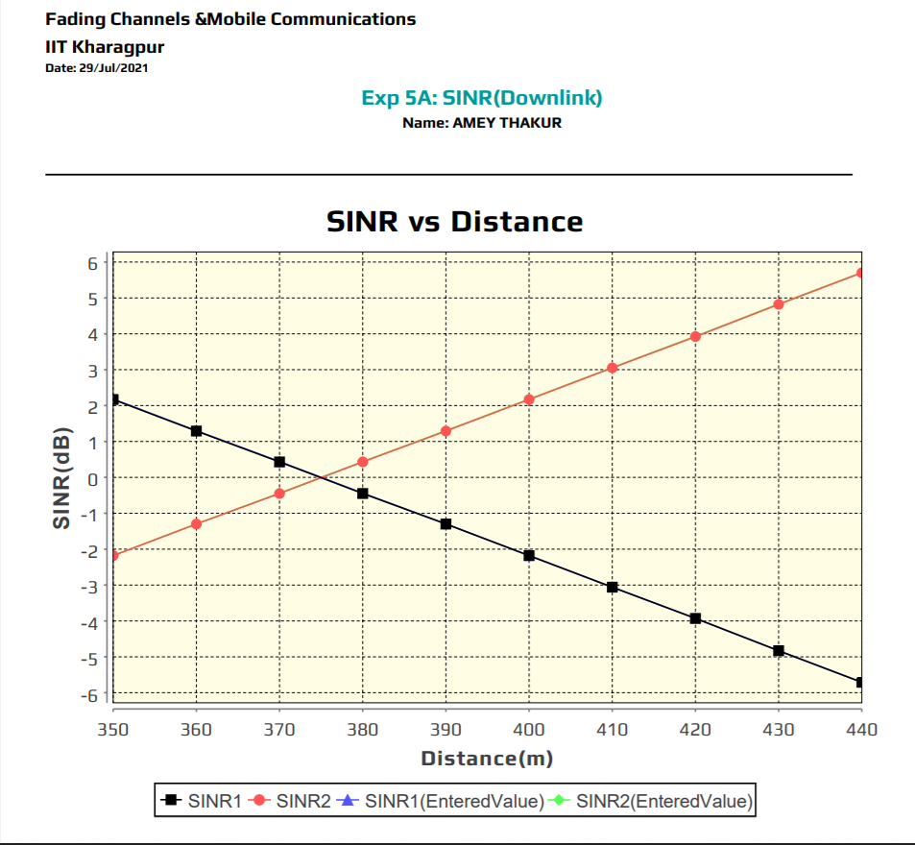

**Discussion:**

Co-channel interference or CCI is crosstalk from two different radio transmitters using the same channel. Co-channel interference can be caused by many factors from weather conditions to administrative and design issues. Co-channel interference may be controlled by various radio resource management schemes.

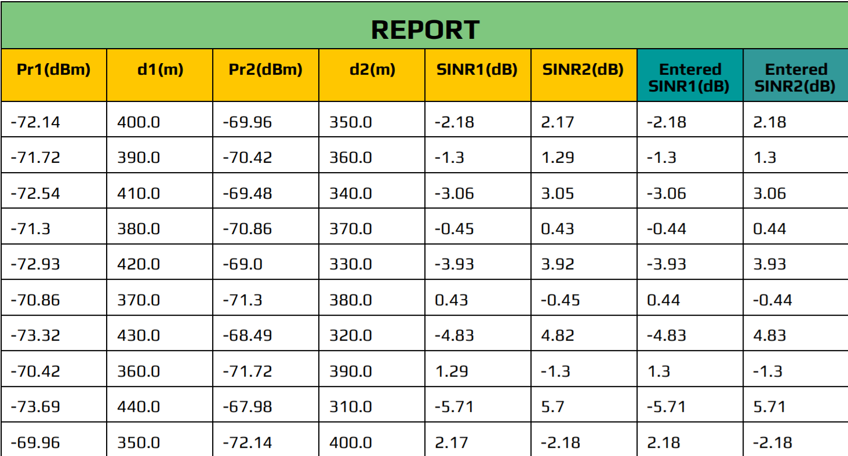

**Experiment 5B: SINR (Uplink)**

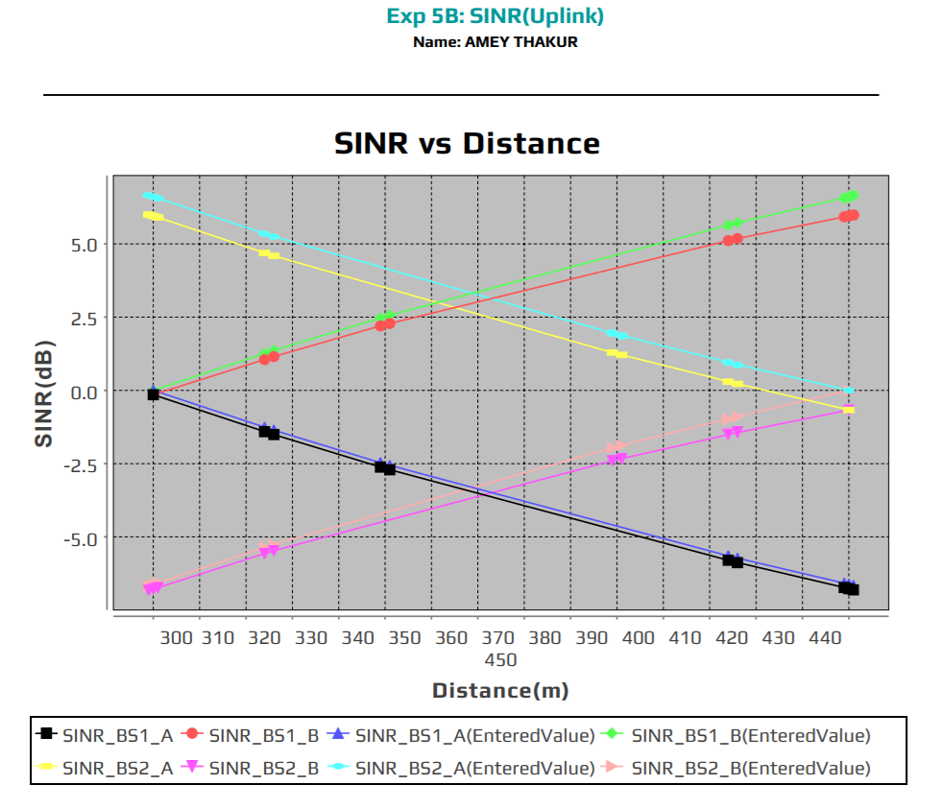

**Discussion:**

Co-channel interference or CCI is crosstalk from two different radio transmitters using the same channel. Co-channel interference can be caused by many factors from weather conditions to administrative and design issues. Co-channel interference may be controlled by various radio resource management schemes.

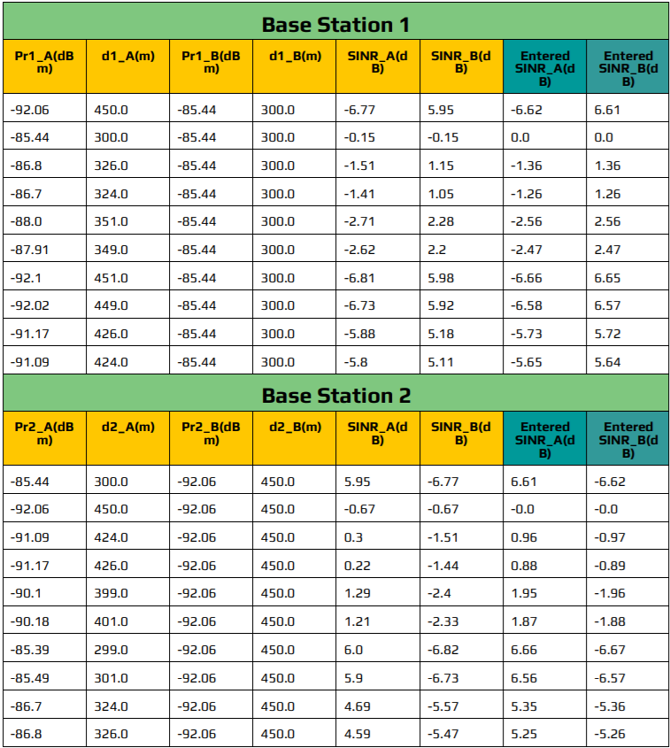

**B.2 Conclusion**

Hence we’ve successfully performed and understood the concepts of co-channel interference and SINR( Signal to Noise Ratio) through Uplink and Downlink-the two-way communication between a cell tower and user phone.

**B.3 Question of Curiosity**

1. Solve the quiz given in the virtual lab related to this experiment and attached screenshots of the same.

Ans:

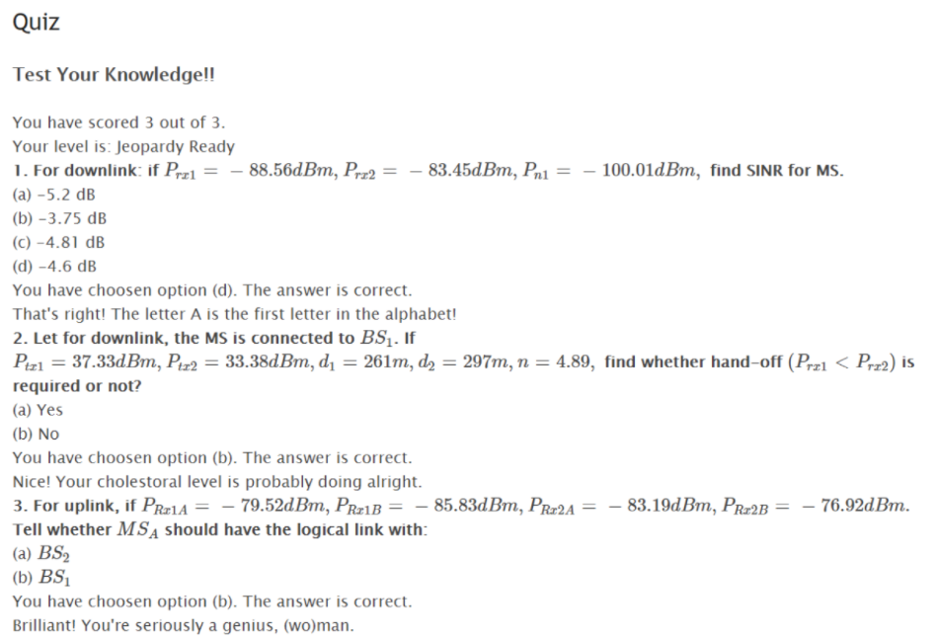

1. What is uplink and what is downlink in mobile communication? Explain.

Ans:

Uplink and downlink, also called upload and download, refers to the two-way communication between a cell tower and your phone. Downlink definition – signal coming from a cell tower to your cellular device Uplink definition – signal leaving your cellular device and going back to a cell tower Most of us have experienced cell phone conversations when you can hear the other person but they can’t hear you or vice versa. A disruption in downlink or uplink in cellular communication causes this issue.