**Terna Engineering College**

**Computer Engineering Department**

Program: Sem VII

[**Course: MOBILE COMMUNICATION & COMPUTING AND MOBILE APPLICATION DEVELOPMENT LAB (MCC & MAD Lab)**](https://github.com/Amey-Thakur/MOBILE-COMMUNICATION-AND-COMPUTING-AND-MOBILE-APPLICATION-DEVELOPMENT-LAB)

**Experiment No. 03**

**PART B**

**(PART B: TO BE COMPLETED BY STUDENTS)**

***(Students must submit the soft copy as per the following segments within two hours of the practical. The soft copy must be uploaded on the Blackboard or emailed to the concerned lab in charge faculties at the end of the practical in case there is no Blackboard access available)***

| Roll No. 50 | Name: AMEY THAKUR |
| --- | --- |
| Class: BE-COMPS-50 | Batch: B3 |
| Date of Experiment: 19-07-2021 | Date of Submission: 19-07-2021 |
| Grade : |  |

**Aim:** To understand the cellular network frequency reuse concept fulfilling the following objectives:

1. Finding the co-channel cells for a particular cell.
2. Finding the cell clusters within a certain geographic area.

**B.1 Input and Output:**

**Experiment 6A: Frequency Reuse (Output): CO-CHANNEL CELLS**

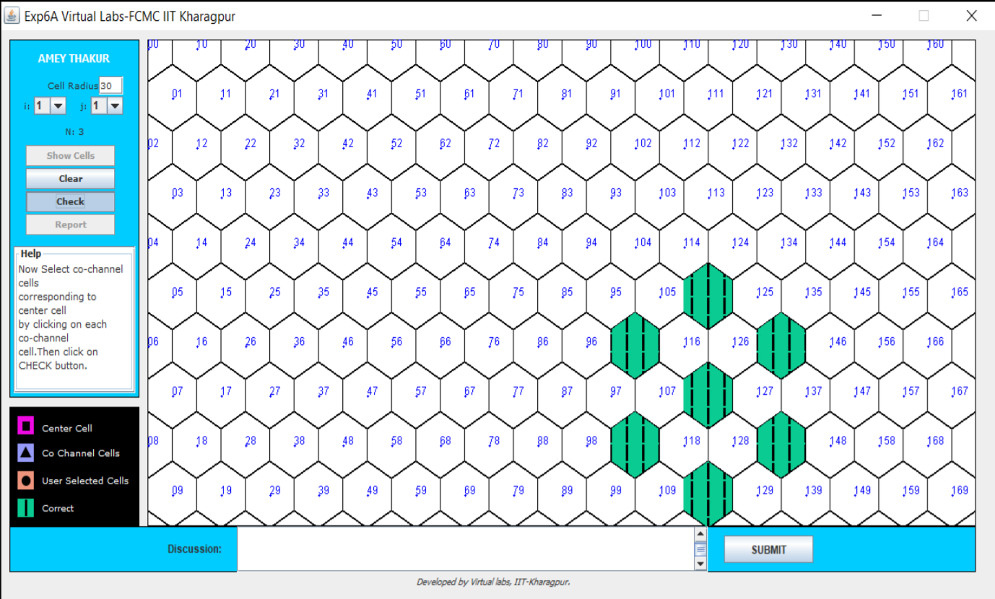

**Experiment 6B: Frequency Reuse (Output): CELL CLUSTERS**

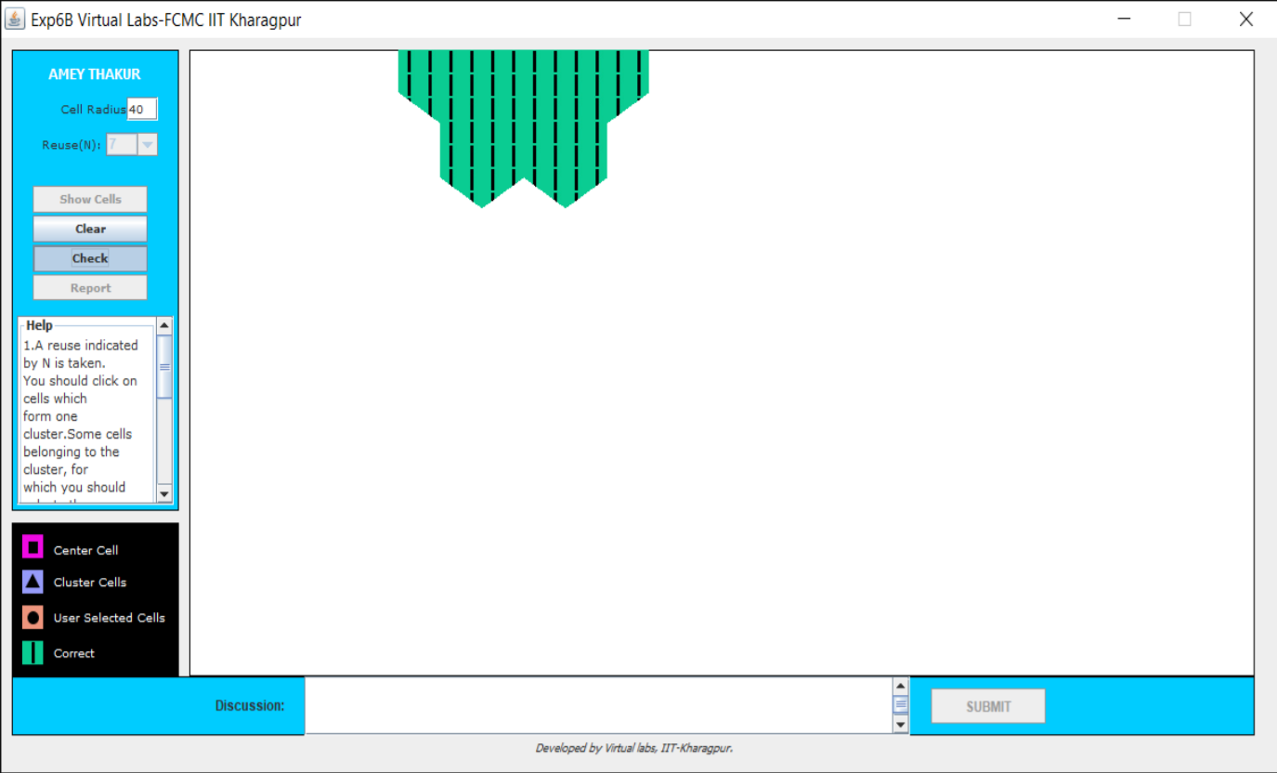

**B.2 Conclusion**

Hence we’ve successfully implemented an experiment to understand the cellular frequency concepts by:

1. Finding the co-channel cells.
2. Finding cell clusters within a certain geographical area.

**B.3 Question of Curiosity**

1. With an example, explain Co-channel cells.

Ans:

Two cells having the same number in the adjacent cluster, use the same set of RF channels and hence are termed as “Co-channel cells”.

Consider a cellular system with S duplex channels available, let each cell be allocated a group of k channels(k<s), and if the S channels are divided among N cells. Available radio channels can be expressed as

S = KN

The N cells which collectively use the complete set of available frequencies are called a cluster. If it is replicated M times within the system, total no. of duplex channels: C can be used as a measure of capacity and is given by

C = MKN

= MS

N = Cluster size and typically equal to 4,7,12

The geometry of hexagons is such that the number of cells per Cluster, N, can only have the values which satisfy the equation

N = i2 + ij + j2

i and j are non-negative integers.

N can have the values of 3, 4, 7, 9, 12, 13,19,...

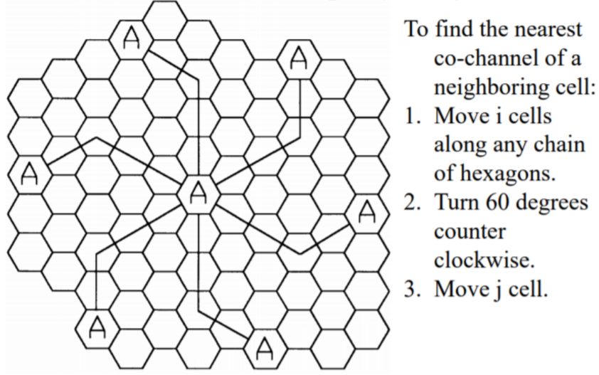

1. Explain the working of a cellular system.

Ans:

In the cellular system, the service area is divided into cells. A transmitter is designed to serve an individual cell. The system seeks to make efficient use of available channels by using low-power transmitters to allow frequency reuse at much smaller distances. Maximizing the number of times each channel can be reused in a given geographic area is the key to an efficient cellular system design.