**Terna Engineering College**

**Computer Engineering Department**

Program: Sem VII

[**Course: MOBILE COMMUNICATION & COMPUTING AND MOBILE APPLICATION DEVELOPMENT LAB (MCC & MAD Lab)**](https://github.com/Amey-Thakur/MOBILE-COMMUNICATION-AND-COMPUTING-AND-MOBILE-APPLICATION-DEVELOPMENT-LAB)

**Experiment No. 04**

**PART B**

**(PART B: TO BE COMPLETED BY STUDENTS)**

***(Students must submit the soft copy as per the following segments within two hours of the practical. The soft copy must be uploaded on the Blackboard or emailed to the concerned lab in charge faculties at the end of the practical in case there is no Blackboard access available)***

| Roll No. 50 | Name: AMEY THAKUR |
| --- | --- |
| Class: BE-COMPS-50 | Batch: B3 |
| Date of Experiment: 13-08-2021 | Date of Submission: 13-08-2021 |
| Grade : |  |

**Aim:** To understand the handover mechanism.

**B.1 Input and Output:**

Experiment 8: Handoff

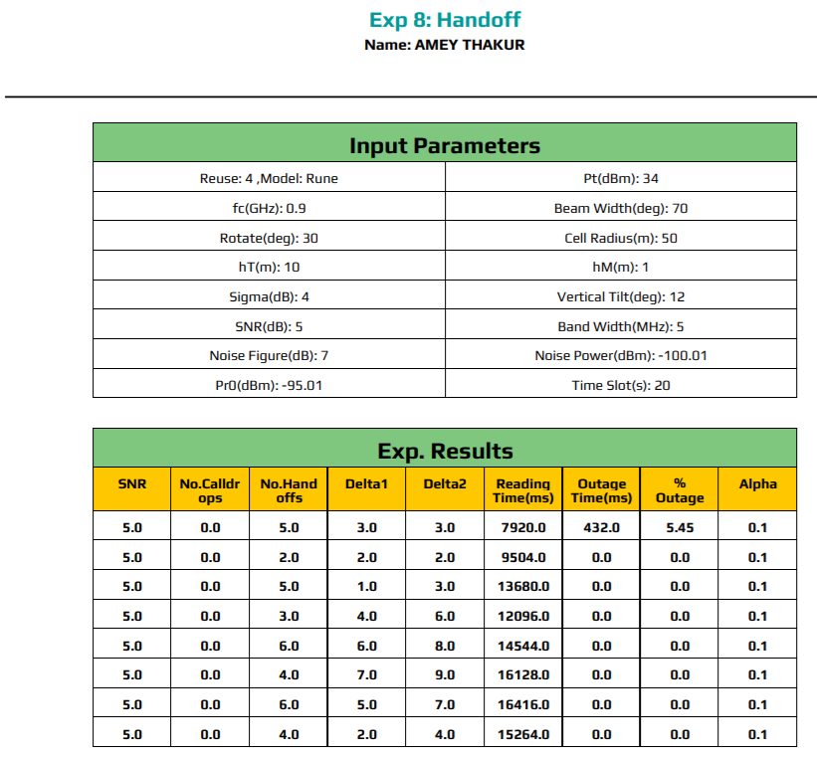



**B.2 Conclusion**

Hence we’ve successfully performed and understood the concept of Handoff and Call drops in Mobile communication.

**B.3 Question of Curiosity**

1. Differentiate between hard and soft handover.

Ans:

| **Soft Handover** | **Hard Handover** |
| --- | --- |
| The handover in which radio links are  added and removed in a way that MS  always keeps at least one radio link to  the UTRAN is known as soft handover. | The handover in which all the old radio  links in MS are removed before the  new radio links are established is  known as hard handover. |
| This can also be simplified to make  before break. | This can also be simplified as a break  before make. |
| As the call drop rate is lower this  handover is used to lower the rate of  call drop. | In this case, higher rates of call drops  are found. |

1. Solve the quiz after executing this virtual lab experiment and attach the snapshot of the same:

