**Terna Engineering College**

**Computer Engineering Department**

Program: Sem VII

[**Course: MOBILE COMMUNICATION & COMPUTING AND MOBILE APPLICATION DEVELOPMENT LAB (MCC & MAD Lab)**](https://github.com/Amey-Thakur/MOBILE-COMMUNICATION-AND-COMPUTING-AND-MOBILE-APPLICATION-DEVELOPMENT-LAB)

**Experiment No. 05**

**PART B**

**(PART B: TO BE COMPLETED BY STUDENTS)**

***(Students must submit the soft copy as per the following segments within two hours of the practical. The soft copy must be uploaded on the Blackboard or emailed to the concerned lab in charge faculties at the end of the practical in case there is no Blackboard access available)***

| Roll No. 50 | Name: AMEY THAKUR |
| --- | --- |
| Class: BE-COMPS-50 | Batch: B3 |
| Date of Experiment: 20-08-2021 | Date of Submission: 20-08-2021 |
| Grade : |  |

**Aim:** Write a program using WML to display user form with validation for WAP-enabled phones.

**B.1 Software Code written by a student:**

* **Validation.wml**

<?xml version="1.0"?>

<!DOCTYPE wml PUBLIC "-//WAPFORUM//DTD WML 1.3//EN"

"http://www.wapforum.org/DTD/wml13.dtd">

<wml>

<card id="card1" title="Registration Form">

<p> <big>STUDENT DETAILS</big><br/>

Notice: Fields with * are required.<br/><br/>

<b>$(errorMsg)</b><br/>

* First name:

<input name="firstname"/><br/>

* Last name:

<input name="lastname"/><br/>

* Password (min. 8 characters):

<input type="password" name="password"/><br/>

* Email:<br/>

<input name="email"/><br/>

Birthday (MMDDYYYY):<br/>

<input name="birthday" format="NNNNNNNN"

emptyok="true"/><br/>

<br/>

Select Your Branch:

<select>

<option value="comps">CS</option>

<option value="it">IT</option>

<option value="extc">EXTC</option>

</select>

<br/>

What topics are you interested in?

<select>

<option value="ds">Data Structures</option>

<option value="ai">Artificial Intelligence</option>

<option value="ml">Machine Learning</option>

</select>

<br/>

<a href="validate.wmls#validate()" href="#card_two">Submit

Form Data</a>

</p>

</card>

<card id="card_two" title="Thanks">

<p> <b>THANK YOU FOR FILLING THE FORM!!</b>

</p>

</card>

</wml>

* **Validate.wmls**

extern function validate()

{

var form_firstname = String.trim(WMLBrowser.getVar("firstname"));

var form_lastname = String.trim(WMLBrowser.getVar("lastname"));

var form_password = String.trim(WMLBrowser.getVar("password"));

var form_email = String.trim(WMLBrowser.getVar("email"));

var form_name = String.trim(WMLBrowser.getVar("name"));

var form_birthday = String.trim(WMLBrowser.getVar("birthday"));

if (""==form_firstname){

WMLBrowser.setVar("errorMsg", "The First Name field must not be

empty.");

WMLBrowser.refresh();

return;

} if (""==form_lastname){

WMLBrowser.setVar("errorMsg", "The Last Name field must not be

empty.");

WMLBrowser.refresh();

return;

}

if (""==form_password){

WMLBrowser.setVar("errorMsg", "The Password field must not be

empty.");

WMLBrowser.refresh();

return;

}

if (""==form_email){

WMLBrowser.setVar("errorMsg", "The Email field must not be

empty.");

WMLBrowser.refresh();

return;

}

if (String.length(form_password) < 8){

WMLBrowser.setVar("errorMsg", "The password must contain at

least 8 characters since a short password is less secure.");

WMLBrowser.refresh();

return;

}

else{

WMLBrowser.setVar("errorMsg", "THANK YOU FOR FILLING THE FORM");

WMLBrowser.refresh();

} submit_form(form_firstname,form_lastname, form_password,

form_email, form_name, form_birthday);

}

**B.2 Input and Output:**

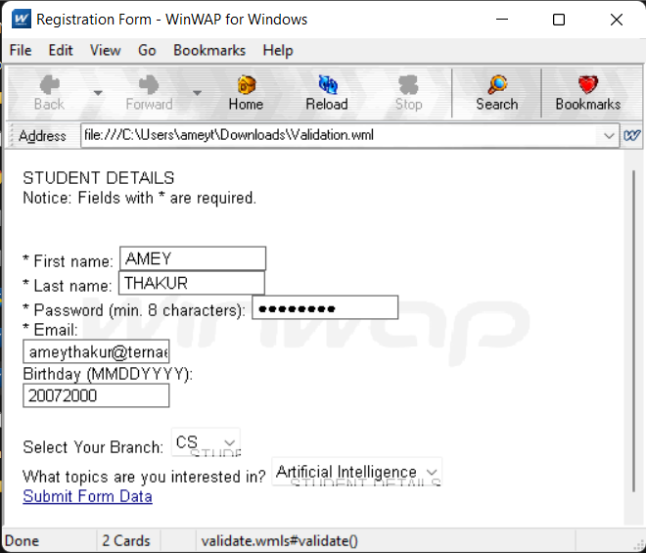

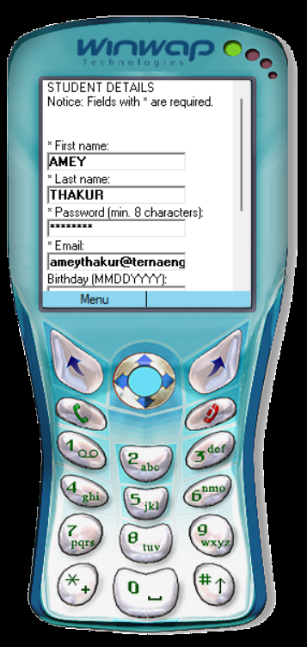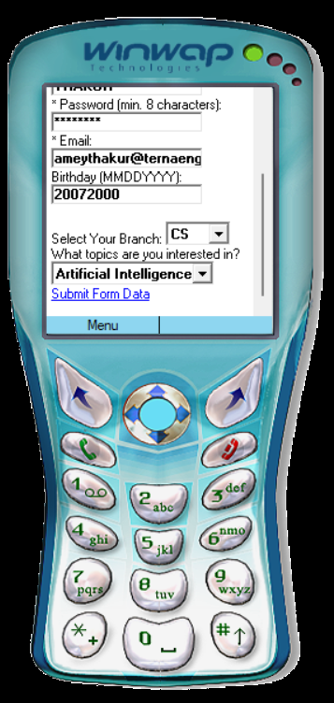

**B.3 Conclusion:**

Hence we’ve successfully implemented a program for validating student information in the Registration form using WML(Wireless Markup Language) on the WinWAP browser as well as the mobile emulator.

**B.4 Question of Curiosity**

1. Differentiate HTML and WML

Ans:

| **Sr. No.** | **HTML** | **WML** |
| --- | --- | --- |
| **1** | HTML refers to HyperText Markup Language. | WML refers to Wireless Markup  Language. |
| **2** | HTML is the markup language for wired communication. | WML is the markup language for  wireless communication. |
| **3** | It does not use variables. | It makes use of variables. |
| **4** | HTML is applied for desktop  computers. | WML is applied for wireless devices  i.e. cellular phones, PDAs. |
| **5** | Content is integrated with the  presentation. | Content separates from the  presentation. |
| **6** | JavaScript is embedded in the  same HTML file. | WML scripts are stored in a separate  file. |
| **7** | In HTML images are stored as GIF, JPEG, or PNG. | In WML images are stored in WBMP. |
| **8** | It is not case-sensitive. | It is case-sensitive. |

1. Explain the use of WMLscript.

Ans:

* WMLScript (Wireless Markup Language Script) is the client-side scripting language of WML (Wireless Markup Language). A scripting language is similar to a programming language but is of lighter weight.
* With WMLScript, the wireless device can do some of the processing and computation. This reduces the number of requests and responses to/from the server.
* Just like HTML is a markup language that renders content for desktop browsers, WML renders content for wireless devices that do not have appropriate processing capabilities.
* It does this by defining the protocol stack and WWW-based Internet access for wireless devices. WAP also has sites written in WML like HTML-based sites.
* WML is designed to handle issues like small display size, limited user input capabilities, narrowband network connection with high latency, limited memory, and computational processing power.