**Terna Engineering College**

**Computer Engineering Department**

Program: Sem VII

[**Course: MOBILE COMMUNICATION & COMPUTING AND MOBILE APPLICATION DEVELOPMENT LAB (MCC & MAD Lab)**](https://github.com/Amey-Thakur/MOBILE-COMMUNICATION-AND-COMPUTING-AND-MOBILE-APPLICATION-DEVELOPMENT-LAB)

**Experiment No. 06**

**PART B**

**(PART B: TO BE COMPLETED BY STUDENTS)**

***(Students must submit the soft copy as per the following segments within two hours of the practical. The soft copy must be uploaded on the Blackboard or emailed to the concerned lab in charge faculties at the end of the practical in case there is no Blackboard access available)***

| Roll No. 50 | Name: AMEY THAKUR |
| --- | --- |
| Class: BE-COMPS-50 | Batch: B3 |
| Date of Experiment: 27-08-2021 | Date of Submission: 27-08-2021 |
| Grade : |  |

**Aim:** Write a program using WML to display a calculator and calendar for android phones.

**B.1 Software Code written by students:**

* **Calculator.wml**

<?xml version="1.0"?>

<!DOCTYPE wml PUBLIC "-//WAPFORUM//DTD WML 1.2//EN"

"http://www.wapforum.org/DTD/wml12.dtd">

<wml>

<card id="card1" title="Calculator">

<p>

<h2> CALCULATOR </h2>

<br/>

<b>

Enter 1st Number: <input name="x" title="First Number:"

format="*N" />

<br/><br/>

Operator:

<select name="op" title="Operation:">

<option value="+">Addition</option>

<option value="-">Subtraction</option>

<option value="*">Multiplication</option>

<option value="/">Division</option>

</select>

<br/><br/>

Enter 2nd Number: <input name="y" title="Second Number:"

format="*N" />

<br/><br/>

<do type="accept" label="Result">

<go href="Calculator.wmls#solve($(x), $(y))”/>

</do>

</b>

</p>

</card>

<card id="card2" title="result">

<p>

Here is the result:<br/>

<b> $(x) $(op) $(y) = $(r) <b/>

</p><b>

<do type="accept" label="TRY WITH DIFFERENT VALUES"><b/>

<prev/>

</do>

</card>

</wml>

* **Calculator.wmls**

extern function solve(a, b)

{

var d = WMLBrowser.getVar("op");

var z = 0;

if (d == "+") {

z = a + b;

} else if ( d == "-") {

z = a - b;

} else if ( d == "*") {

z = a * b;

} else if ( d == "/") {

z = a / b;

} WMLBrowser.setVar("r", z);

WMLBrowser.go("Calculator.wml#card2");

}

* **Calendar.wml**

<?xml version="1.0"?>

<!DOCTYPE wml PUBLIC "-//WAPFORUM//DTD WML 1.1//EN"

"http://www.wapforum.org/DTD/wml_1.1.xml">

<wml>

<card>

<p>

<h1>September 2021</h1><br/>

<table columns="7">

<tr><td>Su</td><td>Mo</td><td>Tu</td><td>We</td><td>Th</td><td>Fr</td>

<td>Sa</td></tr>

<tr><td> </td><td> </td><td>

</td><td>1</td><td>2</td><td>3</td><td>4</td></tr>

<tr><td>5</td><td>6</td><td>7</td><td>8</td><td>9</td><td>10</td><td>1

1</td></tr>

<tr><td>12</td><td>13</td><td>14</td><td>15</td><td>16</td><td>17</td>

<td>18</td></tr>

<tr><td>19</td><td>20</td><td>21</td><td>22</td><td>23</td><td>24</td>

<td>25</td></tr>

<tr><td>26</td><td>27</td><td>28</td><td>29</td><td>30</td></tr>

</table>

</p>

</card>

</wml>

**B.2 Input and Output:**

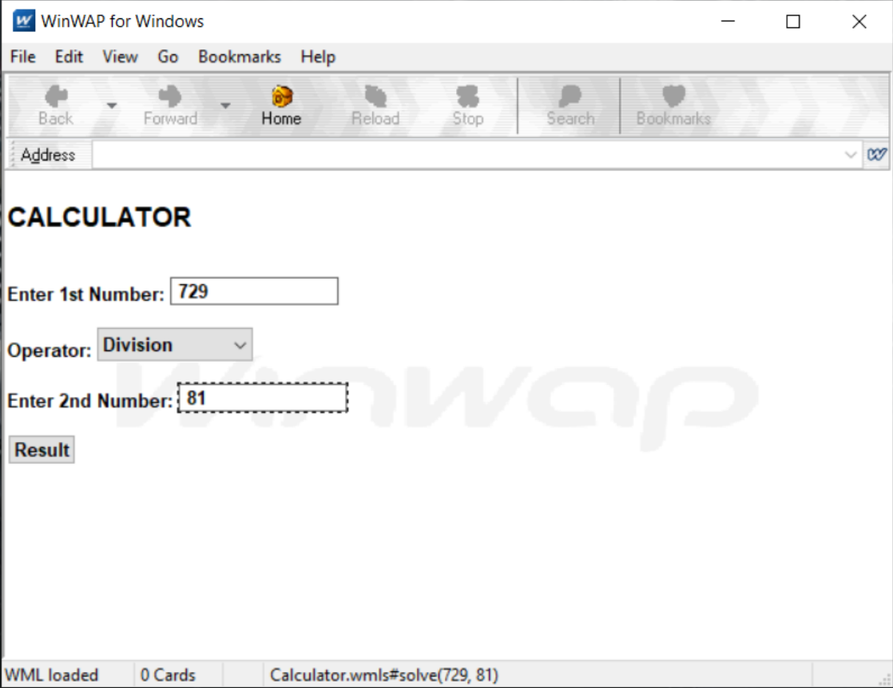

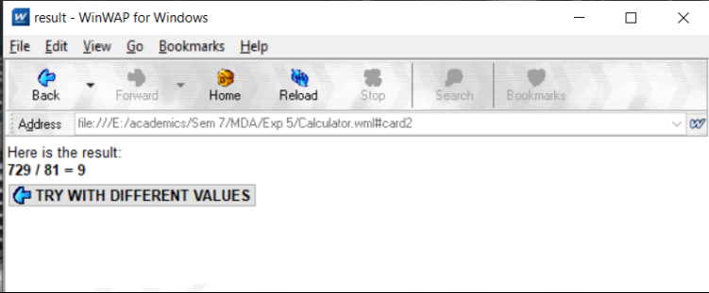

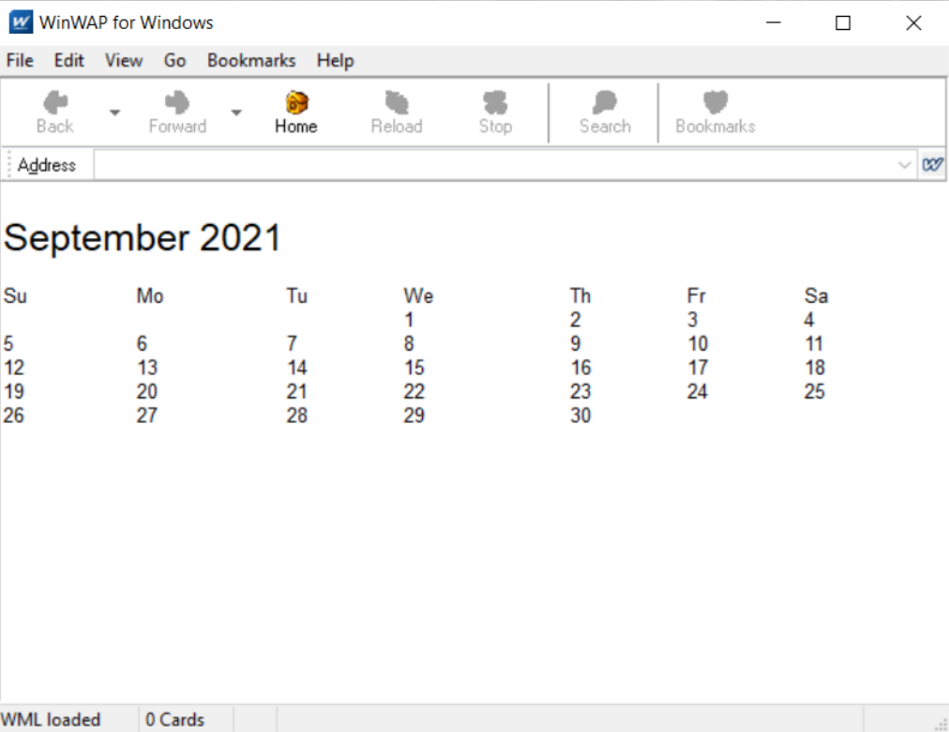

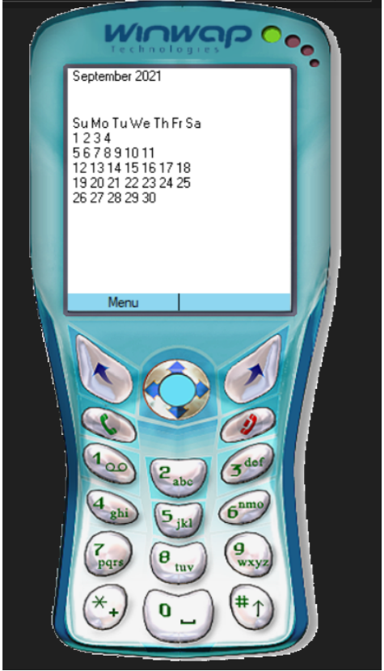

**B.3 Conclusion**

Hence we’ve successfully implemented a program for a calculator application capable of carrying out basic mathematical operations using WML(Wireless Markup Language) on the WinWAP browser.

**B.4 Questions of Curiosity:**

1. Explain the pros and cons of WML.

Ans:

Pros:

* Implementation near to the Internet model.
* Most modern mobile telephone devices support WAP.
* Real-time send/receive data.
* Multi-Platform functionality.
* No hardware obsolescence.

Cons:

* Low speeds, security, and a very small user interface.
* Not very familiar to the users.
* The business model is expensive.
* Forms are hard to design.
* Third-party is included.