**Fading Channels & Mobile Communications IIT Kharagpur**

**Date: 19 Jul 2021**

**Exp 6B: Frequency Reuse**

**Name: AMEY THAKUR**



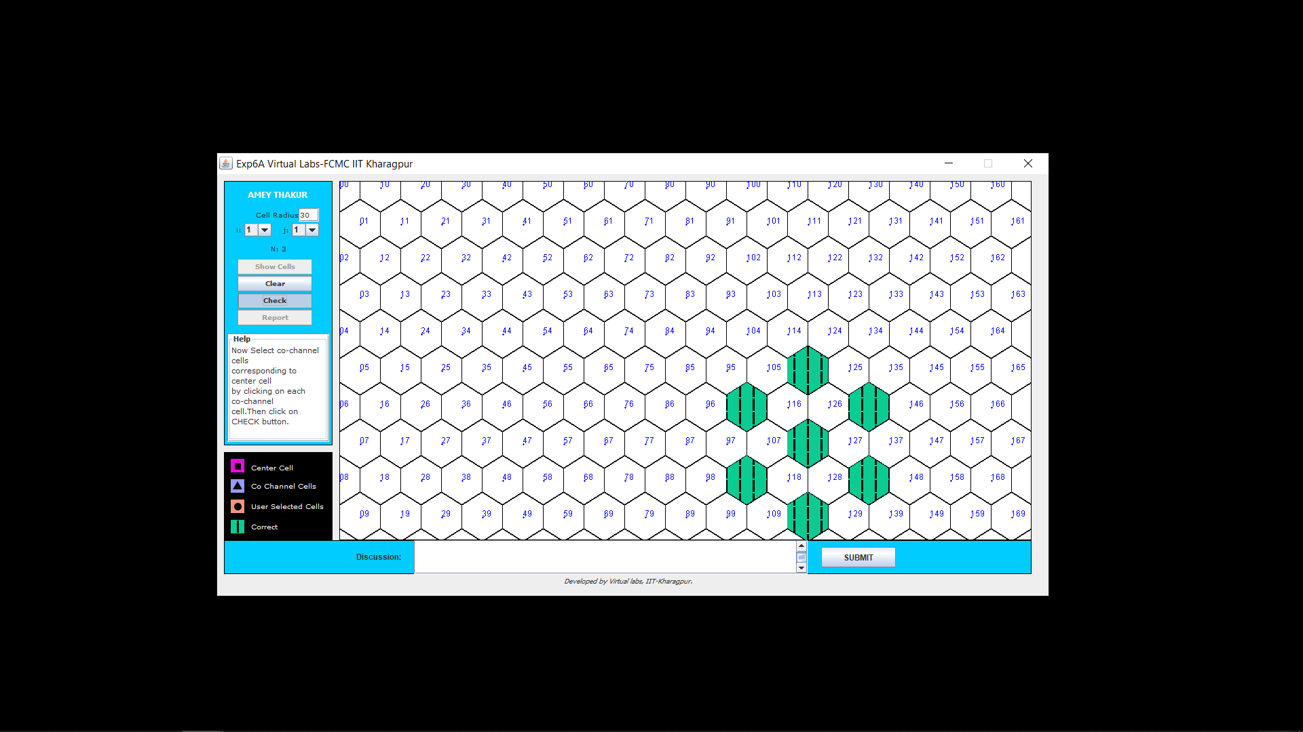

**Discussion:** As I have selected the correct cells so it is showing green colour.

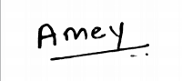

(Signature of AMEY THAKUR)

(Signature of Faculty)