Fading Channels & Mobile Communications IIT Kharagpur
Date: 19 Jul 2021
Exp 6B: Frequency Reuse
Name: AMEY THAKUR

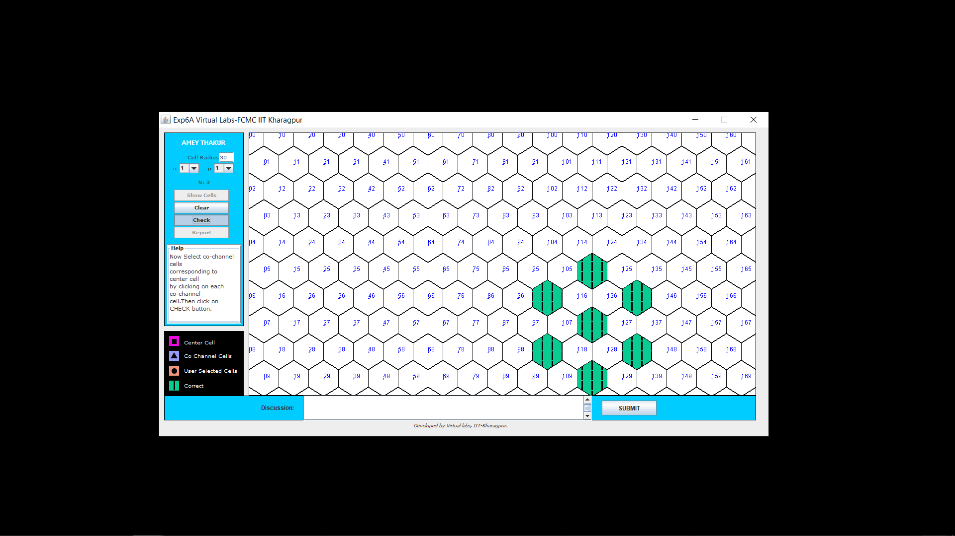

Discussion: As I have selected the correct cells so it is showing green colour.

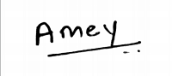
(Signature of AMEY THAKUR)

(Signature of Faculty)

