Terna Engineering College
Computer Engineering Department

Program: Sem VII

Course: MOBILE COMMUNICATION & COMPUTING AND MOBILE APPLICATION DEVELOPMENT LAB (MCC & MAD Lab)

Experiment No. 08
PART B
(PART B: TO BE COMPLETED BY STUDENTS)
(Students must submit the soft copy as per the following segments within two hours of the practical. The soft copy must be uploaded on the Blackboard or emailed to the concerned lab in charge faculties at the end of the practical in case there is no Blackboard access available)

Roll No. 50 | Name: AMEY THAKUR
Class: BE-COMPS-50 | Batch: B3
Date of Experiment: 24-09-2021 | Date of Submission: 24-09-2021
Grade :

Aim:
- Install Ubuntu in Virtual box and Install NS2 on Ubuntu.
- Create a small wireless network (MANET) using NS2.
B.1 Installation Snapshots:
Ubuntu Installed on VMware:
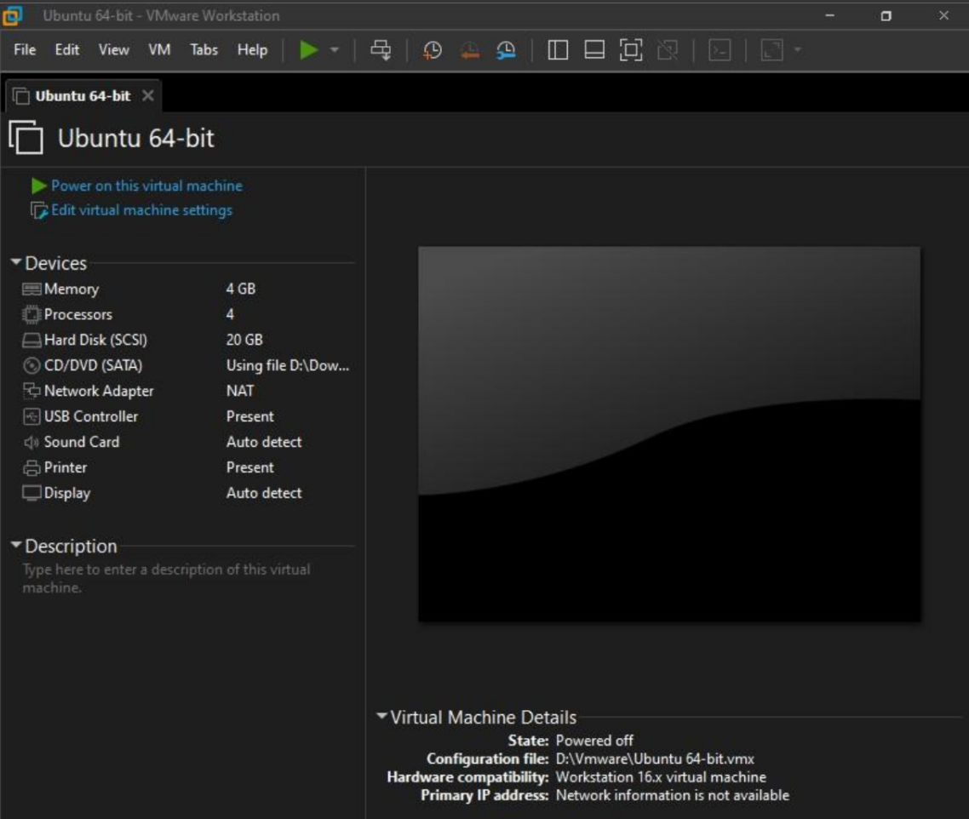
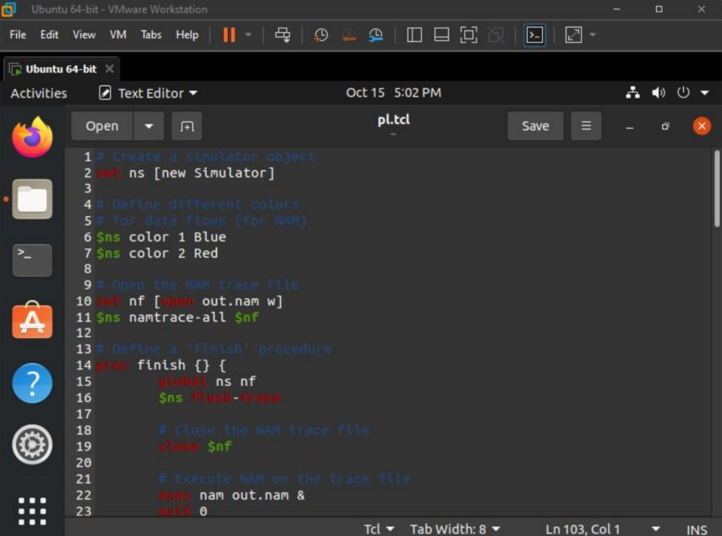

B.2 Snapshots of Code and Network created usingNS2:
# Create a simulator object
set ns [new Simulator]
# Define different colors
# for data flows (for NAM)
$ns color 1 Blue
$ns color 2 Red
# Open the NAM trace file
set nf [open out.nam w]
$ns namtrace-all $nf
# Define a 'finish' procedure
proc finish {} {
global ns nf
$ns flush-trace
# Close the NAM trace file
close $nf
# Execute NAM on the trace file
exec nam out.nam &
exit 0
}
# Create four nodes
set n0 [$ns node]
set n1 [$ns node]
set n2 [$ns node]
set n3 [$ns node]
# Create links between the nodes
$ns duplex-link $n0 $n2 2Mb 10ms DropTail
$ns duplex-link $n1 $n2 2Mb 10ms DropTail
$ns duplex-link $n2 $n3 1.7Mb 20ms DropTail
# Set Queue Size of link (n2-n3) to 10
$ns queue-limit $n2 $n3 10
# Give node position (for NAM)
$ns duplex-link-op $n0 $n2 orient right-down
$ns duplex-link-op $n1 $n2 orient right-up
$ns duplex-link-op $n2 $n3 orient right
# Monitor the queue for link (n2-n3). (for NAM)
$ns duplex-link-op $n2 $n3 queuePos 0.5
# Setup a TCP connection
set tcp [new Agent/TCP]
$tcp set class_ 2
$ns attach-agent $n0 $tcp
set sink [new Agent/TCPSink]
$ns attach-agent $n3 $sink
$ns connect $tcp $sink
$tcp set fid_ 1
# Setup a FTP over TCP connection
set ftp [new Application/FTP]
$ftp attach-agent $tcp
$ftp set type_ FTP
# Setup a UDP connection
set udp [new Agent/UDP]
$ns attach-agent $n1 $udp
set null [new Agent/Null]
$ns attach-agent $n3 $null
$ns connect $udp $null
$udp set fid_ 2
# Setup a CBR over UDP connection
set cbr [new Application/Traffic/CBR]
$cbr attach-agent $udp
$cbr set type_ CBR
$cbr set packet_size_ 1000
$cbr set rate_ 1mb
$cbr set random_ false
# Schedule events for the CBR and FTP agents
$ns at 0.1 "$cbr start"
$ns at 1.0 "$ftp start"
$ns at 4.0 "$ftp stop"
$ns at 4.5 "$cbr stop"
# Detach tcp and sink agents
# (not really necessary)
$ns at 4.5 "$ns detach-agent $n0 $tcp ; $ns detach-agent $n3 $sink"
# Call the finish procedure after
# 5 seconds of simulation time
$ns at 5.0 "finish"
# Print CBR packet size and interval
puts "CBR packet size = [$cbr set packet_size_]"
puts "CBR interval = [$cbr set interval_]"
# Run the simulation
$ns run
OUTPUT: out.nam
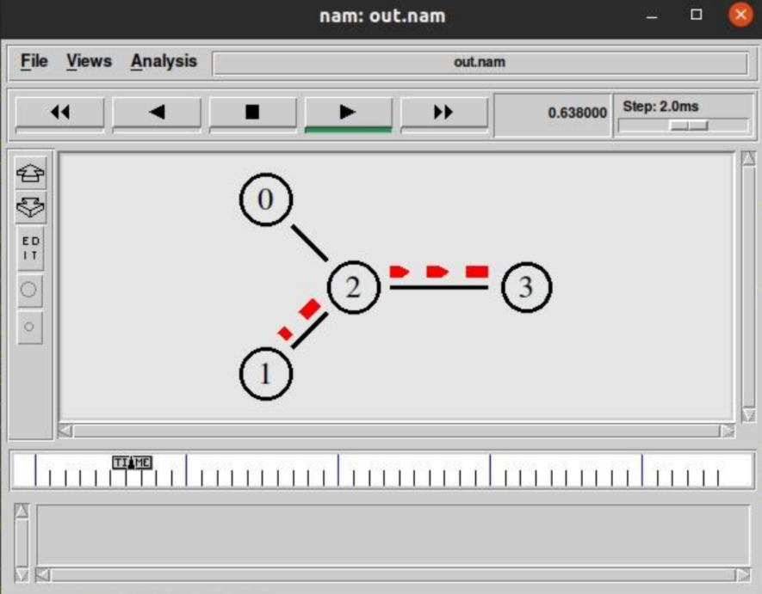
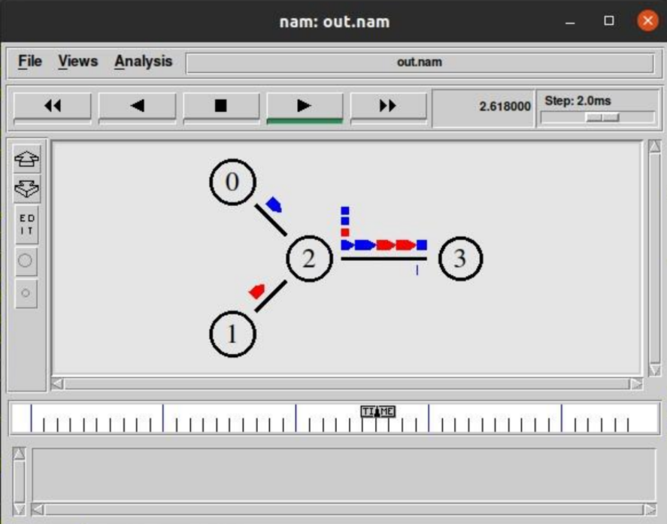
B.2 Conclusion
Hence we’ve successfully implemented a program to simulate the network on NS2 which was installed in the Ubuntu environment.
B.3 Question of Curiosity
- What is Virtualization? List out various virtualization Tools.
Ans:
- The virtualization concept can be simply considered as one computer within another.
- It will allow us to use multiple operating systems on a single computer or machine. This, in turn, makes the work much easier as we cannot change the operating system as per our requirement every time.
- For IT Professionals or Developers it will be an easier option to use virtualization software.
- Developers require multiple operating systems to build different systems in different environments. For testers, it will be an easier option as they can check different systems in different environments.
- With the help of virtualization tools, you can take the maximum benefit of your machine and you can use the original machine along with one more machine which is virtual.
- Virtualization software also provides security options and helps you in keeping your data safe. For this, you can take a snapshot of your system and restore your system to this state. Sandbox provides more security options for virtualization.
- Some well-known virtualization tools are:
- VMWare Workstation
- SolarWinds Virtualization Manager
- Parallel Desktops
- Virtual PC
- QEMU

- What is NS2? Explain the architecture of NS2.
Ans:
- NS2 stands for Network Simulator Version 2. It is an open-source event-driven simulator designed specifically for research in computer communication networks.
- Some features of NS2:
- It is a discrete event simulator for networking research.
- It provides substantial support to simulate a bunch of protocols like TCP, FTP, UDP, HTTPS, and DSR.
- It simulates wired and wireless networks.
- It is primarily Unix-based.
- Basic Architecture:
NS2 consists of two key languages: C++ and Object-oriented Tool Command Language (OTcl). While the C++ defines the internal mechanism (i.e., a backend) of the simulation objects, the OTcl sets up simulation by assembling and configuring the objects as well as scheduling discrete events. The C++ and the OTcl are linked together using TclCL.
