**Terna Engineering College**

**Computer Engineering Department**

**Program: Sem VI**

**Course: Software Engineering Lab**

**LAB Manual**

**PART A**

(PART A: TO BE REFERRED BY STUDENTS)

**Experiment No.03**

**A.1 Aim:**

Draw Data Flow Diagram for your selected Mini-Project.

**A.2 Prerequisite:**

Knowledge about requirement engineering processes of SDLC and requirement modelling.

**A.3 Outcome:**

After successful completion of this experiment, students will be able to: Model requirements of the project (software) using Data Flow Diagram (DFD).

**A.4 Theory:**

1. ***DATA FLOW DIAGRAM (DFD):***

* *The data flow diagram is a graphical model of a system, which shows what are the various functions (activities) performed by the system and how data flows among various functions.*
* ***Each function is considered as a separate process****.*
* *A* ***data flow diagram*** *(****DFD****) is a graphical representation of the "flow" of data through an information system. DFDs can also be used for the visualization of data processing (structured design).*
* *On a DFD, data items flow from an external data source or an internal data store to an internal data store or an external data sink, via an internal process.*
* *A DFD provides no information about the timing of processes, or about whether processes will operate in sequence or parallel.*
* *It is therefore quite different from a flowchart, which shows the flow of control through an algorithm, allowing a reader to determine what operations will be performed, in what order, and under what circumstances, but not what kinds of data will be input to and output from the system, nor where the data will come from and go to, nor where the data will be stored (all of which are shown on a DFD).*
* *Data Flow diagrams (DFD) that help you model data flows and functional requirements for a designed system.*

***Elements of Data Flow Diagram***

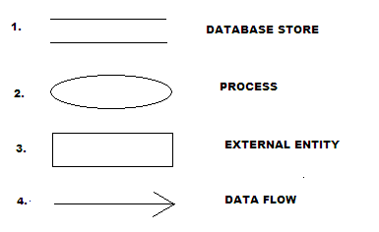

1. ***DATA STORE****:-A data store is a holding place for information within the system*
2. ***PROCESS****:-A process performs transformation or manipulation on input data and produces output data.*
3. ***ENTITY****:-An entity is anything that interacts with the system and is a source or destination of a data.*
4. ***DATA FLOW****:-A data flow shows the flow of information from its source to its destination*.

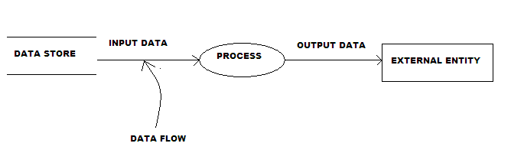

**Data flow diagram Example**

* **DFD-LEVELS**
* **Level-0-DFD(Context Level DFD) :-**
* It is common practice to draw a context-level data flow diagram first, which shows the interaction between the system and external agents which act as data sources and data sinks.
* In the context diagram (also known as the 'Level 0 DFD') the system's interactions with the outside world are modelled purely in terms of data flows across the *system boundary*. **The context diagram shows the entire system as a single process** and **gives no clues as to its internal organization.**
* **Level-1-DFD:-**
* A Level 1 DFD that shows some of the detail of the system being modelled.
* The Level 1 DFD shows how the system is divided into subsystems (processes), each of which deals with one or more of the data flows to or from an external agent, and which together provide all of the functionality of the system as a whole.
* It also identifies internal data stores that must be present for the system to do its job and shows the flow of data between the various parts of the system.
* **Level-2-DFD:-**
* This level is a decomposition of a process shown in a level-1 diagram. There should be a level-2 diagram for every process shown in a level-1 diagram. i.e. it is a breakdown of level-1-DFD.

* **Level-3-DFD:-**
* Level 3 DFD is a breakdown of Level 2 DFD.

**Example:**

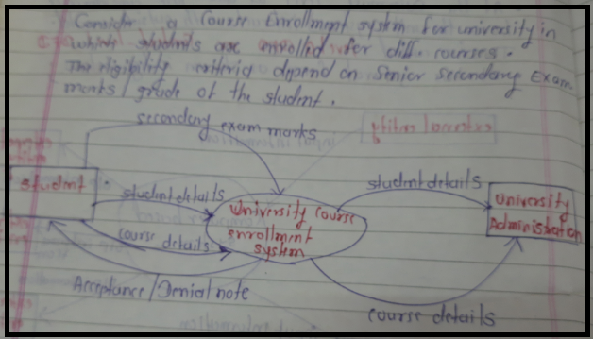

**Level 0 DFD or Context level DFD**

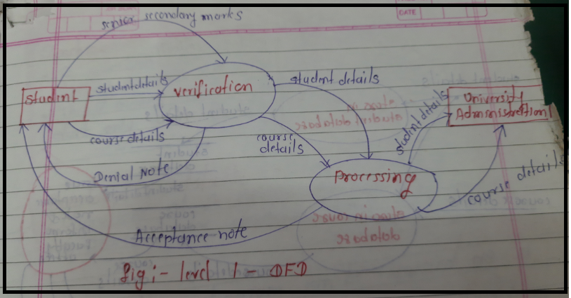

**Level 1 DFD**

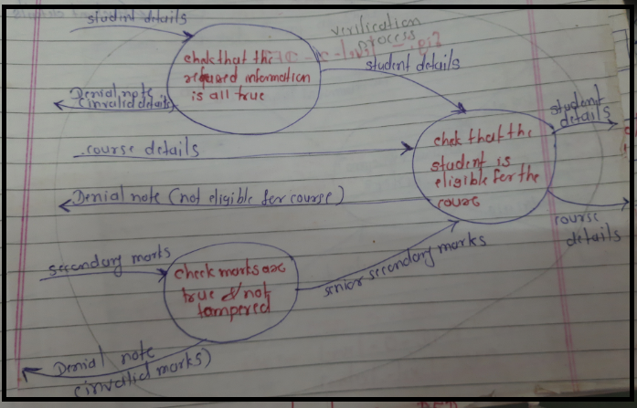

**Level 2 DFD for verification Process of level 1 DFD**

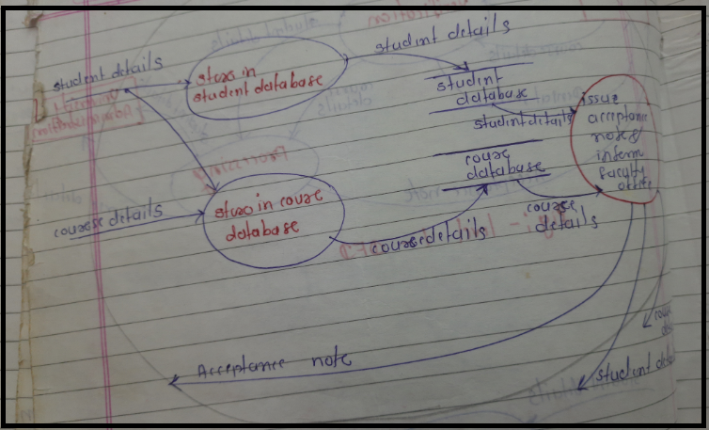

**Level 2 DFD for Processing Process of level 1 DFD**

**PART B**

(PART B: TO BE COMPLETED BY STUDENTS)

***(Students must submit the soft copy as per the following segments within two hours of the practical. The soft copy must be uploaded on the Blackboard or emailed to the concerned lab in charge faculties at the end of the practical in case there is no Blackboard access available)***

|  |  |
| --- | --- |
| **Roll No.** 50 | **Name:** AMEY THAKUR |
| **Class:** Comps TE B | **Batch:** B3 |
| **Date of Experiment:** 10/02/2021 | **Date of Submission:** 10/02/2021 |
| **Grade:** |  |

**B.1 Draw DFD of the selected mini-project up to level 2**

Ans:

**Data Flow Diagram:**

The data flow diagram is a graphical representation of the flow of data in an information system. It is capable of depicting incoming data flow, outgoing data flow and stored data. The DFD does not mention anything about how data flows through the system.

There is a prominent difference between DFD and Flowchart. The flowchart depicts a flow of control in program modules. DFDs depict the flow of data in the system at various levels. DFD does not contain any control or branch elements.

**Types of DFD**

Data Flow Diagrams are either Logical or Physical.

* **Logical DFD:** This type of DFD concentrates on the system process, and flow of data in the system.For example in a Banking software system, how data is moved between different entities.
* **Physical DFD:** This type of DFD shows how the data flow is implemented in the system. It is more specific and close to the implementation.

**DFD Components:**

DFD can represent Source, destination, storage and flow of data using the following set of components -

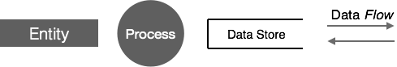

* **Entities:** Entities are the source and destination of information data. Entities are represented by rectangles with their respective names.
* **Process:** Activities and action taken on the data are represented by Circle or Round-edged rectangles.
* **Data Storage:** There are two variants of data storage - it can either be represented as a rectangle with an absence of both smaller sides or as an open-sided rectangle with only one side missing.
* **Data Flow:** Movement of data is shown by pointed arrows. Data movement is shown from the base of an arrow as its source towards the head of the arrow as a destination.

**Zero Level Data flow Diagram(0 Level DFD) of Online Book Store:**

This is the Zero Level DFD of Online Book Store, where we have elaborated the high-level process of Book Store. It’s a basic overview of the whole Online Book Store or process being analyzed or modelled. It’s designed to be an at-a-glance view of Bill’s, Book Stocks and Delivery showing the system as a single high-level process, with its relationship to external entities of Book, Customer and Order. It should be easily understood by a wide audience, including Book, Order and Bills.

In zero level DFD of Online Book Store, we have described the high-level flow of the Book Store system.

**High-Level Entities and process flow of the Online Book Store:**

* Managing all the Book
* Managing all the Customer
* Managing all the Order
* Managing all the Order Update
* Managing all the Bills
* Managing all the Book Stocks
* Managing all the Delivery

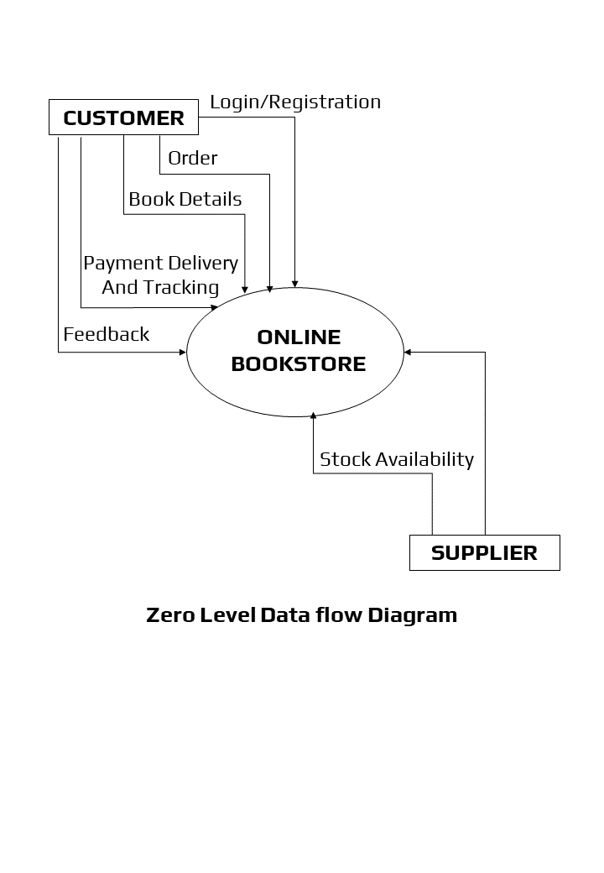

**First Level Data flow Diagram(1st Level DFD) of Online Book Store:**

First Level DFD (1st Level) of Online Book Store shows how the system is divided into subsystems (processes), each of which deals with one or more of the data flows to or from an external agent, and which together provide all of the functionality of the Online Book Store system as a whole. It also identifies internal data stores of Delivery, Book Stocks, Bills, Order Update, Order that must be present for the Book Store system to do its job, and shows the flow of data between the various parts of Book, Order, Book Stocks, Delivery, Bills of the system. DFD Level 1 provides a more detailed breakout of pieces of the 1st level DFD.

**Main entities and output of First Level DFD (1st Level DFD):**

* Processing Book records and generate a report of all Book
* Processing Customer records and generates a report of all Customer
* Processing Order records and generates a report of all Order
* Processing Order Update records and generates a report of all Order Update
* Processing Bills records and generate a report of all Bills
* Processing Book Stocks records and generate a report of all Book Stocks
* Processing Delivery records and generate a report of all Delivery

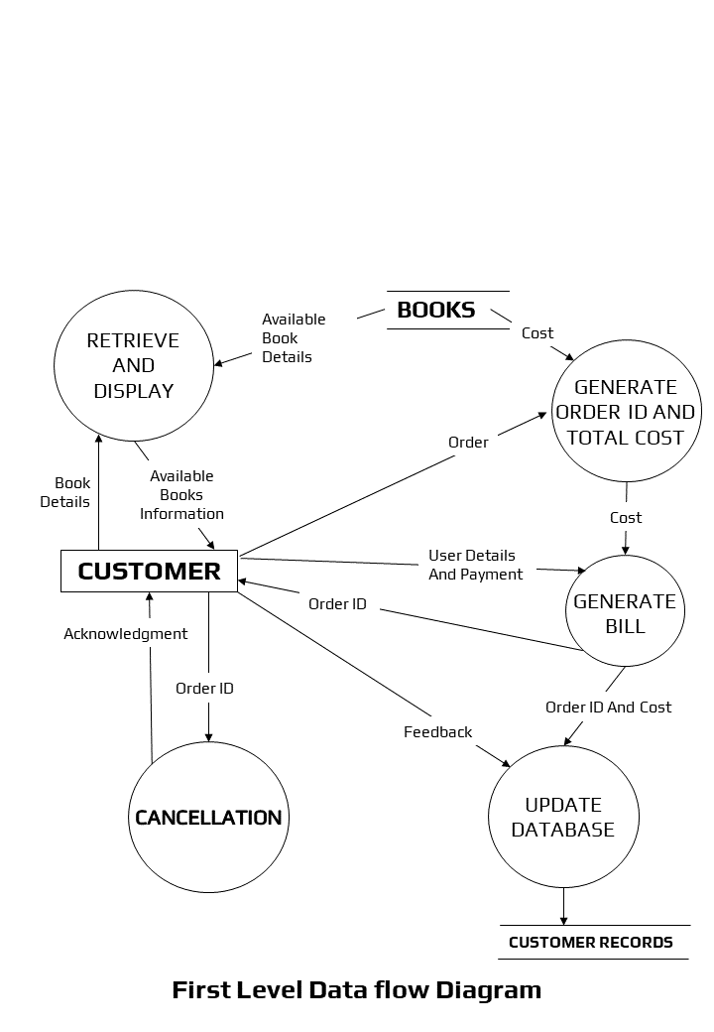

**Second Level Data flow Diagram(2nd Level DFD) of Online Book Store:**

DFD Level 2 then goes one step deeper into parts of Level 1 of the Book Store. It may require more functionalities of the Book Store to reach the necessary level of detail about the Book Store functioning. First Level DFD (1st Level) of the Online Book Store shows how the system is divided into subsystems (processes). The 2nd Level DFD contains more details of Delivery, Book Stocks, Bills, Order Update, Order, Customer, Book.

**Low-level functionalities of Online Book Store:**

* Admin logins to the system and manage all the functionalities of Online Book Store
* Admin can add, edit, delete and view the records of Book, Order, Bills, Delivery
* Admin can manage all the details of Customer, Order Update, Book Stocks
* Admin can also generate reports of Book, Customer, Order, Order Update, Bills, Book Stocks
* Admin can search the details of Customer, Bills, Book Stocks
* Admin can apply different level of filters on report of Book, Order Update, Bills
* Admin can track the detailed information of Customer, Order, Order Update, Bills

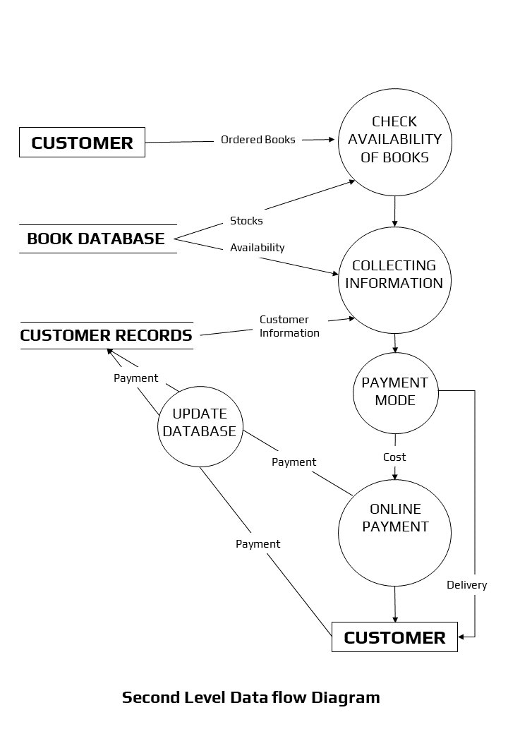

**B.2 Conclusion:**

*(****Students must write the conclusion)***

Data-flow diagrams can be a powerful tool for not only making business decisions but to be used by accounting in many different areas. The simple symbols used make it easy to follow the flow of the charts to understand how decisions are reached or processed.

Data flow analysis has proved itself to be an essential technique in the grand scheme of developing custom software solutions. It greatly improves conceptual clarity, for both the developer and the client. It helps show the true scope of the project, which is almost always bigger than originally anticipated.

**B.3 Question of Curiosity**

1. What do you mean by requirement modelling? Why is it required?

Ans:

**Requirements Modeling:**

Requirements modelling is the process used in software development projects where requirements and solutions constantly evolve through collaborative efforts and teamwork. By using this method of cross-functional and self-organizing teams, you can ensure that your team meets the exact needs of the stakeholders.

The main aim of requirements modelling is to support the end goals of software development. It also aims to achieve these objectives:

* Identify and establish the best practices required to create an effective model.
* Outline the ways you intend to put said practices into action.
* Always have alternatives to improve the overall modelling approach.

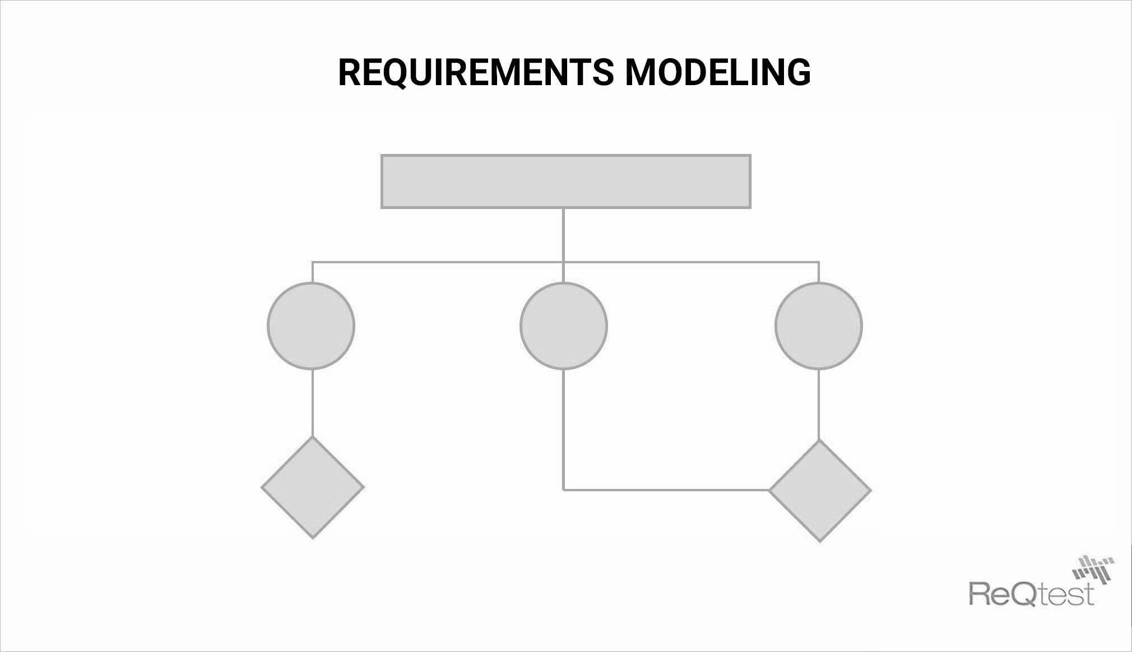

**Requirements Modeling is required to:**

* To achieve fast, consistent and continuous delivery of your software, requirements modelling is critical. Though this process may not provide succinct solutions, it does provide a solid guide for the final product.
* This will ensure that the development team will gain a deeper understanding of the product and its development processes. Thus, it is beneficial for both the developers and the clients should they have any concerns.
* By utilizing this process, you can provide both your project stakeholders and clients with a detailed plan. In this plan, you can address any changes that are necessary to meet their exact requirements and specifications.
* By enhanced and rapid feedback at the start of the project and throughout the entire process, you will decrease the risk of obstacles down the road.
* Even more so when new team members are being added. These processes will offer new team members a quick look into the project in its entirety – from inception to completion. This allows new employees to better understand the prioritization of the iterations in this system.

1. List of various requirement gathering techniques.

Ans:

**Requirement Gathering Techniques:**

Techniques describe how tasks are performed under specific circumstances. A task may have none or one or more related techniques. A technique should be related to at least one task.

The following are some of the well-known requirements gathering techniques −

* One-on-One Interviews
* Group Interviews
* Questionnaires/Surveys
* User Observation
* Analyzing Existing Documents
* Joint Application Design/JAD
* AJAD (Automated JAD)
* Focus Group
* Brainstorming
* Interface analysis
* Requirement Workshops
* Prototyping
* Reverse Engineering

************************