**Terna Engineering College**

**Computer Engineering Department**

**Program: Sem VI**

**Course: Software Engineering Lab**

**LAB Manual**

**PART A**

(PART A: TO BE REFERRED BY STUDENTS)

**Experiment No.06**

**A.1 Aim:**

Develop Sequence and Collaboration diagram for the selected mini-project.

**A.2 Prerequisite:**

Requirement Modelling

**A.3 Outcome:**

After successful completion of this experiment, students will be able to

* Able to model requirements using UML

**A.4 Theory:**

* **Interaction Diagram**
* Show how objects interact with one another, it shows an interaction of a set of objects and their relationships, including the messages that they exchanged among them. This set of messages are used by the objects to communicate with each other.
* **UML supports two types of interaction diagrams**
* Sequence diagrams
* Collaboration diagrams
* **Sequence Diagram**

A sequence diagram shows an interaction arranged in a time sequence. It is an alternate way to understand the overall flow of the control of the system program.

* **UML Sequence Diagram consists of**;
* **Objects**
* **Object lifeline**
* **Focus of Control**
* **Messages send** by the objects to communicate with each other
* Sequence diagrams demonstrate the behaviour of objects in a use case by describing the objects and the messages they pass.
* A sequence diagram shows the sequence of events that occurs.
* The horizontal dimension shows the objects participating in the interaction.
* The vertical arrangement of messages indicates their order**.**
* **Collaboration Diagram:**
* Collaboration diagrams are equivalent to sequence diagrams. All the features of sequence diagrams are equally applicable to collaboration diagrams
* **Use a sequence diagram when the transfer of information is the focus of attention.**
* **Use a collaboration diagram when concentrating on the classes.**

**Example: Sequence Diagram for Online Airline Reservation system**

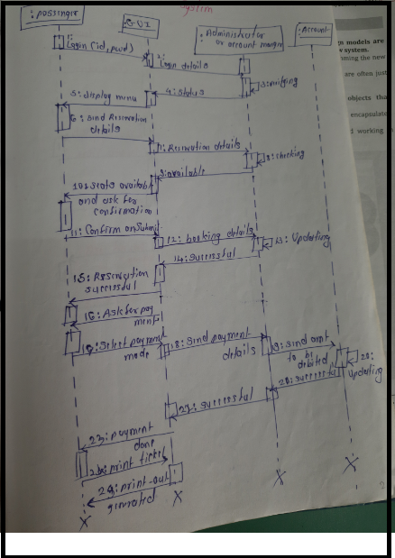

**Example: Collaboration Diagram for Online Airline Reservation system**

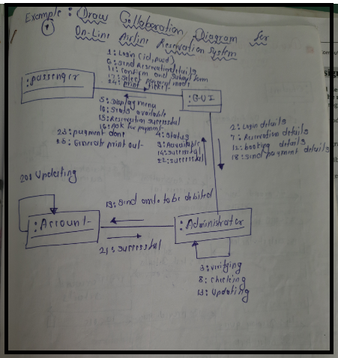

**PART B**

(PART B: TO BE COMPLETED BY STUDENTS)

***(Students must submit the soft copy as per the following segments within two hours of the practical. The soft copy must be uploaded on the Blackboard or emailed to the concerned lab in charge faculties at the end of the practical in case there is no Blackboard access available)***

|  |  |
| --- | --- |
| **Roll No.** 50 | **Name:** AMEY THAKUR |
| **Class:** Comps TE B | **Batch:** B3 |
| **Date of Experiment:** 03/03/2021 | **Date of Submission:** 03/03/2021 |
| **Grade:** |  |

**B.1 Draw Sequence and Collaboration Diagram for selected mini project**

**Sequence Diagram**

* The sequence diagram represents the flow of messages in the system and is also termed an event diagram. It helps in envisioning several dynamic scenarios. It portrays the communication between any two lifelines as a time-ordered sequence of events, such that these lifelines took part at the run time. In UML, the lifeline is represented by a vertical bar, whereas the message flow is represented by a vertical dotted line that extends across the bottom of the page. It incorporates the iterations as well as branching.
* Purpose of a Sequence Diagram

1. To model high-level interaction among active objects within a system.
2. To model interaction among objects inside a collaboration realizing a use case.
3. It either models generic interactions or some certain instances of interaction.

**Collaboration Diagram**

* The collaboration diagram is used to show the relationship between the objects in a system. Both the sequence and the collaboration diagrams represent the same information but differently. Instead of showing the flow of messages, it depicts the architecture of the object residing in the system as it is based on object-oriented programming. An object consists of several features. Multiple objects present in the system are connected. The collaboration diagram, which is also known as a communication diagram, is used to portray the object's architecture in the system.

**Sequence Diagram:**

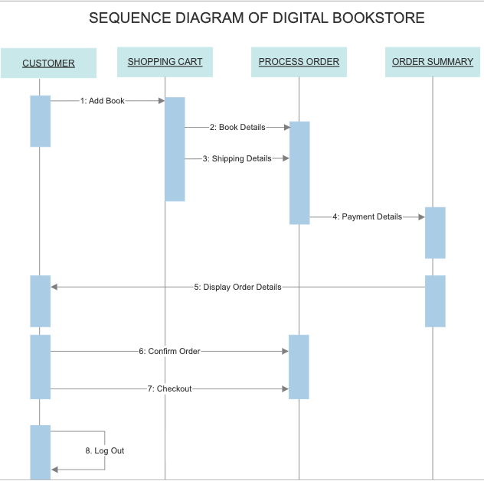

**Collaboration Diagram:**

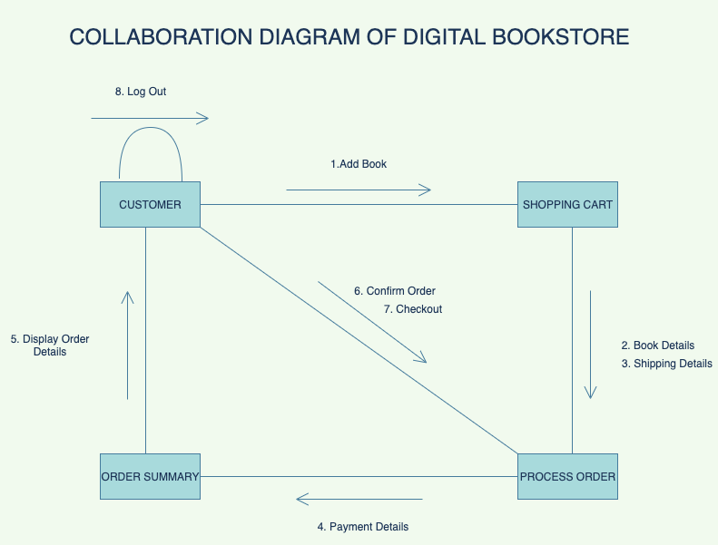

**B.2 Conclusion:**

*(****Students must write the conclusion)***

* The interactions are simply units of the behaviour of a classifier.
* The critical elements in an interaction diagram are lifeline and messages.
* The sequence UML diagram is to visualize the sequence of a message flow in the system.
* The purpose of a collaboration diagram is to emphasize structural aspects.

**B.3 Question of Curiosity**

1. Explain various elements of the sequence diagram.

Ans:

**Lifeline**

An individual participant in the sequence diagram is represented by a lifeline. It is positioned at the top of the diagram.

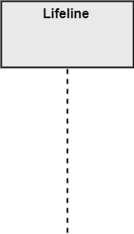

**Actor**

A role played by an entity that interacts with the subject is called an actor. It is out of the scope of the system. It represents the role, which involves human users and external hardware or subjects. An actor may or may not represent a physical entity, but it purely depicts the role of an entity. Several distinct roles can be played by an actor or vice versa.

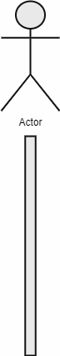

**Activation**

It is represented by a thin rectangle on the lifeline. It describes the time in which an operation is performed by an element, such that the top and the bottom of the rectangle is associated with the initiation and the completion time, respectively.

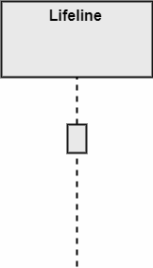

**Messages**

The messages depict the interaction between the objects and are represented by arrows. They are in sequential order on the lifeline. The core of the sequence diagram is formed by messages and lifelines.

Following are types of messages enlisted below:

* **Call Message:** It defines a particular communication between the lifelines of an interaction, which represents that the target lifeline has invoked an operation.

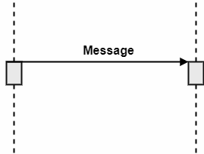

* **Return Message:** It defines a particular communication between the lifelines of interaction that represent the flow of information from the receiver of the corresponding caller message.

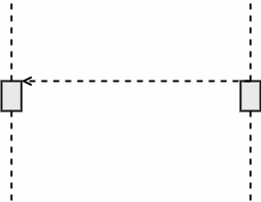

* **Self Message:** It describes a communication, particularly between the lifelines of an interaction that represents a message of the same lifeline, has been invoked.

Sequence Diagram

* **Recursive Message:** A self message sent for recursive purpose is called a recursive message. In other words, it can be said that the recursive message is a special case of the self message as it represents the recursive calls.

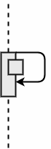

* **Create Message:** It describes a communication, particularly between the lifelines of an interaction describing that the target (lifeline) has been instantiated.

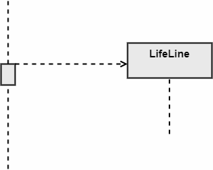

* **Destroy Message:** It describes a communication, particularly between the lifelines of an interaction that depicts a request to destroy the lifecycle of the target.

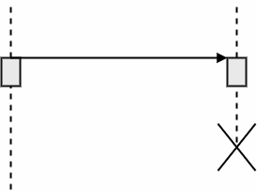

* **Duration Message:** It describes a communication particularly between the lifelines of an interaction, which portrays the time passage of the message while modelling a system.

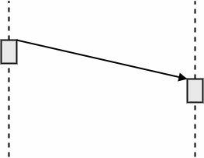

**Note**

A note is a capability of attaching several remarks to the element. It carries useful information for the modellers.

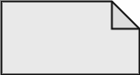

1. Explain various elements of the Collaboration diagram.

Ans:

**Elements of a collaboration diagram:**

* **Objects:** The representation of an object is done by an object symbol with its name and class underlined, separated by a colon.  
  In the collaboration diagram, objects are utilized in the following ways:
  1. The object is represented by specifying its name and class.
  2. Every class doesn’t need to appear.
  3. A class may constitute more than one object.
  4. In the collaboration diagram, firstly, the object is created, and then its class is specified.
  5. To differentiate one object from another object, it is necessary to name them.
* **Actors:** In the collaboration diagram, the actor plays the main role as it invokes the interaction. Each actor has his respective role and name. In this, one actor initiates the use case.
* **Links:** The link is an instance of association, which associates the objects and actors. It portrays a relationship between the objects through which the messages are sent. It is represented by a solid line. The link helps an object to connect with or navigate to another object, such that the message flows are attached to links.
* **Messages:** It is a communication between objects which carries information and includes a sequence number, so that the activity may take place. It is represented by a labelled arrow, which is placed near a link. The messages are sent from the sender to the receiver, and the direction must be navigable in that particular direction. The receiver must understand the message.

************************