**Terna Engineering College**

**Computer Engineering Department**

**Program: Sem VI**

**Course: Software Engineering Lab**

**LAB Manual**

**PART A**

(PART A: TO BE REFERRED BY STUDENTS)

**Experiment No.07**

**A.1 Aim:**

Develop UML Activity and state chart diagram for the selected mini-project.

**A.2 Prerequisite:**

Requirement Modelling

**A.3 Outcome:**

After successful completion of this experiment, students will be able to

* Able to model requirements using UML

**A.4 Theory:**

* **Activity Diagram**
* The activity diagram is essentially a flowchart, showing the flow of control from activity to activity.
* We use an activity diagram to model the dynamic flow of the system.
* Using an activity diagram, we can model the flow of an object as it moves from state to state at different points in the flow of control.
* **Activity Diagram includes the following elements.**
* **Start activity and End Activity**
* **Activity states and Action states**
* **Transitions**
* **Branching**
* **Forking and Joining**
* **Swim lane**

**Example: Activity diagram for online examination system**

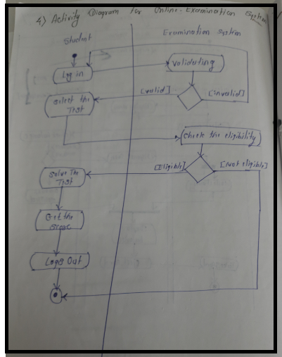

**Example: Activity diagram for Video Rental system**

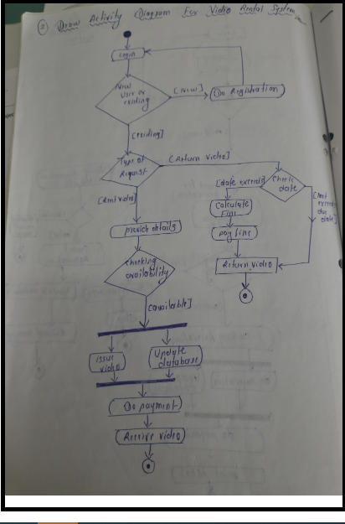

* **State Chart Diagram**
* State Diagrams show the sequences of states an object goes through during its life cycle in response to stimuli, together with its responses and actions; an abstraction of all possible behaviours.
* Statechart diagram consists of;
* **Start State**
* **Final/end state**
* **Simple state/Composite state**
* **Transition**

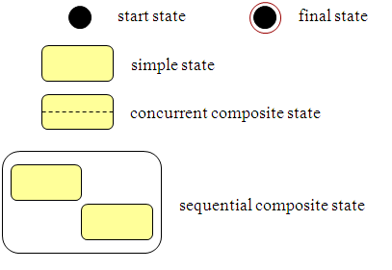

* **Example:**

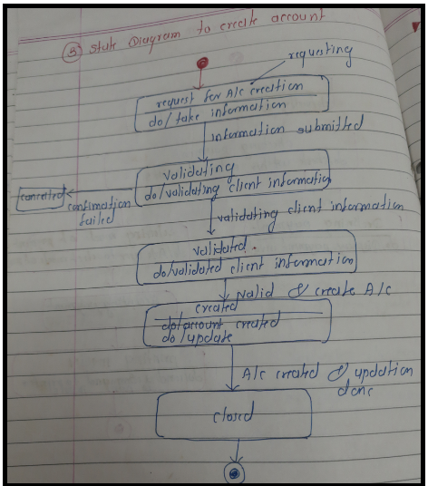

* **Example:**

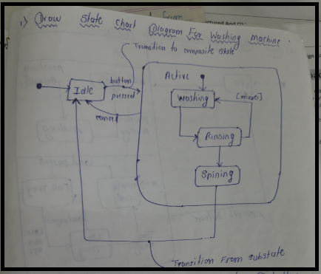

**PART B**

(PART B: TO BE COMPLETED BY STUDENTS)

***(Students must submit the soft copy as per the following segments within two hours of the practical. The soft copy must be uploaded on the Blackboard or emailed to the concerned lab in charge faculties at the end of the practical in case there is no Blackboard access available)***

|  |  |
| --- | --- |
| **Roll No.** 50 | **Name:** AMEY THAKUR |
| **Class:** Comps TE B | **Batch:** B3 |
| **Date of Experiment:** 10/03/2021 | **Date of Submission:** 10/03/2021 |
| **Grade:** |  |

**B.1 Draw Statechart and Activity Diagram for selected mini project**

**Statechart Diagram:**

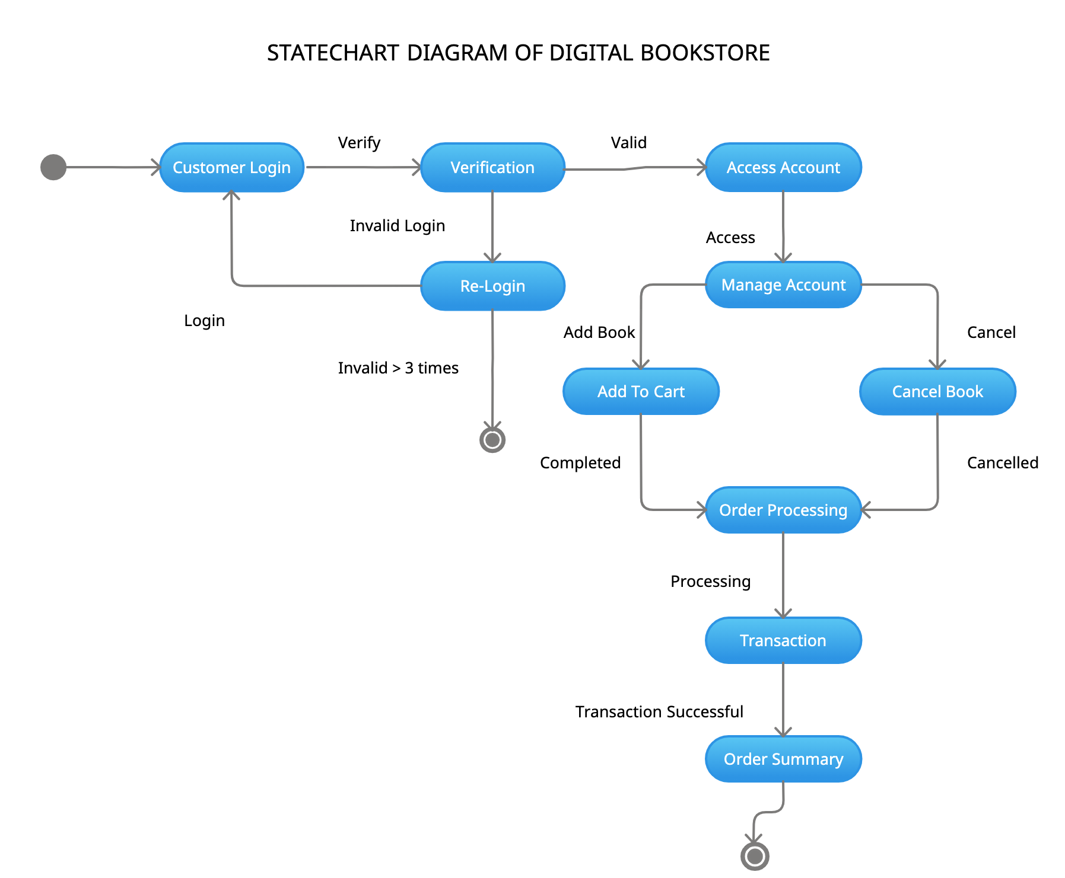

**Activity Diagram:**

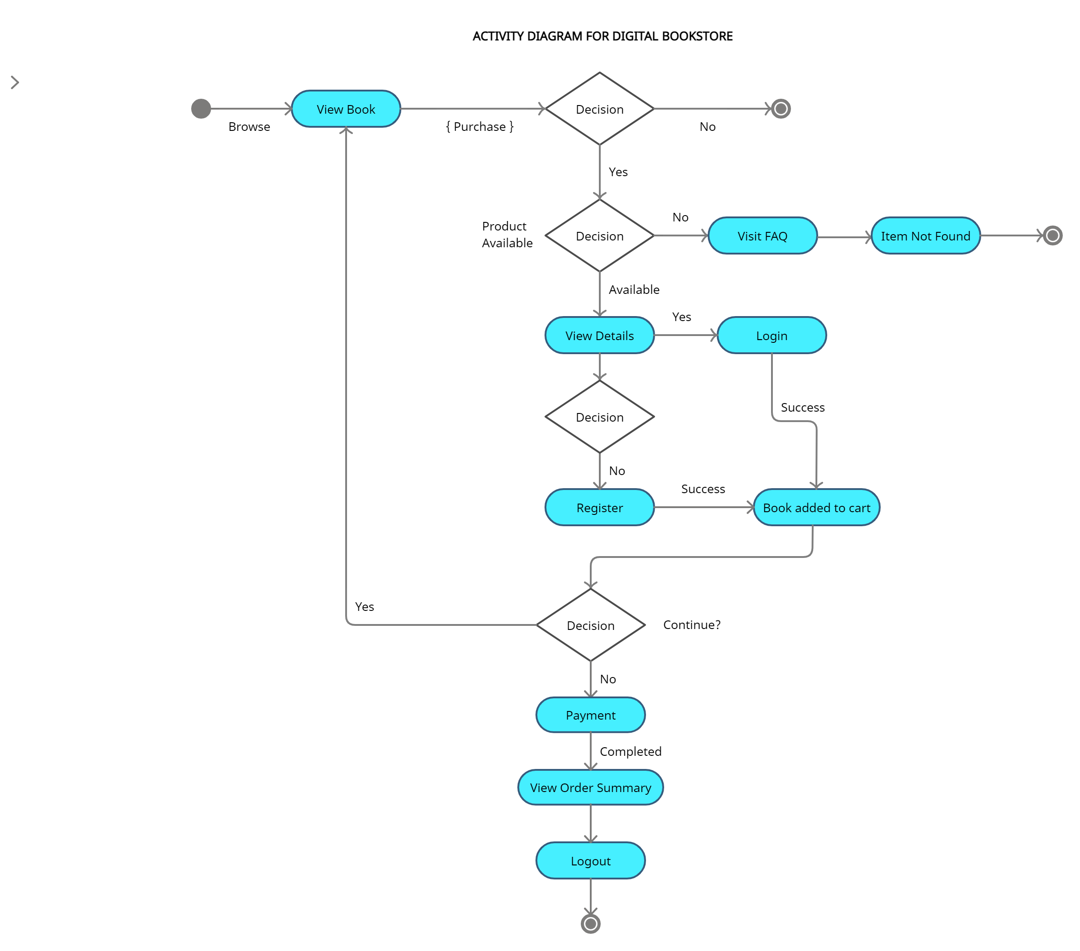

**B.2 Conclusion:**

*(****Students must write the conclusion)***

In conclusion, the Statechart diagram defines the states of a component and these state changes are dynamic. Its specific purpose is to define the state changes triggered by events. Events are internal or external factors influencing the system. Activity diagrams are fairly easy to get the hang of, and will be useful for most projects because they "simply and quite plainly show how things work." Unlike many diagramming techniques, activity diagrams also enable the depiction of multiple choices and actors within a workflow, and they are easy for even non-technical users to follow.

**B.3 Question of Curiosity**

1. Explain various elements of the Activity diagram.

Ans:

The following are the most commonly used elements of the Activity Diagram:

* **Initial Node** - The initial node represents the starting point of the activity diagram.
* **Activity Final Node** - The activity final node represents the termination point of the activity.
* **Action Node** - An action node is a type of activity node that represents a single action or behaviour of the activity being modelled.
* **Activity Edge** - An activity edge creates a directed connection between two activity nodes. It represents the path that a token can take between two activity nodes.
* **Decision** - A decision has one flow entering and several exiting. The exiting flows each has a condition that must be met to traverse the flow.
* **Merge** - A merge has several flows entering and one exiting. The merge denotes that multiple parallel flows are merging at a single point. Only one flow must reach the merge point to continue to traverse the flow to the next activity.
* **Fork** - A fork has one flow entering and several exiting. A fork denotes that several processes are occurring in parallel.
* **Join -** A join has several flows entering it and one exiting it. A join denotes that multiple parallel flows are merging at a single point. All flows going into the join must be completed before the next activity can start.

1. Explain various elements of the statechart diagram.

Ans:

The following are the most commonly used elements of the Statechart Diagram:

* **Initial State:** This state shows the first activity of the flow. The first or the default state the object is in. It is denoted by a solid circle.
* **State:** A state represents the state of an object at a particular given point in time. All the states an object can go in are mentioned in this. It is represented by a rectangle with rounded edges.
* **Transition:** The transition from one state to another state of objects is represented by an arrow. Depicted by an arrow from the source state to the destination state.
* **Event and Action:** A trigger that causes a transition to occur.
* **Signal:** When a message or a trigger caused by an event to a state, which causes a transition, this message is called a signal.
* **Final State:** The state diagram ends with a diagram that depicts a bull’s eye is known as Final State. Depicts the end of the. It is shown by a bull's eye symbol.