COMPUTER ENGINEERING DEPARTMENT

ASSIGNMENT NO-01
SUB: Software Engineering

COURSE: T.E. Year: 2020-2021 Semester: VI
DEPT: Computer Engineering
SUBJECT CODE: CSC601 SUBMISSION DATE: 20/03/2021
===================================================================================

Name: Amey Thakur | Roll No.: 50
Class: TE Comps B-50 | ID: TU3F1819127

Assignment No 1

Sr.  No. | Question | CO  mapping | PO mapping | PSO  Mapping
1 | What is Agile Methodology?  Explain it with principles used.  Explain any one agile methodology. | CO1 | PO2,PO3,PO10, PO11, PO12 | 1
2 | Differentiate the Waterfall model and Spiral model.  Explain the advantages and disadvantages of each. | CO1 | PO2,PO3,PO10, PO11, PO12 | 1
3 | Define Requirement.  What are the various types of requirements?  Also, explain different requirement gathering techniques in detail. | CO2 | PO1PO2,PO3,PO4, PO5,PO7,PO8,PO9,PO10, PO11,  PO12 | 1
4 | What is DFD?  What are the various elements of DFD?  Draw DFD for Online Course Enrolment system (Up to level 2) and also draw DFD for withdrawal of money using ATM. | CO2 | PO1,PO2,PO3,PO4, PO5,PO7,  PO8,PO9,PO10,  PO11,  PO12 | 1,2
5 | What is an object Point?  Explain the COCOMO II model in detail | CO3 | PO3,PO4, PO6,PO7,  PO8,PO9,PO10,  PO11,  PO12 | 1,2
6 | For CAD software, calculate the size of software using function point metric; using the following data.  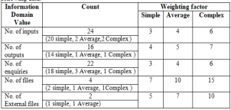  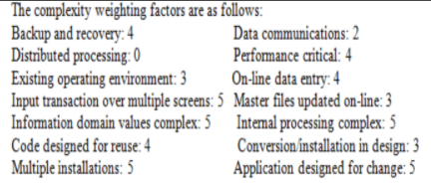 | CO3 | PO3,PO4,PO6,PO7,  PO8,PO9,PO10,  PO11,  PO12 | 1,2

