PART B
EXPERIMENT NUMBER 7

Aim: To design and implement the first pass of a two-pass assembler for IBM 360/370 Processor.

(PART B: TO BE COMPLETED BY STUDENTS)

(Students must submit the soft copy as per the following segments within two hours of the practical. The soft copy must be uploaded at the end of the practical)

Roll No. 50 | Name: AMEY THAKUR
Class: Comps TE B | Batch: B3
Date of Experiment: 30/04/2021 | Date of Submission: 30/04/2021
Grade:

B.1 Software Code written by a student:
(Paste your code completed during the 2 hours of practice in the lab here)

- SPCC-7.C

#include<stdio.h>
#include<string.h>
#include <stdlib.h>

int main()
{
FILE *f1,*f2,*f3,*f4;
int lc,sa,l,op1,o,len;
char m1[20],la[20],op[20],otp[20];
f1=fopen("INPUT.txt","r");
f3=fopen("SYMTAB.txt","w");
fscanf(f1,"%s %s %d",la,m1,&op1);
if(strcmp(m1,"START")==0)
{
sa=op1;
lc=sa;
printf("\t%s\t%s\t%d\n",la,m1,op1);
}
else
lc=0;
fscanf(f1,"%s %s",la,m1);
while(!feof(f1))
{
fscanf(f1,"%s",op);
printf("\n%d\t%s\t%s\t%s\n",lc,la,m1,op);
if(strcmp(la,"-")!=0)
{
fprintf(f3,"\n%d\t%s\n",lc,la);
}
f2=fopen("OPTAB.txt","r");
fscanf(f2,"%s %d",otp,&o);
while(!feof(f2))
{
if(strcmp(m1,otp)==0)
{
lc=lc+3;
break;
}
fscanf(f2,"%s %d",otp,&o);
}
fclose(f2);
if(strcmp(m1,"WORD")==0)

{
lc=lc+3;
}
else if(strcmp(m1,"RESW")==0)
{
op1=atoi(op);
lc=lc+(3*op1);
}
else if(strcmp(m1,"BYTE")==0)
{
if(op[0]=='X')
lc=lc+1;
else
{
len=strlen(op)-2;
lc=lc+len;}
}
else if(strcmp(m1,"RESB")==0)
{
op1=atoi(op);
lc=lc+op1;
}
fscanf(f1,"%s%s",la,m1);
}
if(strcmp(m1,"END")==0)
{
printf("Program length =\n%d",lc-sa);
}
fclose(f1);
fclose(f3);
return 0;
}

- INPUT.TXT

copy START 1000
- LDA ALPHA
- ADD ONE
- SUB TWO
- STA BETA
ALPHA BYTE C'KLNCE
ONE RESB 2
TWO WORD 5
BETA RESW 1
_ END _

- OPTAB.TXT

LDA 00
STA 23
ADD 01
SUB 05

- SYMTAB.TXT

1012 ALPHA

1017 ONE

1019 TWO

1022 BETA

1025 _
B.2 Input and Output:

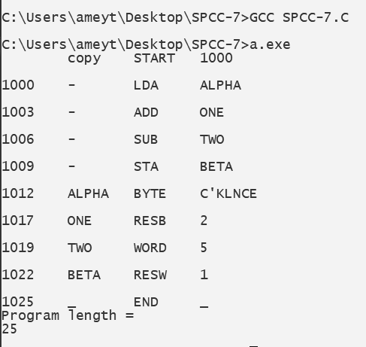

B.3 Observations and learning:
(Students are expected to comment on the output obtained with clear observations and learning for each task/ subpart assigned)
We have learnt about the two passes of the assembler and implemented the first pass.
B.4 Conclusion:
(Students must write the conclusion as per the attainment of individual outcome listed above and learning/observation noted in section B.3)
Hence, we have successfully implemented the program for the first pass of a two-pass assembler.
B.5 Question of Curiosity
(To be answered by a student based on the practical performed and learning/ observations)

- Define Data Structures
Ans:

- Mnemonic Operation Table
This table indicates the symbolic mnemonic for each instruction and its length.

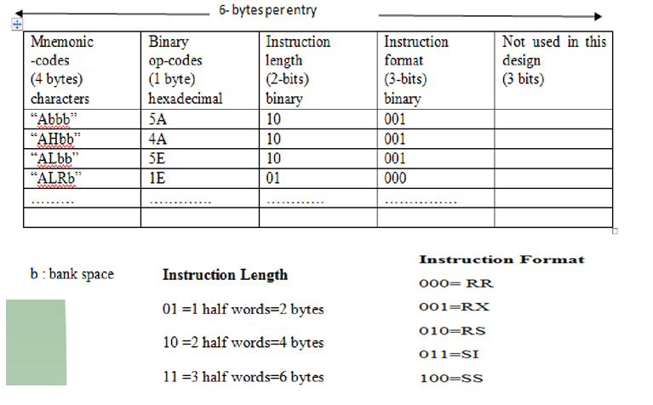

- Symbol Table
It stores each label along with its value.
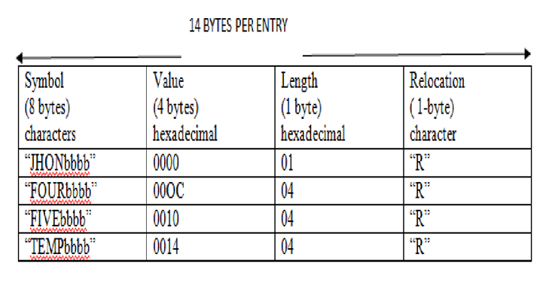

- Segment Register Table
It stores information about the segment name and segment register.
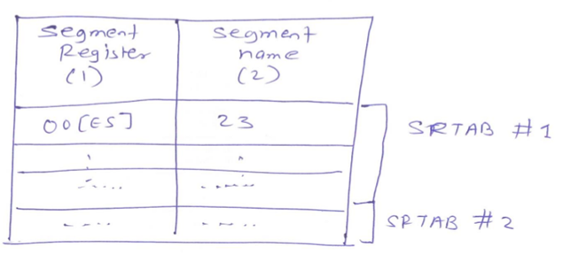

- Forward Reference Table
It stores information about forwarding references.
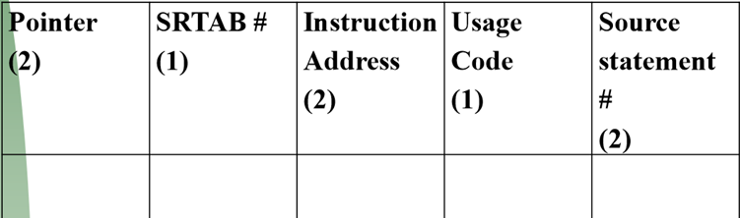

- Cross Reference Table
It lists out all references to a symbol in ascending order of statements.
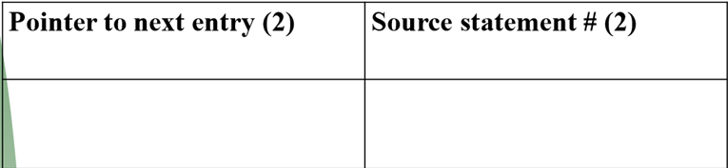

- Comment on the Forward Reference Problem and Remedy.
Ans:
- In an assembly language program, we can use symbols which are the names associated with data or instructions.
- The symbols may be referred to before they are defined. This is called a forward reference.
- One approach to solve this problem is to have two passes over the source program. So the first pass just defines the symbols and the second pass finds the addresses.

