**PART B**

**EXPERIMENT NUMBER 1**

**Aim:** Write a program to implement Lexical Analyzer for given language using Finite Automata.

**(PART B: TO BE COMPLETED BY STUDENTS)**

***(Students must submit the soft copy as per following segments within two hours of the practical. The soft copy must be uploaded at the end of the practical)***

|  |  |
| --- | --- |
| **Roll No.** 50 | **Name:** AMEY THAKUR |
| **Class:** Comps TE B | **Batch:** B3 |
| **Date of Experiment:** 05/02/2021 | **Date of Submission:** 05/02/2021 |
| **Grade:** |  |

**B.1 Software Code written by a student:**

***(Paste your code completed during the 2 hours of practice in the lab here)***

* **SPCC-1.c**

#include <stdio.h>

#include <conio.h>

#include <string.h>

int dfa = 0;

void start(char c)

{

if (c == 'a')

dfa = 1;

else if (c == 'b')

dfa = 3;

else

dfa = -1;

}

void state1(char c)

{

if (c == 'a')

dfa = 2;

else if (c == 'b')

dfa = 4;

else

dfa = -1;

}

void state2(char c)

{

if (c == 'b')

dfa = 3;

else if (c == 'a')

dfa = 1;

else

dfa = -1;

}

void state3(char c)

{

if (c == 'b')

dfa = 3;

else if (c == 'a')

dfa = 4;

else

dfa = -1;

}

void state4()

{

dfa = -1;

}

int isAccepted(char str[])

{

int i, len = strlen(str);

for (i = 0; i < len; i++) {

if (dfa == 0)

start(str[i]);

else if (dfa == 1)

state1(str[i]);

else if (dfa == 2)

state2(str[i]);

else if (dfa == 3)

state3(str[i]);

else if (dfa == 4)

state4(str[i]);

else

return 0;

}

if (dfa == 3)

return 1;

else

return 0;

}

int main()

{

char str[50];

printf("Kindly enter string in a sequence of a and b: ");

scanf("%s",str);

if (isAccepted(str))

printf("ACCEPTED");

else

printf("NOT ACCEPTED");

getch();

return 0;

}

* **Lexical_Analyzer.c**

#include<stdio.h>

#include<stdlib.h>

#include<string.h>

#include<ctype.h>

int isKeyword(char buffer[]){

char keywords[32][10] = {"auto","break","case","char","const","continue","default",

"do","double","else","enum","extern","float","for","goto",

"if","int","long","register","return","short","signed",

"sizeof","static","struct","switch","typedef","union",

"unsigned","void","volatile","while"};

int i, flag = 0;

for(i = 0; i < 32; ++i){

if(strcmp(keywords[i], buffer) == 0){

flag = 1;

break;

}

}

return flag;

}

int main(){

char ch, buffer[15], operators[] = "+-*/%=";

FILE *fp;

int i,j=0;

fp = fopen("C:\\Users\\ameyt\\Desktop\\test.txt","r");

if(fp == NULL){

printf("error while opening the file\n");

exit(0);

}

while((ch = fgetc(fp)) != EOF){

for(i = 0; i < 6; ++i){

if(ch == operators[i])

printf("%c is operator\n", ch);

}

if(isalnum(ch)){

buffer[j++] = ch;

}

else if((ch == ' ' || ch == '\n') && (j != 0)){

buffer[j] = '\0';

j = 0;

if(isKeyword(buffer) == 1)

printf("%s is keyword\n", buffer);

else

printf("%s is indentifier\n", buffer);

}

}

fclose(fp);

return 0;

}

**B.2 Input and Output:**

* **SPCC-1.c**

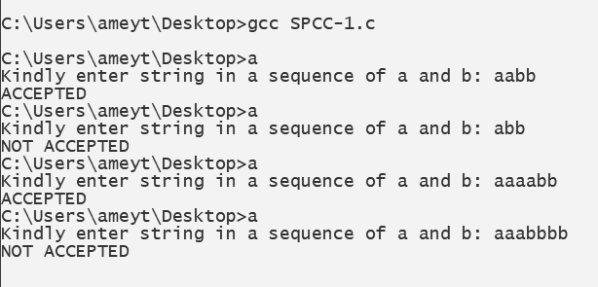

* **Lexical_Analyzer.c**

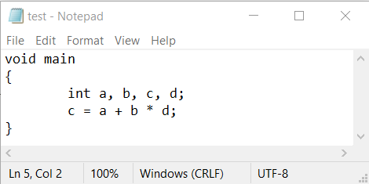

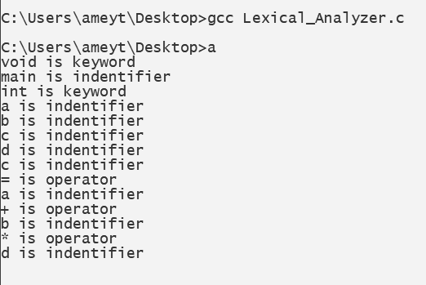

**B.3 Observations and learning:**

***(Students are expected to comment on the output obtained with clear observations and learning for each task/ subpart assigned)***

From the diagram that we drew concerning our DFA, we implemented DFA functions to accept a string of characters from the user and tell whether the string is accepted or not. Hence, we learnt a program to implement Lexical Analyzer for a given language using Finite Automata.

**B.4 Conclusion:**

***(Students must write the conclusion as per the attainment of individual outcome listed above and learning/observation noted in section B.3)***

We learnt how to implement DFA in c using functions.

**B.5 Question of Curiosity**

***(To be answered by a student based on the practical performed and learning/ observations)***

1. What is a token?

Ans:

* A token is the smallest element(character) of a computer language program that is meaningful to the compiler. The parser has to recognize these as tokens: identifiers, keywords, literals, operators, punctuators, and other separators.
* A stream of these tokens makes up a translation to ASM or in some cases a Low-Level Language as C.
* Sample of C++ Tokens below.

KeyWords.

1. for,if,else,while,etc.

Source Token Characters For Reserved Words or Operators)

1. a b c d e f g h i j k l m n o p q r s t u v w x y z
2. A B C D E F G H I J K L M N O P Q R S T U V W X Y Z
3. 0 1 2 3 4 5 6 7 8 9
4. _ { } [ ] # ( ) < > % : ; . ? * + - / ^ & | ~ ! = , \ " '

Identifiers —(Variable Names).

1. _ a b c d e f g h i j k l m
2. n o p q r s t u v w x y z
3. A B C D E F G H I J K L M
4. N O P Q R S T U V W X Y Z
5. 1,2,3,4,5,6,7,8,9 ZERO-"0"- IS NOT ALLOWED IN IDENTIFIERS BUT SOME LANGUAGES CONVERT THESE TO A LETTER OR NUMBER IN THE COMPILER
6. C++ Language recognizes all character sets in Japanese.

Unicode. (Examples)

1. 00A8, 00AA, 00AD, 00AF, 00B2-00B5, 00B7-00BA, 00BC-00BE, 00C0-00D6, 00D8-00F6, 00F8-00FF, 0100-02FF, 0370-167F, 1681-180D, 180F-1DBF, 1E00-1FFF, 200B-200D, 202A-202E, 203F-2040, 2054, 2060-206F, 2070-20CF, 2100-218F, 2460-24FF, 2776-2793, 2C00-2DFF, 2E80-2FFF, 3004-3007, 3021-302F, 3031-303F, 3040-D7FF, F900-FD3D, FD40-FDCF, FDF0-FE1F, FE30-FE44, FE47-FFFD, 10000-1FFFD, 20000-2FFFD, 30000-3FFFD, 40000-4FFFD, 50000-5FFFD, 60000-6FFFD, 70000-7FFFD, 80000-8FFFD, 90000-9FFFD, A0000-AFFFD, B0000-BFFFD, C0000-CFFFD, D0000-DFFFD, E0000-EFFFD

Separators.

1. \s, \n, \t, \r,etc.

Comments.

1. /* comment */
2. or
3. // comment
4. What is the role of lexical analyzer?

Ans:

The lexical analyzer performs below given tasks:

* Helps to identify token into the symbol table
* Removes white spaces and comments from the source program
* Correlates error messages with the source program
* Helps you to expands the macros if it is found in the source program
* Read input characters from the source program

1. What is the output of Lexical analyzer?

Ans:

The lexical analysis produces a stream of tokens as output, which consists of identifier, keywords, separator, operator, and literals.