**PART B**

**EXPERIMENT NUMBER 2**

**Aim:** To implement Lexical Analyzer for a given language using the Lex tool.

**(PART B: TO BE COMPLETED BY STUDENTS)**

***(Students must submit the soft copy as per the following segments within two hours of the practical. The soft copy must be uploaded at the end of the practical)***

|  |  |
| --- | --- |
| **Roll No.** 50 | **Name:** AMEY THAKUR |
| **Class:** Comps TE B | **Batch:** B3 |
| **Date of Experiment:** 26/02/2021 | **Date of Submission:** 26/02/2021 |
| **Grade:** |  |

**B.1 Software Code written by a student:**

***(Paste your code completed during the 2 hours of practice in the lab here)***

* **SPCC-2.l**

%{

int COMMENT=0;

%}

identifier [a-zA-Z][a-zA-Z0-9]*

%%

#.* {printf("\n%s is a preprocessor directive",yytext);}

int | float | char | double | while | for | struct | typedef | do | if | break | continue | void | switch | return | else | goto

{printf("\n\t%s is a keyword",yytext);}

"/*" {COMMENT=1;}{printf("\n\t %s is a COMMENT",yytext);}

{identifier}\( {if(!COMMENT)printf("\nFUNCTION \n\t%s",yytext);}

\{ {if(!COMMENT)printf("\n BLOCK BEGINS");}

\} {if(!COMMENT)printf("BLOCK ENDS ");}

{identifier}(\[[0-9]*\])? {if(!COMMENT)

printf("\n %s IDENTIFIER",yytext);}

\".*\" {if(!COMMENT)printf("\n\t %s is a STRING",yytext);} [0-9]+ {if(!COMMENT) printf("\n %s is a NUMBER ",yytext);}

\)(\:)? {if(!COMMENT)printf("\n\t");ECHO;printf("\n");}

\( ECHO; = {if(!COMMENT)printf("\n\t %s is an ASSIGNMENT OPERATOR",yytext);}

\<= |

\>= |

\< |

== |

\> {if(!COMMENT) printf("\n\t%s is a RELATIONAL OPERATOR",yytext);}

%%

int main(int argc, char **argv)

{

FILE *file; file=fopen("SPCC-2.C","r"); if(!file)

{

printf("could not open the file"); exit(0);

}

yyin=file; yylex(); printf("\n"); return(0);

}

int yywrap()

{

return(1);

}

* **SPCC-2.C**

#include<stdio.h>

#include<conio.h>

void main()

{

int a,b,c;

a=1;

b=2;

c=a+b;

printf("Sum:%d",c);

}

**B.2 Input and Output:**

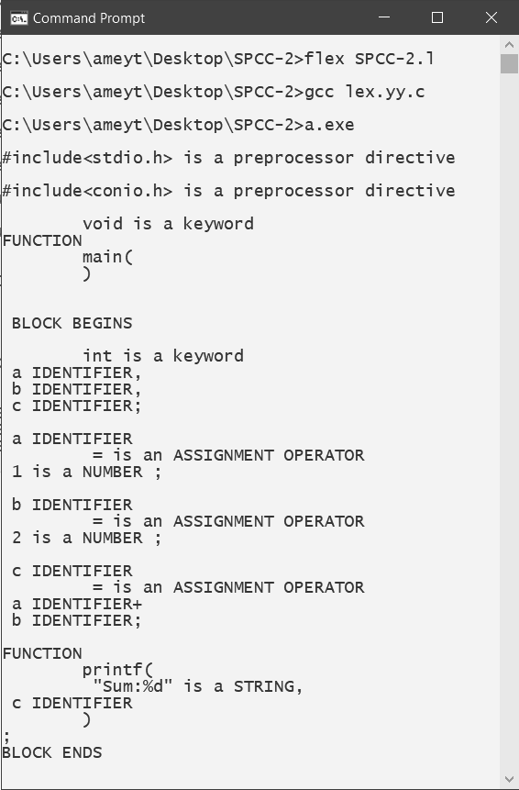

**B.3 Observations and learning:**

***(Students are expected to comment on the output obtained with clear observations and learning for each task/ subpart assigned)***

Lexical analysis is the first phase of a compiler. It takes the modified source code from language preprocessors that are written in the form of sentences. The lexical analyzer breaks these syntaxes into a series of tokens, by removing any whitespace or comments in the source code.

**B.4 Conclusion:**

***(Students must write the conclusion as per the attainment of individual outcome listed above and learning/observation noted in section B.3)***

Thus we have studied lexical analyzer which is used for lexical analysis and have successfully implemented lexical analyzer using c language

**B.5 Question of Curiosity**

***(To be answered by a student based on the practical performed and learning/ observations)***

1. What is a token?

Ans:

* A token is the smallest element(character) of a computer language program that is meaningful to the compiler. The parser has to recognize these as tokens: identifiers, keywords, literals, operators, punctuators, and other separators.
* A stream of these tokens makes up a translation to ASM or in some cases a Low-Level Language as C.
* Sample of C++ Tokens below.

KeyWords.

1. for,if,else,while,etc.

Source Token Characters For Reserved Words or Operators)

1. a b c d e f g h i j k l m n o p q r s t u v w x y z
2. A B C D E F G H I J K L M N O P Q R S T U V W X Y Z
3. 0 1 2 3 4 5 6 7 8 9
4. _ { } [ ] # ( ) < > % : ; . ? * + - / ^ & | ~ ! = , \ " '

Identifiers —(Variable Names).

1. _ a b c d e f g h i j k l m
2. n o p q r s t u v w x y z
3. A B C D E F G H I J K L M
4. N O P Q R S T U V W X Y Z
5. 1,2,3,4,5,6,7,8,9 ZERO-"0"- IS NOT ALLOWED IN IDENTIFIERS BUT SOME LANGUAGES CONVERT THESE TO A LETTER OR NUMBER IN THE COMPILER
6. C++ Language recognizes all character sets in Japanese.

Unicode. (Examples)

1. 00A8, 00AA, 00AD, 00AF, 00B2-00B5, 00B7-00BA, 00BC-00BE, 00C0-00D6, 00D8-00F6, 00F8-00FF, 0100-02FF, 0370-167F, 1681-180D, 180F-1DBF, 1E00-1FFF, 200B-200D, 202A-202E, 203F-2040, 2054, 2060-206F, 2070-20CF, 2100-218F, 2460-24FF, 2776-2793, 2C00-2DFF, 2E80-2FFF, 3004-3007, 3021-302F, 3031-303F, 3040-D7FF, F900-FD3D, FD40-FDCF, FDF0-FE1F, FE30-FE44, FE47-FFFD, 10000-1FFFD, 20000-2FFFD, 30000-3FFFD, 40000-4FFFD, 50000-5FFFD, 60000-6FFFD, 70000-7FFFD, 80000-8FFFD, 90000-9FFFD, A0000-AFFFD, B0000-BFFFD, C0000-CFFFD, D0000-DFFFD, E0000-EFFFD

Separators.

1. \s, \n, \t, \r,etc.

Comments.

1. /* comment */
2. or
3. // comment
4. What is the role of the lexical analyzer?

Ans:

The lexical analyzer performs below given tasks:

* Helps to identify token into the symbol table
* Removes white spaces and comments from the source program
* Correlates error messages with the source program
* Helps you to expands the macros if it is found in the source program
* Read input characters from the source program

1. What is the output of the Lexical analyzer?

Ans:

The lexical analysis produces a stream of tokens as output, which consists of identifier, keywords, separator, operator, and literals.

1. Which errors can be detected by Lexical Analyzer?

Ans:

* Spelling error.
* Exceeding the length of an identifier or numeric constants.
* The appearance of illegal characters.
* To remove the character that should be present.
* To replace a character with an incorrect character.
* Transposition of two characters.