**PART B**

**EXPERIMENT NUMBER 3**

**Aim:** To implement the program to remove left recursion from grammar and find first and follow the given grammar.

**(PART B: TO BE COMPLETED BY STUDENTS)**

***(Students must submit the soft copy as per the following segments within two hours of the practical. The soft copy must be uploaded at the end of the practical)***

|  |  |
| --- | --- |
| **Roll No.** 50 | **Name:** AMEY THAKUR |
| **Class:** Comps TE B | **Batch:** B3 |
| **Date of Experiment:** 05/03/2021 | **Date of Submission:** 05/03/2021 |
| **Grade:** |  |

**B.1 Software Code written by a student:**

***(Paste your code completed during the 2 hours of practice in the lab here)***

* **LEFT_RECURSION.C**

#include<stdio.h>

#include<string.h>

int i,j,l,m,n=0,o,p,nv,z=0,x=0;

char str[10],temp,temp2[10],temp3[20],*ptr;

struct prod

{

char lhs[10],rhs[10][10],ft[10],fol[10];

int n;

}pro[10];

void findter()

{

int k,t;

for(k=0;k<n;k++)

{

if(temp==pro[k].lhs[0])

{

for(t=0;t<pro[k].n;t++)

{

if( pro[k].rhs[t][0]<65 || pro[k].rhs[t][0]>90 )

pro[i].ft[strlen(pro[i].ft)]=pro[k].rhs[t][0];

else if( pro[k].rhs[t][0]>=65 && pro[k].rhs[t][0]<=90 )

{

temp=pro[k].rhs[t][0];

if(temp=='S')

pro[i].ft[strlen(pro[i].ft)]='#';

findter();

}

}

break;

}

}

}

void findfol()

{

int k,t,p1,o1,chk;

char *ptr1;

for(k=0;k<n;k++)

{

chk=0;

for(t=0;t<pro[k].n;t++)

{

ptr1=strchr(pro[k].rhs[t],temp);

if( ptr1 )

{

p1=ptr1-pro[k].rhs[t];

if(pro[k].rhs[t][p1+1]>=65 && pro[k].rhs[t][p1+1]<=90)

{

for(o1=0;o1<n;o1++)

if(pro[o1].lhs[0]==pro[k].rhs[t][p1+1])

{

strcat(pro[i].fol,pro[o1].ft);

chk++;

}

}

else if(pro[k].rhs[t][p1+1]=='\0')

{

temp=pro[k].lhs[0];

if(pro[l].rhs[j][p]==temp)

continue;

if(temp=='S')

strcat(pro[i].fol,"$");

findfol();

chk++;

}

else

{

pro[i].fol[strlen(pro[i].fol)]=pro[k].rhs[t][p1+1];

chk++;

}

}

}

if(chk>0)

break;

}

}

int main()

{

FILE *f;

//clrscr();

for(i=0;i<10;i++)

pro[i].n=0;

f=fopen("SPCC-3.txt","r"); //READ this txt file

while(!feof(f))

{

fscanf(f,"%s",pro[n].lhs);

if(n>0)

{

if( strcmp(pro[n].lhs,pro[n-1].lhs) == 0 )

{

pro[n].lhs[0]='\0';

fscanf(f,"%s",pro[n-1].rhs[pro[n-1].n]);

pro[n-1].n++;

continue;

}

}

fscanf(f,"%s",pro[n].rhs[pro[n].n]);

pro[n].n++;

n++;

}

printf("\n\nTHE GRAMMAR IS AS FOLLOWS\n\n");

for(i=0;i<n;i++)

for(j=0;j<pro[i].n;j++)

printf("%s = %s\n",pro[i].lhs,pro[i].rhs[j]);

pro[0].ft[0]='#';

for(i=0;i<n;i++)

{

for(j=0;j<pro[i].n;j++)

{

if( pro[i].rhs[j][0]<65 || pro[i].rhs[j][0]>90 )

{

pro[i].ft[strlen(pro[i].ft)]=pro[i].rhs[j][0];

}

else if( pro[i].rhs[j][0]>=65 && pro[i].rhs[j][0]<=90 )

{

temp=pro[i].rhs[j][0];

if(temp=='S')

pro[i].ft[strlen(pro[i].ft)]='#';

findter();

}

}

}

printf("\n\nFIRST\n");

for(i=0;i<n;i++)

{

printf("\n%s = ",pro[i].lhs);

for(j=0;j<strlen(pro[i].ft);j++)

{

for(l=j-1;l>=0;l--)

if(pro[i].ft[l]==pro[i].ft[j])

break;

if(l==-1)

printf("%c",pro[i].ft[j]);

}

}

for(i=0;i<n;i++)

temp2[i]=pro[i].lhs[0];

pro[0].fol[0]='$';

for(i=0;i<n;i++)

{

for(l=0;l<n;l++)

{

for(j=0;j<pro[i].n;j++)

{

ptr=strchr(pro[l].rhs[j],temp2[i]);

if( ptr )

{

p=ptr-pro[l].rhs[j];

if(pro[l].rhs[j][p+1]>=65 && pro[l].rhs[j][p+1]<=90)

{

for(o=0;o<n;o++)

if(pro[o].lhs[0]==pro[l].rhs[j][p+1])

strcat(pro[i].fol,pro[o].ft);

}

else if(pro[l].rhs[j][p+1]=='\0')

{

temp=pro[l].lhs[0];

if(pro[l].rhs[j][p]==temp)

continue;

if(temp=='S')

strcat(pro[i].fol,"$");

findfol();

}

else

pro[i].fol[strlen(pro[i].fol)]=pro[l].rhs[j][p+1];

}

}

}

}

printf("\n\nFOLLOW\n");

for(i=0;i<n;i++)

{

printf("\n%s = ",pro[i].lhs);

for(j=0;j<strlen(pro[i].fol);j++)

{

for(l=j-1;l>=0;l--)

if(pro[i].fol[l]==pro[i].fol[j])

break;

if(l==-1)

printf("%c",pro[i].fol[j]);

}

}

printf("\n");

//getch();

}

* **SPCC-3.TXT**

S ABCDE

A a|0

B b|0

C c

D d|0

E e|0

**B.2 Input and Output:**

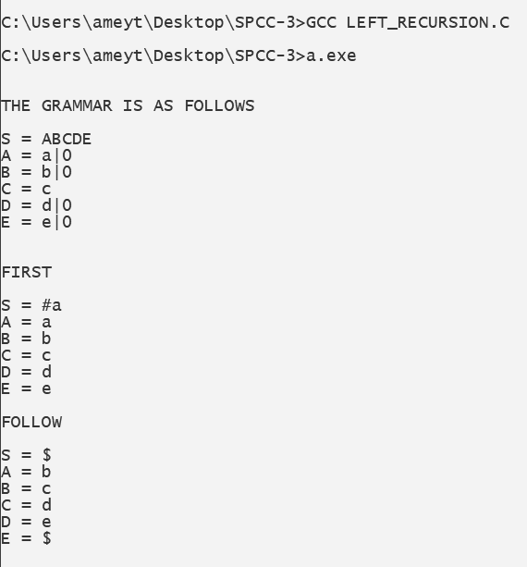

**B.3 Observations and learning:**

***(Students are expected to comment on the output obtained with clear observations and learning for each task/ subpart assigned)***

Thus we observed the method to remove left recursion along with various types of recursion also various other methods.

**B.4 Conclusion:**

***(Students must write the conclusion as per the attainment of individual outcome listed above and learning/observation noted in section B.3)***

Thus we have studied various recursions to be removed from the given grammar.

**B.5 Question of Curiosity**

***(To be answered by a student based on the practical performed and learning/ observations)***

1. What is the need for a Predictive parser?

Ans:

* The goal of predictive parsing is to construct a top-down parser that never backtracks. To do so, we must transform grammar in two ways:

1. Eliminate left recursion, and
2. Perform left factoring.

* These rules eliminate most common causes for backtracking although they do not guarantee a completely backtrack-free parsing

1. Difference between top-down and bottom-up parser?

Ans:

|  |  |  |  |
| --- | --- | --- | --- |
| **Sr. No.** | **Key** | **Top-Down Parsing** | **Bottom-Up Parsing** |
| **1** | **Strategy** | The top-down approach starts evaluating the parse tree from the top and moves downwards for parsing other nodes. | The bottom-up approach starts evaluating the parse tree from the lowest level of the tree and moves upwards for parsing the node. |
| **2** | **Attempt** | Top-down parsing attempts to find the leftmost derivation for a given string. | Bottom-up parsing attempts to reduce the input string to the first symbol of the grammar. |
| **3** | **Derivation Type** | Top down parsing uses leftmost derivation. | Bottom-up parsing uses the rightmost derivation. |
| **4** | **Objective** | Top down parsing searches for a production rule to be used to construct a string. | Bottom-up parsing searches for a production rule to be used to reduce a string to get a starting symbol of the grammar. |

1. Why is there a necessity of removing a left recursion?

Ans:

* Left recursion often poses problems for parsers, either because it leads them into infinite recursion (as in the case of most top-down parsers) or because they expect rules in a normal form that forbids it (as in the case of many bottom-up parsers, including the CYK algorithm). Therefore, grammar is often preprocessed to eliminate the left recursion.