**PART B**

**EXPERIMENT NUMBER 5**

**Aim:** Write a program to implement any code optimization techniques.

**(PART B: TO BE COMPLETED BY STUDENTS)**

***(Students must submit the soft copy as per the following segments within two hours of the practical. The soft copy must be uploaded at the end of the practical)***

|  |  |
| --- | --- |
| **Roll No.** 50 | **Name:** AMEY THAKUR |
| **Class:** Comps TE B | **Batch:** B3 |
| **Date of Experiment:** 30/03/2021 | **Date of Submission:** 30/03/2021 |
| **Grade:** |  |

**B.1 Software Code written by a student:**

***(Paste your code completed during the 2 hours of practice in the lab here)***

* **SPCC-5.C**

#include<stdio.h>

#include<conio.h>

#include<string.h>

struct op

{

char l;

char r[20];

}

op[10],pr[10];

int main()

{

int a,i,k,j,n,z=0,m,q;

char *p,*l;

char temp,t;

char *tem;

printf("ENTER THE NUMBER OF VALUES: ");

scanf("%d",&n);

for(i=0;i<n;i++)

{

printf("LEFT: ");

scanf(" %c",&op[i].l);

printf("RIGHT: ");

scanf(" %s",&op[i].r);

}

printf("INTERMEDIATE CODE\n") ;

for(i=0;i<n;i++)

{

printf("%c=",op[i].l);

printf("%s\n",op[i].r);

}

for(i=0;i<n-1;i++)

{

temp=op[i].l;

for(j=0;j<n;j++)

{

p=strchr(op[j].r,temp);

if(p)

{

pr[z].l=op[i].l;

strcpy(pr[z].r,op[i].

r);

z++;

}

}

}

pr[z].l=op[n-1].l;

strcpy(pr[z].r,op[n-1].r);

z++;

printf("\nAFTER DEAD CODE ELIMINATION\n");

for(k=0;k<z;k++)

{

printf("%c\t=",pr[k].l);

printf("%s\n",pr[k].r);

}

for(m=0;m<z;m++)

{

tem=pr[m].r;

for(j=m+1;j<z;j++)

{

p=strstr(tem,pr[j].r);

if(p)

{

t=pr[j].l;

pr[j].l=pr[m].l;

for(i=0;i<z;i++)

{

l=strchr(pr[i].r,t) ;

if(l)

{

a=l-pr[i].r;

printf("pos: %d\n",a);

pr[i].r[a]=pr[m].l;

}}}}}

printf("ELIMINATE COMMON EXPRESSION\n");

for(i=0;i<z;i++)

{

printf("%c\t=",pr[i].l);

printf("%s\n",pr[i].r);

}

for(i=0;i<z;i++)

{

for(j=i+1;j<z;j++)

{

q=strcmp(pr[i].r,pr[j].r);

if((pr[i].l==pr[j].l)&&!q)

{

pr[i].l='\0';

}

}

}

printf("OPTIMIZED CODE\n");

for(i=0;i<z;i++)

{

if(pr[i].l!='\0')

{

printf("%c=",pr[i].l);

printf("%s\n",pr[i].r);

}

}

}

**B.2 Input and Output:**

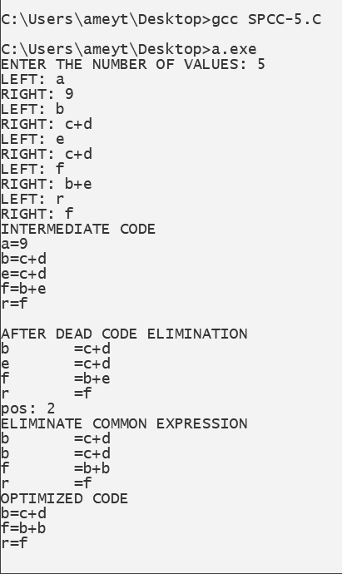

**B.3 Observations and learning:**

***(Students are expected to comment on the output obtained with clear observations and learning for each task/ subpart assigned)***

Hence we learnt and observed the various code optimization techniques.

**B.4 Conclusion:**

***(Students must write the conclusion as per the attainment of individual outcome listed above and learning/observation noted in section B.3)***

Hence we can implement various code optimization techniques like dead code and common subexpression. The implementation of common sub-expression elimination is done and the output of the same is given above.

**B.5 Question of Curiosity**

***(To be answered by a student based on the practical performed and learning/ observations)***

1. What are the types of block transformation?

Ans:

There are two types of basic block optimization. These are as follows:

1. **Structure preserving transformations:**

The primary Structure-Preserving Transformation on basic blocks is as follows:

* 1. **Common subexpression elimination:**

In the common sub-expression, you don't need to be computed over and over again. Instead of this you can compute it once and keep it in-store from where it's referenced when encountered again.

a : = b + c

b : = a - d

c : = b + c

d : = a - d

In the above expression, the second and forth expression computed the same expression. So the block can be transformed as follows:

a : = b + c

b : = a - d

c : = b + c

d : = b

* 1. **Dead-code elimination:**

A program may contain a large amount of dead code.

This can be caused when once declared and defined and forget to remove them in this case they serve no purpose.

Suppose the statement x:= y + z appears in a block and x is a dead symbol that means it will never subsequently be used. Then without changing the value of the basic block you can safely remove this statement.

* 1. **Renaming temporary variables:**

A statement t:= b + c can be changed to u:= b + c where t is a temporary variable and u is a new temporary variable. All the instances of t can be replaced with u without changing the basic block value.

* 1. **Interchange of the statement:**

Suppose a block has the following two adjacent statements:

t1 : = b + c

t2 : = x + y

These two statements can be interchanged without affecting the value of the block when the value of t1 does not affect the value of t2.

1. **Algebraic transformations:**

In the algebraic transformation, we can change the set of expressions into an algebraically equivalent set. Thus the expression x:= x + 0 or x:= x *1 can be eliminated from a basic block without changing the set of expressions.

Constant folding is a class of related optimization. Here at compile-time, we evaluate constant expressions and replace the constant expression with their values. Thus the expression 5*2.7 would be replaced by13.5.

Sometimes the unexpected common subexpression is generated by the relational operators like <=, >=, <, >, +, = etc.

Sometimes the associative expression is applied to expose common subexpression without changing the basic block value. if the source code has the assignments

a:= b + c

e:= c +d +b

The following intermediate code may be generated:

a:= b + c

t:= c +d

e:= t + b

1. State the Normal form of Block.

Ans:

* In compiler construction, a basic block is a straight-line code sequence with no branches in except to the entry and no branches out except at the exit. This restricted form makes a basic block highly amenable to analysis.Compilers usually decompose programs into their basic blocks as a first step in the analysis process. Basic blocks form the vertices or nodes in a control flow graph.
* The code in a basic block has:
* One [entry point](https://en.wikipedia.org/wiki/Entry_point), meaning no code within it is the destination of a [jump instruction](https://en.wikipedia.org/wiki/Jump_instruction) anywhere in the program.
* One exit point, meaning only the last instruction can cause the program to begin executing code in a different basic block.