**PART B**

**EXPERIMENT NUMBER 6**

**Aim:** Write a program to generate the target code.

**(PART B: TO BE COMPLETED BY STUDENTS)**

***(Students must submit the soft copy as per the following segments within two hours of the practical. The soft copy must be uploaded at the end of the practical)***

|  |  |
| --- | --- |
| **Roll No.** 50 | **Name:** AMEY THAKUR |
| **Class:** Comps TE B | **Batch:** B3 |
| **Date of Experiment:** 09/04/2021 | **Date of Submission:** 09/04/2021 |
| **Grade:** |  |

**B.1 Software Code written by a student:**

***(Paste your code completed during the 2 hours of practice in the lab here)***

* **SPCC-6.C**

#include<stdio.h>

#include<conio.h>

#include<string.h>

int main()

{

char A[12][12]={"T=A B","X=T"};

char B;

int OP=0;

printf("MOV %c,R1\n",A[0][2]);

printf("MOV %c,R2\n",A[0][4]);

B=A[0][3];

printf("THERE ARE TWO EXPRESSIONS: \n1.T=A OP B\n2.X=T\nCHOOSE THE OP VALUE FROM OPTION\n1.+\n2.-\n3.*\n4./\n");

scanf("%d",&OP);

switch(OP)

{

case 1:

printf("ADD R1,R2\n");

break;

case 2:

printf("SUB R1,R2\n");

break;

case 3:

printf("MUL R1,R2\n");

break;

case 4:

printf("DIV R1,R2\n");

break;

default:

break;

}

printf("MOV R1,x");

getch();

}

**B.2 Input and Output:**

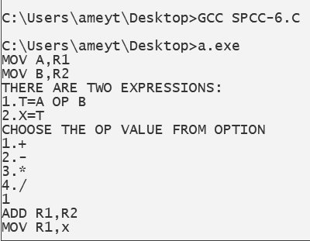

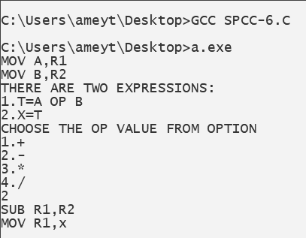

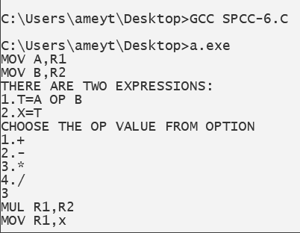

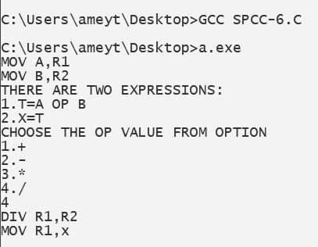

**B.3 Observations and learning:**

***(Students are expected to comment on the output obtained with clear observations and learning for each task/ subpart assigned)***

Target code could be easily generated by making use of the switch case.

**B.4 Conclusion:**

***(Students must write the conclusion as per the attainment of individual outcome listed above and learning/observation noted in section B.3)***

We implemented a program to generate target code understood intermediate code generation and code generation phase of the compiler

**B.5 Question of Curiosity**

***(To be answered by a student based on the practical performed and learning/ observations)***

1. **Differentiate Between Machine Dependent and Machine Independent code optimization.**

**Ans:**

The main difference between both is that the machine-dependent optimization is applied to the object code and the independent code optimization is applied to the intermediate code.

* Machine code depends on specific features of the computer to which it was written. Independent computer or portable code includes less and, preferably, no such dependency.
* Machine-based optimization requires CPU registers and absolute memory references, while CPU registers or absolute memory references are not used in machine-independent code optimization.

1. **Describe Peephole Optimization.**

**Ans:**

* Peephole optimization is a type of Code Optimization performed on a small part of the code. It is performed on a very small set of instructions in a segment of code.
* *The small set of instructions or a small part of the code on which peephole optimization is performed is known as* ***peephole*** *or* ***window****.*
* It works on the theory of replacement in which a part of code is replaced by shorter and faster code without change in output. The peephole is machine-dependent optimization.
* The objective of peephole optimization is:

1. To improve performance
2. To reduce memory footprint
3. To reduce code size

**Peephole Optimization Techniques:**

1. Redundant load and store elimination:

In this technique, redundancy is eliminated.  
 Initial code:  
 y = x + 5;  
 i = y;  
 z = i;  
 w = z * 3;  
 Optimized code:  
 y = x + 5;  
 i = y;  
 w = y * 3;

1. Constant folding:

The code that can be simplified by the user itself, is simplified.  
 Initial code:  
 x = 2 * 3;  
 Optimized code:  
 x = 6;

1. Strength Reduction:

The operators that consume higher execution time are replaced by the operators consuming less execution time.  
 Initial code:  
 y = x * 2;  
 Optimized code:  
 y = x + x; or y = x << 1;  
 Initial code:  
 y = x / 2;  
 Optimized code:  
 y = x >> 1;

1. Null sequences:  
    Useless operations are deleted.
2. Combine operations:  
    Several operations are replaced by a single equivalent operation.