**PART B**

**EXPERIMENT NUMBER 7**

**Aim:** To design and implement the first pass of a two-pass assembler for IBM 360/370 Processor.

**(PART B: TO BE COMPLETED BY STUDENTS)**

***(Students must submit the soft copy as per the following segments within two hours of the practical. The soft copy must be uploaded at the end of the practical)***

|  |  |
| --- | --- |
| **Roll No.** 50 | **Name:** AMEY THAKUR |
| **Class:** Comps TE B | **Batch:** B3 |
| **Date of Experiment:** 30/04/2021 | **Date of Submission:** 30/04/2021 |
| **Grade:** |  |

**B.1 Software Code written by a student:**

***(Paste your code completed during the 2 hours of practice in the lab here)***

* **SPCC-7.C**

#include<stdio.h>

#include<string.h>

#include <stdlib.h>

int main()

{

FILE *f1,*f2,*f3,*f4;

int lc,sa,l,op1,o,len;

char m1[20],la[20],op[20],otp[20];

f1=fopen("INPUT.txt","r");

f3=fopen("SYMTAB.txt","w");

fscanf(f1,"%s %s %d",la,m1,&op1);

if(strcmp(m1,"START")==0)

{

sa=op1;

lc=sa;

printf("\t%s\t%s\t%d\n",la,m1,op1);

}

else

lc=0;

fscanf(f1,"%s %s",la,m1);

while(!feof(f1))

{

fscanf(f1,"%s",op);

printf("\n%d\t%s\t%s\t%s\n",lc,la,m1,op);

if(strcmp(la,"-")!=0)

{

fprintf(f3,"\n%d\t%s\n",lc,la);

}

f2=fopen("OPTAB.txt","r");

fscanf(f2,"%s %d",otp,&o);

while(!feof(f2))

{

if(strcmp(m1,otp)==0)

{

lc=lc+3;

break;

}

fscanf(f2,"%s %d",otp,&o);

}

fclose(f2);

if(strcmp(m1,"WORD")==0)

{

lc=lc+3;

}

else if(strcmp(m1,"RESW")==0)

{

op1=atoi(op);

lc=lc+(3*op1);

}

else if(strcmp(m1,"BYTE")==0)

{

if(op[0]=='X')

lc=lc+1;

else

{

len=strlen(op)-2;

lc=lc+len;}

}

else if(strcmp(m1,"RESB")==0)

{

op1=atoi(op);

lc=lc+op1;

}

fscanf(f1,"%s%s",la,m1);

}

if(strcmp(m1,"END")==0)

{

printf("Program length =\n%d",lc-sa);

}

fclose(f1);

fclose(f3);

return 0;

}

* **INPUT.TXT**

copy START 1000

- LDA ALPHA

- ADD ONE

- SUB TWO

- STA BETA

ALPHA BYTE C'KLNCE

ONE RESB 2

TWO WORD 5

BETA RESW 1

_ END _

* **OPTAB.TXT**

LDA 00

STA 23

ADD 01

SUB 05

* **SYMTAB.TXT**

1012 ALPHA

1017 ONE

1019 TWO

1022 BETA

1025 _

**B.2 Input and Output:**

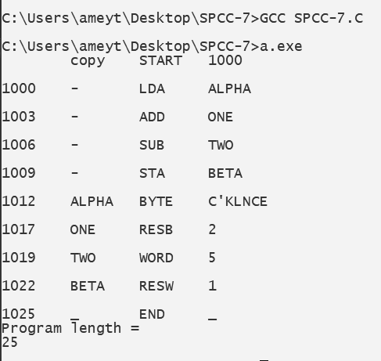

**B.3 Observations and learning:**

***(Students are expected to comment on the output obtained with clear observations and learning for each task/ subpart assigned)***

We have learnt about the two passes of the assembler and implemented the first pass.

**B.4 Conclusion:**

***(Students must write the conclusion as per the attainment of individual outcome listed above and learning/observation noted in section B.3)***

Hence, we have successfully implemented the program for the first pass of a two-pass assembler.

**B.5 Question of Curiosity**

***(To be answered by a student based on the practical performed and learning/ observations)***

1. Define Data Structures

Ans:

1. **Mnemonic Operation Table**

This table indicates the symbolic mnemonic for each instruction and its length.

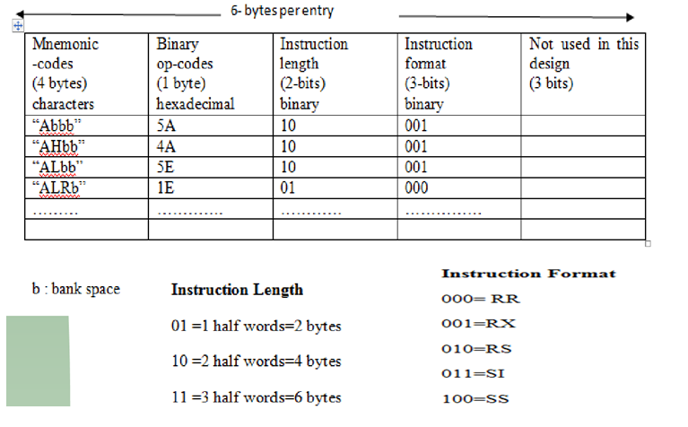

1. **Symbol Table**

It stores each label along with its value.

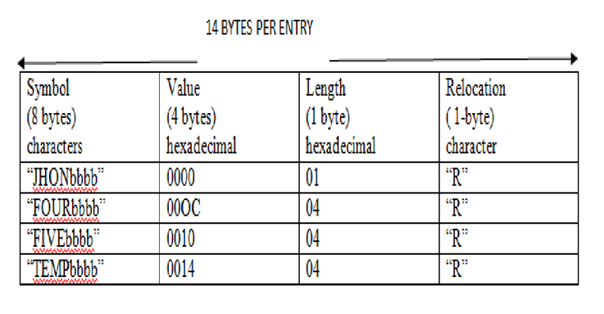

1. **Segment Register Table**

It stores information about the segment name and segment register.

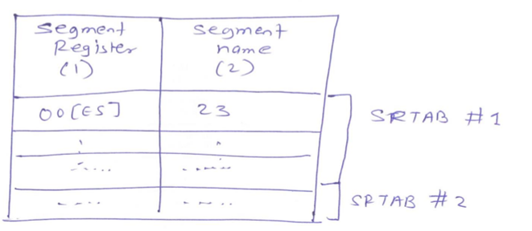

1. **Forward Reference Table**

It stores information about forwarding references.

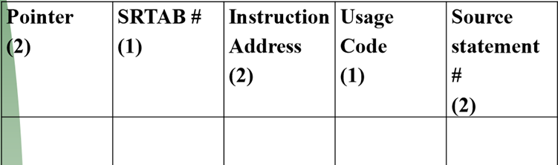

1. **Cross Reference Table**

It lists out all references to a symbol in ascending order of statements.

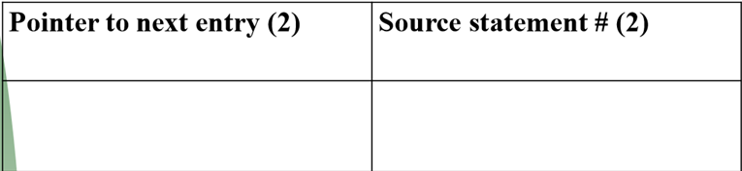

1. Comment on the Forward Reference Problem and Remedy.

Ans:

* In an assembly language program, we can use symbols which are the names associated with data or instructions.
* The symbols may be referred to before they are defined. This is called a forward reference.
* One approach to solve this problem is to have two passes over the source program. So the first pass just defines the symbols and the second pass finds the addresses.