**Assigment 2**

Working with EC2

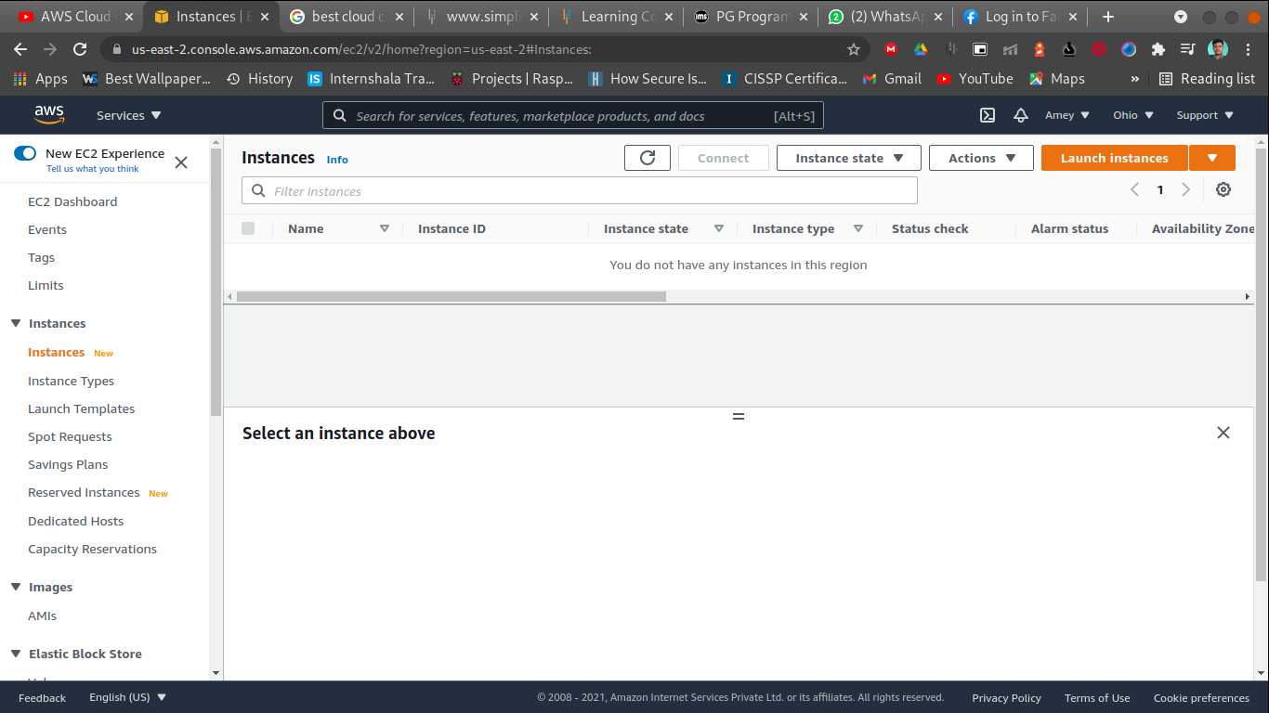

Creating an ec2 instance and display instance details

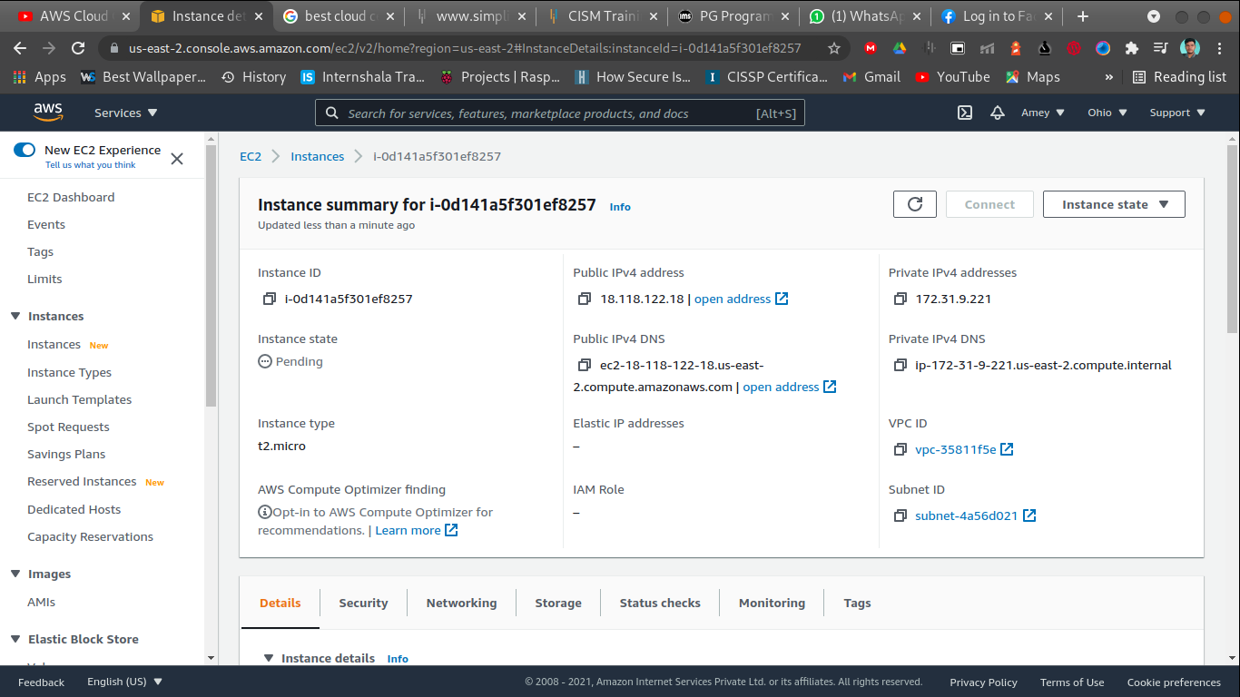

Enable termination protection

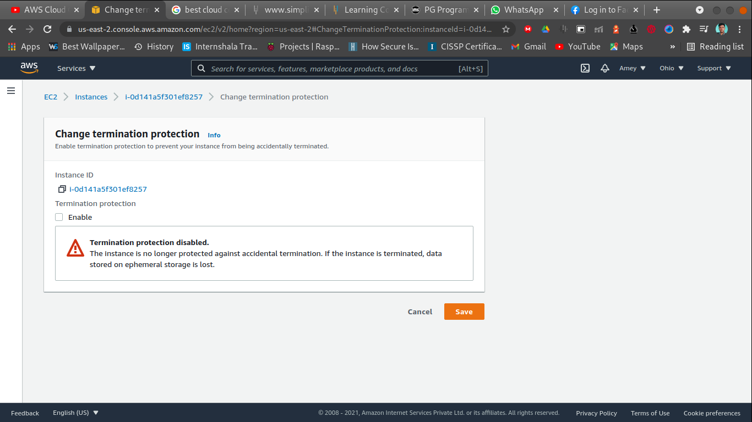

Terminate you instance after disabling termination protection

