**Assignment 3**

Deploying a sample application elastic beanstalk

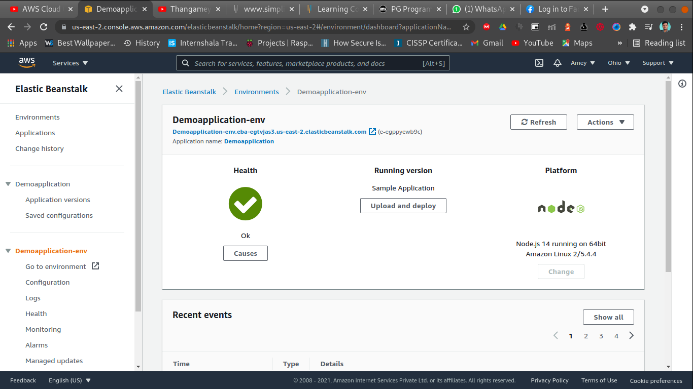

http://demoapplication-env.eba-egtvjas3.us-east-2.elasticbeanstalk.com/

Events

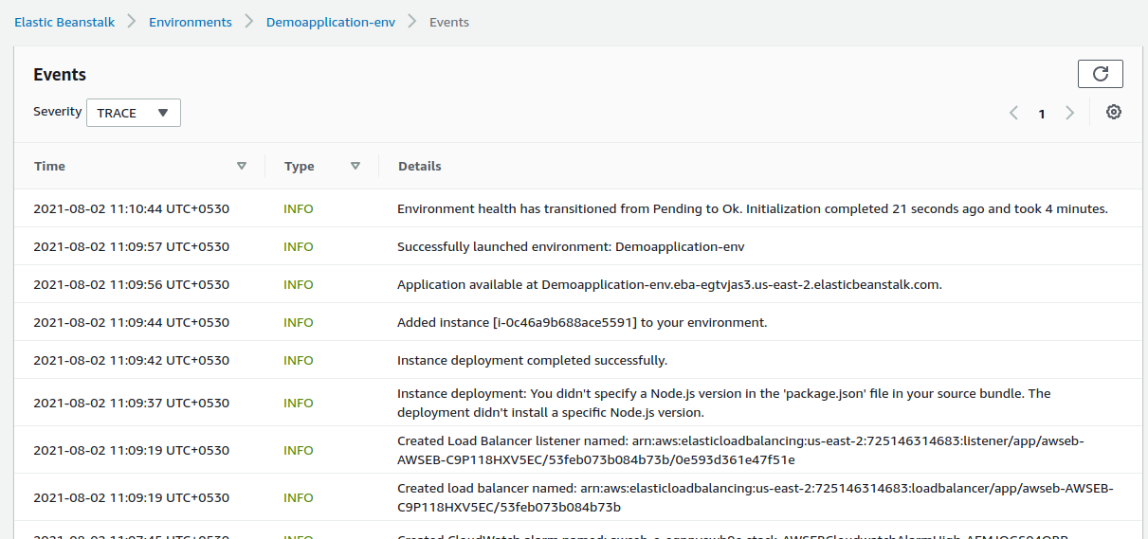

Enviroments

