Name: Amey Abhay Kelekar

Instructor Name: Kal Bugrara

Application Engineering Development INFO 5100

12/07/2014

**DIRECT DONATE SYSTEM**

**GIVE DIRECTLY: a radical new way to give: directly**

1. **Problem with current charity system**

Problems with current charity method

* Riddled with bureaucracy and corruption
* Chances of mismanagement of funds and fraud
* Sub-contractor / Middle man / third party problem

1. **Proposed Solution to the problem**

* A Donor Donates Money through Direct Donate Website.
* Direct Donate identifies recipient based on the government census data/ public records.
* Field team goes and collect the digital data of the recipient.
* The same data is verified by a supervisor to check the eligibility of the recipient.
* Direct donate System donate money electronically to the recipient
* Recipients collects the money from nearest vendor in their locality**.**
* Recipients are free to use the donation as per their wishes. No strings attached.

1. **Scope of the project**

By this system, donors can directly send money transfers to poor people without the involvement of any third party. The donors send cash via DDS website and all cash received is then directly transferred to the poor people. The donor can’t select to whom to send the money because that approach will lead to uneven distribution of wealth.

1. **Assumptions**

**3.a) General Assumptions**

* The recipient will not disclose his/her recipient ID and his credentials to anyone else.
* The system cannot restrict the recipient on how to use the donated money.
* The vendor, money transfer agent, field team and supervisor should have a good code of conduct and should not be corrupt.
* There should be at least one vendor in each and every remote places in Kenya and Uganda.

**3.b) Project related Assumptions**

* All the organizations need to be created by admin before running the system.
* Recipient is able to login and send request to the vendor to collect money.

1. **Business Model**

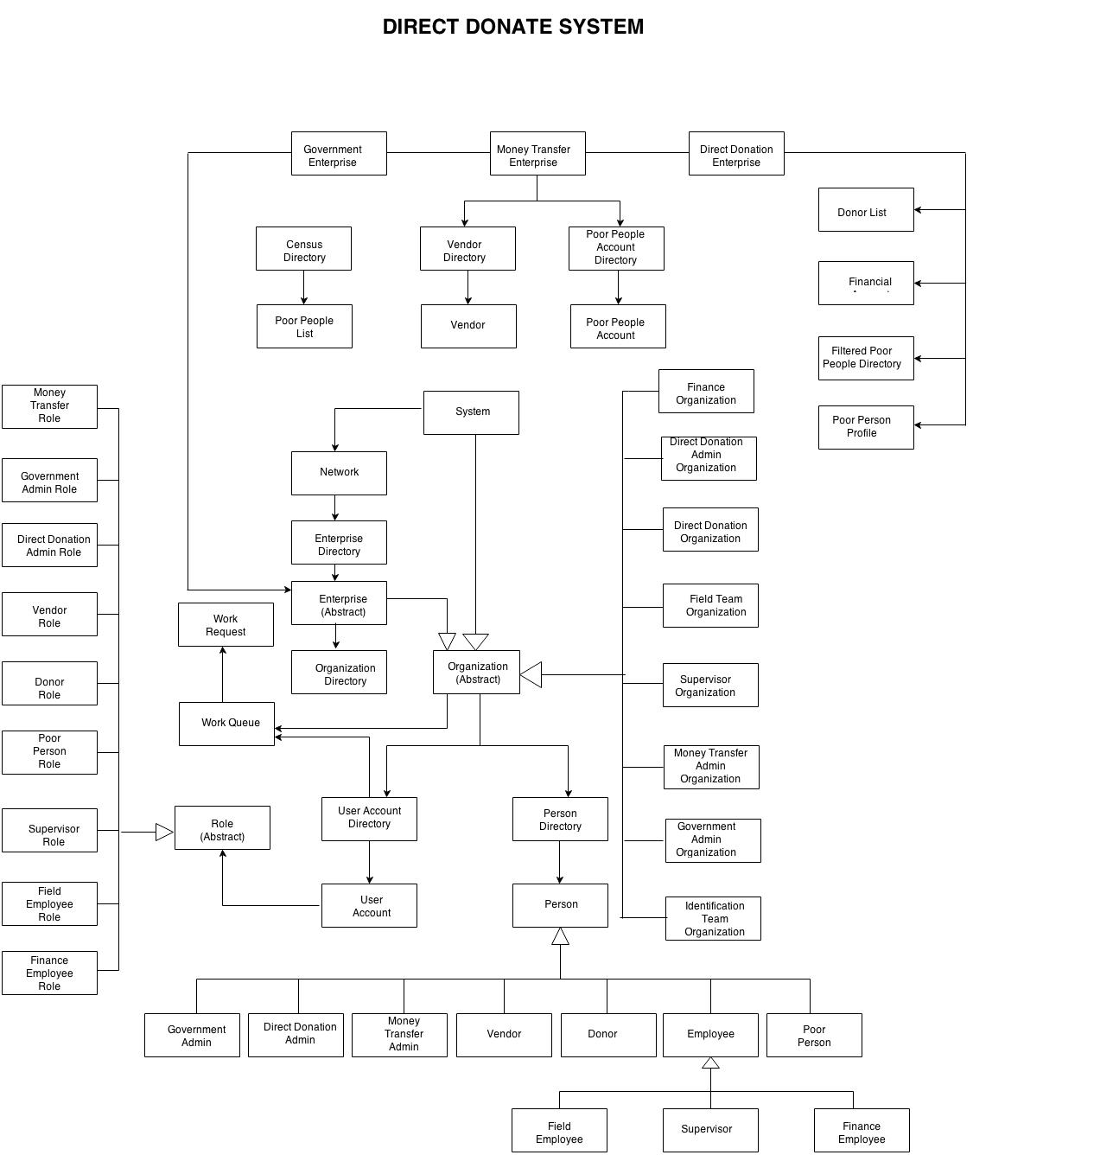

1. **Use Cases**

