DineDash Food Delivery Data Analysis
Azure Databricks Capstone Report
Prepared by
Amey Vishnu Mahajani
mahajaniameyvishnu@gmail.com

Project Background
The food delivery industry has experienced rapid growth over the last decade, driven by the increasing demand for convenience, improved delivery logistics, and the expansion of digital platforms. MealDash has revolutionized the way food is ordered and delivered, creating new opportunities for restaurant owners and consumers alike.
However, as the industry continues to expand, food delivery platforms face increasing competition, rising customer expectations for faster and more personalized services, and challenges in optimizing their operations across a diverse and extensive menu offering. The case study focuses on using big data and advanced analytics to streamline operations, optimize delivery times, enhance customer experience, and improve menu offerings.

Key Dataset Attributes
Customers: customer_id, name, email, signup_date.
Restaurants: restaurant_id, name, cuisine, location_id.
Menu Items: item_id, restaurant_id, item_name, price.
Orders: order_id, timestamp, customer_id, restaurant_id, agent_id, delivery_location_id, items_ordered, total_amount, tip, payment_method, order_status.
Delivery Agents: agent_id, name, phone, rating.

Proposed Solution Scope
The proposed architecture uses Databricks and Apache Spark with a data lake, ETL pipelines using Delta Live Tables/Lakeflow, streaming processing, and analytics dashboards. The executed work in this report focuses on ETL pipelines, streaming data analytics, dashboards, and workflow orchestration.

Business Needs
The case study identifies the need for data integration, real-time analytics, predictive analytics, optimization algorithms, personalization, and continuous KPI monitoring. This report documents the implemented data-engineering scope: ingestion, transformation, incremental processing, streaming analytics, data quality, dashboards, and workflow orchestration.

Key Challenges
1. Data Fragmentation: Different systems for orders, customer profiles, menus, and delivery logs lead to fragmented data, making it difficult to analyze information comprehensively.
2. Customer Segmentation: Understanding customer preferences from historical data is essential for personalized promotions, recommendations, and loyalty rewards.
3. Order Prediction: Predicting order volumes across regions and times helps optimize delivery capacity and reduce wait times.
4. Menu Optimization: Identifying popular and profitable menu items helps improve menu offerings and item combinations.
5. Order Fulfillment Delays: On-time delivery can be affected by traffic, weather, and restaurant preparation delays.
6. Promotions and Discounts: Effective offers should increase order value and repeat purchases while maintaining profitability.

DineDash Source Data Storage Structure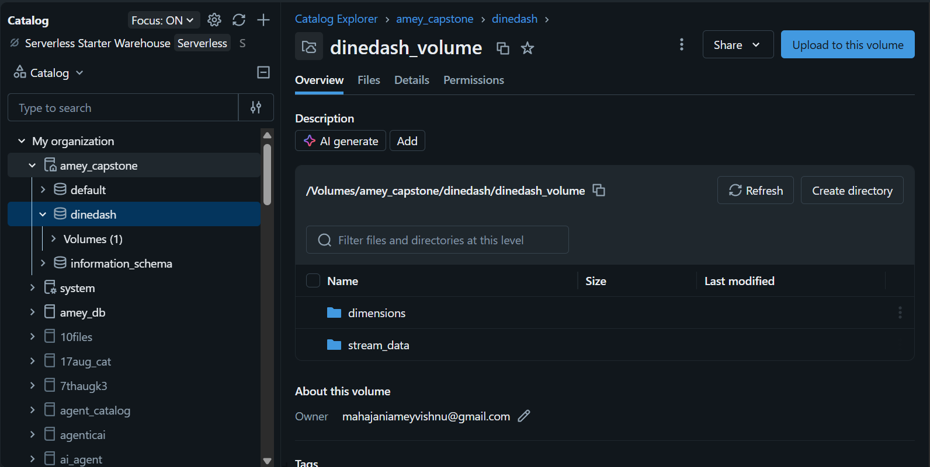
A Unity Catalog Volume was created for the DineDash project . Two directories, dimensions and stream_data, were created the Volume. The dimensions directory is used to store the customer, delivery-agent, location, menu-item, and restaurant datasets, while stream_data is used to store the monthly 2024 order JSON files. This structure provides a clear separation between dimension data and order data used for incremental processing.

Initial DineDash Source Data Upload

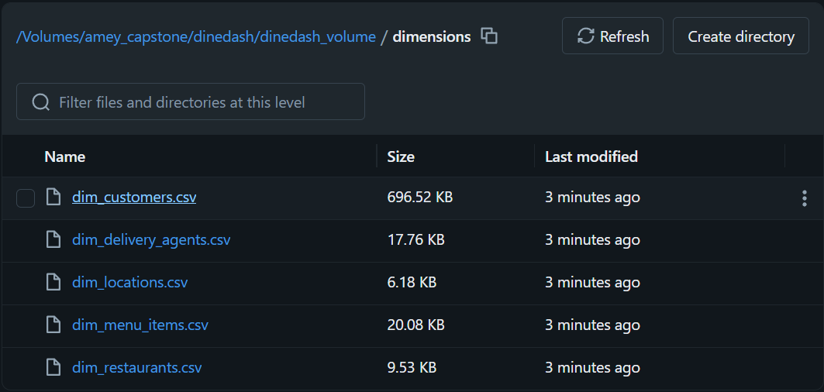
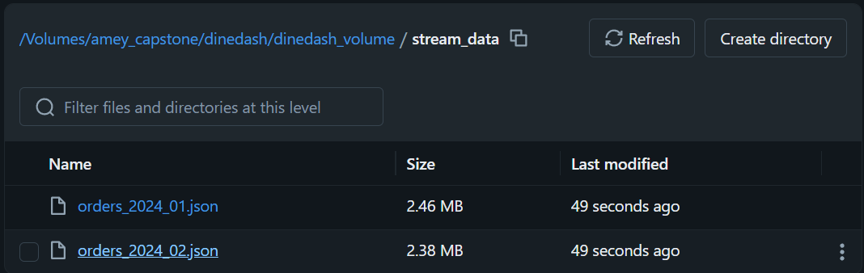
The initial source-data load contains the five-dimension datasets and the January and February 2024 order datasets. The remaining monthly order files are retained for subsequent incremental ingestion as specified in the project instructions.

Initial Data Exploration
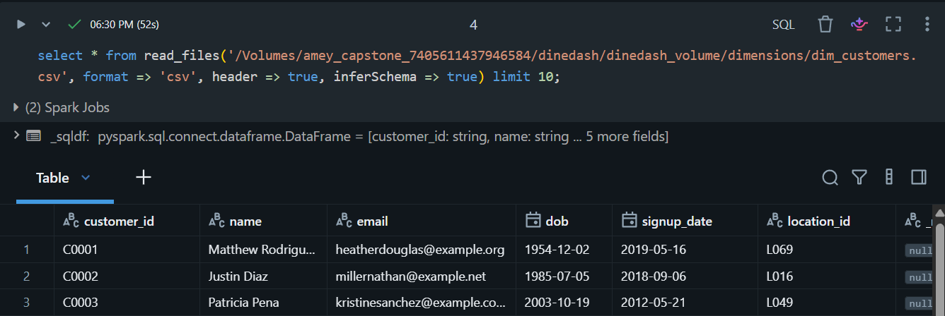
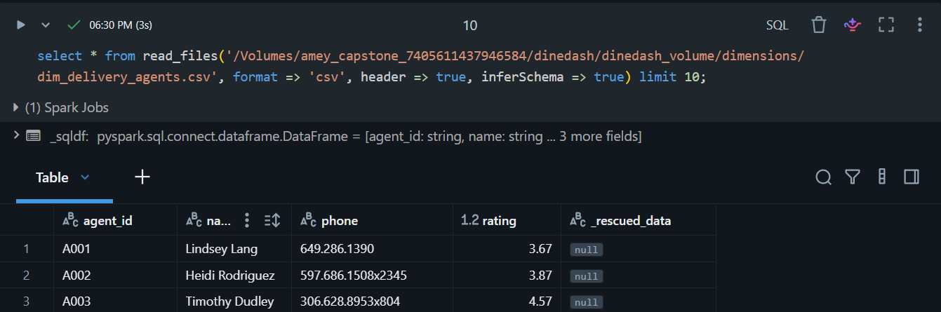
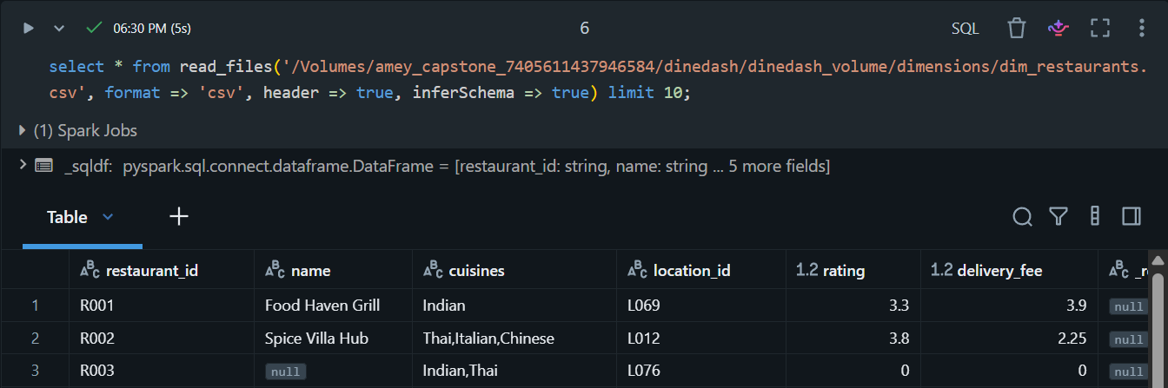
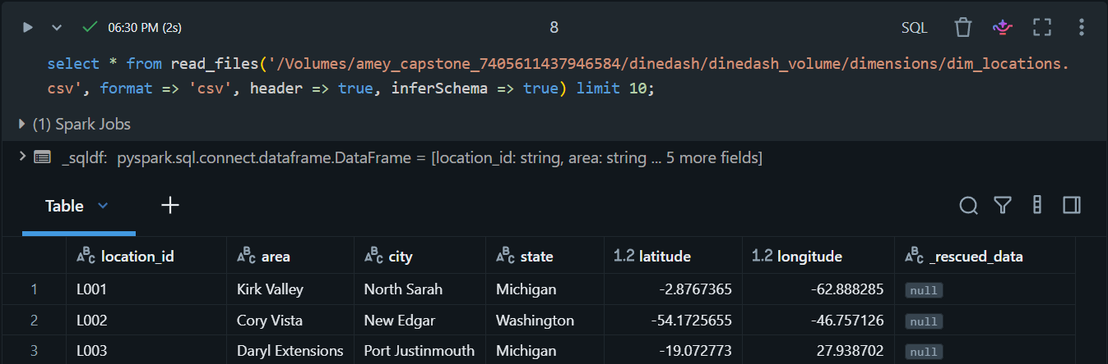
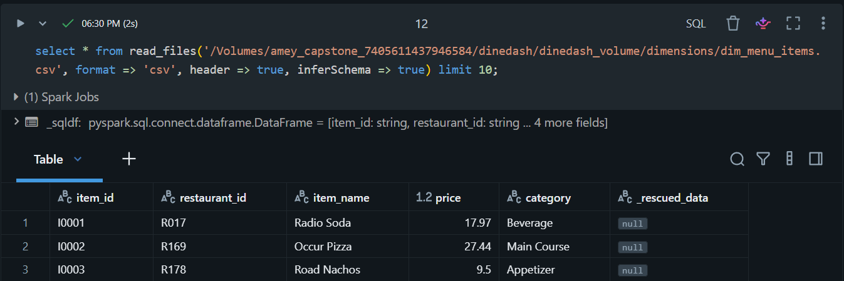
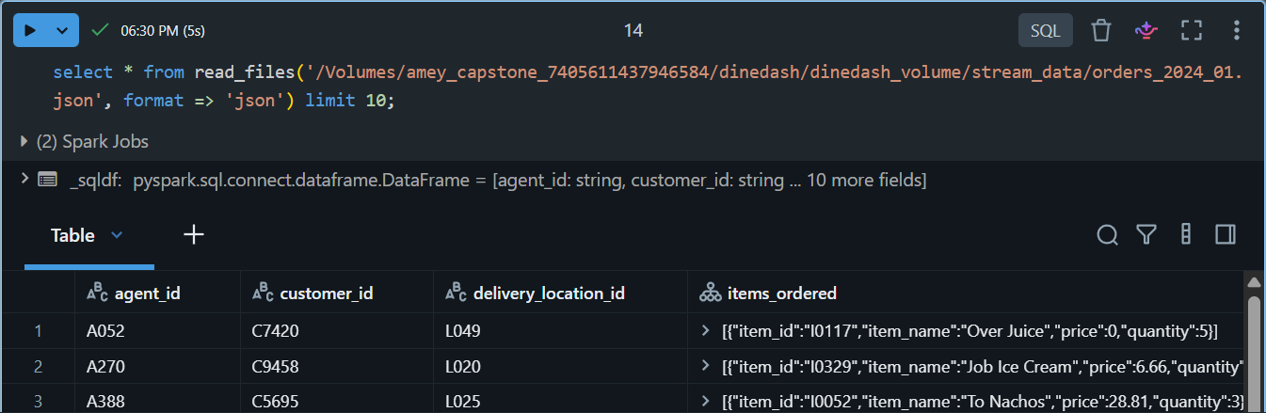

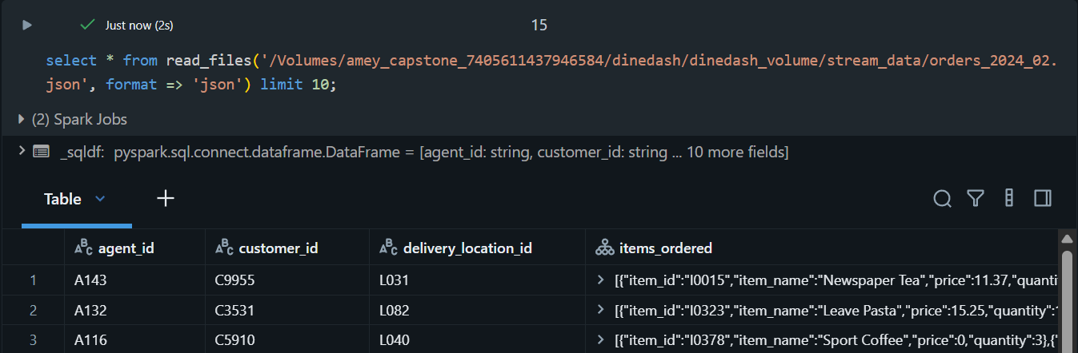
The source datasets were queried directly from the DineDash Volume before table creation. Ten sample records were displayed for the dimension datasets and order data to inspect the available columns, inferred data types, and nested order-item structure. The order dataset contains an items_ordered array, which is used later for item-level transformations and analysis.

DineDash Temporary Views

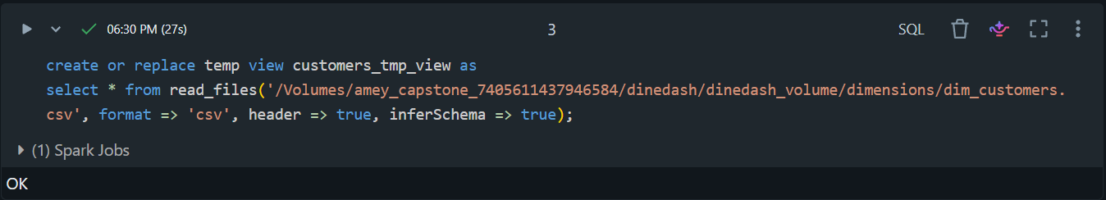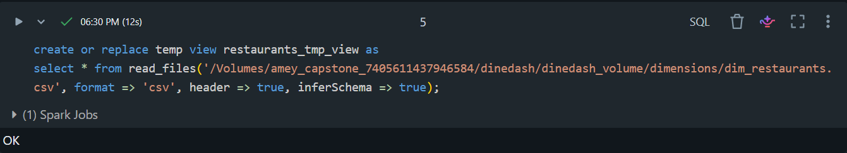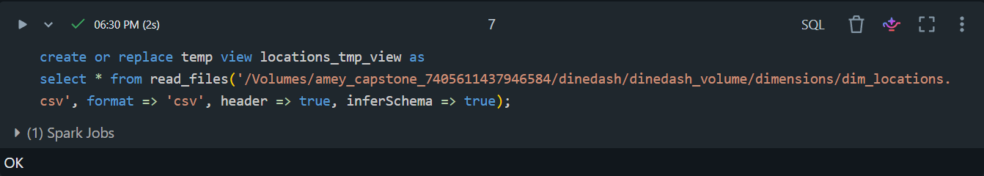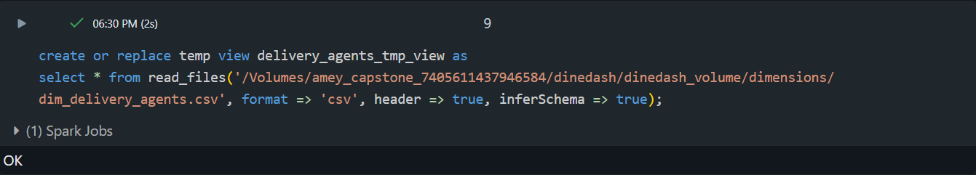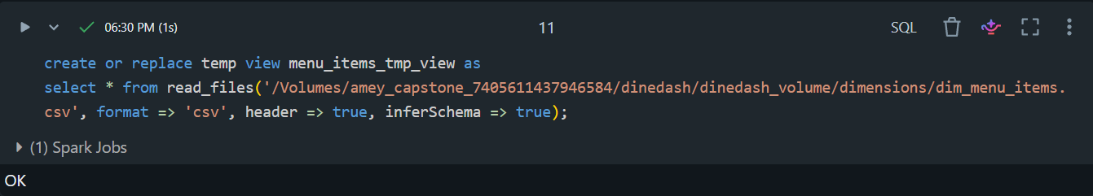

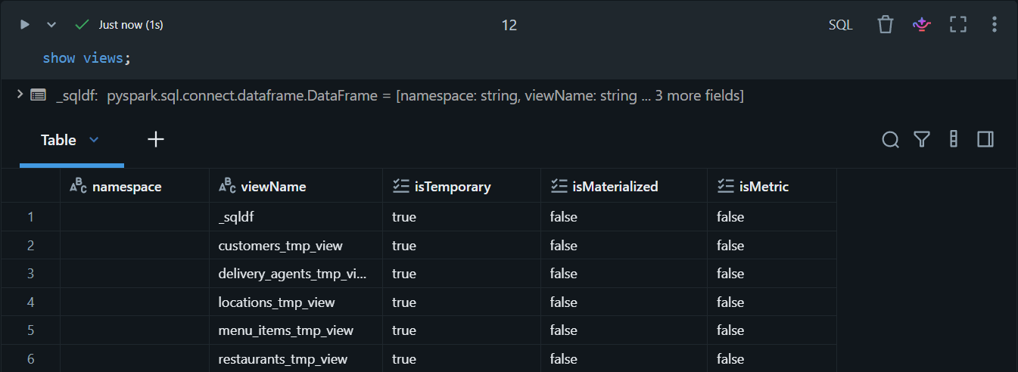
Temporary views were created for the five-dimension source datasets using the read_files() table-valued function with schema inference. These views provide a temporary SQL representation of the source files and are used as the starting point for creating the raw Bronze Delta tables.

Bronze tables
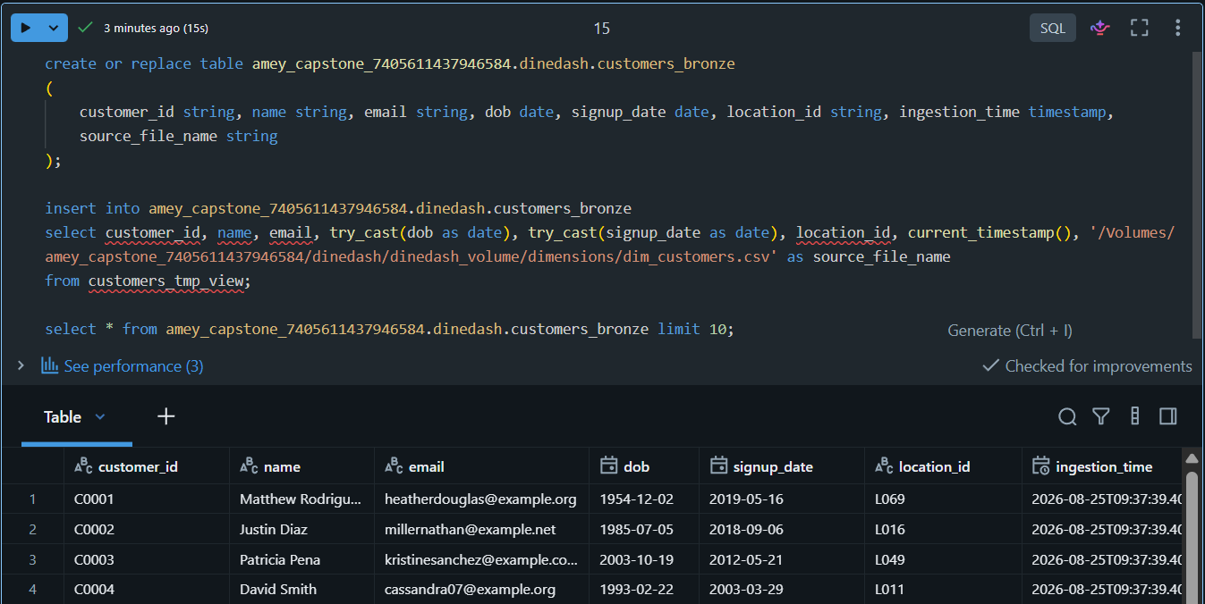
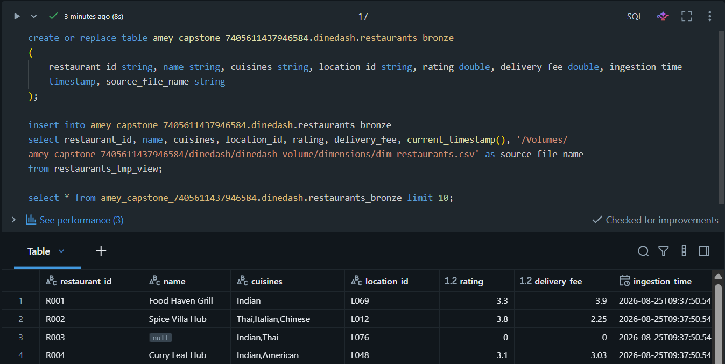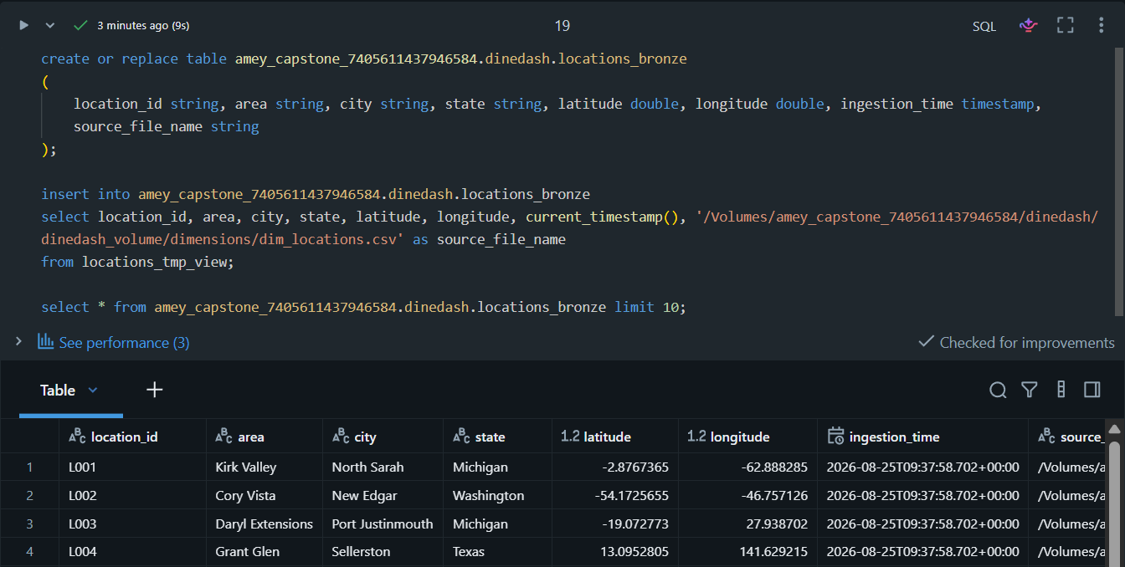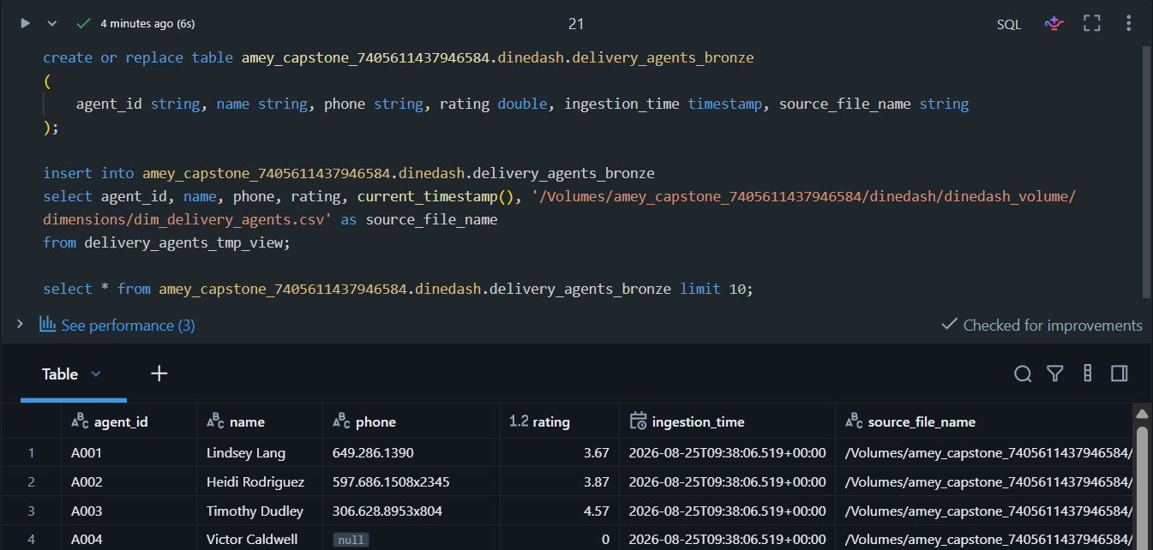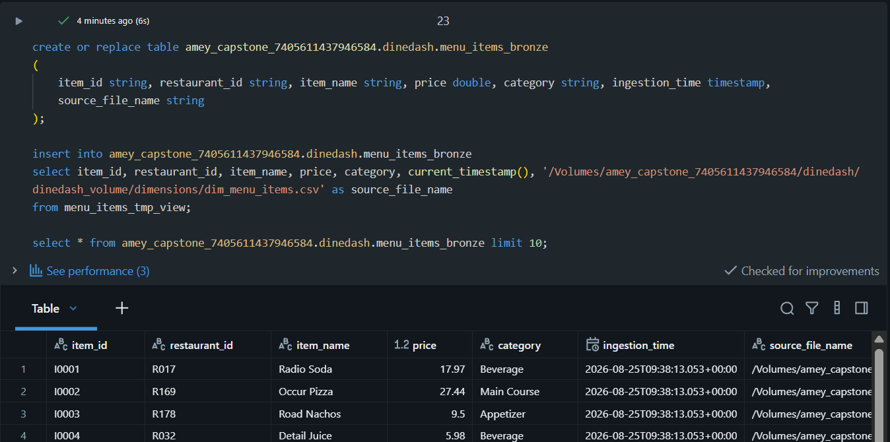
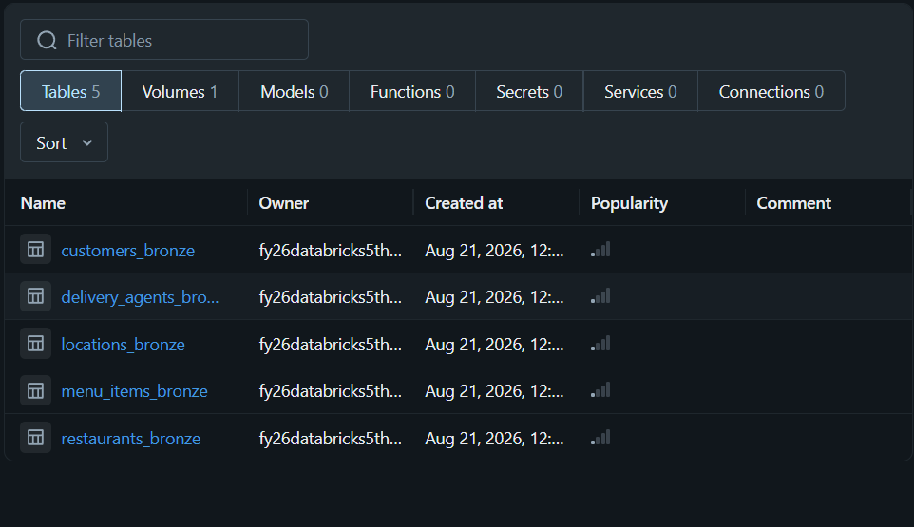

Bronze table data
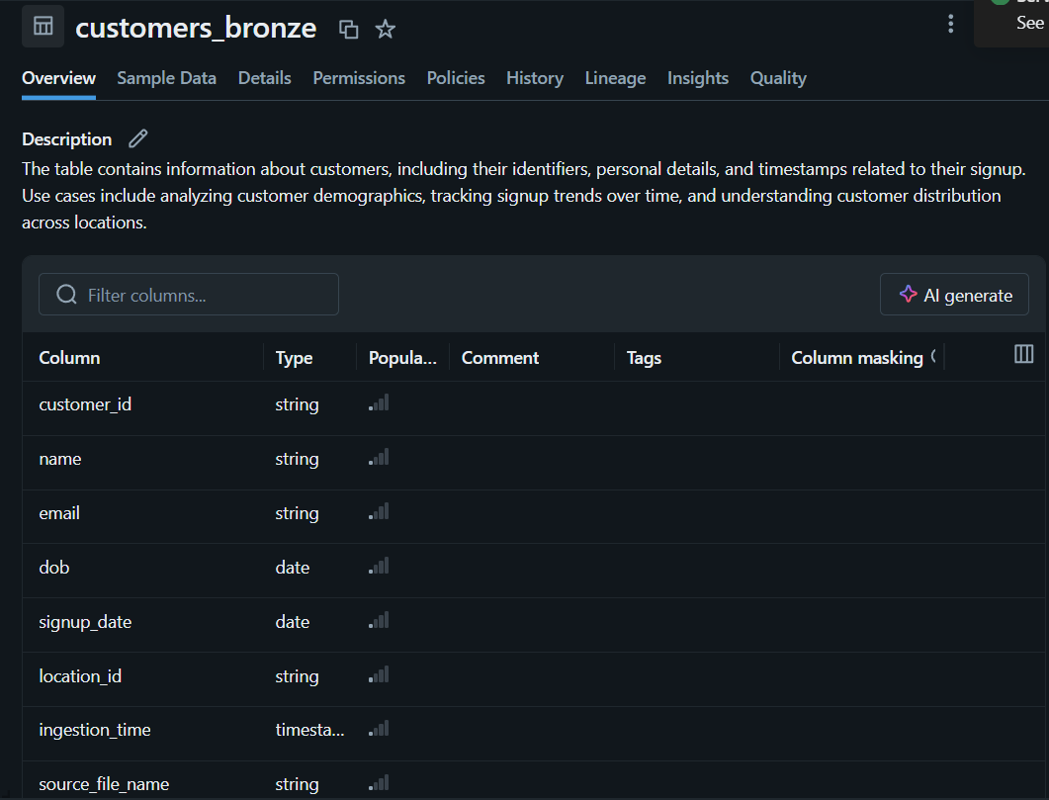
Raw Delta tables were created for the five-dimension datasets using manually defined schemas. The Bronze tables preserve the source attributes and additionally record the ingestion timestamp and source file name for each record.
Implementation detail: each Bronze table was first created using an explicit manual schema and then populated from its temporary view with INSERT INTO

DineDash Filtered Dimension Tables
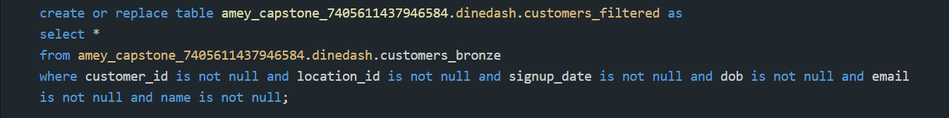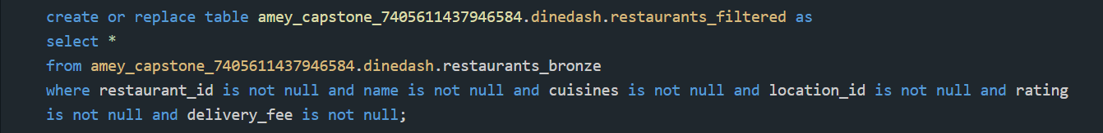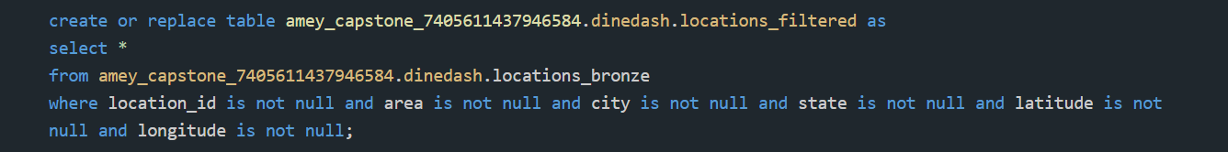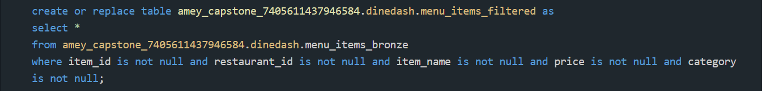
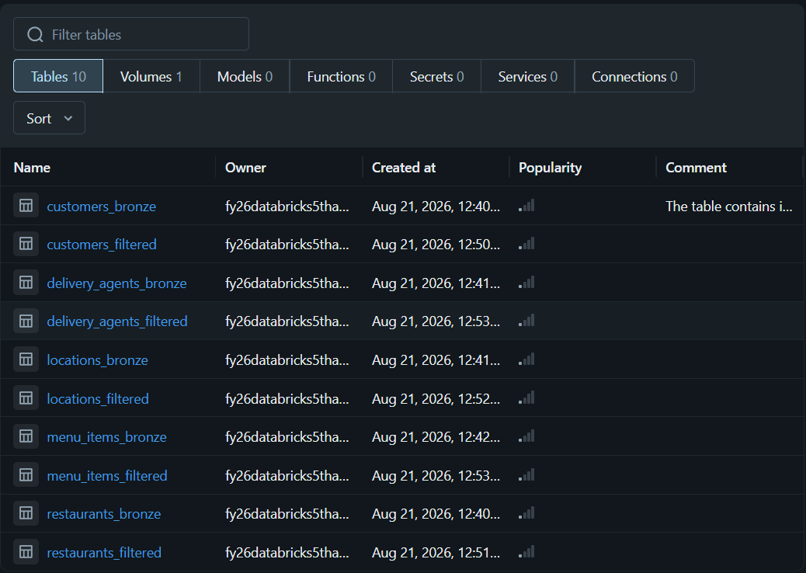

Dimension Data Quality Validation

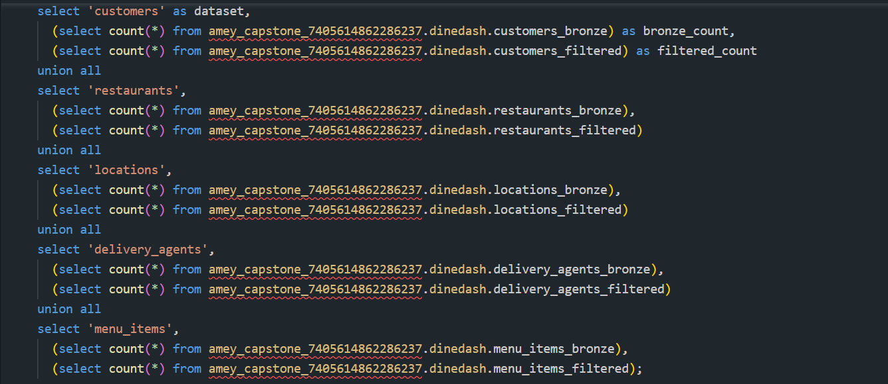
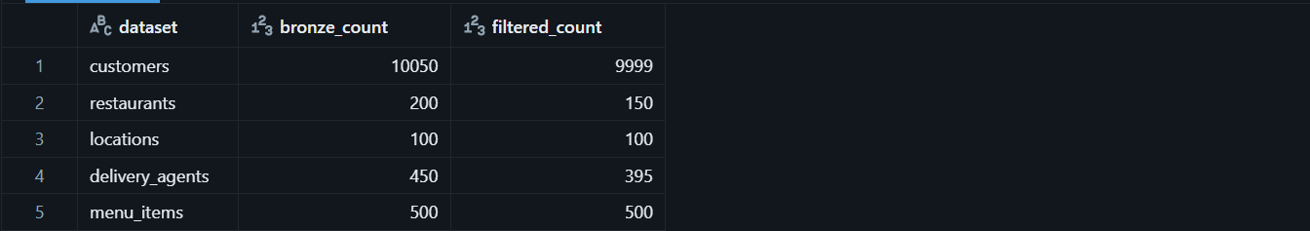
The Bronze dimension tables were filtered using the mandatory non-null fields specified in the project requirements. Records missing any of the required fields were excluded from the corresponding filtered tables.

Jan+Feb Order Load Verification
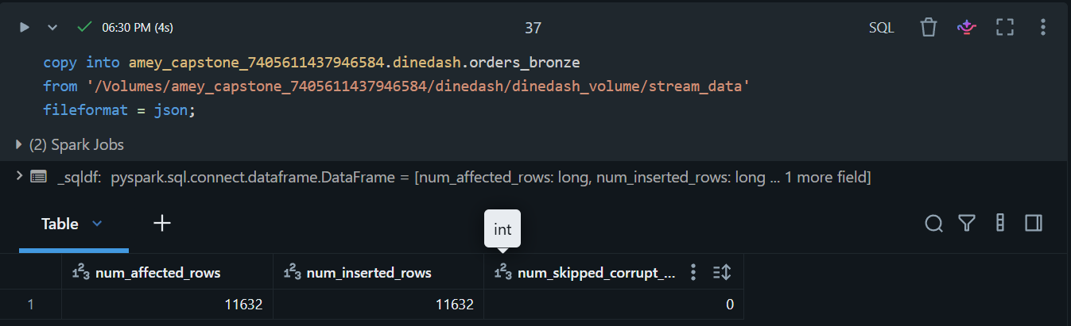

March Incremental Order Load Verification
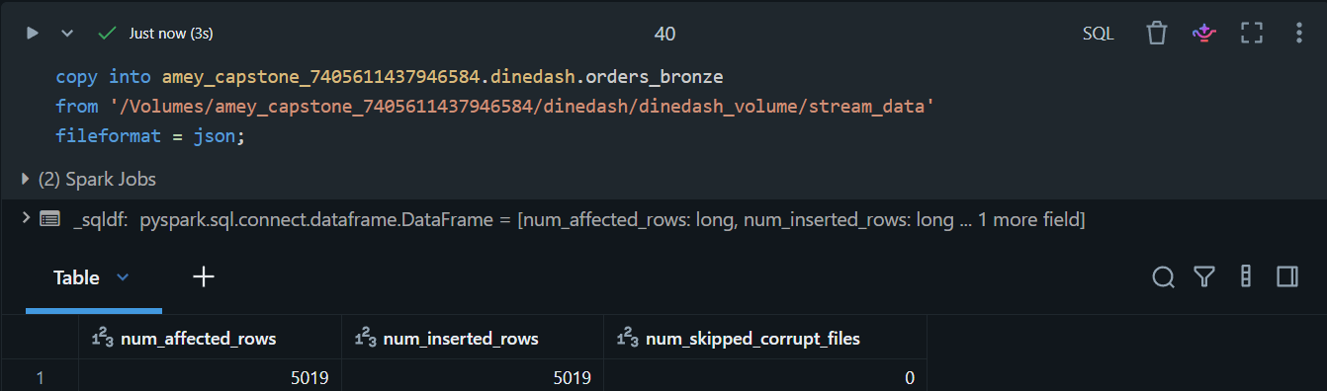
Total Count
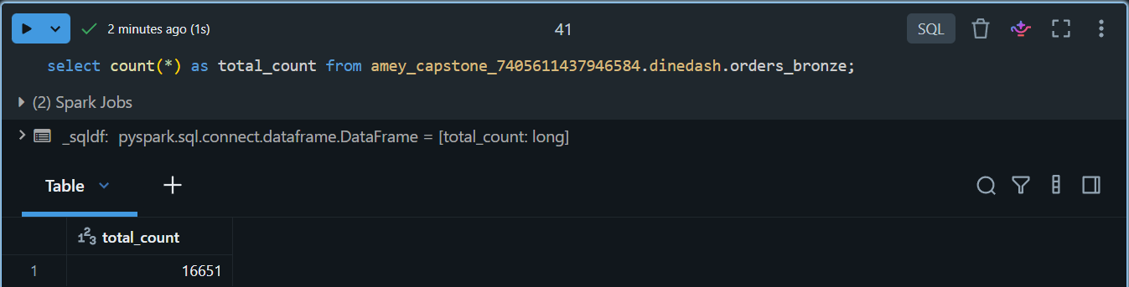

An orders_bronze Delta table was created without a predefined schema. Order data was incrementally loaded from the DineDash Volume using the COPY INTO command. January 2024-February 2024 order data was loaded first and the record count was verified. March 2024 data was subsequently introduced and loaded using the same ingestion process, with the final record count verified. This demonstrates the incremental monthly ingestion process required for the order data.

12 Queries
Q1. Total number of orders placed.
The total number of orders placed was calculated by counting all records in the orders_bronze table.

Q2. Distribution of orders by payment method.
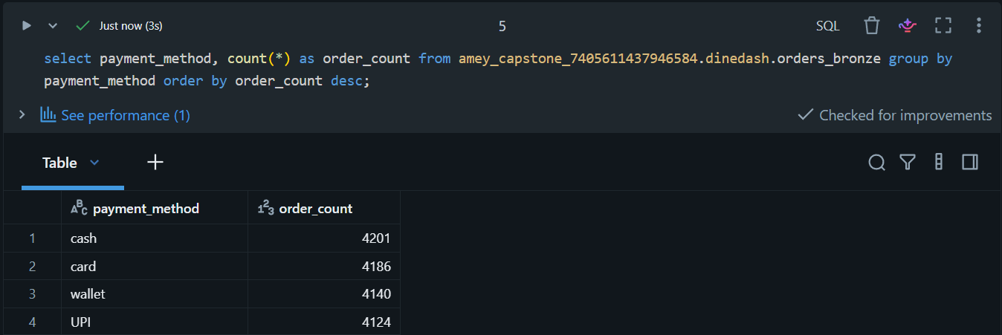
The distribution of orders by payment method was determined by grouping the orders according to payment_method and counting the number of orders in each group.

Q3. Distribution of order status (e.g., delivered, preparing, cancelled).
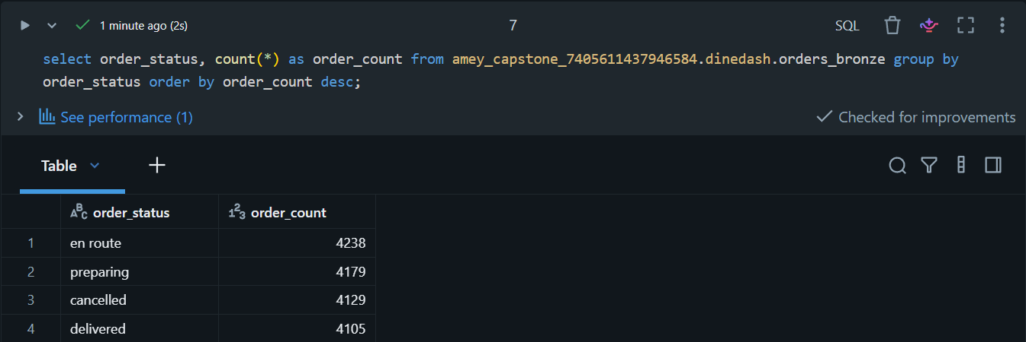
The distribution of orders by status was determined by grouping the order records according to order_status and counting the number of orders in each status.

Q4. Orders per restaurant (volume of business).
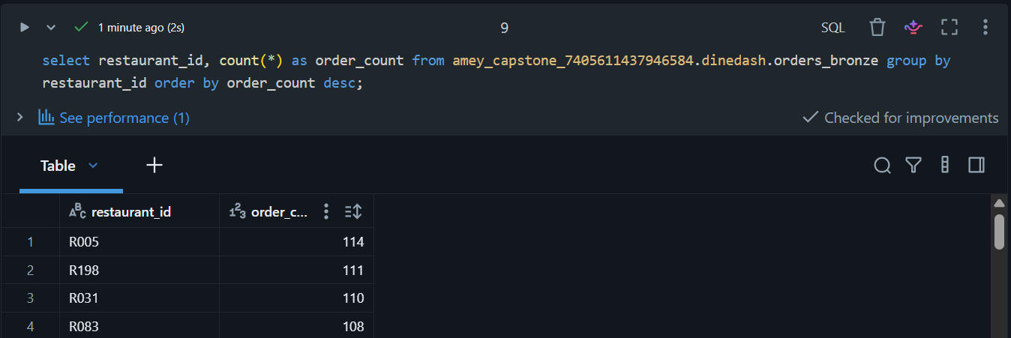
The order volume for each restaurant was calculated by grouping orders according to restaurant_id and counting the number of orders associated with each restaurant.

Q5. Orders per customer (loyalty insight).
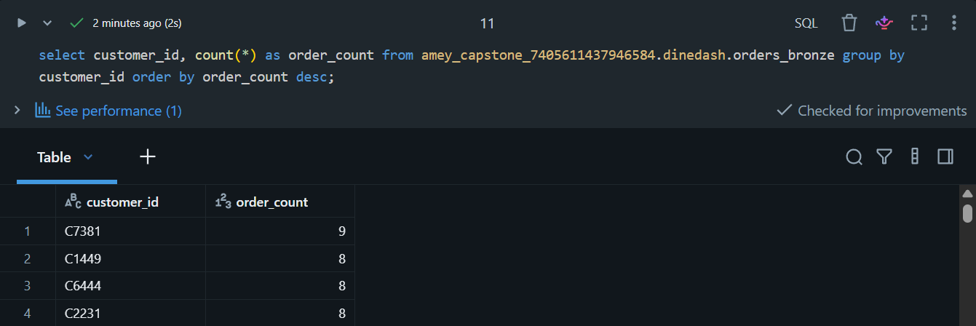
The number of orders placed by each customer was calculated by grouping the order records by customer_id and counting the associated orders. This provides an indication of customer ordering frequency.

Q6. Orders handled per delivery agent.
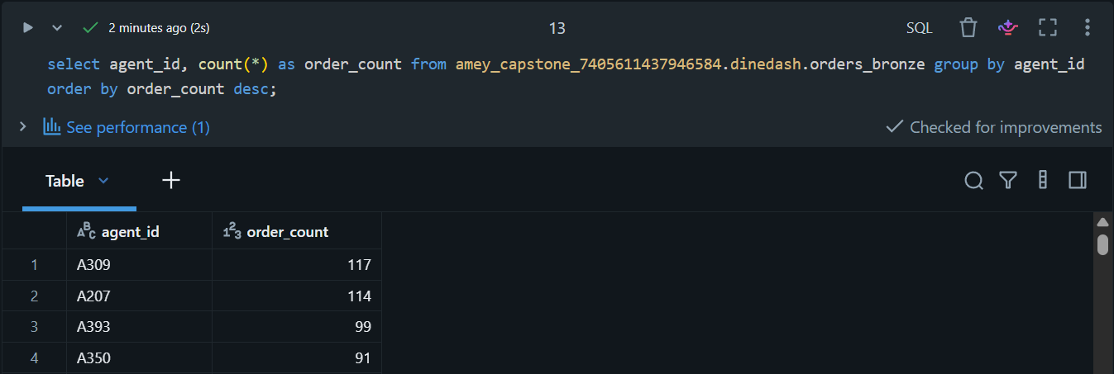
The number of orders handled by each delivery agent was calculated by grouping the orders by agent_id and counting the associated order records.

Q7. Top 10 orders by total amount.
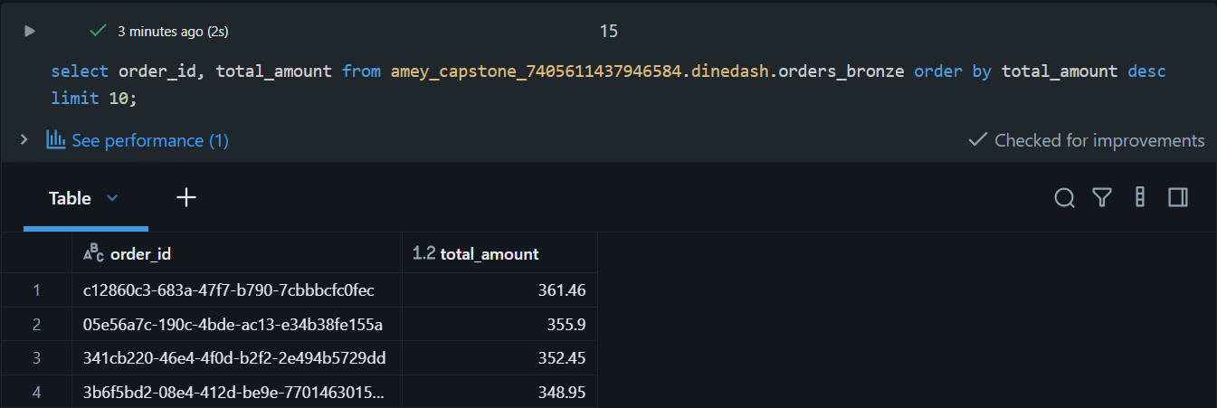
The top 10 orders by total amount were identified by sorting the orders in descending order of total_amount and selecting the first 10 records.

Q8. Average tip amount per payment method.
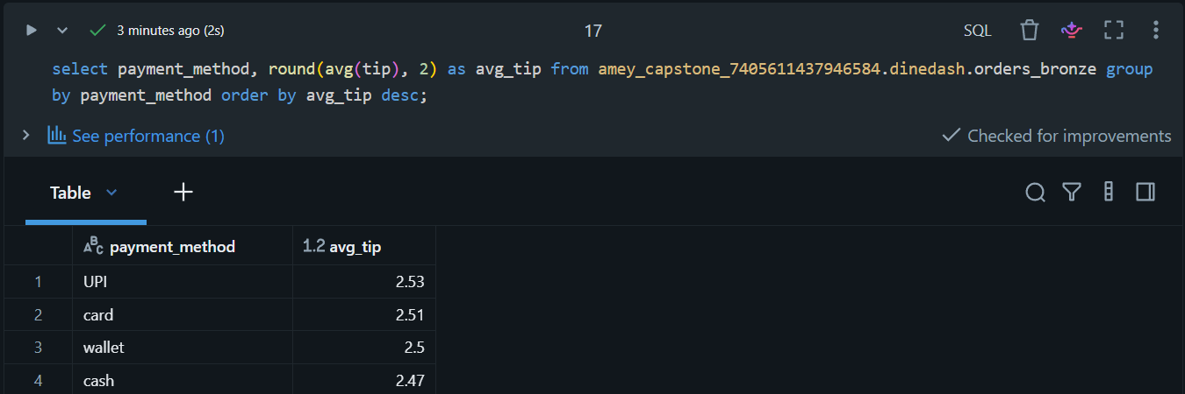
The average tip amount was calculated for each payment method by grouping orders according to payment_method. The resulting floating-point values were rounded up to two decimal places as specified in the project requirements.

Q9. Percentage of orders with tip > 10% of total_amount.
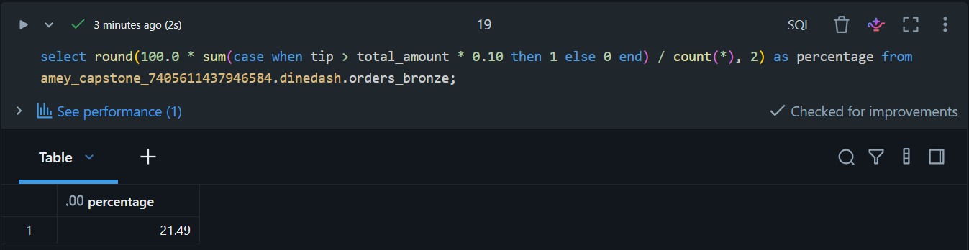
The percentage of orders where the tip exceeded 10% of the total order amount was calculated by comparing tip with 10% of total_amount for each order and dividing the qualifying orders by the total number of orders. The resulting percentage was rounded up to two decimal places.

Q10. Percentage of successful vs cancelled vs failed orders.
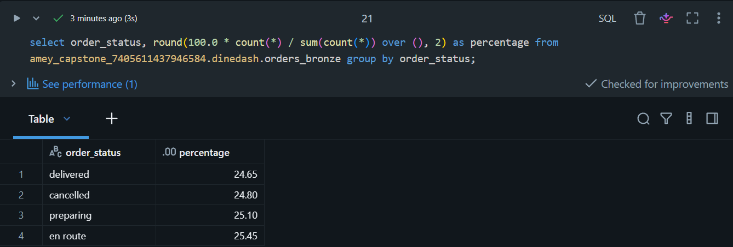
The percentage distribution of orders by status was calculated by determining the proportion of orders represented by each order_status relative to the total number of orders. The resulting percentages were rounded up to two decimal places.

Q11. Top customers (by number of orders) and top restaurants (by number of orders).

Top Customers
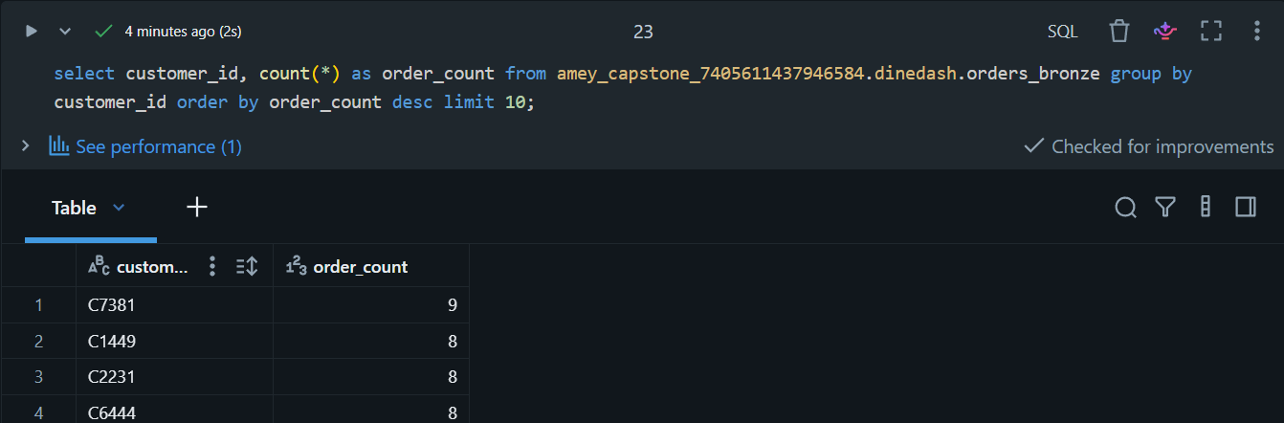

Top Restaurants
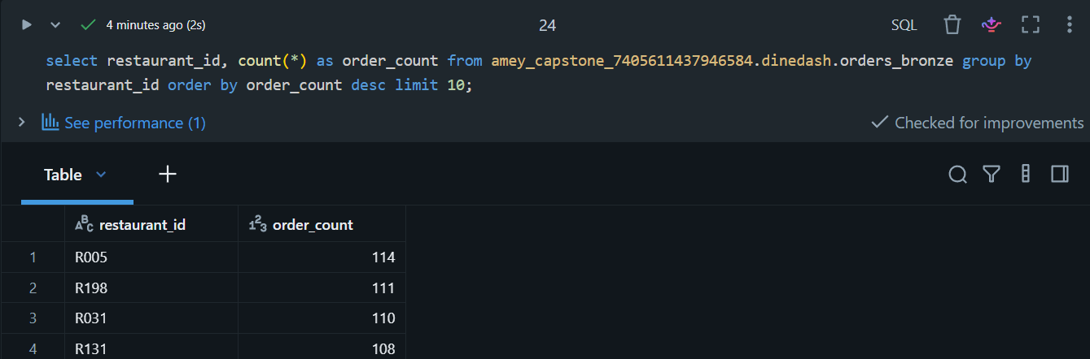
The top customers were identified by grouping orders by customer_id, counting the orders for each customer, and selecting the 10 customers with the highest order counts. Similarly, the top restaurants were identified by grouping orders by restaurant_id and selecting the 10 restaurants with the highest order counts.

Q12. Item-Level Insights (explode items_ordered):
A. Find the most frequently ordered items.
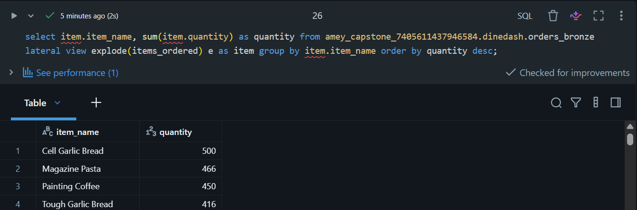
B. Find the average number of items per order.

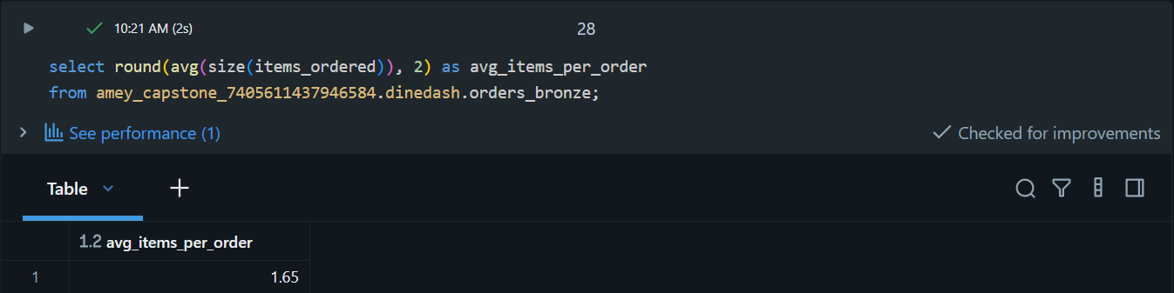
C. Find item revenue contribution per restaurant.
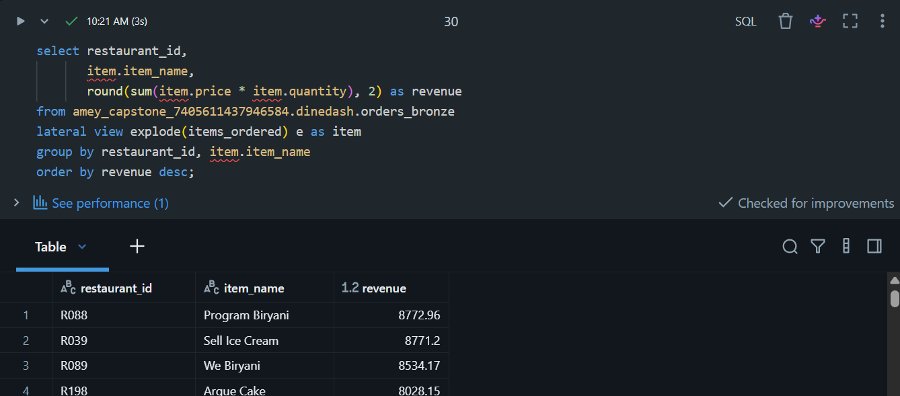
The explode() function converts each item in the items_ordered array into a separate row. This allows us to calculate the most frequently ordered items, average number of items per order, and item-level revenue contribution for each restaurant.

15 Queries
Q1. Find the preferred restaurant names for each customer.
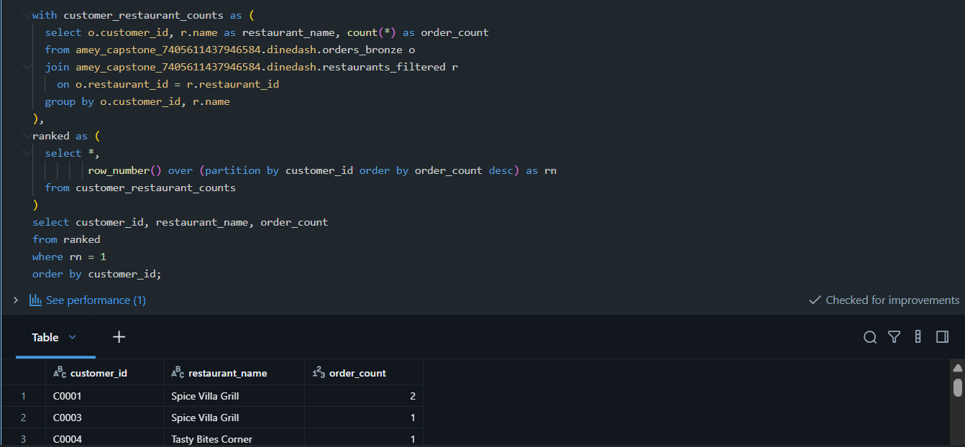
Customer ordering preferences were determined by counting orders for each customer-restaurant combination and ranking the restaurants based on order frequency for each customer. The restaurant or restaurants with the highest order count were identified as the customer's preferred restaurant.

Q2. Find the top 10 areas receiving orders in each month.
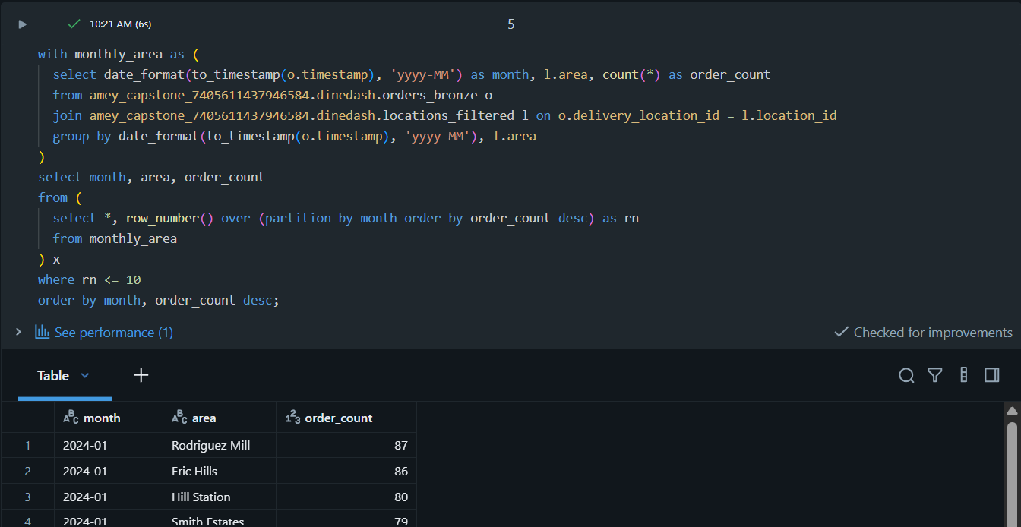
Orders were grouped by delivery area and month using the order timestamp. The areas were ranked within each month according to order volume, and the top 10 areas for each month were selected.

Q3. Find all successfully delivered orders that were paid using a card, to analyze payment preferences and delivery success rates.
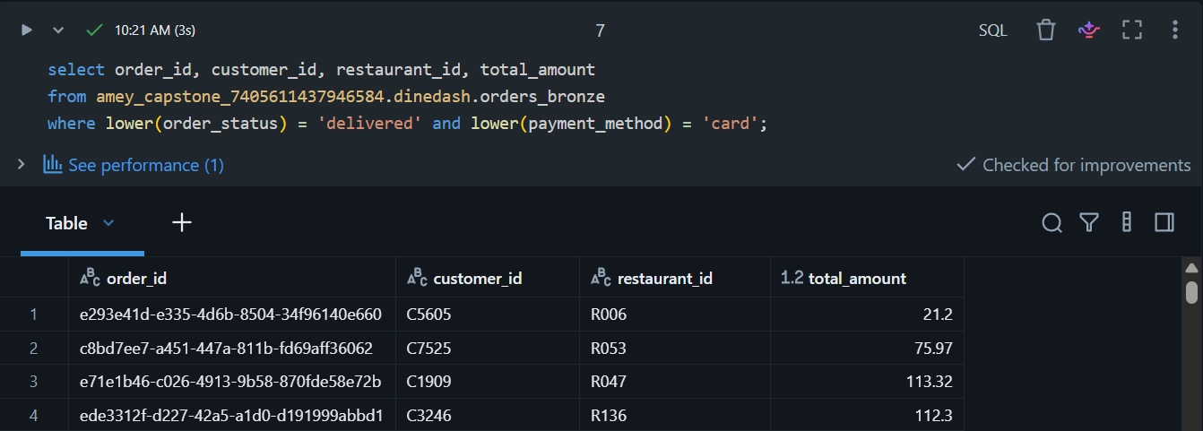
Orders were filtered to identify successfully delivered orders where the payment method was card. The result provides the order, customer, restaurant, and amount details for this combination of delivery status and payment preference.

Q4. Which cuisines generate the highest average order value?
Hint: Join orders, restaurants, group by cuisine, and calculate average total_amount.
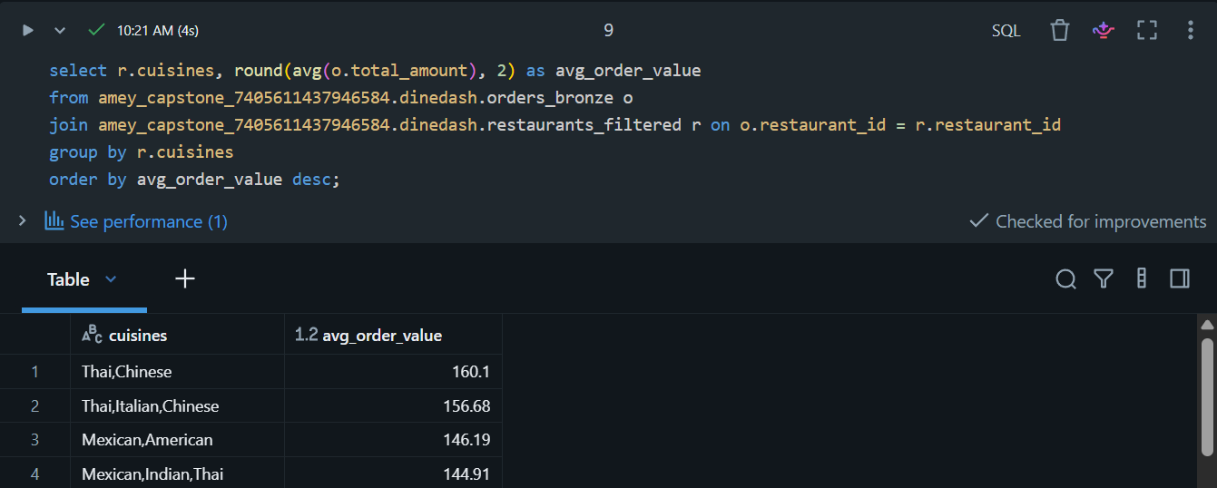
Orders were joined with restaurant information and grouped by cuisine. The average total_amount was calculated for each cuisine to identify cuisines generating the highest average order value.

Q5. Which delivery agents have delivered the most high-value orders (above $50)?
Hint: Filter orders for total_amount > 50, join with agent, group by agent_id, and count orders.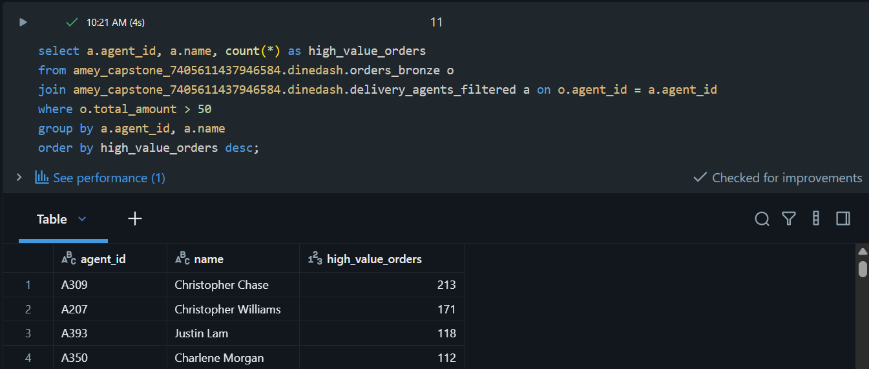
Orders with a total_amount greater than $50 were filtered and grouped by delivery agent. The number of high-value orders handled by each agent was then counted and sorted in descending order.

Q6. Which cities (area_name) are generating the most revenue for Italian cuisine?
Hint: Join orders, restaurants, locations, filter cuisine = 'Italian', group by area_name, and sum total_amount.
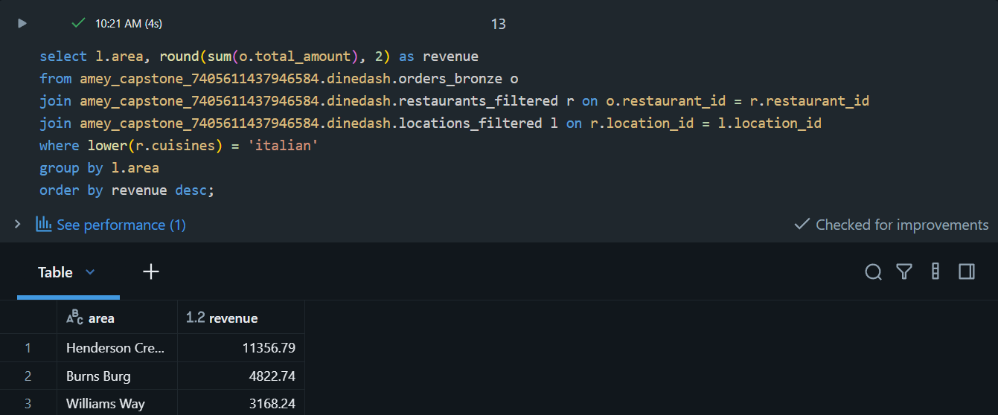
Orders were joined with restaurant and location information. Orders from Italian restaurants were filtered and grouped by area, and the total revenue was calculated by summing total_amount for each area.

Q7. What is the tip-to-total ratio by cuisine type?
Hint: Join orders, restaurants, group by cuisine, and calculate average tip / total_amount.
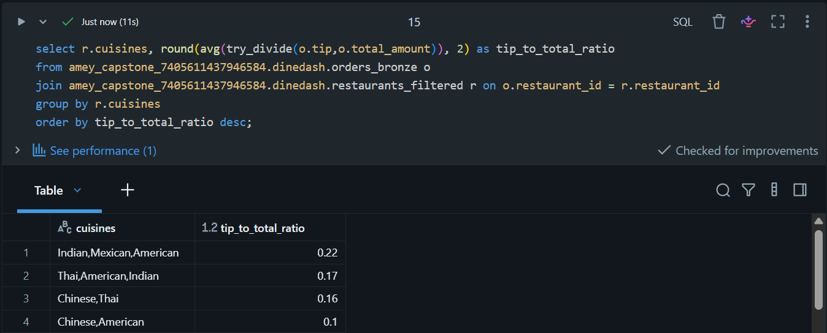
Orders were joined with restaurant information and grouped by cuisine. The average ratio of tip to total order amount was calculated for each cuisine type.

Q8. Which menu items are most frequently ordered, and from which restaurants?
Hint: Explode items_ordered in orders, join with menu_items, group by item_name, restaurant_id, and count.
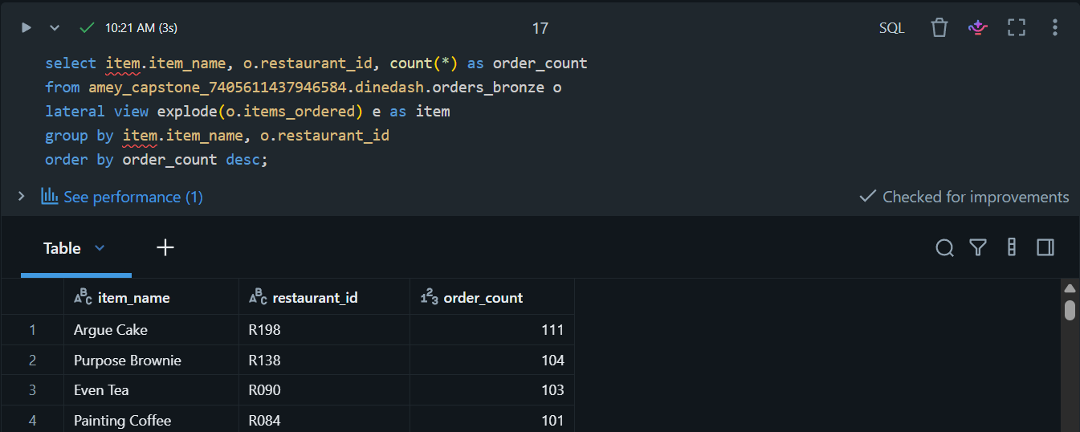
The nested items_ordered array was exploded into individual menu-item records. The items were then grouped by item name and restaurant, and their order frequency was calculated.

Q9. Which agents have delivered the most diverse cuisines?
Hint: Join orders, restaurants, group by agent_id, and count distinct cuisine.
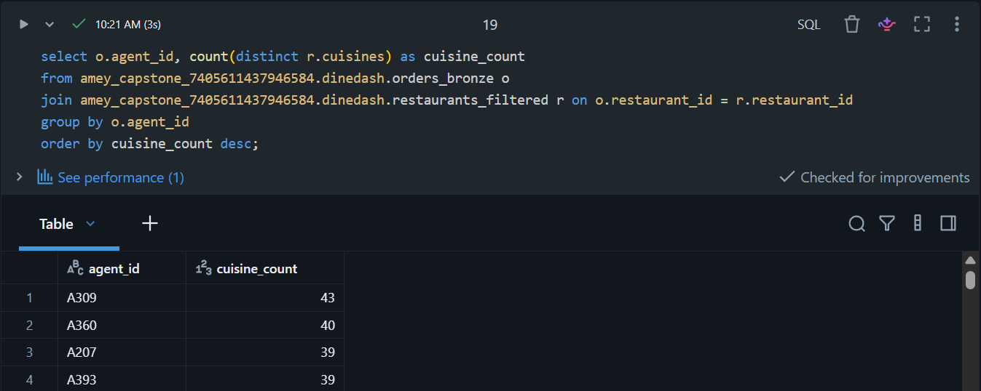
Delivery orders were joined with restaurant information and grouped by delivery agent. The number of distinct cuisines associated with each agent was calculated to identify agents handling the widest variety of cuisines.

Q10. What is the average customer lifetime value by signup year?
Hint: Join orders, customers, extract year from signup_date, group by year, sum total_amount per customer, then average total_amount per customer.
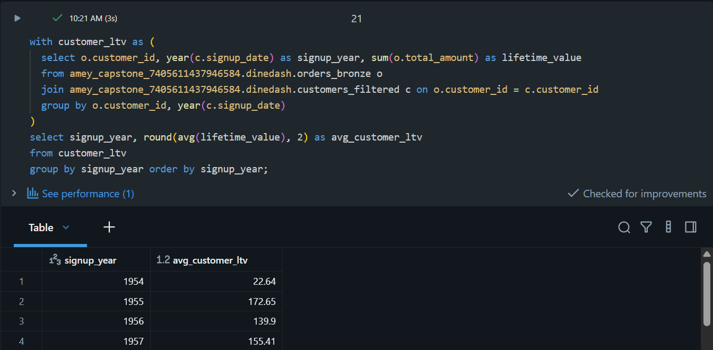
Customer lifetime value was calculated by summing the total order amount for each customer. Customers were grouped according to their signup year, and the average lifetime value was then calculated for each signup year.

Q11. Which restaurants have the highest order frequency per location?
Hint: Join orders, restaurants, locations, group by restaurant_id, location_id, and count orders.
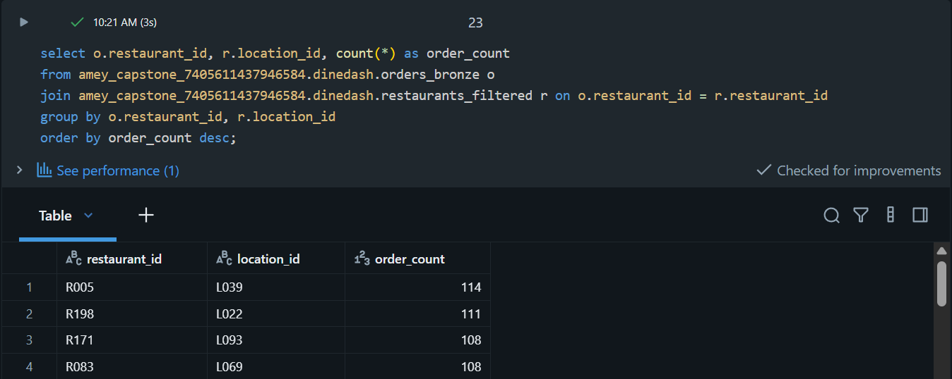
Orders were joined with restaurant information and grouped by restaurant_id and location_id. The number of orders for each restaurant-location combination was counted and sorted in descending order to identify locations with the highest restaurant order frequency.

Q12. Which locations are prone to order cancellations?
Hint: Filter orders with order_status = 'cancelled', join locations using delivery_location_id, group by area_name, and count.
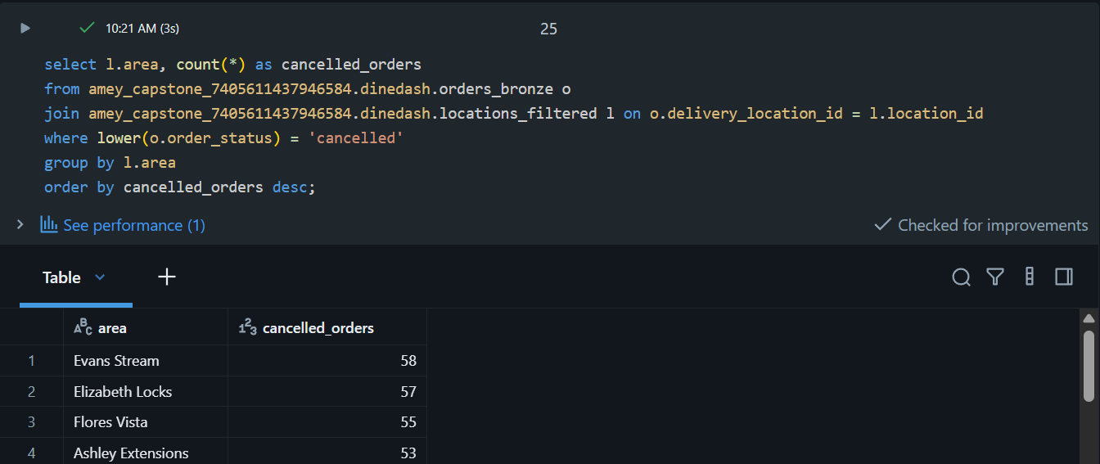
Cancelled orders were filtered and joined with location information using delivery_location_id. The orders were grouped by the actual location area field and counted to identify areas with the highest number of cancellations.

Q13. Find the top 10 customers who have ordered from the widest variety of restaurants.
Hint: Join orders, group by customer_id, count distinct restaurant_id, sort, and pick top 10.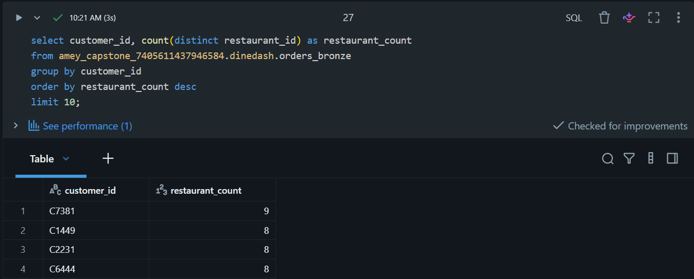
The top 10 customers with the widest variety of restaurant choices were identified by counting the distinct restaurants from which each customer had placed orders and sorting the results in descending order.

Q14. Identify restaurants with frequent repeat customers.
Hint: Join orders, group by restaurant_id, customer_id, count, and filter where count > 1.
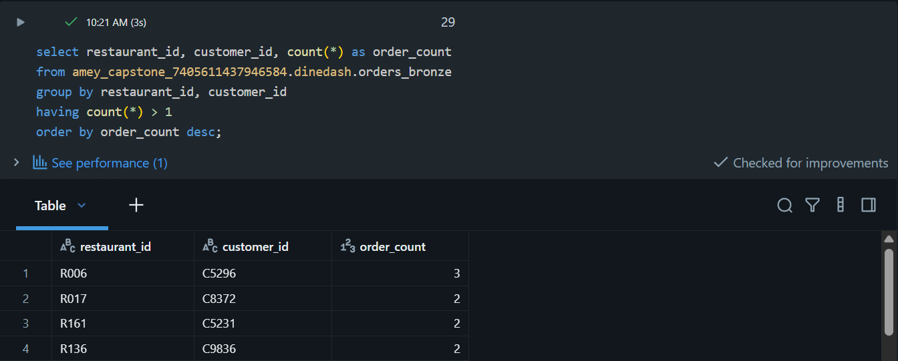
Customer orders were grouped by restaurant_id and customer_id. Combinations with more than one order were identified as repeat-customer relationships, allowing restaurants with frequent repeat customers to be identified.

Q15. Which payment methods are most preferred for high-value orders across cuisines?
Hint: Filter orders with total_amount > 40, join restaurants, group by cuisine, payment_method, and count.
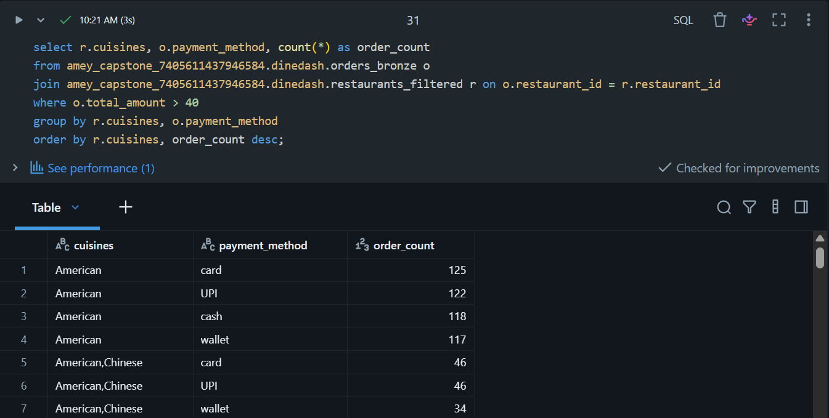
Orders with a total amount greater than $40 were filtered and joined with restaurant information. The results were grouped by cuisine and payment method, and the number of high-value orders was counted to identify payment preferences across cuisines.

Preparation of Initial DLT Input Data
The initial DLT input range was prepared by staging January–June 2024 order files in the active stream_data directory.
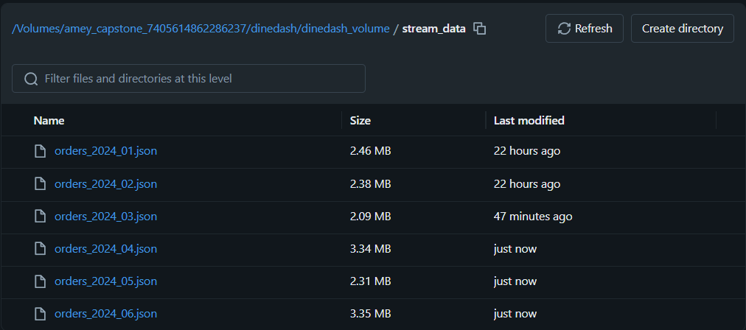
Figure 11.1 — DLT Initial Order Data Through June 2024

DLT Bronze Layer — Raw Data Ingestion
Ingest the DineDash source datasets into the pipeline's Bronze layer. Used read_files() for the Volume-based CSV/JSON sources and a streaming Bronze table for incoming orders. Six Bronze pipeline datasets were defined.
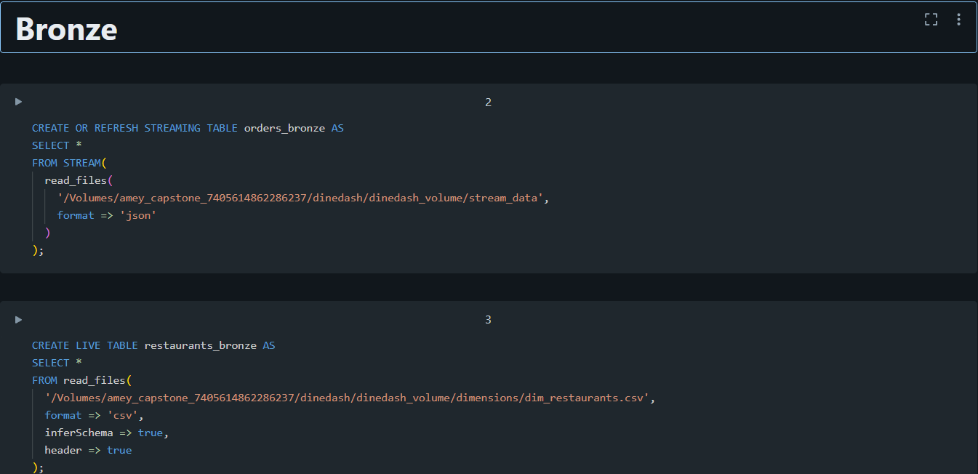

DLT Bronze Pipeline Execution
Validate the initial Bronze ingestion pipeline. Executed the configured DLT/Lakeflow pipeline containing the Bronze ingestion definitions. Bronze datasets were processed from the Volume source files.
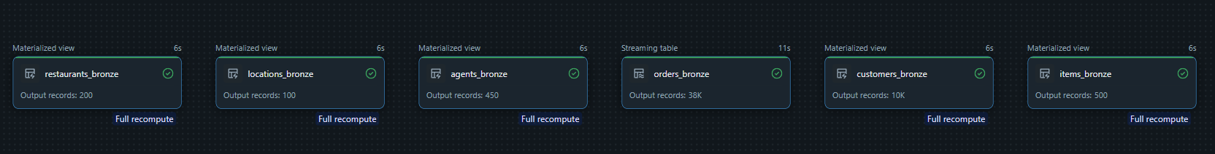

Silver Layer — Order Cleaning
Clean and validate incoming orders. Applied the three required expectations and exploded items_ordered. cleaned_orders defined as the first Silver-stage dataset.
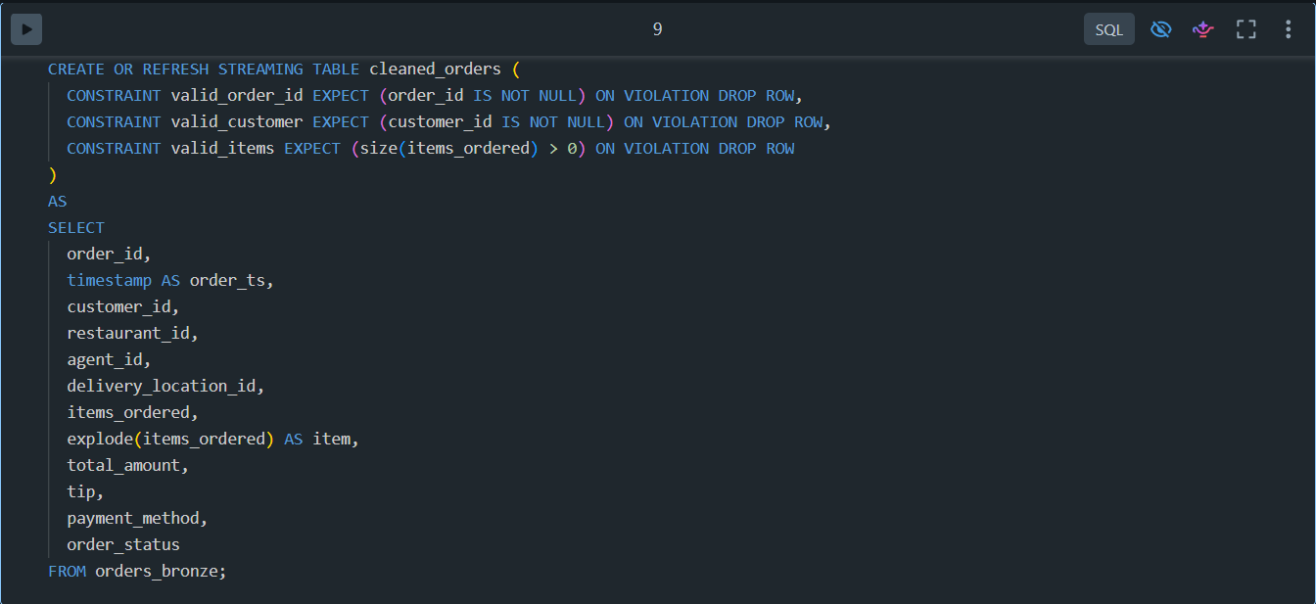

Silver Layer — orders_silver
Enrich cleaned orders with customer, restaurant, agent, item and location information. Joined cleaned_orders with the five Bronze datasets and applied the three required expectations. orders_silver defined as the enriched Silver dataset.
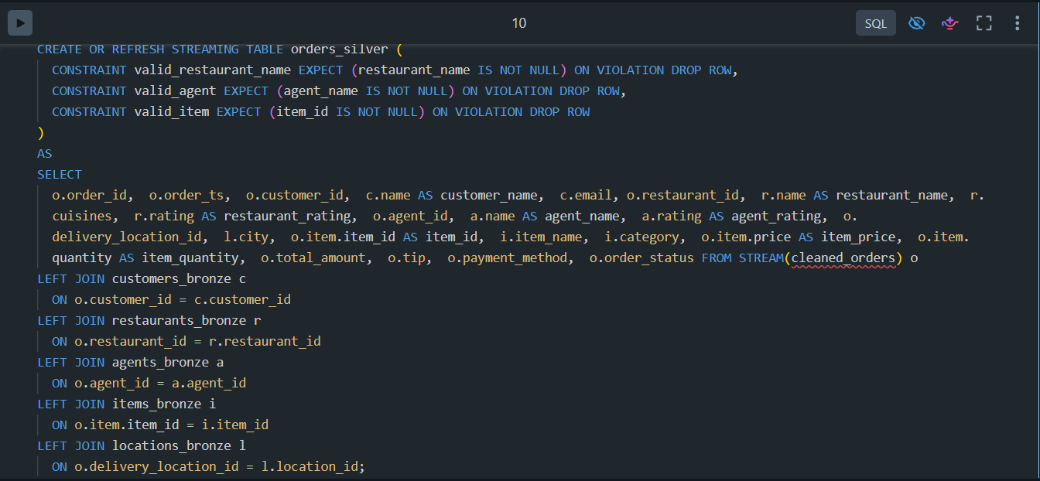

orders_with_agents
Enrich cleaned orders with delivery-agent information. Left joined cleaned_orders with agents_bronze. orders_with_agents created for agent-level analysis.
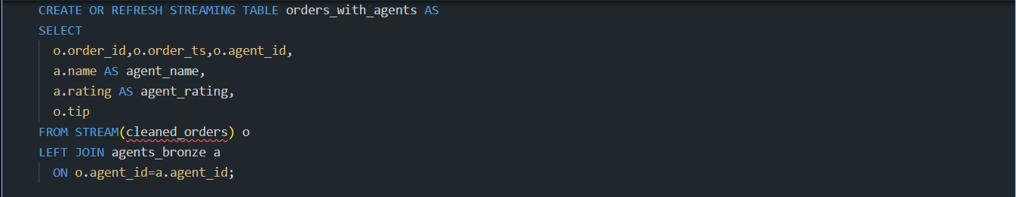

orders_with_items
Create item-level order records. Exploded items_ordered and joined each item with items_bronze. orders_with_items created for item-level analysis.
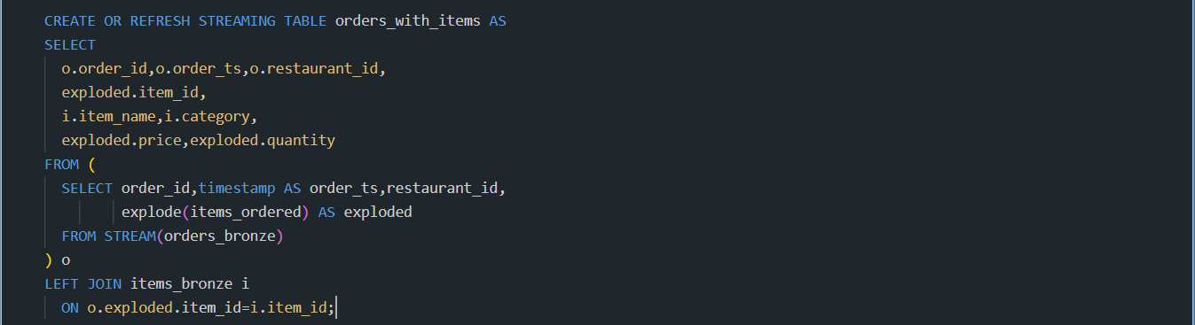

orders_with_locations
Enrich orders with delivery-location information. Joined cleaned_orders with locations_bronze. orders_with_locations created with city, state, and area.
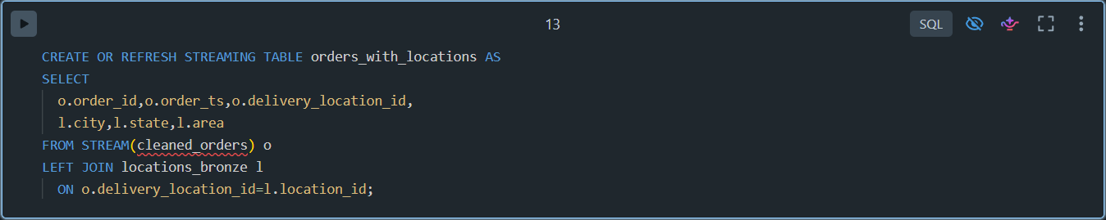

Gold Layer — total_orders_per_restaurant
Calculate total orders for each restaurant. Grouped orders_silver by restaurant and counted distinct orders. total_orders_per_restaurant defined.

Gold Layer — top_selling_items
Identify the top-selling menu items. Grouped orders_silver by item_name and summed item_quantity. Top 10 items defined in top_selling_items.
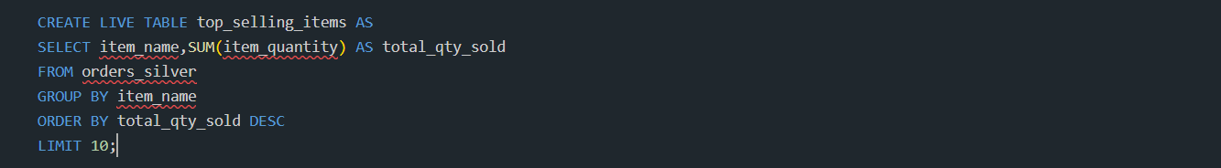

Gold Layer — avg_fees_by_city
Calculate city-level average restaurant rating and tip. Grouped orders_silver by city and calculated the two averages. avg_fees_by_city defined.
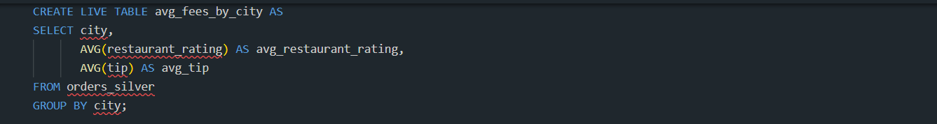

Gold Layer — agent_order_counts
Measure delivery-agent order volume and average rating. Grouped orders_silver by agent_name and calculated distinct orders and average rating. agent_order_counts defined.
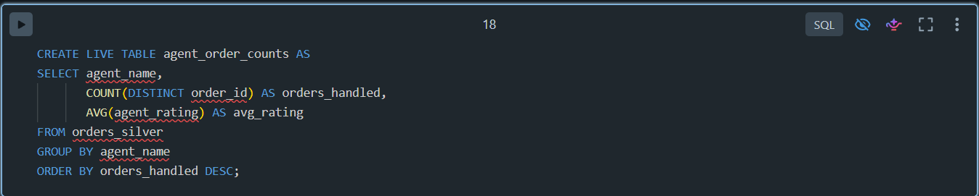

Gold Layer — daily_revenue_trend
Calculate daily order revenue. Grouped orders_silver by order date and summed total_amount. daily_revenue_trend defined.
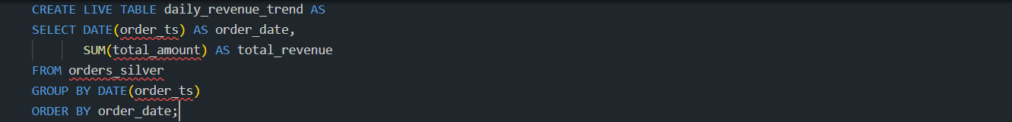

Gold Layer — customer_ltv
Calculate customer lifetime spend. Grouped orders_silver by customer and summed total_amount. customer_ltv defined.
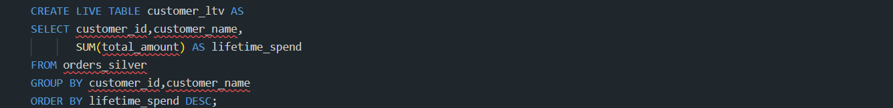

orders_with_customers
Enrich orders with customer information. Joined cleaned_orders with customers_bronze. orders_with_customers defined.

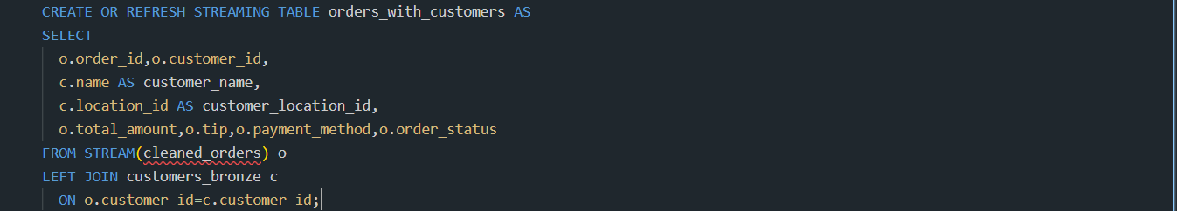

Gold Layer — customer_order_counts
Calculate total orders for each customer. Grouped orders_with_customers by customer_name and counted the orders. customer_order_counts defined.

DLT Pipeline Execution
Execute the complete DineDash transformation pipeline. Ran the configured Lakeflow/DLT pipeline containing Bronze, Silver and Gold transformations. Pipeline execution completed and transformation dependencies were evaluated.
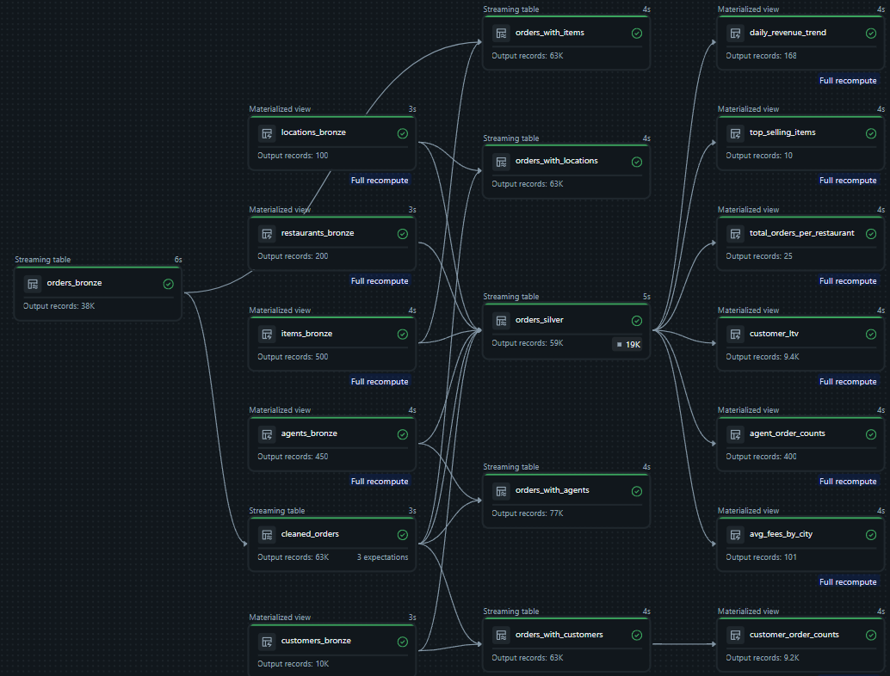July and Aug Added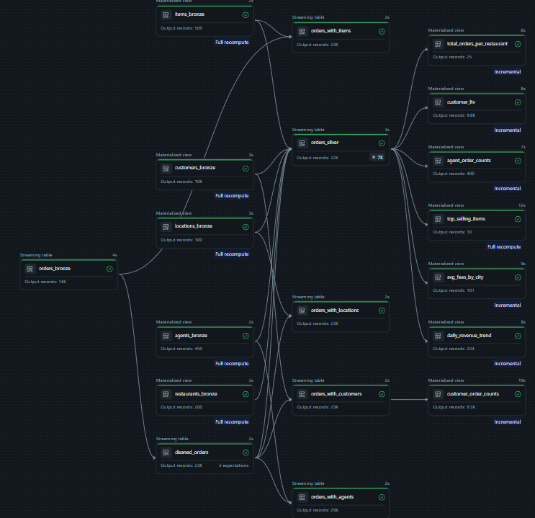

Data Quality Observation – July & August Incremental Load

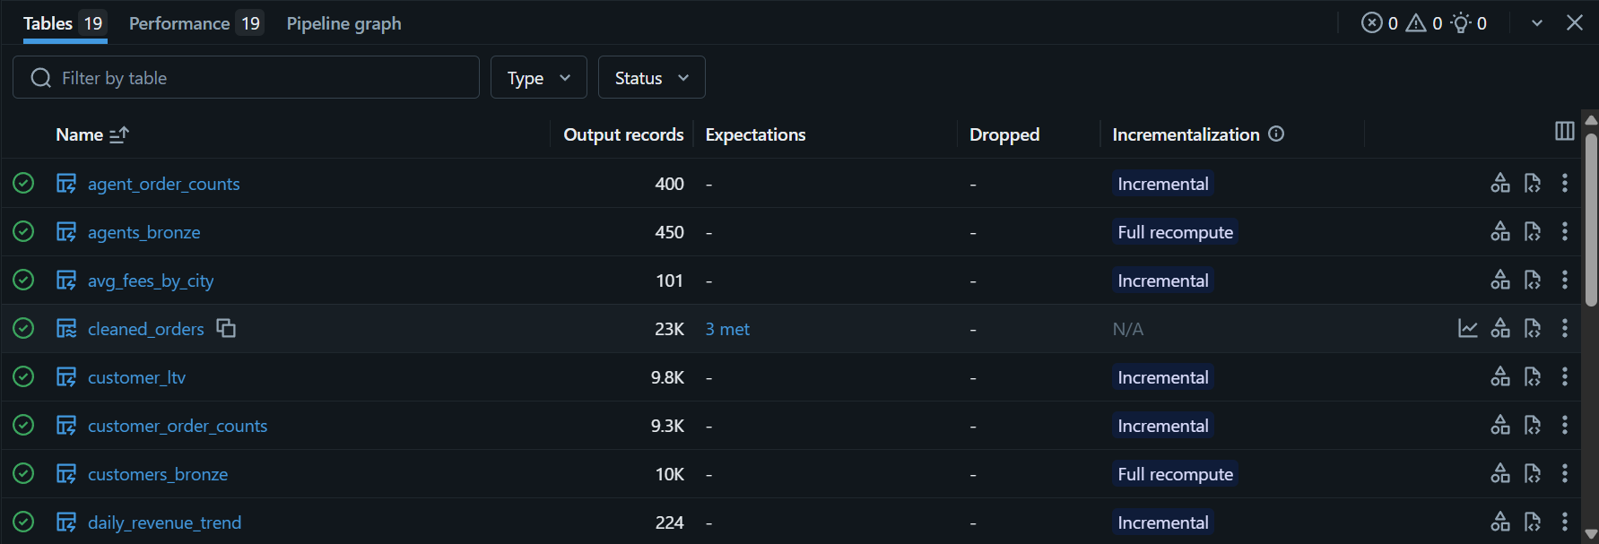
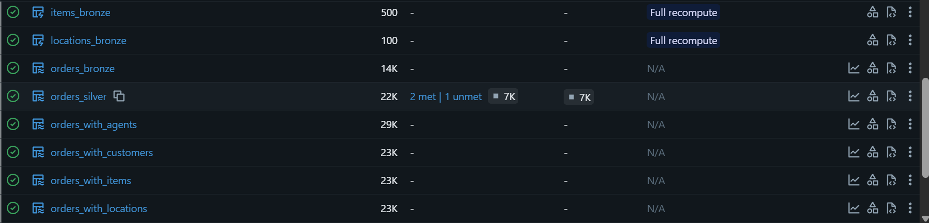
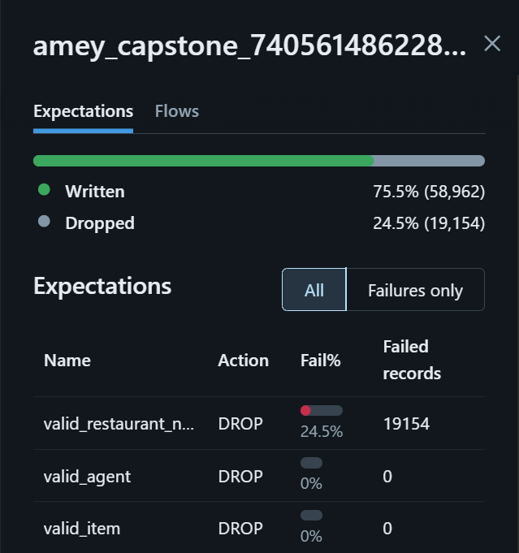
During the July–August incremental pipeline run, the orders_silver data-quality expectations were evaluated. A total of 19,154 records (24.5%) were dropped, while 58,962 records (75.5%) were written. The dropped records failed the valid_restaurant_n... expectation, whereas the valid_agent and valid_item expectations had zero failed records.

Remaining 2024 Order Files Added to Streaming Source
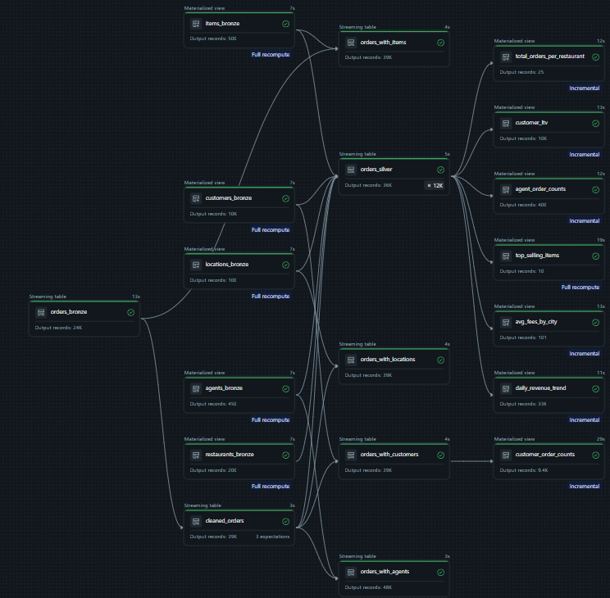

Data Quality Validation — September to December
The September–December incremental pipeline run was completed and the resulting data-quality checks were reviewed for the remaining 2024 order files.

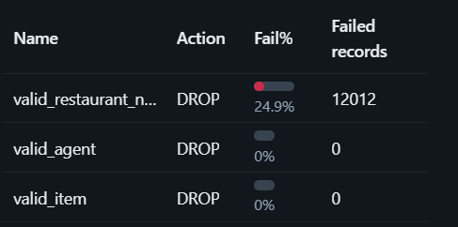

Dashboarding
To demonstrate incremental dashboard and workflow updates, the July–December order files were temporarily removed from the active source directory before the initial dashboard run and then reintroduced in stages for incremental processing.

Dashboard Query — Total Orders per Restaurant
Prepare the restaurant order-volume metric for the dashboard. Queried the Gold total_orders_per_restaurant dataset and created a visualization. Restaurant-wise order counts are available for dashboard display.
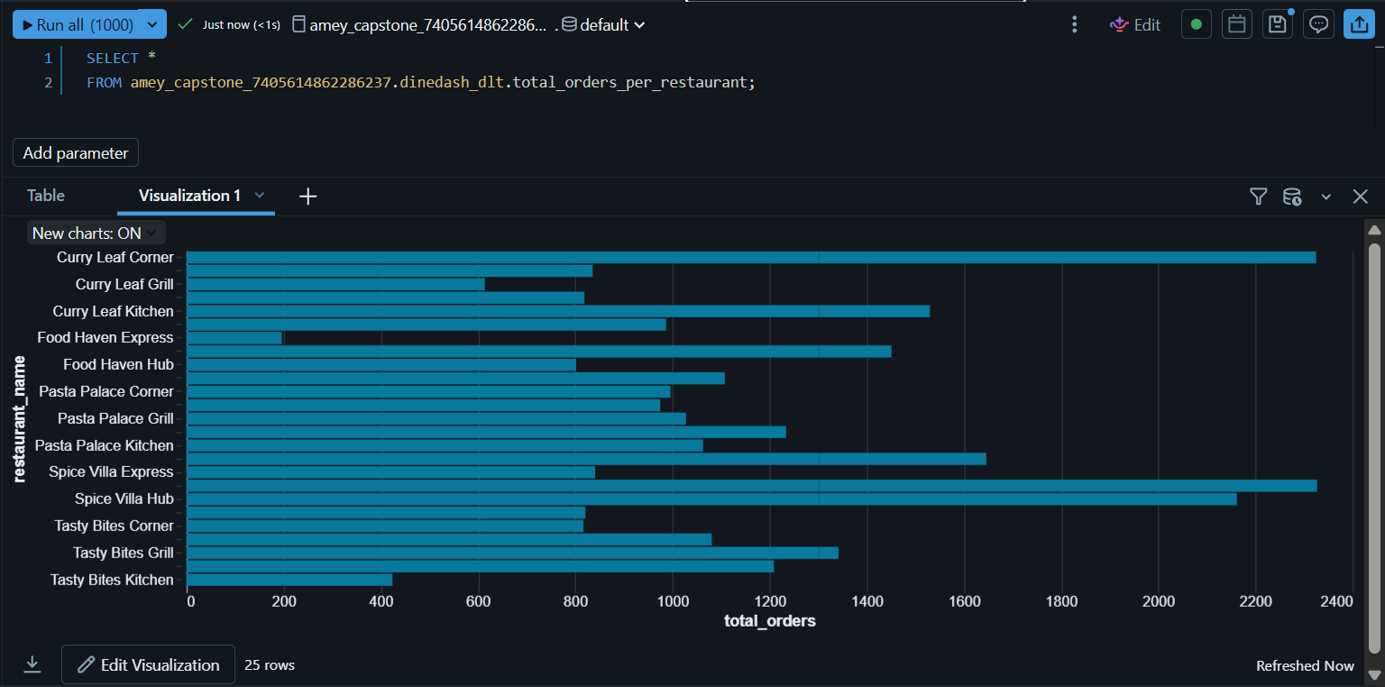

Dashboard Query — Top-Selling Items
Prepare the top-selling menu items metric for the dashboard. Queried the Gold top_selling_items dataset and created a visualization. The 10 top-selling items are available for dashboard display.
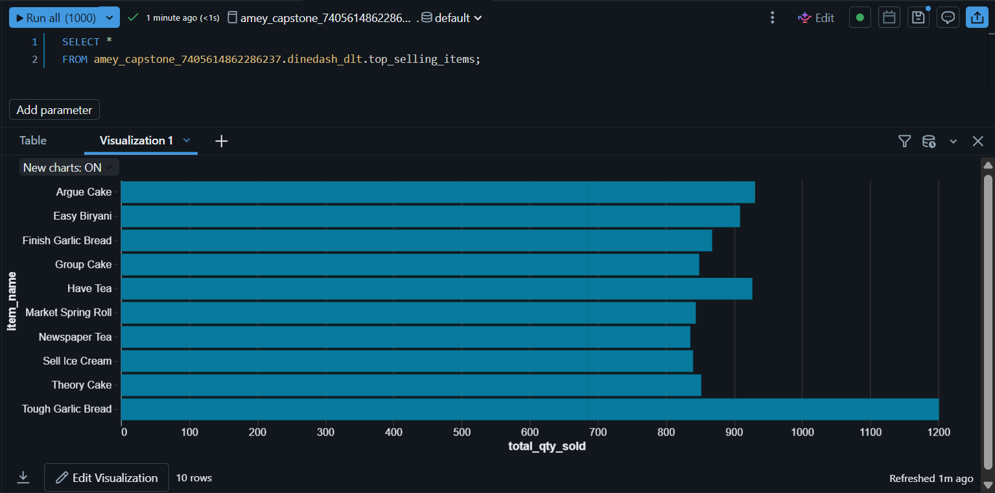

Dashboard Query — Daily Revenue Trend
Prepare daily revenue data for dashboard visualization. Queried the Gold daily_revenue_trend dataset and created a time-series visualization. Daily revenue values are available for dashboard display.
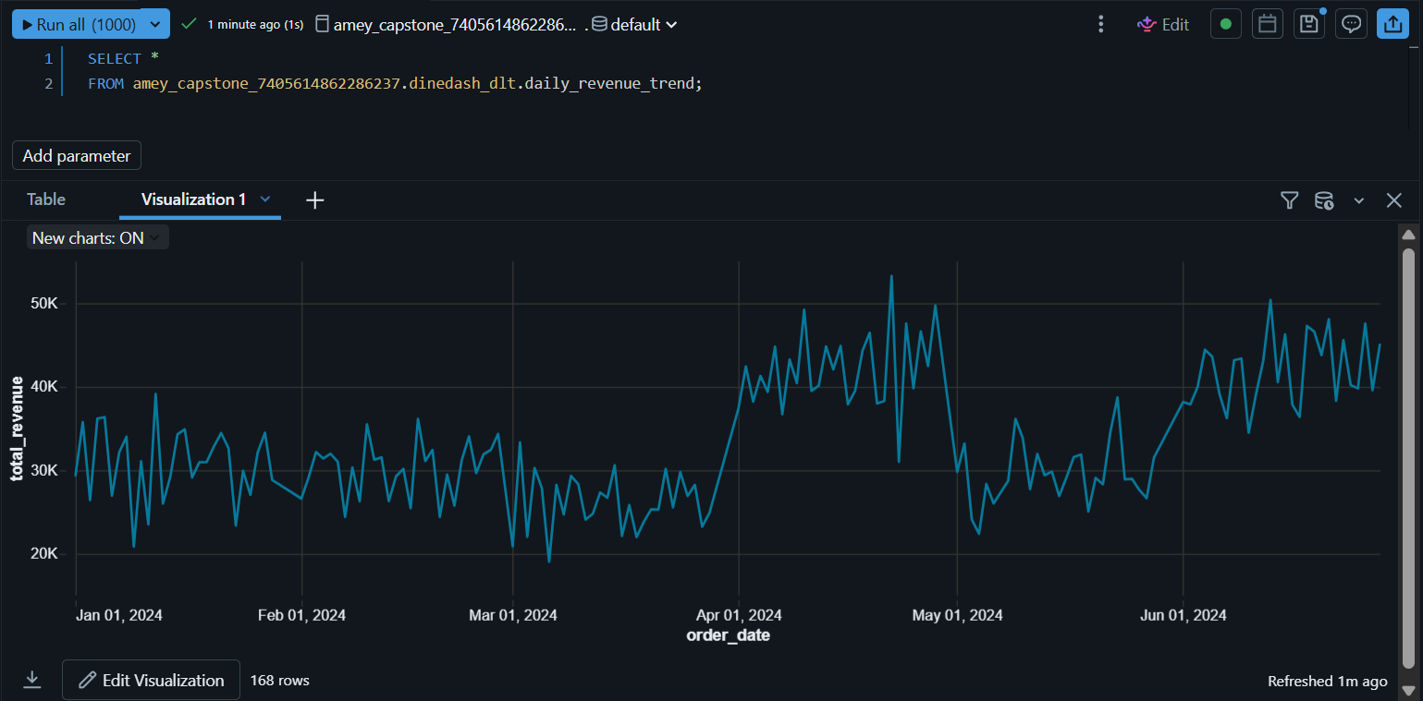

Dashboard Query — Total Revenue
Calculate the overall revenue generated across the available daily revenue data. Summed total_revenue from the Gold daily_revenue_trend dataset. A single total-revenue value was produced for the dashboard.
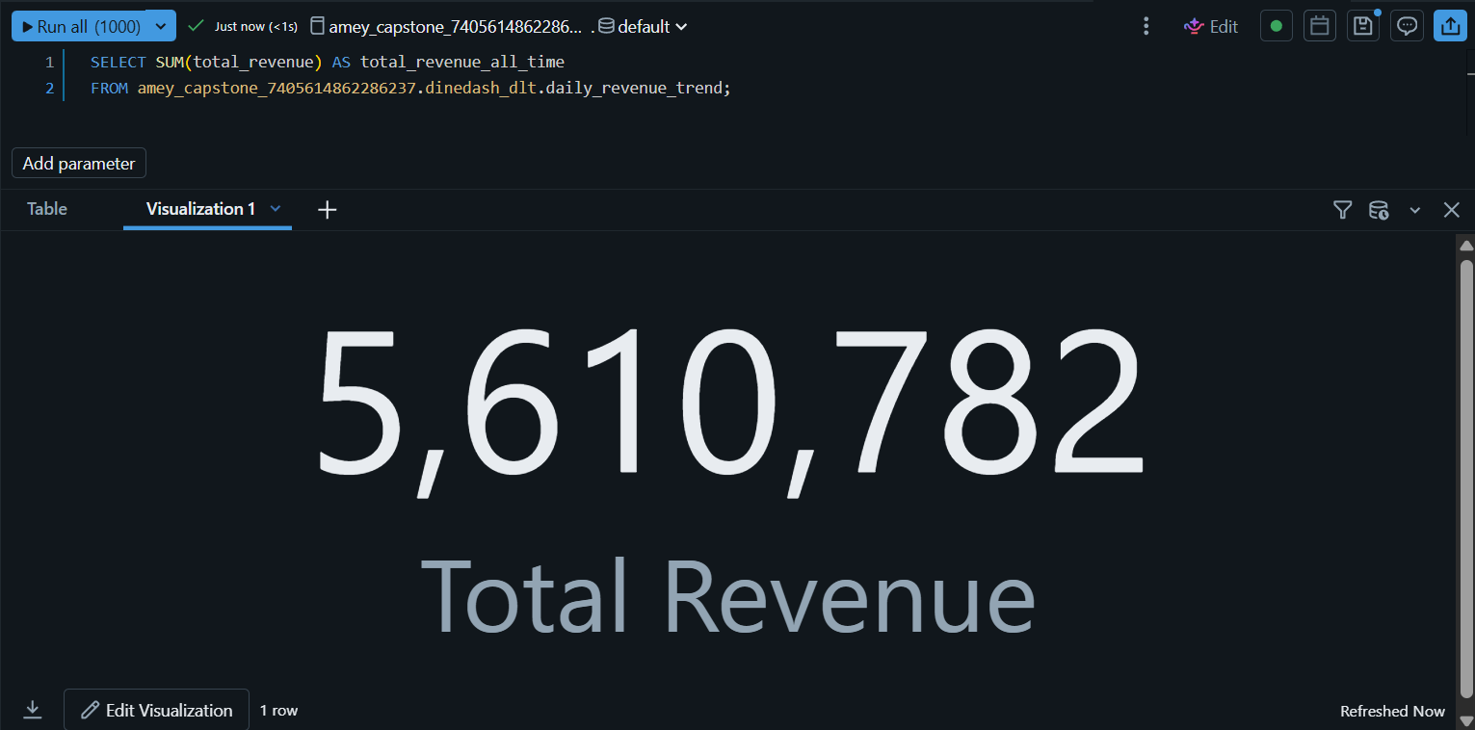

Dine Dash Metrics Dashboard
Create the dashboard that will contain the required business insights. Added the Total Orders Per Restaurant visualization to a new dashboard named Dine Dash Metrics Dashboard. The dashboard was created and is ready for the remaining visualizations.
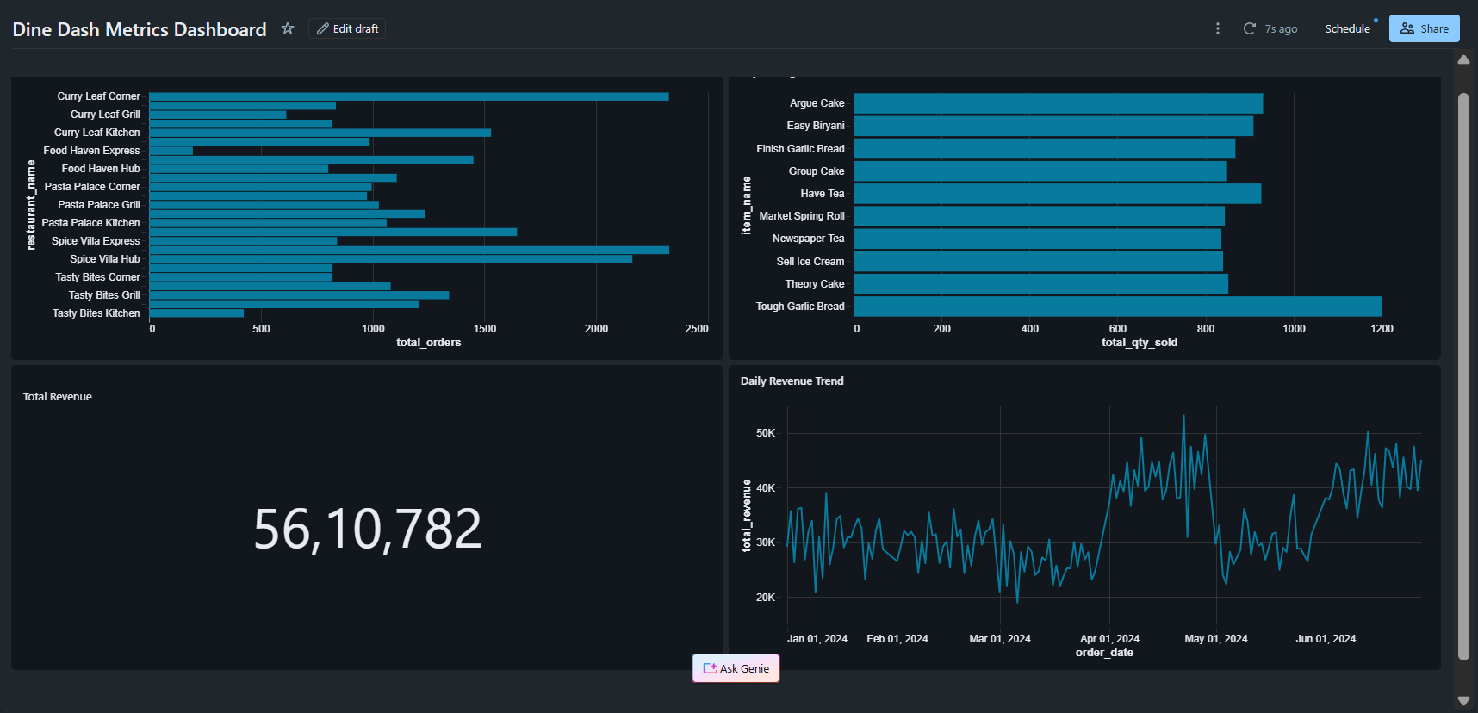

Publish Dine Dash Metrics Dashboard
Publish the completed dashboard. Published Dine Dash Metrics Dashboard using the default publishing options. The dashboard is published and contains the required visualizations.

Workflow Incremental Update — July and August

DineDash Workflow — Pipeline Task
Create the workflow required to execute the DineDash DLT pipeline. Created DineDash Workflow and added Dinedash_ETL_Pipeline as the first Pipeline task. The workflow contains the DLT pipeline as Task 1.
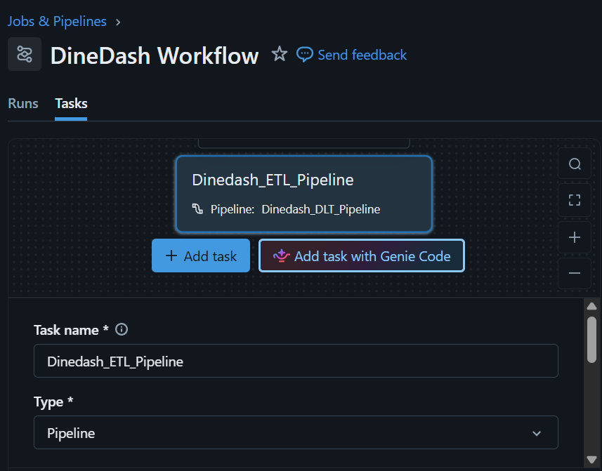

DineDash Workflow — Dashboard Task
Add the dashboard as the second workflow task. Added DineDash_Dashboard and configured it to run after Dinedash_ETL_Pipeline succeeds. The workflow now contains the required Pipeline → Dashboard dependency.
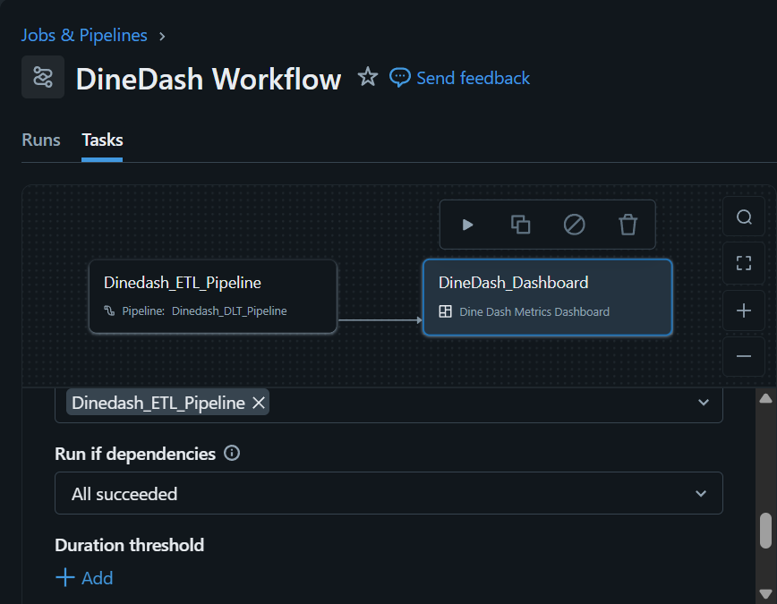

DineDash Workflow Execution
Execute the complete workflow. Ran the workflow using Run now, executing the DLT pipeline followed by the dashboard task. Both workflow tasks completed successfully.
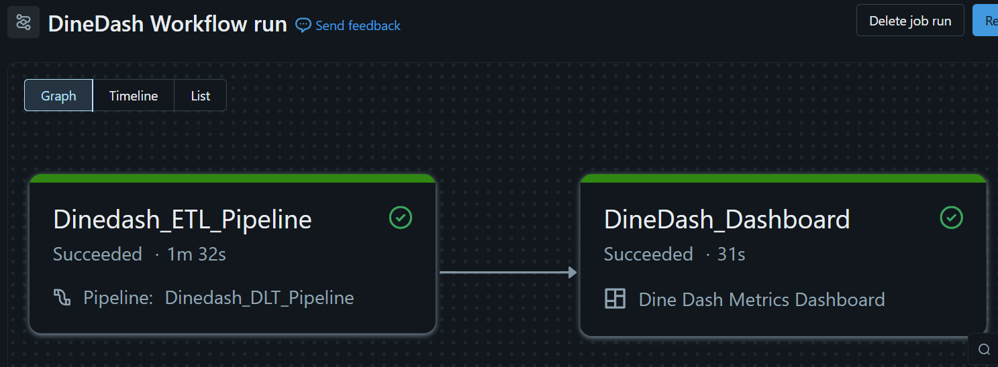

Workflow Run Validation
Verify successful execution of both workflow tasks. Opened the latest workflow run and inspected the task execution details. The pipeline and dashboard tasks completed successfully.

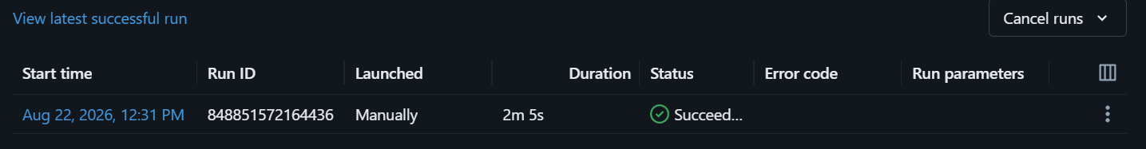

Dashboard Validation through Workflow
Verify that the workflow successfully refreshes the dashboard. Opened the dashboard link from the successful dashboard task and inspected the displayed metrics. The DineDash dashboard was refreshed and displayed the required business metrics.

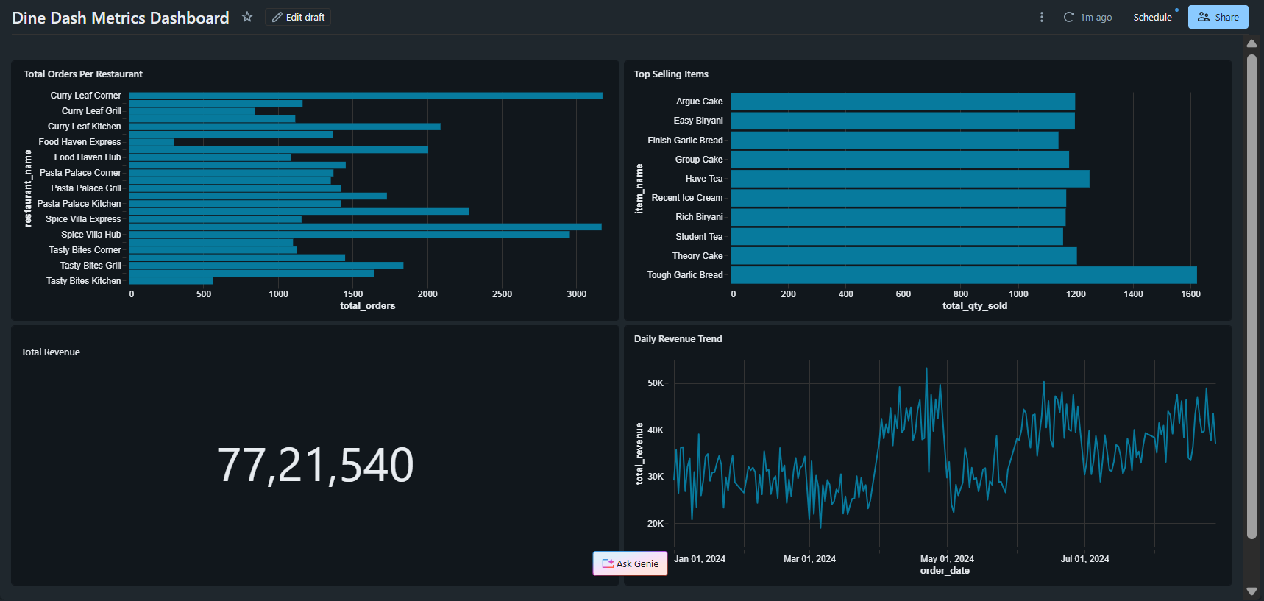

Workflow Incremental Update — Remaining 2024 Files
The remaining order files from September to December were added to the existing orders folder. The workflow was then executed using Run Now, triggering the DLT pipeline and dashboard tasks to process the newly added data. The workflow successfully processed the remaining order data incrementally, and the dashboard was updated with the additional data.

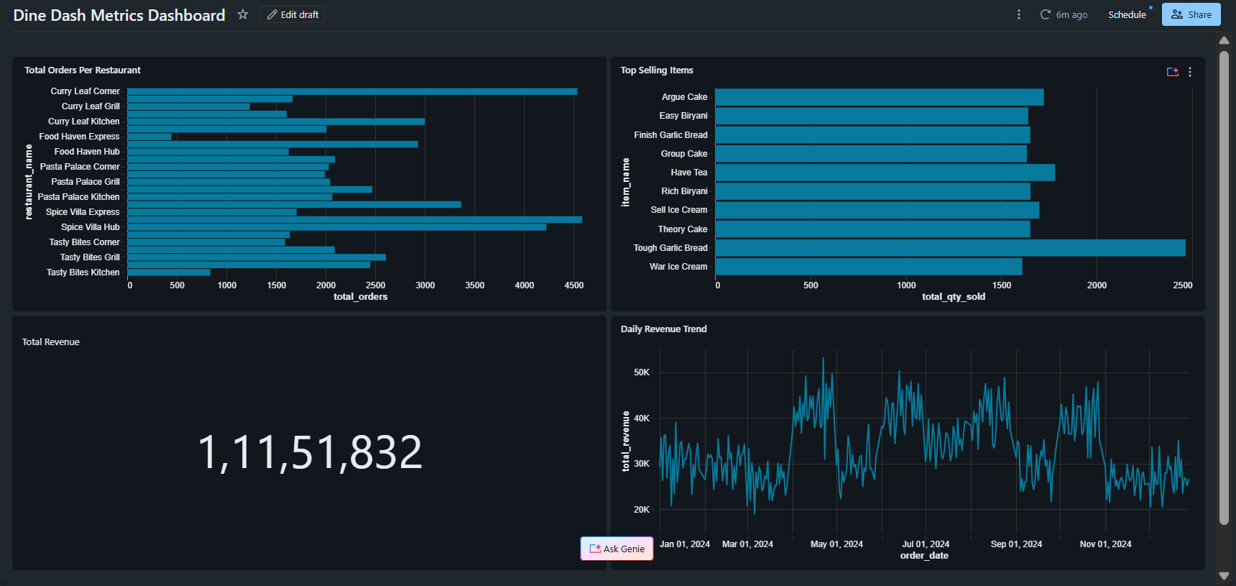

Additional Analysis and Observations
Data quality observation: some order records reference restaurants for which the enriched restaurant name is unavailable. This is also reflected in the DLT data-quality results, where records failing the restaurant-name expectation are dropped. The same issue therefore appears both in analysis and in automated pipeline validation.
Some records contain a total order amount of $0, including records marked as delivered. This should be treated as a source-data quality issue rather than automatically as a meaningful business pattern.
Some customer signup dates appear substantially older than the operating history described in the case study. This is best interpreted as a characteristic of the supplied sample dataset rather than as an operational conclusion about DineDash.
The orders_bronze table intentionally preserves the raw order stream without the same dimension-level filtering applied to the five reference datasets. As a result, source-data issues can propagate into downstream analysis until Silver-layer expectations are applied.
The cuisine-diversity metric should be interpreted carefully because the supplied dataset contains a limited number of cuisine categories. A high diversity count therefore reflects the available category range as well as agent activity.

Conclusion
This capstone implemented the DineDash data-engineering workflow on Azure Databricks from source ingestion through SQL analysis, automated DLT processing, Gold-layer business metrics, dashboarding, and workflow orchestration. The project demonstrated manual incremental ingestion with COPY INTO as well as streaming and incremental processing with the DLT pipeline. The final workflow connected pipeline execution with dashboard refresh, while the data-quality checks exposed issues present in the supplied source data and showed how Silver-layer expectations can identify and handle those records.

Final Results
Source data was organized in a Unity Catalog Volume with separate dimension and streaming-order directories.
Dimension datasets were explored through direct reads, represented as temporary views, stored in manually defined Bronze Delta tables, and filtered into cleaned dimension tables.
orders_bronze was populated incrementally for January, February, and March using COPY INTO with record-count verification.
The required 12 Order Data Analysis and 15 Orders and Dimension Dataset Analysis questions were completed.
The DLT pipeline processed the initial January-June data, then processed July-August incrementally, followed by the remaining 2024 files.
DLT data-quality expectations were reviewed during incremental processing, including observation of dropped records and their failing expectation.
The required Gold-layer metrics were used to create and publish the DineDash dashboard.
The Databricks workflow executed the DLT pipeline and dashboard tasks and was rerun with additional source data to demonstrate incremental dashboard updates.

