Enhancing Bone Fracture Detection with Task Specialized Attention Models and Knowledge distillation
Sneha Sharma
Amity Centre for Artificial Intelligence
Amity University, Noida
Uttar Pradesh, India
ssharma54@amity.edu
Amey Ganesh Medewar
Department of Information Technology , Shri Guru Gobing Singhji Institute of Engineering and Technology, Nanded, Maharashtra , India .
2022bit153@sggs.ac.in

Abstract - Accurate and timely detection of bone fractures is essential for effective clinical management and treatment planning. Conventional methods, reliant on manual interpretation of X-ray images by radiologists, are labour-intensive and prone to variability. In recent years, deep learning, especially convolutional neural networks (CNNs), has significantly enhanced fracture detection accuracy by automating image analysis processes. In CNN a special technique known as knowledge distillation has emerged as a promising way within deep learning, enabling the transfer of knowledge from complex "teacher" models to simpler "student" models. This approach boosts computational efficiency and speeds up inference times while maintaining diagnostic precision, making it particularly advantageous in medical imaging.
This research investigates the application of knowledge distillation to develop robust model for automated bone fracture detection from X-ray images. By distilling insights from sophisticated teacher models into streamlined student models, the study aims to optimize fracture detection performance while minimizing computational complexity. Various deep neural network configurations, including multi-head CNNs and Long Short-Term Memory (LSTM) architectures, are explored to enhance the student models' ability to accurately identify fractures across anatomical regions such as the hand, leg, shoulder, and hipbone.

Keywords - CNN, X-RAY, Knowledge Distillation, Bone fracture , teacher-student model.

INTRODUCTION
One of the significant challenges in the field of orthopedics is the issue of undiagnosed or misdiagnosed bone fractures [Ahmed, K. D.(2023)]. Such diagnostic errors can lead to incorrect treatment plans and result in extended treatment periods. In accidental scenario before an orthopedic specialist can examine the patient, emergency department staff must interpret X-ray images to identify fractures. This task requires a combination of radiological and surgical expertise, which involves time-consuming and specialized training [[Zou J(2024)].
As the rise of advanced deep learning techniques in computer vision has opened up new avenues for fracture detection. By leveraging sophisticated deep learning models, it is possible expedite the detection of bone fractures from X-ray images and reduce the workload for physicians.
In recent years, deep learning models have achieved rapid advancements and demonstrated exceptional performance across various domains. However, these models are often characterized by a large number of parameters, which makes them both large and slow [Gou J(2021)]. The development of advanced computing hardware, such as GPUs and TPUs, has enabled the training and deployment of these complex models in numerous applications [zara A(2021)]. Despite these advancements, deploying deep learning models in mobile and embedded systems, like smartphones or robots, presents significant challenges due to limitations in energy consumption and computational power. This has sparked interest in research focused on methods to reduce the size and complexity of deep learning models while preserving or even enhancing their accuracy. Strategies for achieving this includes optimizing computational operations, employing pruning techniques, quantizing model parameters to minimize memory usage and improve inference speed, and designing more efficient model architectures.
A particularly promising approach in this area is Knowledge Distillation [Gou J(2021)]. This method involves using a large, well-trained model, known as the "teacher," to guide the development of a smaller, more efficient model called the "student" [zara A(2021)]. The goal of knowledge distillation is to transfer the knowledge from the larger model to the smaller one, balancing the need for reduced computational demands with the desire for high performance. The success of this technique heavily depends on the capabilities of the teacher model [Hinton G(2015]. If the teacher model is not sufficiently effective, the distillation process may not yield a highly accurate student model. Conversely, very powerful teacher models can produce overly confident predictions, which might limit the effectiveness of the knowledge transfer. The major contribution of this paper is summarized as follows:
- A novel task specialized knowledge distillation approach is proposed

that aims to train multiple teacher models, focusing on different, non-overlapping regions of X-ray images.

- The multi-head convolutional model is proposed that is capable of detecting features at multiple scales, which is essential given the variability in the appearance of bone fractures.
- Analyzing the performance metrics such as classification accuracy, precision, recall, and F1-score to evaluate the effectiveness of the model under different distribution schemes.
The structure of the remaining paper is organized as follows: In section 2, a review of the existing methods for knowledge distillation and bone fracture detection is presented, highlighting how our proposed method differs from and advances these existing approaches. Section 3 provides a detailed explanation of the proposed method, including its theoretical foundations and practical implications. Section 4 presents the results obtained for the classification of fractured and non-fractured bone X-ray images, while comparing the proposed task specific knowledge distillation method and conventional teacher student knowledge distillation method. These models are also trained under different distribution schemes, highlighting the effectiveness of our proposed approach. Additionally, this section compares the trainable parameter size and memory usage for the proposed teacher student network architecture. Finally, section 5 extends a conclusion and outlines potential directions for future research.

RELATED WORK

Knowledge Distilation

Knowledge Distillation was initially introduced as a model compression technique designed to simplify the training of deep networks by employing a student-teacher framework. In this paradigm, the student model is trained based on a softened version of the output produced by the teacher model [Hinton G(2015]. The underlying premise is that the knowledge learned by the teacher model is embedded within the soft probabilities of its predictions. Thus, to effectively train a student model to think in the same way as the teacher, it is essential to transfer the similarities between classes for each sample, rather than focusing solely on the final predictions. To facilitate the transfer of this knowledge, which reflects the similarities between different classes, Hinton et al. [Hinton G(2015] introduced a temperature parameter 𝑇 in the SoftMax activation function. This parameter allows for adjusting the smoothness of class probability estimations, making the output distribution less spiked and more informative.
More specifically, Knowledge Distillation operates as follows. Let {K_{i}|i=1,2…,n} represent a set of n training samples with L classes, and let N(⋅) ∈R^{L} denote the teacher network that outputs logits for each class. For simplicity, S_{pq} refers to the qth logit for the p-th training sample. The probability of the q-th class for the p-th sample is then estimated as:
$X_{pq}=\frac{exp⁡({ S}_{pq} /T)}{\sum_{L}{exp⁡( { S}_{pq} /T)}}$ (1)

Higher values of T result in a smoother, softer probability distribution, whereas lower values produce a more peaked distribution. When appropriately tuned, the temperature parameter reveals intra-class similarities for each sample, aiding in the knowledge transfer process.
The student model, denoted as M_{j}(⋅)​, where j represents its trainable parameters. The soft probabilities of the student model, $Y_{pq}$ ​, are computed in the same manner as $X_{pq}$​, and ${Z'}_{pq}$ is used to denote the student model's output when T=1. The overall distillation loss function is then defined by combining the standard cross-entropy loss with the constraint that encourages the student to mimic the teacher's behavior [4]:
${Loss}_{KD} = -α\sum_{p=1}^{n}{\sum_{q=1}^{L}{X_{pq}\log{Y_{pq}}}}-\left(1-α\right) \sum_{p=1}^{n}{\sum_{q=1}^{L}{Z_{pq}\log{{Z'}_{pq}}}}.$ (2)

where $Z_{p}$ represents the one-hot encoded ground truth label for the p-th sample, and $α$ ∈[0,1] is a hyperparameter that controls the balance between the distillation process and the regular training of the student model. This approach allows the student model to simultaneously learn from the teacher's output and the ground truth labels.

Applications of Knowledge Distilation

Knowledge distillation has emerged as a powerful technique for transferring knowledge from large, complex neural networks to smaller, more efficient models, enabling their deployment in resource-constrained environments without significant loss in performance. Beyond model compression, Knowledge distillation has been employed for various applications. For instances, in the study by Zheng et al. (2024), knowledge distillation was applied to the recognition and classification of Chinese herbal medicine using a dual-teacher supervised decay (DTSD) model. The dual-teacher framework allowed the model to optimize predictions by combining soft labels from two teacher models, ResNet50_vd and DenseNet121, significantly improving recognition accuracy and robustness. The study reported an impressive classification accuracy of 98.60% while maintaining a compressed model size of 10 MB. Li et al. (2023) explored the application of knowledge distillation for low-light image enhancement, addressing the challenges of high computational cost in convolutional neural network (CNN)-based methods. The proposed teacher-student framework used gradient-guided networks, where the student network learned from the teacher network via attention map-based distillation loss. Cheng Dai et al. (2023) introduce a lightweight model for human action recognition using skeleton-based features, focusing on edge computing environments, where resources are limited. Their novelty lies in using tucker decomposition to transfer knowledge from a large teacher model to a smaller student model, ensuring efficiency in edge devices. Zhou W (2024) have shown that, KD is applied through a dual semantic approximation network (DSANet-KD) to improve rail surface defect detection. The focus was on both foreground and background knowledge using a teacher-student framework. Specifically, a thoroughly trained teacher defect detection network equipped with dual semantic approximation information guides the student network's training. KD effectively enhances object detection, improves low-precision network performance, and boosts self-supervised learning by leveraging different models for pretext and main tasks. In another work by [Adepu, A. K., (2023)], they employed KD for efficient classification of melanoma from dermatoscopy images. Initially the teacher model is a pre-trained EfficientNet-B5, and the student model is a smaller EfficientNet-B2. The knowledge distillation process involves using the predictions of the teacher model as soft targets to guide the student model's learning, in addition to the hard targets (ground truth labels). These diverse applications demonstrate the versatility of knowledge distillation in addressing various challenges in machine learning, including model compression, accuracy improvement, and robustness enhancement.
Table 1: Literature Review on KD

No. | Data | Dataset | Model | Evaluation | Application
[8] | Rail Surface Images | Not available | Ds ANet-KD | Adversial sample success rate 0.45 | To address the common problem of balance between number of parameters and accuracy  Of RSDD models
[10] | Dermatoscopic images | ISIC-2020 dataset | EfficientNet B5 (FL): teacher  EfficientNet B2 with distillation : Student | Not available | For Accurate melanoma classification
[11] | Pediatric wrist images | Medical University of Graz provides a public dataset named GRAZEPEDWRI-DX | YOLO-V8 | Not available | The application is  Designed to assist pediatric surgeons in analyzing fractures on pediatric wrist trauma x-ray images
[12] | Bone Fracture images | Not available | Different machine learning methods (Naïve Bayes,Random Forest,SVM,Decision Tree | Between 0.64 and 0.92 | Creating a program to help doctors for bone fracture analysis very quickly
[13] | Facial expression | AffectNet dataset | Light weight Mobile-Net v2 using KD | Not available | For facial expression recognition

PROPOSED METHODS

3.1 Task-Specialized Knowledge Distillation
Task-Specialized Knowledge Distillation (TSKD) is an effective framework for developing a generalized model by leveraging the expertise of multiple specialized teacher models. In this framework, each teacher model is independently trained on a specific bone fracture category, such as hip, hand, or leg fractures, using datasets tailored to their respective domains. These teacher models achieve high accuracy by focusing on their specialized tasks. A student model is then trained to generalize across all bone fracture categories using a combined dataset containing examples from all domains. Knowledge is transferred from the teacher models to the student through the knowledge distillation process.
During training, each teacher model outputs logits (z_{i}) corresponding to its specific fracture category, which are converted into softened probabilities using a SoftMax function with a temperature parameter (T). These softened probabilities (p_{i}​) act as soft targets, providing the student model with valuable insights into the teacher models' decision-making processes. The logits from all teachers are aggregated, either by averaging or weighted summation, to produce a unified output distribution. The student model is trained using a combination of the soft targets and the ground truth labels, with the total loss comprising two components: the distillation loss and the classification loss. The distillation loss minimizes the divergence between the student's predictions and the soft targets, while the classification loss ensures that the model adheres to the ground truth labels. The overall loss function is formulated as
L= $α$ L_{task} +(1− $α$) L_{distill}, (3)

where λ balances the importance of the two terms. The distillation loss is defined as the cross-entropy between the teacher's soft targets and the student's predictions, while the classification loss uses the ground truth labels for supervision. A higher temperature T is employed to soften the probability distribution of the teacher models, enabling the student to learn finer-grained relationships between classes. By combining task-specific expertise from multiple teacher models, the student gains a comprehensive understanding of all bone fracture categories. The student model's performance is then evaluated on a combined dataset to ensure its generalization across all tasks.
This framework presents several advantages. By training specialized teacher models and consolidating their knowledge into a single student model, TSKD achieves both specialization and generalization. The process enhances the performance of the student model while reducing the computational complexity of deploying multiple teacher models. This approach is particularly valuable in medical imaging, where domain-specific models for detecting fractures in different bones can be unified into a robust and efficient model.

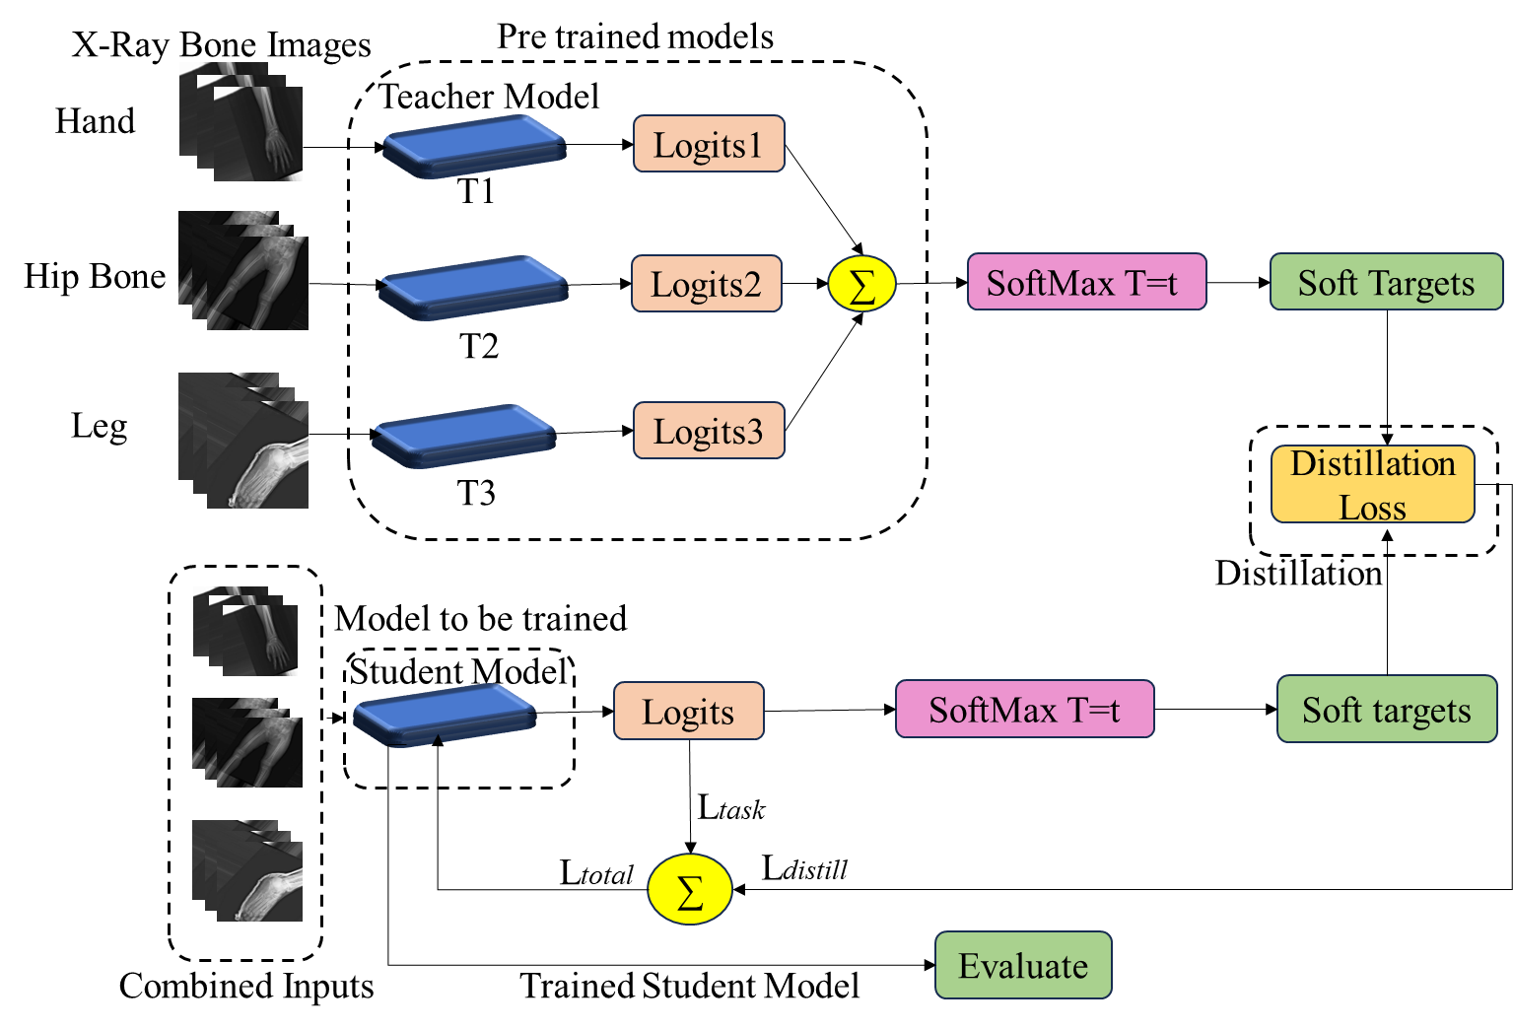

Figure 1. Overview of Task specialized knowledge distillation framework

3.2 Teacher Network Architecture
Figure 2. presents a teacher network architecture that is designed for bone fracture detection from X-ray images. The input layer processes X-ray images resized to 128×128, ensuring uniform dimensions for computational efficiency and compatibility with the network. A multi scale feature extraction is achieved through two head architecture through a series of two convolutional layers (with filter size 8 and 16 respectively) employing different kernel sizes of 3×3 and 5×5. Smaller kernels 3×3 is effective to focus on local details, which are crucial for detecting small cracks, sharp edges, small discontinuities, or hairline fractures that might be missed by larger kernels. Whereas larger kernels (5×5) provide a global perspective by identifying broader structural anomalies, irregular patterns or larger fractures that span multiple regions in the image. Two separate heads process the input data in parallel, ensuring the network learns a richer and more diverse set of features. This reduces the risk of missing critical patterns that may only be apparent at a specific scale. These layers are complemented by MaxPooling operations with pool size of 2×2 to reduce spatial dimensions while preserving salient features.
Additionally, when combined with mechanisms like spatial attention, a two-head architecture can direct the network to focus on fracture-relevant areas across multiple scales, ensuring no important detail is overlooked. Thus, a spatial attention module in each head is used to identifies and enhances the regions of the feature maps that are most relevant to the task, such as areas with fractures or structural irregularities in the X-ray. By assigning higher weights to spatial locations in the feature map that are likely to contain fracture-specific patterns, ensuring that the network prioritizes critical regions during the learning process. This process begins with global average pooling, which summarizes spatial information from the input feature map into a single feature vector per channel. This operation captures the global context of the feature distribution, ensuring the network considers broader patterns, such as the overall intensity and structural changes across the bone. Following this, a 1×1 convolutional layer is applied to generate a single-channel attention map, with a sigmoid activation function that scales the values between 0 and 1. This attention map highlights spatially important regions by assigning higher values to areas likely to contain fractures and lower values to irrelevant regions such as background or soft tissue.

The attention map is then element-wise multiplied with the original feature map, amplifying the features in regions identified as important and suppressing those deemed less relevant. This refinement ensures that the fracture-relevant information is preserved and emphasized while filtering out noise or unrelated background features. The final output of this process is an attention-refined feature map, which is passed to subsequent timeDistributed layer and an LSTM block (30 units) to process sequential dependencies. This enables the architecture to handle multiple perspectives or temporal patterns effectively, which is valuable in scenarios involving multiple X-ray views of the network. For classification, the architecture utilizes fully connected layers with Dropout (set at 0.4) to mitigate overfitting, particularly important given the typically limited size of medical datasets. The final Dense layer produces a single output neuron with a sigmoid activation function, yielding a probability score for the presence of a fracture. This design ensures robust and interpretable predictions, aligning with clinical needs by emphasizing areas of potential fractures.
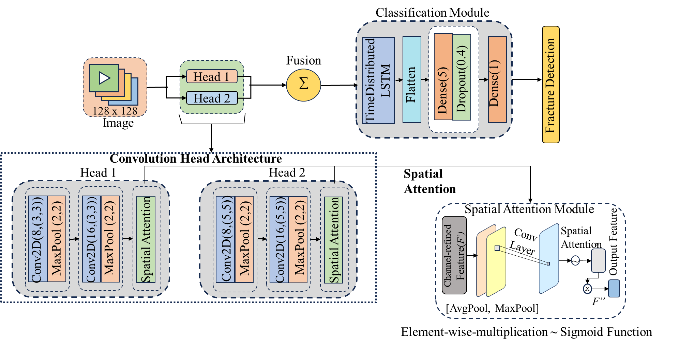

Figure 2. Multi head spatial attention-based teacher network architecture

3.2 Student Network Architecture
Figure 3. illustrates the student network architecture, designed as a computationally efficient counterpart to the teacher model, with the goal of maintaining fracture detection accuracy while being resource-conservative. Like the teacher, the student network processes input X-ray images resized to 128×128, ensuring standardized dimensions for effective feature extraction and alignment with the teacher model during knowledge distillation.
The head of the student model follows a simplified architecture, consisting of two convolutional layers with filters of size 8 and 16 and a uniform kernel size of 3×3. This choice prioritizes extracting essential local features, such as small cracks or edges, while minimizing model complexity. Each convolutional layer is followed by a MaxPooling operation with a pool size of 2×2, which reduces the spatial dimensions and emphasizes critical patterns relevant to fracture detection.
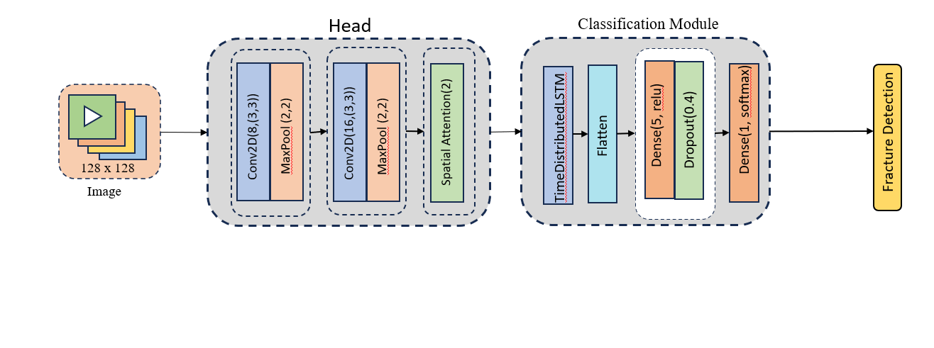
To enhance the model's focus on regions critical to fracture identification, the student employs a spatial attention module. This module operates by generating an attention map that highlights fracture-relevant regions while suppressing irrelevant areas. By doing so, the network ensures that only the most significant features are propagated forward.
After feature extraction, the output is processed through a TimeDistributed LSTM block to model sequential dependencies. This capability is valuable when analyzing multiple perspectives or temporal patterns in X-ray views. The LSTM is followed by a flattening operation and a fully connected dense layer with 5 units and a ReLU activation function, which facilitates intermediate representation learning.
To prevent overfitting, a Dropout layer with a rate of 0.4 is integrated before the final classification stage. The network concludes with a dense layer consisting of a single output neuron and a softmax activation function, which generates the probability score for the presence of a fracture.
This streamlined design leverages the learned knowledge distilled from the teacher network to optimize performance and computational efficiency, achieving robust predictions aligned with the clinical requirements of fracture detection.

METHODOLOGY

Firstly introducing the dataset used to evaluate robustness of the model along with it employed architectures and then the evaluation results are displayed and discussed..

3.1 Datasets and evaluation setup:

The proposed model was evaluated using the FractAtlas dataset, available on Internet, to optimize the hyperparameters crucial for achieving the best performance. This dataset comprises approximately 3,500 X-ray images categorized into fracture and non-fracture types, encompassing four distinct anatomical regions: hand, leg, hip, and shoulder. To enhance model performance, preprocessing techniques were applied to these images. Given the inherent imbalance in the dataset, data augmentation strategies were employed to equalize the distribution of fracture and non-fracture images.
The model development process involved training three distinct teacher models, each specialized in a different domain of the dataset. The data was initially segmented according to the provided CSV file, and then each teacher model was trained independently on its respective subset. Following the training of these teacher models, knowledge distillation was performed to create a lightweight student model.

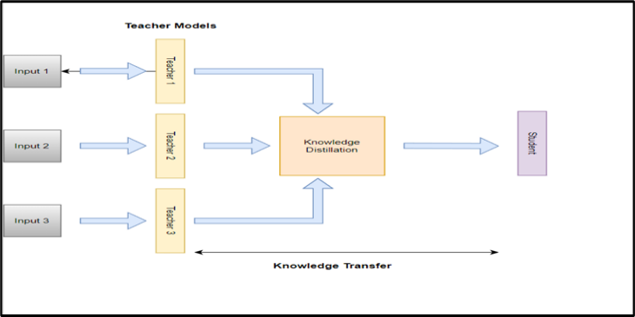
Figure 2: Process Architecture of Knowledge Distillation

  - Teacher Model Architecture

To enhance the efficiency and effectiveness of the model, knowledge distillation was employed to transfer insights from the three robust teacher models into a streamlined student model [Pravin S(2024)]. This technique leverages the sophisticated feature extraction and representation capabilities of the teacher models while crafting a student model that retains high performance with a significantly smaller computational footprint (Figure 1).
The teacher models utilized a multi-head CNN architecture. Specifically, each teacher model featured two distinct convolutional heads. Each head comprised two convolutional layers followed by a max-pooling layer. The outputs from these two heads were concatenated into a unified feature map. This concatenated feature map was subsequently processed by a LSTM network. The LSTM layer was followed by a flattening operation, and then a fully connected (dense) layer with 10 units was applied. The final output was produced by a dense layer with a single unit, representing the binary classification of fracture versus non-fracture.
This multi-head CNN approach was designed to capture different aspects of the input data, enhancing the model's ability to learn complex features (Figure 2)[ Ju, R.]. The concatenation of features from the two convolutional heads allows the model to leverage diverse feature representations, which are then effectively processed by the LSTM layer to capture temporal dependencies.
The knowledge distillation process involves training the student model to replicate the nuanced behivour and decision-making patterns of the teacher models [Gou J(2021)]. This transfer of knowledge not only preserves the accuracy and robustness derived from the teacher models but also ensures that the student model operates with improved efficiency, facilitating faster inference and reduced resource consumption (Figure 3).

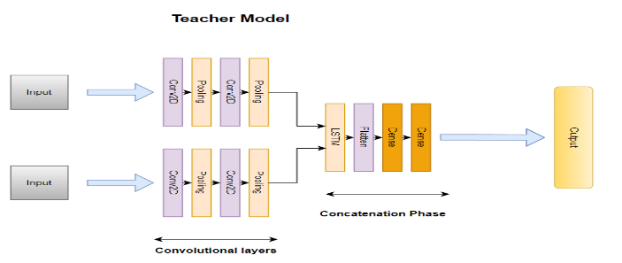
Figure 3: Teacher Model Architecture

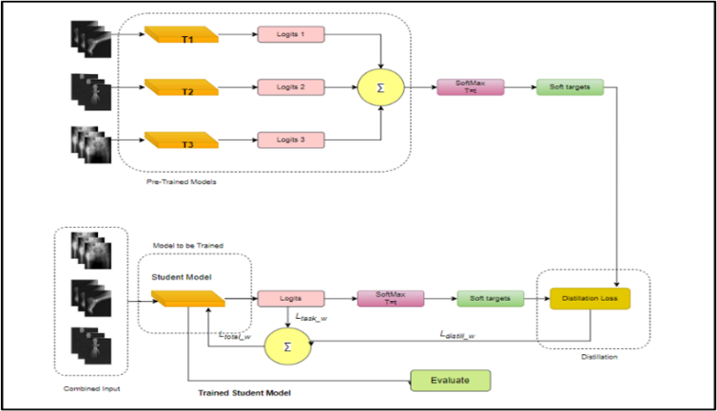
Figure 4: Detailed Knowledge Distillation process

  - Model Training

Key points for the model training :

- Data Preparation: Images of fixed sizes (128 X 128) and their corresponding labels are stored in arrays images and labels, respectively. The data is shuffled using a random state of 42 to ensure randomization.

- Data Split: The shuffled data is split into training (80%) and testing (20%) sets using a standard train_test_split approach.

- Labelling : The labels (train_labels and test_labels) are converted into categorical values to prepare them for model training.

- Model Architecture: Initially, a Multihead CNN and LSTM architecture were implemented for the teacher model. This configuration involves two sets of two CNN layers, followed by concatenation and connection to LSTM and dense layers. Conversely, the student model is designed with a simpler architecture, consisting of two CNN layers followed by LSTM and dense layers.

- Model Compilation: Each model is compiled using binary crossentropy as the loss function, Adam optimizer, and binary accuracy as the evaluation metric.

- Input Data: The training data train_images and corresponding labels train_labels are used for model training.

- Validation Split: A validation split of 0.1 is applied, meaning that 10% of the training data is reserved for validation during each epoch. This helps monitor model performance on unseen data and prevents overfitting.

- Epochs: The model is trained for 50 epochs, representing the number of times the entire training dataset is passed forward and backward through the neural network.

- Verbose: Setting verbose=1 enables verbose mode during training, displaying progress bars and training metrics for each epoch.

- Batch Size: The batch size is set to 32, indicating that the training data is divided into batches of 32 samples each for efficient computation during training

EXPERIMENTAL EVALUATION

4.1 Accuracy Evaluation and Model Comparison

The evaluation of the models involved detailed accuracy reporting beyond just the final ensemble results. A rigorous comparison was made between the student model, the individual teacher models, and the ensembles of teacher models. This analysis offered a multi-dimensional view of model performance.
In addition to the overall accuracies, we specifically examined three scenarios to understand the models' generalization capabilities. For these cases, each teacher model was trained on a combined dataset from two types of bone images and then tested on a third, different type. This approach was intended to assess how well the models adapt to bone types they were not directly trained on.

The evaluation consists following things:

1. Student Model Accuracy: Reflecting the performance metrics of the compact model resulting from knowledge distillation.
2. Teacher Models' Accuracy: Providing detailed performance scores for each individual teacher model to showcase their specialized capabilities.
3. Ensemble Accuracy: Demonstrating the aggregated performance when the teacher models are combined.
4. Case Study Accuracy: Results from specific scenarios where teacher models, trained on combined data
from two bone types, were tested on a third type, highlighting their adaptability.
Table 2: Testing accuracies of Models on different combinations of data

 | Training Data | Testing Data | Testing Accuracies
Same Distribution | Combined | Combined | 84
 | Hand, Leg | Hip | 36
Different Distribution | Hand, Hip | Leg | 53
 | Leg, Hip | Hand | 47

The final accuracy reported as :

1. Single Teacher, Single Student Model Accuracy: This metric reflects the performance when a single teacher model is trained on the entire dataset and knowledge distillation is applied to create the student model. This combined approach evaluates how well the distilled student model performs when trained with the full range of data.
2. Task-Specialized Unified Ensemble Model Accuracy: For this metric, each teacher model is trained on a specific subset of data, corresponding to particular bone types. Knowledge distillation is then applied to these task-specialized teacher models to create a unified ensemble. This approach assesses the performance of the ensemble model when leveraging specialized training for each teacher model, providing insights into how well the ensemble handles the diverse tasks.

This comprehensive reporting ensured a well-rounded understanding of how each model configuration performed. By including these varied accuracy measures, we were able to gain deeper insights into the effectiveness of the student model and the teacher models, as well as their performance in handling diverse fracture detection tasks.

  - Experimental Results:

The case-wise accuracies by training each teacher model on datasets created from three different combinations: two subsets were used for training while the remaining subset was utilized for testing. This approach was deliberately chosen to demonstrate how variations in the data impact model performance. As anticipated, this setup led to lower accuracies, highlighting the challenges of using diverse data for training and testing.

Table 1: Accuracies of Models on Different Distribution

The accuracies on segregated data are presented for three different models: the student model, the individual teacher model, and the ensemble of teacher models. This comparison illustrates how model complexity affects performance. As expected, the lightweight student model was designed to be more efficient but did not surpass the more complex teacher model in accuracy. Conversely, the ensemble of teacher models, which aggregates the knowledge of three distinct teacher models, achieved the highest accuracy, reflecting the benefits of combining multiple complex models.
Table 3:Training accuracies of Models on segregated data

Data | Student Accuracies | Teacher Accuracies
Hand | 81 | 93
Leg | 83 | 94
Hip | 83 | 88

The final accuracies are reported for two key configurations: the single teacher-single student model and the multiple teacher-single student model, also known as the task-specialized ensemble of teacher models. Based on a comprehensive comparison of all scenarios, the multiple teacher-single student model demonstrates the best performance, achieving a training accuracy of 97% and a testing accuracy of up to 91%. This suggests that the ensemble approach, which leverages specialized training from multiple teachers, yields superior results compared to the single teacher model setup.

Table 4:Performance analysis of Different Models after distillation

Model | Training Accuracy | Testing Accuracy
Single teacher Single Student | 90 | 87
Multiple Teacher Single Student(Task Specialized Ensembles) | 97 | 91

CONCLUSION

This paper introduces a method designed for training Knowledge Distillation aware teachers for detection of fracture or non-fracture bone from x-ray images. The approach involves training separate task-specific teachers within a unified ensemble structure, allowing for simultaneous end-to-end training of all teacher models. Experiments were conducted using three different datasets extracted from the FractAtlas X-ray image data. Various model configurations and combinations were employed for comparative testing.
Key conclusions drawn from the experiments include:
1. The lightweight student model can achieve significantly better performance when it benefits from knowledge transfer from a teacher model.
2. Whether explicitly or implicitly, diversifying the models within a teacher ensemble generally enhances KD efficiency.
3. Models trained on specialized datasets and incorporating knowledge transfer consistently outperform other configurations, providing the best results in the given setup.
.

References

- Ahmed, K. D., & Hawezi, R. (2023). Detection of bone fracture based on machine learning techniques. Measurement: Sensors, 27, 100723.
- Zou, J., & Arshad, M. R. (2024). Detection of whole body bone fractures based on improved yolov7. Biomedical Signal Processing and Control, 91, 105995.
- Gou, J., Yu, B., Maybank, S. J., & Tao, D. (2021). Knowledge distillation: A survey. International Journal of Computer Vision, 129(6), 1789-1819.
- Zaras, A., Passalis, N., & Tefas, A. (2021). Improving knowledge distillation using unified ensembles of specialized teachers. Pattern Recognition Letters, 146, 215-221.
- Hinton, G., Vinyals, O., & Dean, J. (2015). Distilling the knowledge in a neural network. arXiv preprint arXiv:1503.02531.
- Papernot, N., McDaniel, P., Wu, X., Jha, S., & Swami, A. (2016, May). Distillation as a defense to adversarial perturbations against deep neural networks. In 2016 IEEE symposium on security and privacy (SP) (pp. 582-597). IEEE.
- Rusu, A. A., Colmenarejo, S. G., Gulcehre, C., Desjardins, G., Kirkpatrick, J., Pascanu, R., ... & Hadsell, R. (2015). Policy distillation. arXiv preprint arXiv:1511.06295.
- Zhou, W., Hong, J., Ran, X., Yan, W., & Jiang, Q. (2024). DSANet-KD: Dual semantic approximation network via knowledge distillation for rail surface defect detection. IEEE Transactions on Intelligent Transportation Systems.
- Nair, A. M., Shreekumar, S., Sanap, T., Sarkar, R. K., & Narawade, V. E. (2024). Bone Fracture Detection using Artificial Intelligence-A Systematic Review. Grenze International Journal of Engineering & Technology (GIJET), 10.
- Adepu, A. K., Sahayam, S., Jayaraman, U., & Arramraju, R. (2023). Melanoma classification from dermatoscopy images using knowledge distillation for highly imbalanced data. Computers in biology and medicine, 154, 106571.
- Ju, R. Y., & Cai, W. (2023). Fracture detection in pediatric wrist trauma X-ray images using YOLOv8 algorithm. Scientific Reports, 13(1), 20077.
- Sahin, M. E. (2023). Image processing and machine learning‐based bone fracture detection and classification using X‐ray images. International Journal of Imaging Systems and Technology, 33(3), 853-865.
- Mollahosseini, A., Hasani, B., & Mahoor, M. H. (2017). Affectnet: A database for facial expression, valence, and arousal computing in the wild. IEEE Transactions on Affective Computing, 10(1), 18-31.
- Bhatnagar, A., Kekatpure, A. L., Velagala, V. R., & Kekatpure, A. (2024). A Review on the Use of Artificial Intelligence in Fracture Detection. Cureus, 16(4).
- Parvin, S., & Rahman, A. (2024). A real-time human bone fracture detection and classification from multi-modal images using deep learning technique. Applied Intelligence, 1-17.
Zheng, L., Long, W., Yi, J., Liu, L., & Xu, K. (2024). Enhanced Knowledge Distillation for Advanced Recognition of Chinese Herbal Medicine. Sensors, 24(5), 1559.

Li, Z., Wang, Y., & Zhang, J. (2023). Low-light image enhancement with knowledge distillation. Neurocomputing, 518, 332-343.

Dai, C., Lu, S., Liu, C., & Guo, B. (2024). A light-weight skeleton human action recognition model with knowledge distillation for edge intelligent surveillance applications. Applied Soft Computing, 151, 111166.

to develop high expertise in their specific areas. By specializing the teacher models in this way, we address the limitations of relying on a single, less diverse model. This approach allows each teacher to excel in its own specialized task, and the collective knowledge from these diverse teachers is then transferred to a student model, resulting in more effective and diverse knowledge extraction.

