Updated dataset part:
The Frac-Atlas dataset is an extensively curated collection of approximately 3,500 high-resolution X-ray images specifically designed for bone fracture detection. It stands out from existing fracture datasets by encompassing a diverse range of fracture types—both common and rare—across varying levels of complexity, from clear, easily visible fractures to subtle, minute ones. This diversity ensures a comprehensive training ground for robust fracture detection algorithms. Additionally, the dataset includes images categorized into fracture and non-fracture classes spanning four anatomical regions: hand, leg, hip, and shoulder. Annotated fracture locations, along with detailed metadata such as patient demographics, fracture types, and severity, make Frac-Atlas an invaluable resource for advancing both academic research and clinical applications.
To optimize model performance, various preprocessing techniques were applied to the dataset, focusing on enhancing contrast, edge detection, and size scaling to highlight differences between classes. Given the inherent class imbalance in the dataset, data augmentation strategies were employed to balance the distribution of fracture and non-fracture samples. The model development process involved training three distinct teacher networks, each specializing in a specific subset of the dataset segmented using the provided metadata. These teacher models were subsequently integrated through knowledge distillation to develop a lightweight student model. This approach ensured that the distilled student network retained the essential capabilities of the teachers while being computationally efficient.

Student model architecture part:
Figure 3 illustrates the student network architecture, which is computationally efficient and tailored as a resource-conservative counterpart to the teacher model, aiming to maintain high fracture detection accuracy. Like the teacher network, the student processes input X-ray images resized to 128×128, ensuring standardized dimensions for effective feature extraction and seamless alignment with the teacher during knowledge distillation.
The head of the student network features a streamlined convolutional architecture. It begins with two convolutional layers using 8 and 16 filters, respectively, each with a kernel size of 3×3, to capture key local features like small cracks or edges. To reduce computational complexity, each convolutional layer is followed by MaxPooling operations with a pool size of 2×2, effectively downsizing spatial dimensions and emphasizing significant patterns critical for fracture detection.
To prioritize fracture-relevant regions, the student model incorporates a spatial attention module. This module generates attention maps to highlight areas critical for identifying fractures while suppressing less relevant regions, improving overall feature extraction efficacy.
The intermediate feature maps are further processed through a TimeDistributed LSTM block, enabling sequential dependency modeling. This is particularly useful for scenarios requiring multi-view analysis or temporal context. The LSTM's output undergoes flattening before being passed into a fully connected dense layer with 3 units and a ReLU activation function to produce compact feature representations.
To mitigate overfitting, a Dropout layer with a rate of 0.4 is introduced before the classification phase. The network concludes with a single output neuron using a sigmoid activation function, which provides a binary probability score indicating the presence or absence of a fracture.
This architecture effectively utilizes knowledge distilled from the teacher model to balance computational efficiency with high predictive accuracy, fulfilling clinical fracture detection requirements.

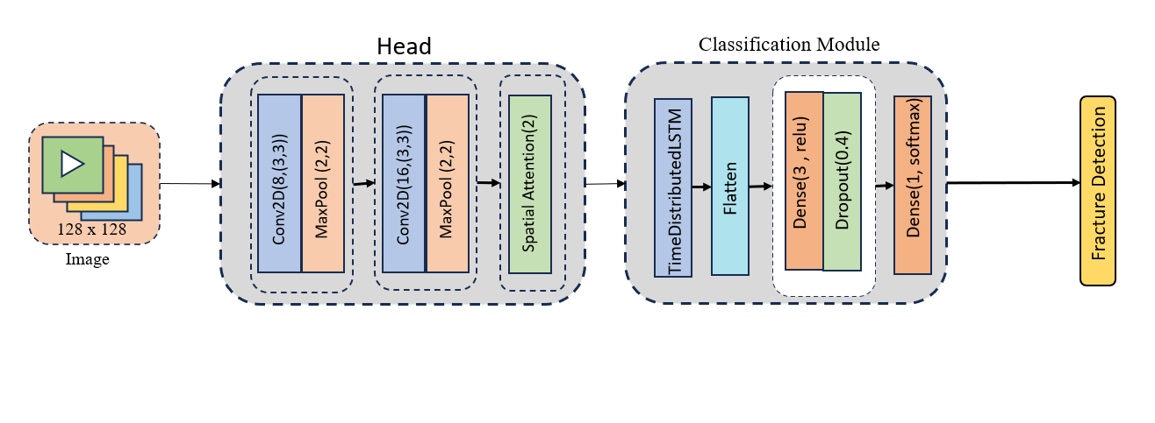

Fracatlas link: https://www.nature.com/articles/s41597-023-02432-4

Equations:
$$F_{i,j,k}=σ\left(\sum_{m=1}^{M}{\sum_{n=1}^{N}{W_{m,n,k}} . X_{i+m,j+n}+ b_{k}}\right)$$
$$P_{i,j,k} = \max\left\{ F_{m,n,k} \right| \left(m,n\right)∈pooling window at (i,j)\}$$
$$G_{k}= \frac{1}{H ×W} \sum_{i=1}^{H}{\sum_{j=1}^{W}{F_{i,j,k}}}$$
$$A_{i,j,k}=σ({Conv}_{1×1}\left(G_{k}\right))$$
$$F_{i,j,k}^{'}= A_{i,j,k }. F_{i,j,k}$$
$$H_{t}=f(W_{dense} . F_{t}^{'}+ b_{dense})$$
$$i_{t}= σ\left(W_{xi} . H_{t-1}+W_{hi} . X_{t}+ b_{i}\right)$$
$$f_{t}= σ\left(W_{xf} . H_{t-1}+W_{hf} . X_{t}+ b_{f}\right)$$
$$o_{t}= σ\left(W_{xo} . H_{t-1}+W_{ho} . X_{t}+ b_{o}\right)$$
$$c_{t}=f_{t}⋅c_{t-1}+i_{t}⋅tan(W_{xc} . H_{t-1}+W_{hc} . X_{t}+ b_{c})$$
$$H_{t}= o_{t} . tanh(C_{t})$$
$$y= σ\left(W_{final} . H + b_{final}\right)$$

