 | SOMAIYA  V I D Y A V I H A R  K J Somaiya Institute of Technology  An Autonomous Institute Permanently Affiliated to the University of Mumbai

DEPARTMENT OF INFORMATION TECHNOLOGY
Report On
SmartShield: Delegatecall-Focused
Smart Contract Security Analyzer

Prepared By:
Siddhesh Pandey (Roll No. B-01)
Harsh Parmar (Roll No. B-04)
Shrey Makarand Rane (Roll No. B-20)
Under the Guidance of:
Dr. Vijaya Umesh Pinjarkar
Professor, Department of Information Technology

Department of Information Technology
Academic Year: 2026-2027
Autonomy Syllabus Scheme-II - SEMESTER VII (LY-IT)

SOMAIYA
V I D Y A V I H A R
K J Somaiya Institute of Technology
An Autonomous Institute Permanently Affiliated to the University of Mumbai
CERTIFICATE
This is to certify that the following students:
Student Name | Roll No. / Seat No.
Siddhesh Pandey | B-01
Harsh Parmar | B-04
Shrey Makarand Rane | B-20

have submitted the Blockchain Mini-Project Report entitled “SmartShield: Delegatecall-Focused Smart Contract Security Analyzer” as partial fulfillment of the requirements of the Bachelor of Technology in Information Technology during the academic year 2026-2027, under the guidance of Dr. Vijaya Umesh Pinjarkar. The work described in this report is based on the project implementation and its documented test fixtures and outputs.

____________________________ | ____________________________
Dr. Vijaya Pinjarkar  Project Guide  Professor, Department of Information Technology | Dr. Radhika Kotecha  Head of Department  Department of Information Technology

Date of Examination: ____________________

Signature of Internal Examiner:  ________________________ | Signature of External Examiner:  ________________________

Table of Contents
Content | Page No.
Acknowledgement | 1
Abstract | 2
1. Introduction | 3
1.1 Motivation | 3
1.2 Aim and Objective | 3
1.3 Scope | 4
2. Literature Review | 5
2.1 Gap Identification | 6
3. Proposed System | 7
3.1 Architecture | 7
3.2 Components Discussion | 8
3.3 Workflow | 9
4. Implementation Details | 10
4.1 Tech stack | 10
4.2 Data and Analysis Description | 11
4.3 Screenshots of project including Solidity Source Code | 13
5. Results and Discussion | 18
5.1 Observations and Analysis | 19
5.2 Comparison of Proposed System with Existing Systems | 19
5.3 Vulnerability Analysis and Validation Boundaries | 20
6. Observations | 23
7. Conclusion | 24
8. Future Work | 25
9. References | 26

Acknowledgement

Before presenting our mini-project entitled “SmartShield: Delegatecall-Focused Smart Contract Security Analyzer”, we would like to express our sincere gratitude to the people who supported us during the planning, implementation, and documentation of this work.
We are grateful to our project guide, Dr. Vijaya Pinjarkar, for her guidance, suggestions, and encouragement throughout the development of the project. Her feedback helped us refine the problem definition, understand the technical requirements, and present the implementation in a structured manner.
We also thank the Principal, Dr. Vivek Sunnapwar, the Head of the Department, Dr. Radhika Kotecha, and the faculty members of the Department of Information Technology, K J Somaiya Institute of Technology, for providing the academic environment and facilities required to complete the mini-project.
Finally, we acknowledge the authors of the DelegateTracker research paper, which provided the technical foundation for studying delegatecall-related state-variable data flow and attack-path reasoning. We also thank our classmates, friends, and families for their support during the project.
The report describes the current implementation as represented by the submitted SmartShield source repository. Any item identified as a candidate or as future work is intentionally not presented as a confirmed vulnerability or a completed feature.

Abstract

The use of delegatecall in Solidity enables a contract to execute code from another contract while retaining the calling contract’s execution context, including its storage. Although this mechanism supports reusable logic and proxy-style designs, unintended writes to caller storage can affect later authorization checks and security-sensitive operations. This project presents SmartShield, a delegatecall-focused static analysis tool for Solidity smart contracts, developed with reference to the read-write data-flow and attack-path methodology proposed by DelegateTracker [1]. SmartShield accepts Solidity source code and constructs a structured contract representation using AST parsing. It extracts contract and function information, tracks state-variable READ and WRITE relationships, builds function call and control-flow representations, identifies delegatecall sites, models basic EVM storage slot and offset information, and detects sensitive operations such as selfdestruct, Ether transfers, and judgment conditions. An attack-path generator correlates these signals into human-readable candidate paths of the form Writer Function → State Variable → Reader Function → Sensitive Sink. The project includes a browser-based interface, a Node.js/Express API, a command-line entry point, JSON/CSV export, and Solidity example contracts covering safe, vulnerable, cross-contract, storage-mismatch, and unresolved-target scenarios. The included example result package for vulnerable_owner.sol reports two candidate paths, both explicitly marked as requiring further validation. SmartShield is therefore a first-stage static analyzer: it assists developers in locating relationships that deserve review, but it does not independently prove runtime exploitability. Symbolic constraint solving, dynamic EVM execution, broader benchmarking, and accuracy evaluation remain important directions for future work.

1. Introduction
Smart contracts encode application rules that execute within a blockchain virtual machine. Their state variables preserve contract data, while public and external functions provide controlled entry points for changing or reading that data. Solidity also provides delegatecall, which executes code located in another contract using the storage and execution context of the calling contract. This behaviour is useful for modular and upgradeable designs, but it creates a security boundary that is different from an ordinary external contract call [1], [6].
A delegatecall-related issue may involve more than the presence of a delegatecall instruction. A function in the delegated code can write a state variable in the caller’s storage. A different function may later read that variable as part of an authorization condition, a transfer decision, or another sensitive operation. The important analysis task is therefore to connect the write, the later read, the delegatecall context, and the operation that may be influenced.
SmartShield is designed as a source-level analysis tool for exploring these relationships. It parses one or more Solidity source inputs, extracts a program model, analyses state-variable access patterns, and presents candidate attack paths with supporting storage and source context. The system is intended to help a developer or reviewer understand why a piece of code deserves further inspection, rather than to replace a complete security audit.

1.1 Motivation
The motivation for SmartShield is the difficulty of interpreting delegatecall security warnings when they are presented only as isolated findings. A warning that states “delegatecall detected” does not necessarily explain which state variable could be affected, which function may write it, where it is read later, or which sensitive operation may depend on it.
- A delegated implementation can execute code in the caller contract’s storage context, so storage declarations and slot alignment need to be considered.
- A state variable may be modified in one function and used in another function, creating a cross-function dependency that is not obvious from a single code fragment.
- Security-sensitive operations include Ether transfers, selfdestruct-related behaviour, and conditions used to control access or execution flow.
- Reviewers need a traceable explanation, including function names, variable names, source locations, and storage context, rather than only a risk label.
- A static analyzer must communicate the boundary between a possible path and a verified exploit, because runtime conditions may prevent the path from being used by an attacker.
The DelegateTracker paper [1] motivates this project by combining read-write data-flow capture with attack-path search and a separate validation stage. SmartShield adapts the path-oriented reasoning into a deterministic source-analysis workflow and a visual inspection interface, while retaining the distinction between static candidates and validated vulnerabilities.

1.2 Aim and Objective

Aim
To design and implement a delegatecall-focused static analysis tool that examines Solidity source code, connects state-variable write and read relationships with security-sensitive operations, and presents explainable candidate attack paths with storage context.

Objectives
1. To parse Solidity source files and construct a structured representation of contracts, functions, modifiers, state variables, and source locations.
2. To identify function-level state-variable READ and WRITE relationships and represent function-call and control-flow relationships for inspection.
3. To detect delegatecall sites and security-sensitive operations, including selfdestruct, Ether transfer operations, and judgment-condition checks.
4. To calculate basic EVM storage slot, byte offset, and packing information and use it as context when presenting delegatecall-related findings.
5. To generate candidate attack paths and expose the results through the web interface, command-line workflow, and machine-readable JSON/CSV exports.

1.3 Scope
The current scope includes source-level analysis of Solidity files, AST-based program extraction, function and state-variable modelling, READ/WRITE data-flow extraction, call-graph and control-flow information, delegatecall identification, sensitive-operation detection, basic storage-layout modelling, candidate attack-path generation, and presentation of findings in the application interface. The repository also includes example Solidity contracts, a CLI, a backend API, and structured result files for handoff to a later validation stage.
The current implementation does not execute contracts on an EVM, does not solve all path constraints symbolically, and does not establish whether a real attacker can satisfy every modifier, access-control check, or runtime branch condition. Dynamic delegatecall targets and complex mapping or dynamic-array storage locations also require deeper analysis. SmartShield is focused on delegatecall-related candidate discovery; it is not a general-purpose audit certification tool and should not be described as proving that a contract is safe.
Included in Current Scope | Outside / Not Fully Implemented in Current Scope
AST-based Solidity source parsing | Full symbolic execution or SMT constraint solving
Function, state-variable and source-location extraction | Runtime exploit reproduction on a live EVM
READ/WRITE, call graph and CFG representations | Proof that every candidate is attacker-reachable
Delegatecall and three sensitive-operation patterns | Complete modelling of all dynamic storage structures
Basic slot / offset / packing context | Automated multi-chain scanning and audit certification
Web UI, CLI, JSON and CSV outputs | Quantitative precision/recall benchmark across a large corpus

2. Literature Review
The project is based primarily on DelegateTracker [1], which studies delegatecall vulnerabilities through read-write data-flow capture. The paper argues that a detector should examine how a delegated function can modify caller-visible state and how that state can later influence sensitive execution. Its proposed workflow separates attack-path search from attack-path verification: pattern-guided search narrows the paths to investigate, while dynamic symbolic execution is used to examine whether the relevant variable changes and is subsequently read under a feasible execution.
The paper groups the consequences of unintended state changes into three broad categories: contract self-destruction anomalies, currency-sending anomalies, and judgment-condition disorder. It also discusses the importance of storage layout because delegatecall executes using the caller contract’s storage. The paper’s evaluation and discussion show the value of path-specific analysis, while also identifying limitations such as dependence on available callee code, memory use at scale, false positives from incomplete language-pattern coverage, and expensive validation with possible path explosion [1].
Other smart-contract analysis systems provide complementary ideas. Slither represents Solidity programs using SlithIR and provides a collection of static analyses and detectors [2]. TaintGuard examines delegatecall-related privilege leakage through AST-level analysis and taint tracking [3]. Securify uses dependency information and compliance or violation patterns to analyse smart-contract properties [4]. SmartCheck converts Solidity source into an intermediate XML representation and applies rule-based patterns to locate known issues [5].
Ref. | Research / Tool | Main Approach | Relevance to SmartShield
[1] | DelegateTracker (Cao et al., 2026) | READ/WRITE data-flow capture, pattern-guided attack-path search, and dynamic-symbolic path validation. | Primary research foundation. SmartShield implements source-level candidate discovery and path presentation, not the paper’s complete dynamic validation stage.
[2] | Slither (Feist et al., 2019) | Static analysis framework with SlithIR and SSA-oriented analyses. | Demonstrates structured intermediate representations and automated static analysis.
[3] | TaintGuard (2023) | AST-level cross-contract analysis and taint tracking for implicit privilege leakage. | Shows the relevance of cross-contract and data-influence reasoning around delegatecall.
[4] | Securify (Tsankov et al., 2018) | Dependency-graph analysis with compliance and violation patterns. | Provides a comparison point for property-oriented analysis and structured dependency information.
[5] | SmartCheck (Tikhomirov et al., 2018) | AST-derived XML representation with XPath-style rule matching. | Illustrates the usefulness and limits of predefined source-level patterns.

The reviewed work suggests that delegatecall analysis benefits from combining code structure, state-variable dependencies, and security-sensitive operations. SmartShield adopts this direction but presents the results as inspectable candidate paths so that a developer can review the evidence before any stronger claim is made.

2.1 Gap Identification
The following design gaps and implementation needs were used to shape SmartShield. They are framed as the practical focus of this project, rather than as a claim that earlier research has not addressed these topics.
1. Isolated delegatecall warnings: A detector that only reports the presence of delegatecall leaves the reviewer to manually discover which state variables and later functions may be affected.
2. Cross-function state influence: A state write and the security-sensitive read may occur in separate functions. A useful inspection workflow should connect the writer, variable, reader, and sink.
3. Storage-context visibility: Because delegatecall uses the caller’s storage context, slot and byte-offset information can help reviewers inspect whether a delegated write can overlap with caller state.
4. Explainable output: A useful project demonstration should show the path and supporting source context, not only a severity label or a raw list of detected keywords.
5. Clear validation boundary: Static evidence alone does not establish reachability or satisfiable runtime constraints. The tool should label findings as candidates and identify the next validation steps.
SmartShield addresses these needs through a combined pipeline of AST parsing, READ/WRITE analysis, call-graph and CFG construction, delegatecall detection, sensitive-operation detection, storage modelling, candidate path generation, and structured export. The remaining validation gap is explicitly retained as future work.

3. Proposed System
SmartShield is organized as a source-analysis application with a browser interface, backend API, and modular analysis engine. The user supplies Solidity source code through the application or CLI. The parser converts the source into an AST, from which the analyzer extracts contract and function information. Subsequent modules derive state-variable access relationships, call and control-flow information, delegatecall locations, sensitive operations, and storage layout. The attack-path generator combines the findings into candidate paths and returns them to the interface or export layer.
The architecture separates the detection of individual code features from the synthesis of a candidate attack path. This separation makes the result easier to inspect: a reviewer can examine the delegatecall site, the function that writes the relevant variable, the function that reads it, the sensitive operation, and the storage location associated with the variable.

3.1 Architecture
Figure 3.1 is represented below as an editable Word table rather than an imported image. It can be rearranged or restyled directly in Word.
Layer / Stage | Main Elements | Output / Responsibility
1. Source Input | Solidity .sol files or source text; single- or multi-file input. | Original source text and file names are passed to the analyzer.
2. Parsing | @solidity-parser/parser; AST traversal. | AST nodes and parser diagnostics.
3. Program Model | Contract, function, modifier, state-variable and source-location extraction. | ContractIR and function-level metadata.
4. Analysis Engines | READ/WRITE, call graph, CFG, delegatecall, sensitive operations, and storage layout. | Structured relationships and feature records.
5. Pattern and Path Analysis | Self-destruct, currency-sending, and judgment-condition patterns; writer-variable-reader-sink linkage. | Candidate attack paths with evidence and storage context.
6. Presentation and Export | React interface, Express API, CLI, JSON/CSV output. | Interactive inspection and machine-readable handoff package.
7. Future Validation Stage | Symbolic execution, SMT constraints, and EVM execution (not part of the present core). | Potential confirmation or rejection of candidates after implementation.

Fig. 3.1: Editable architecture representation of the SmartShield system
The data flow is: Solidity Source → AST and ContractIR → READ/WRITE and graph analysis → delegatecall and sensitive-operation analysis → storage-aware pattern matching → candidate attack paths → Web UI / JSON / CSV. The final validation stage is shown as a future extension and is not part of the current static-analysis claim.

3.2 Components Discussion
A. Source Input and Parser The analyzer accepts Solidity source text together with a file name. ParserService uses the Solidity parser package to produce an AST and collect parser warnings or errors. If no valid AST can be produced, the analyzer returns an error result rather than continuing with an empty analysis.
B. AST and Contract Model ASTAnalyzer traverses the parsed syntax tree. ContractAnalyzer and related extraction logic identify contract definitions, functions, modifiers, state variables, constructors, fallback functions, receive functions, declarations, and source locations. These details are consolidated into a ContractIR representation.
C. Function and State-Variable Analysis Function-level metadata includes visibility, mutability, modifiers, signatures, reachability hints, called functions, and state-variable access sets. The resulting representation helps the tool associate a particular write operation with later reads in other functions.
D. READ/WRITE Data-Flow Engine ReadWriteAnalyzer identifies state-variable mutations such as assignment, compound assignment, increment/decrement, and delete operations. It also records reads occurring in conditions, expressions, function arguments, and return statements. The engine records function-to-variable relationships that are used during path synthesis.
E. Call Graph and Control-Flow Representation CallGraphAnalyzer derives relationships between functions and records callers and callees. CFGAnalyzer builds control-flow information for functions so that the inspection interface can expose structural execution context. These representations provide context for understanding how functions relate to one another.
F. Delegatecall Analyzer DelegatecallAnalyzer identifies delegatecall expressions, their containing function, source location, target expression, and target classification. Some targets may remain unresolved when they depend on runtime parameters or dynamic expressions.
G. Sensitive-Operation Analyzer SensitiveOperationAnalyzer records the operation types used by the project’s three anomaly patterns: SELF_DESTRUCT, CURRENCY_SENDING / Ether transfer, and JUDGMENT_CONDITION. The operation record includes the function and variables associated with the relevant expression or condition.
H. Storage-Layout Analyzer StorageLayoutAnalyzer estimates the storage slot, byte offset, and width for supported elementary variable types and reports complex structures separately. This view gives the reviewer additional context when comparing storage declarations in caller and callee contracts. Dynamic mappings and arrays require runtime keccak-based slot derivation and are not fully resolved by the current simple layout model.
I. Attack-Path Generator and Pattern Engine AttackPathGenerator correlates externally accessible writer functions, variables, reader functions, and sensitive sinks. The generated record includes the path classification, writer and reader functions, candidate variable, delegatecall information, storage details, source lines, reason, status, and validationRequired flag.
J. Backend, Frontend, and Export The Node.js/Express server hosts the API and Vite middleware in development. The React interface exposes overview, source, read/write, call graph, delegatecalls, sensitive operations, storage layout, attack paths, and export views. The CLI supports terminal analysis. JSON and CSV exports provide a structured handoff for later validation.

3.3 Workflow
Step | Process | What the user / system receives
1 | Load or paste Solidity source. | The source and file name are supplied to the analysis service.
2 | Parse source into an AST. | Parser diagnostics and syntax-tree structure.
3 | Extract the contract model. | Contracts, functions, modifiers, variables, signatures, and locations.
4 | Analyze READ/WRITE and function relationships. | Per-function state reads/writes, function calls, and control-flow information.
5 | Detect delegatecall and sensitive operations. | Delegatecall site records and sink records.
6 | Calculate storage context. | Slot, offset, byte-width, and complex-type indicators for supported declarations.
7 | Generate candidate attack paths. | Writer → Variable → Reader → Sensitive Sink records, with evidence.
8 | Inspect and export. | Interactive UI views, JSON analysis package, and CSV candidate-path export.

Illustrative path used in the project demonstration:
Stage | Example evidence
Writer | Implementation.initialize(newOwner) writes the state variable owner.
Variable | owner is represented as a state variable in the contract model and associated with storage slot information.
Reader | VulnerableOwnerProxy.execute() reads owner in the require(msg.sender == owner) condition.
Sensitive sink | The same execute() function reaches recipient.transfer(amount), which is classified as an Ether-transfer sink.
Result | SmartShield can produce separate candidate records for the judgment condition and the currency-sending operation. Both remain CANDIDATE pending symbolic/runtime validation.

This example illustrates how the application connects evidence across functions and contracts. The result should not be interpreted as a confirmed exploit without checking the writer’s actual reachability, access controls, storage alignment, and runtime path constraints.

4. Implementation Details
The submitted repository organizes the implementation into analyzer modules, backend routes and in-memory state, frontend pages and tabs, a command-line entry point, Solidity example inputs, test code, and JSON result artefacts. The following subsections describe the implementation as represented by the supplied source tree.

4.1 Tech stack
Technology / Package | Role in SmartShield
Solidity | Language of the smart-contract source files analysed by the project.
@solidity-parser/parser | Parses Solidity source and supplies the AST used by the analysis modules.
TypeScript | Main implementation language for the analyzer, backend, CLI, and frontend logic.
Node.js | Runtime for the server-side application and command-line analysis.
Express.js | Backend API routing and JSON/CSV response handling.
React | Component-based web interface for inspecting analysis results.
Vite | Frontend development and build tooling; integrated through the server in development.
Tailwind CSS | Utility-based styling declared in the project dependencies.
Lucide React | Icon components used by the interface.
tsx / TypeScript compiler | Execution of TypeScript entry points and type-checking workflow.
Git | Source-code version control and repository management.
JSON / CSV | Machine-readable analysis packages and tabular candidate-path exports.

The repository also declares @google/genai as a package dependency. The supplied source includes a deterministic /api/explain-path endpoint that formats a technical explanation from a candidate record. The core candidate-detection pipeline itself is based on the local static-analysis modules; the presence of a package dependency should not be represented as proof of an active AI-based detector.

4.2 Data and Analysis Description
Module / Source Location | Implementation Responsibility
src/analyzer/parser/ParserService.ts | Invokes the Solidity parser and returns AST plus parser diagnostics.
src/analyzer/ast/ASTAnalyzer.ts | Traverses AST nodes and supports structured extraction.
src/analyzer/contracts/ContractAnalyzer.ts | Extracts contract-level metadata and declarations.
src/analyzer/functions/FunctionAnalyzer.ts | Processes function-level information.
src/analyzer/dataflow/ReadWriteAnalyzer.ts | Captures state-variable READ and WRITE relationships.
src/analyzer/callgraph/CallGraphAnalyzer.ts | Builds function-call relationship information.
src/analyzer/cfg/CFGAnalyzer.ts | Derives control-flow representation for function bodies.
src/analyzer/delegatecall/DelegatecallAnalyzer.ts | Detects delegatecall calls and records target expressions and locations.
src/analyzer/sensitiveOperations/SensitiveOperationAnalyzer.ts | Identifies sensitive sinks used by the project’s anomaly categories.
src/analyzer/storage/StorageLayoutAnalyzer.ts | Computes supported storage slots, offsets, and byte widths.
src/analyzer/attackPaths/AttackPathGenerator.ts | Synthesizes writer-variable-reader-sink candidate records.
src/analyzer/patterns/VulnerabilityPatternEngine.ts | Applies the project’s predefined anomaly patterns.
src/backend/routes.ts and store.ts | Provides REST endpoints and stores the current analysis/history in memory.
src/cli.ts | Runs analysis from a terminal and writes JSON result artefacts.

The analyzer’s central output is an AnalysisResult containing an intermediate representation, candidate attack paths, summary counts, warnings, errors, and a status. Each candidate path is assigned status CANDIDATE and validationRequired=true. This explicit status is an important part of the result schema because the static analysis has not performed symbolic path validation.

4.2.1 Analysis Storage and Output Description
The current implementation does not require a persistent SQL or NoSQL database. The backend uses an in-memory AnalysisStore that retains the current analysis result and a map of analysis history for the lifetime of the running process. Source code is analysed directly and structured result objects are made available through API routes. This design keeps the mini-project focused on static analysis rather than on database administration.

A. In-memory Analysis Data
Data Object | Description | Purpose
ContractIR | Contracts, functions, state variables, modifiers, calls, delegatecalls, sensitive operations, control-flow information, and storage layout. | Structured view of the source program.
CandidateAttackPath | Writer and reader functions, variable, sink, delegatecall location, storage details, evidence, status, and validation flag. | Explainable candidate finding.
Summary | Counts for contracts, functions, state variables, delegatecalls, sensitive operations, and candidates. | Overview cards and scan summary.
Warnings / Errors | Parser warnings and analysis errors. | Communicates incomplete or invalid input conditions.
Analysis History | In-memory map keyed by analysis ID. | Allows retrieval of analysis records while the server process is running.

B. Exported Result Files
File | Contents / Purpose
manifest.json | Schema version, tool name, target file, analysis timestamp, status, candidate count, and handoff notice.
candidate_paths.json | List of candidate attack paths and their supporting evidence.
contract_ir.json | Structured contract and function representation.
storage_layout.json | Variable storage slot, offset, width, contract, and complexity information.
delegatecalls.json | Detected delegatecall locations, target expressions, target classification, and argument summaries.
CSV export | Tabular candidate-path fields such as type, writer, variable, reader, sink, storage slot, confidence, status, and reason.

The CLI and export endpoints write or return these files as a handoff package. The package is intended to support a later symbolic or dynamic validator; it does not itself contain proof that a candidate is exploitable.

4.3 Screenshots of project including Solidity Source Code
Replace each outlined placeholder below with a screenshot captured from the running SmartShield application. Use screenshots from your own project build only. Do not insert figures from the sample report or from the DelegateTracker paper. The figure captions are already prepared and can be edited after the final screenshots are added.
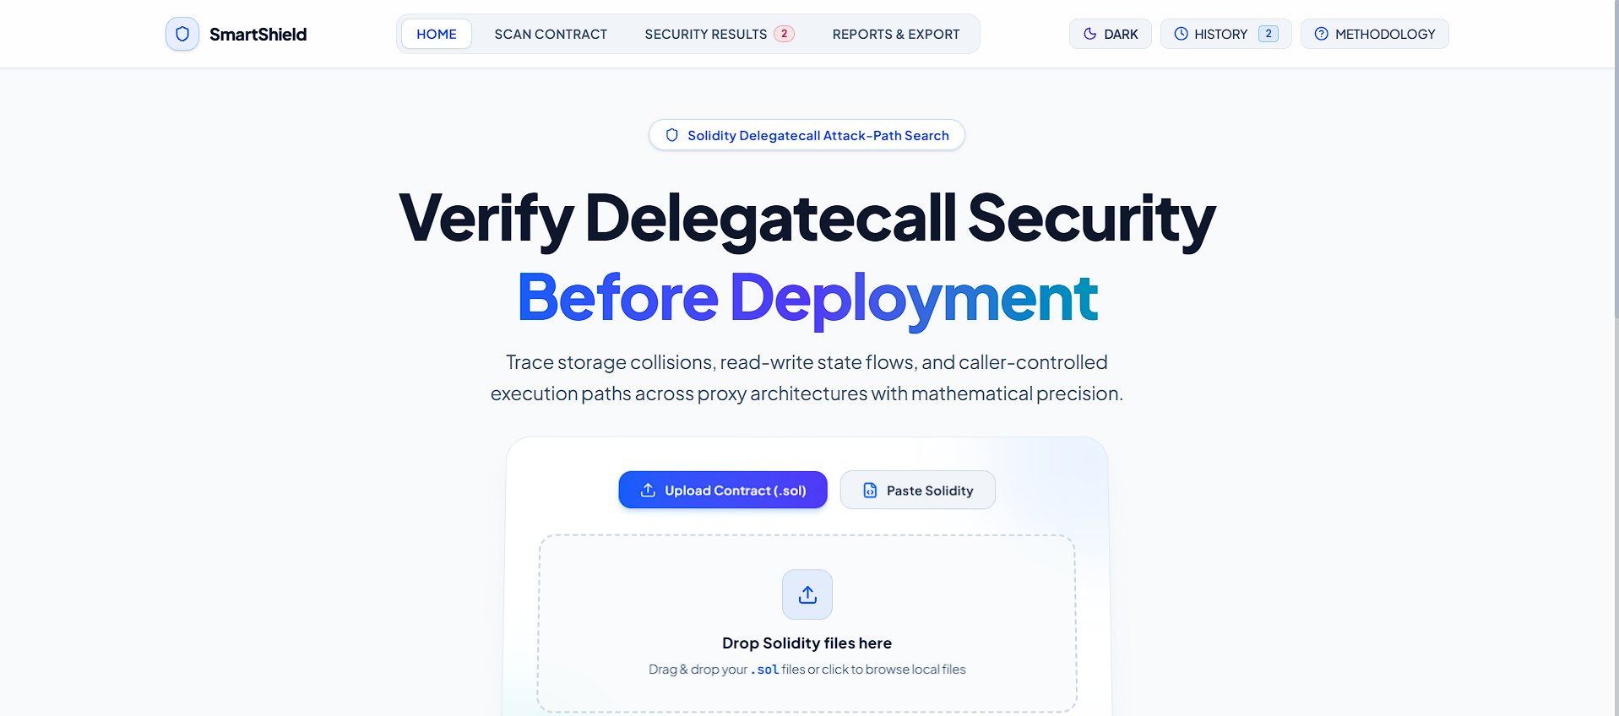

Fig. 4.3.1: SmartShield landing / home page
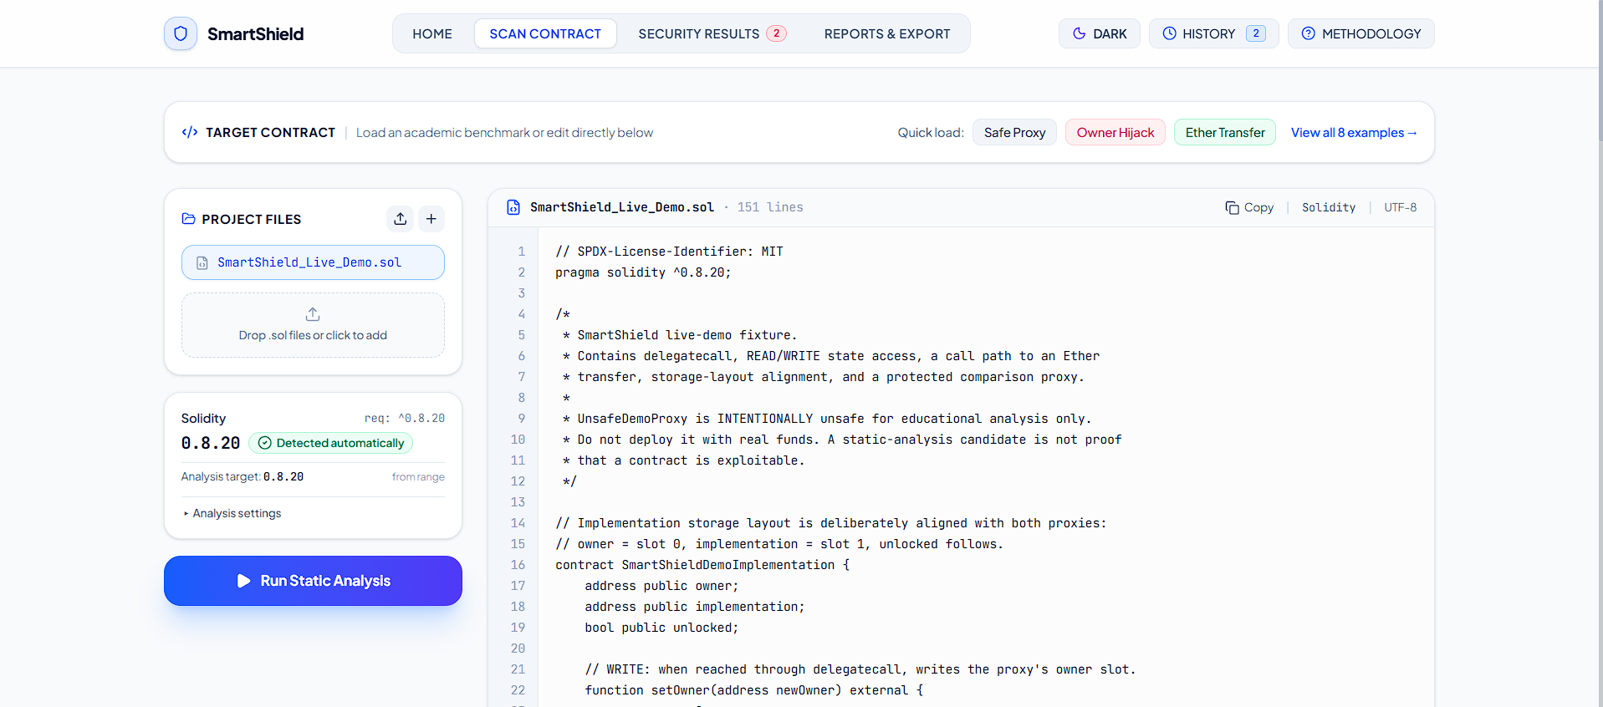

Fig. 4.3.2: Source analyzer / contract input screen

4.3 Screenshots of project (Continued)
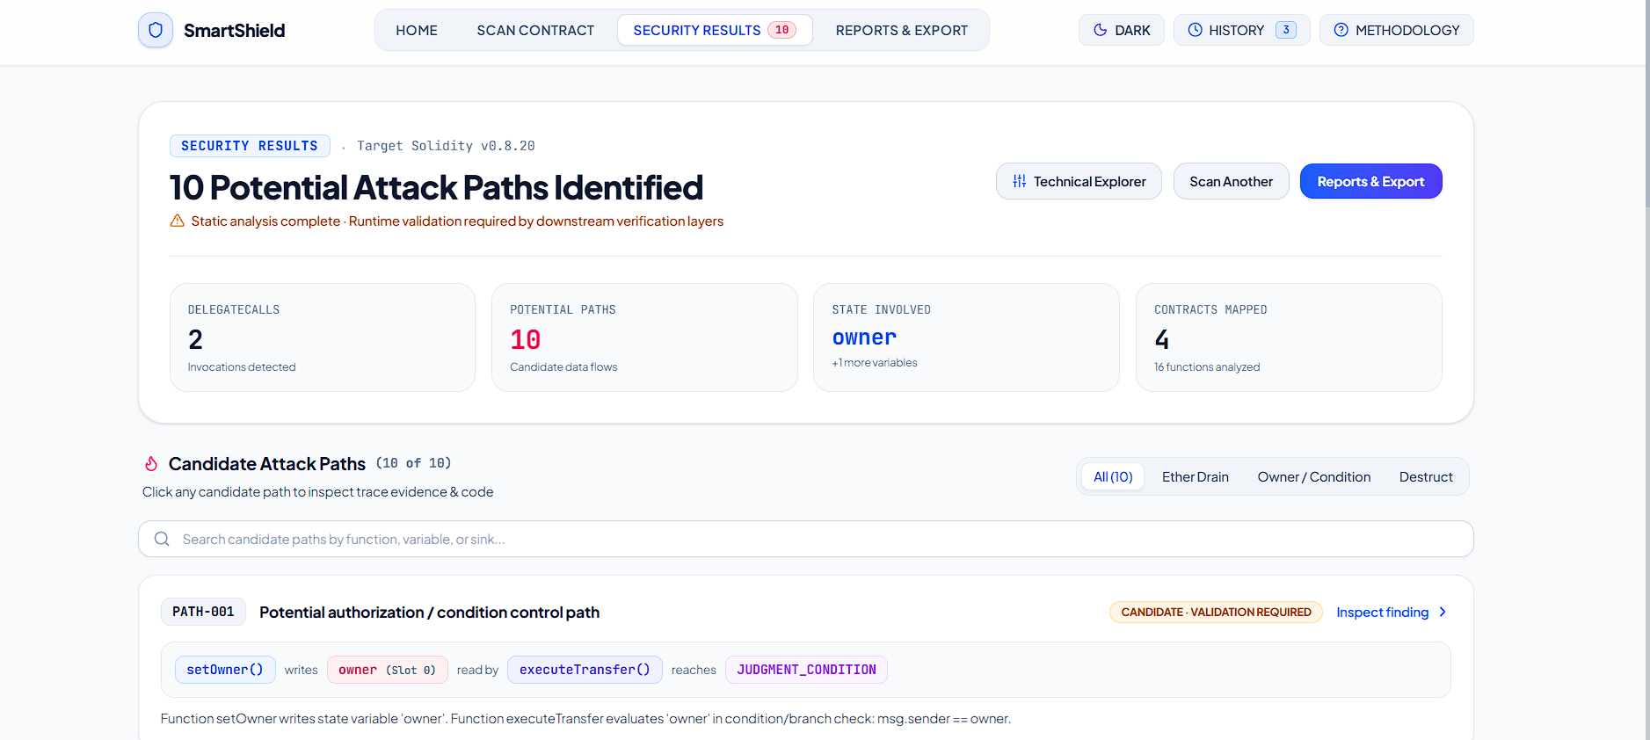

Fig. 4.3.3: Contract overview and scan summary
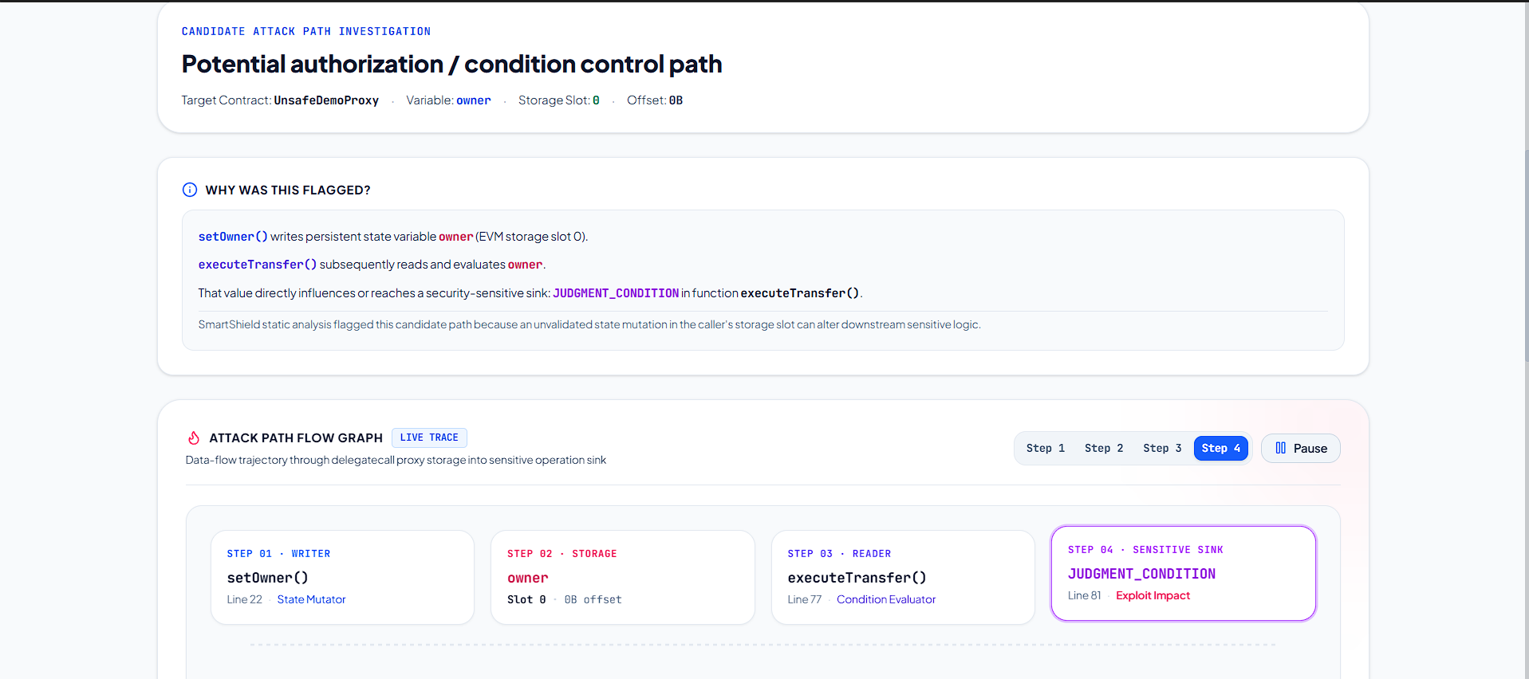

Fig. 4.3.4: READ/WRITE analysis view

4.3 Screenshots of project (Continued)
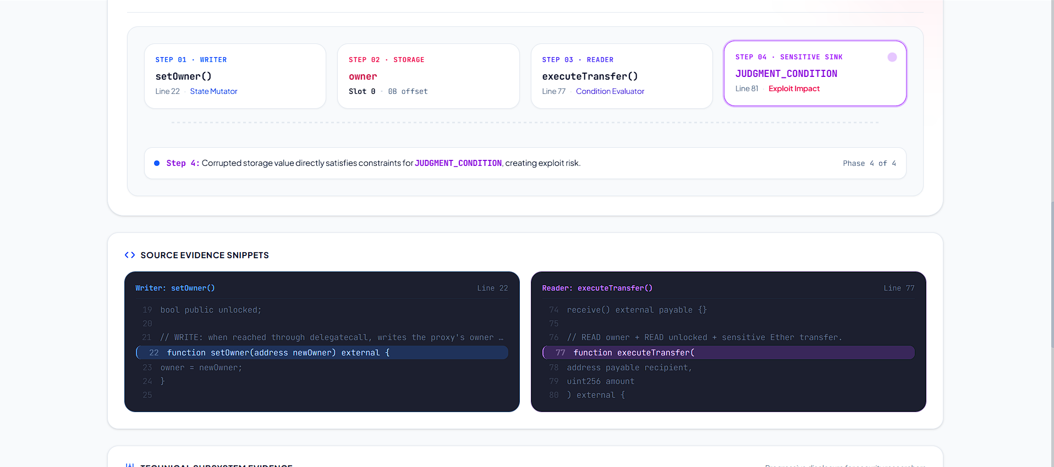

Fig. 4.3.5: Call graph / control-flow inspection
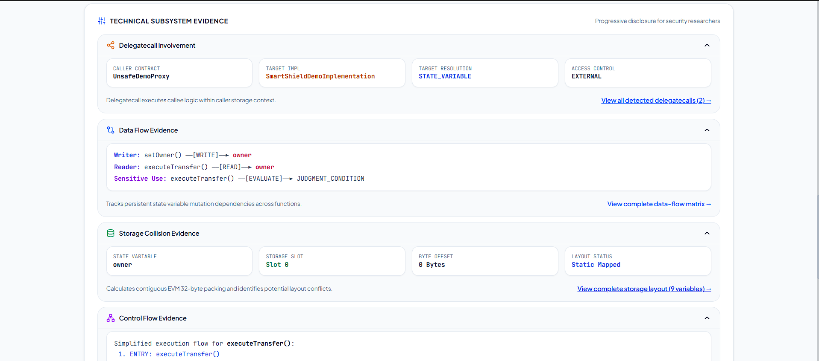

Fig. 4.3.6: Delegatecall detection view

4.3 Screenshots of project (Continued)
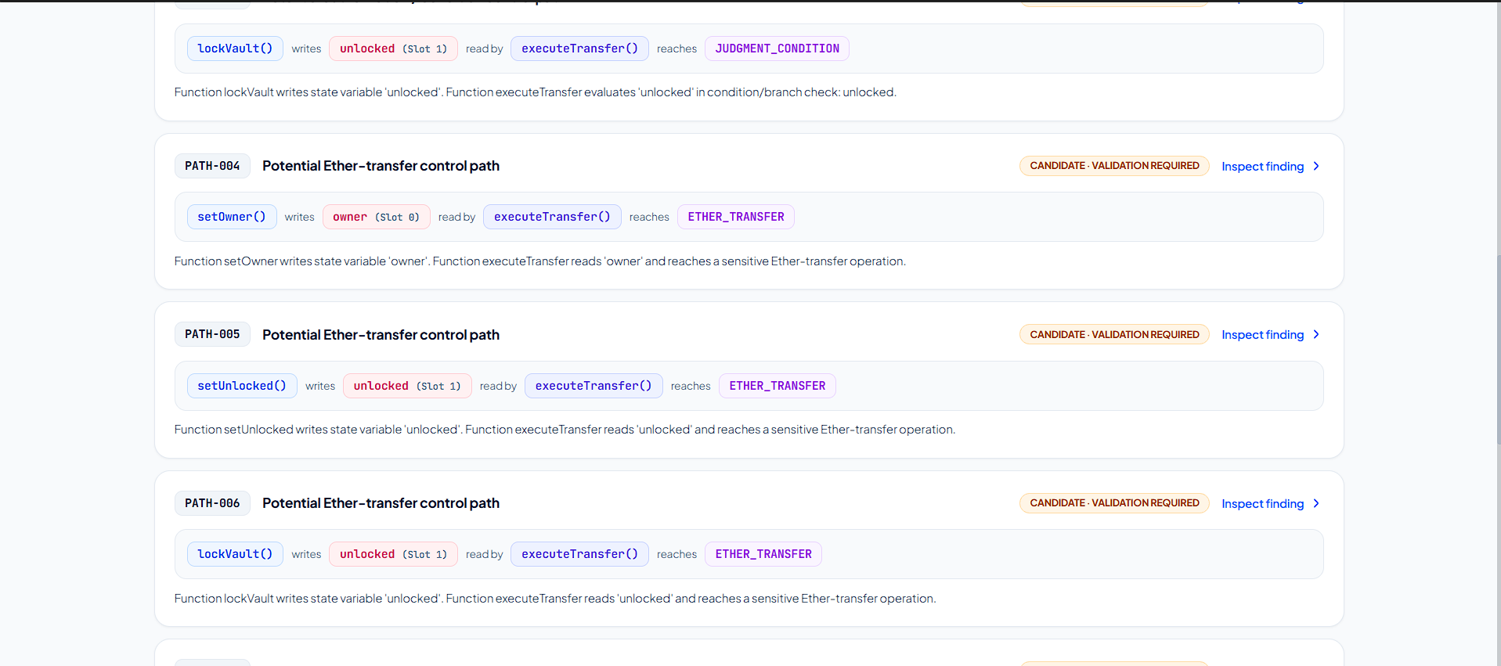

Fig. 4.3.7: Sensitive operations view
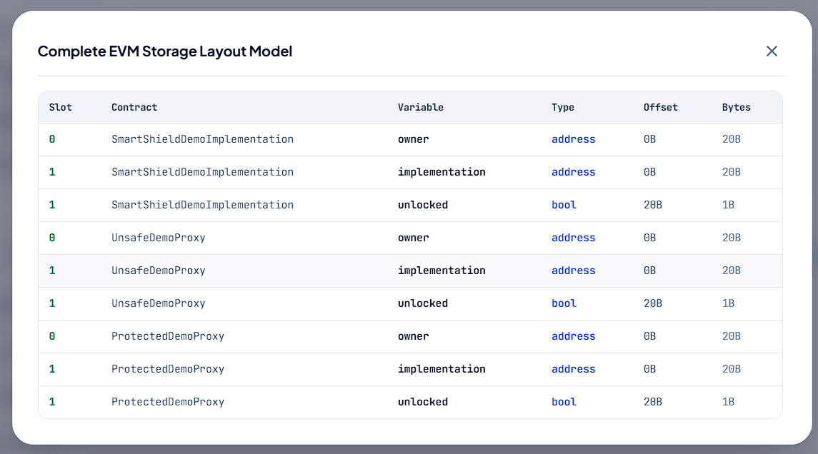

Fig. 4.3.8: Storage layout view

4.3 Screenshots of project (Continued)
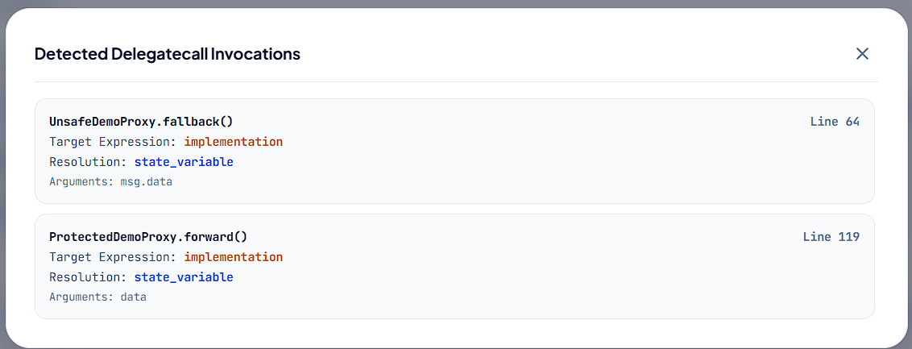

Fig. 4.3.9: Candidate attack paths view
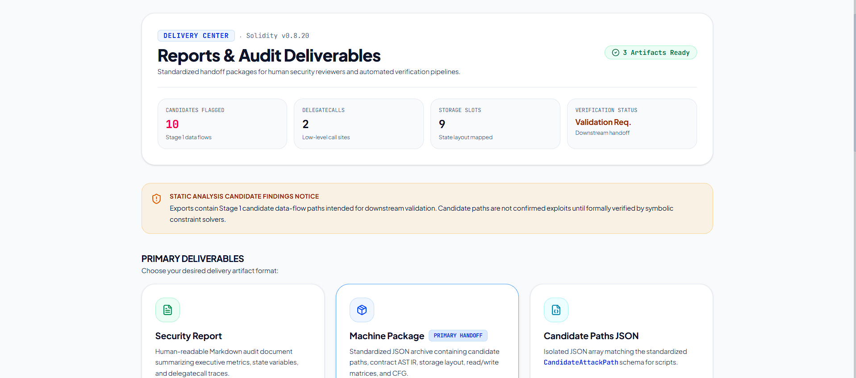

Fig. 4.3.10: Export / generated result package

5. Results and Discussion
The supplied repository contains example Solidity contracts, an automated test specification, and a set of JSON result artefacts. The included result package targets vulnerable_owner.sol. Its manifest records a successful static-analysis run and two candidate attack paths. The figures below are counts from this specific included result package; they are not benchmark averages and should not be generalized to all Solidity contracts.

Included Example Result: vulnerable_owner.sol
Measure | Value in Included Result | Interpretation
Analysis manifest status | SUCCESS | The stored example analysis completed without an error status.
Target source | vulnerable_owner.sol | The result artefact refers to the included owner-proxy example.
Contracts | 2 | VulnerableOwnerProxy and Implementation appear in the extracted contract model.
Functions | 4 | Four function records are present in the stored contract IR.
State variables | 3 | Three state-variable records appear in the extracted result.
Delegatecall sites | 1 | One delegatecall site is recorded.
Sensitive operations | 2 | Two sensitive-operation records appear in the stored IR.
Candidate attack paths | 2 | One judgment-condition candidate and one currency-sending candidate are stored.

The stored candidate records are PATH-001 (JUDGMENT_CONDITION) and PATH-002 (CURRENCY_SENDING / Ether transfer). Both have status CANDIDATE and validationRequired=true. The associated path connects Implementation.initialize() writing owner with VulnerableOwnerProxy.execute() reading owner and reaching a security-sensitive condition or Ether-transfer operation.
The stored manifest timestamp is 25 September 2026. It is included as a repository example artefact, not as a new run carried out during preparation of this report. Before final submission, run the project again with the final source version and replace these values if the output changes.

5.1 Observations and Analysis

A. Functional Observations
- The analyzer separates program extraction from security-pattern detection. This allows the same contract model to support several inspection views.
- READ/WRITE relationships provide a direct way to follow a state variable across functions. In the included owner example, initialize() writes owner and execute() reads owner.
- Delegatecall detection is treated as one part of the evidence chain. A delegatecall occurrence does not automatically produce a confirmed vulnerability.
- Sensitive-operation classification distinguishes selfdestruct, Ether transfer, and judgment-condition patterns so that candidate paths can be categorized.
- Storage slot and offset information adds context for reviewing state alignment between caller and callee contracts.
- The candidate-path output includes source locations and a textual reason, making the output suitable for further manual inspection and machine-readable handoff.

Testing SmartShield on other teams’ smart contracts:
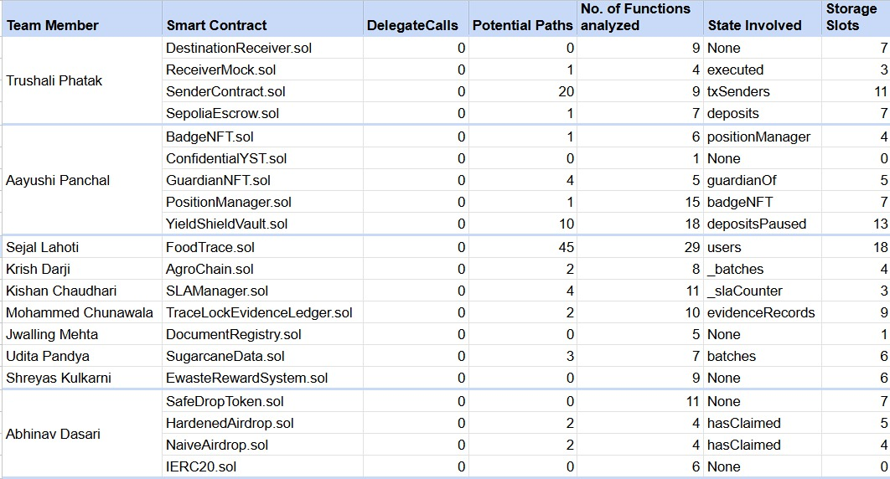

B. Example Path Analysis
Path Stage | Observed Example | Why it matters
Writer | Implementation.initialize(address newOwner) assigns owner = newOwner. | A state-variable write is identified in a function that can be externally invoked in the example.
State variable | owner | The same named variable is represented in the caller and implementation model.
Reader | VulnerableOwnerProxy.execute() evaluates msg.sender == owner. | The owner value participates in a judgment-condition / access-control check.
Sensitive operation | recipient.transfer(amount) | The function also contains an Ether-transfer operation.
Analyzer output | Two candidate records, marked CANDIDATE. | The tool identifies relationships for review but does not solve runtime constraints.

C. Interpretation
The example demonstrates the central idea of SmartShield: tracing the path from a state-changing function to a later security-sensitive use. However, the example also illustrates why static output must be interpreted carefully. A candidate may depend on the actual fallback routing, delegatecall target, function selector, access-control rules, source-level reachability, and storage layout. Those conditions need to be checked before a finding can be described as exploitable.

5.2 Comparison of Proposed System with Existing Systems
The comparison below is qualitative and concerns analysis approach and output scope. It is not a performance ranking, and no common benchmark execution was carried out for this report.
Criterion | DelegateTracker [1] | Slither / SmartCheck / Securify [2], [4], [5] | SmartShield
Primary focus | Delegatecall-specific vulnerability analysis. | General smart-contract static analysis, pattern detection, or property checking. | Delegatecall-focused source inspection and candidate-path generation.
Core representation | Contract information and read/write execution state used by its search and verification phases. | IR, AST-derived representation, or dependency graph depending on the tool. | AST-derived ContractIR with function, variable, call, control-flow, storage, and sink records.
READ/WRITE reasoning | Central part of the proposed read-write data-flow capture algorithm. | Available in different forms depending on the analyzer and detector. | Explicit function-level READ/WRITE sets used for candidate synthesis.
Attack-path output | Attack-path search followed by validation. | Varies by tool; findings are generally detector or property oriented. | Writer → variable → reader → sink candidate records with supporting context.
Runtime / symbolic validation | Dynamic-symbolic attack-path validation is part of the paper’s method. | Tool-dependent; not a shared feature across all systems. | Not implemented in the current core; candidates require separate validation.
Storage context | Storage state and slot information are relevant to the paper’s analysis. | Varies by tool and analysis. | Explicit basic slot, offset, byte-width, and complex-type indicators are exposed.
User interface and handoff | Research tool outputs validated path information. | Tool-specific CLI, reports, or detector outputs. | Browser interface, CLI, JSON/CSV export, and a structured handoff package.

SmartShield’s main contribution within this mini-project is the integration of a candidate path view, storage context, and an accessible interface around source-level analysis. The central difference from DelegateTracker is also the primary limitation: the current SmartShield implementation does not reproduce the full dynamic-symbolic validation stage described in the base paper [1].

5.3 Vulnerability Analysis and Validation Boundaries
SmartShield evaluates three delegatecall-related anomaly patterns: SELF_DESTRUCT, CURRENCY_SENDING, and JUDGMENT_CONDITION. It searches for a relationship in which one function writes a state variable, another function later reads that variable, and the read reaches a sensitive operation or condition. The output is a candidate path for review, not a confirmed vulnerability. The separate symbolic and dynamic attack-path validation stage described in DelegateTracker is not part of the current SmartShield implementation; no results from Slither, SmartCheck, or Osiris are claimed in this report.
The repository includes a test runner at test/run-tests.ts. The source contains 14 named test groups and 41 assertion calls. These cover the extraction and detection features listed below. This is a code-level description of the supplied test suite; the test command was not executed as part of generating this report, so no fresh pass/fail result is claimed here.
Test Group | Focus | Intended Verification
1 | AST extraction | A Solidity source input produces a successful structured parse and identifies a contract.
2 | Function extraction | Functions, signatures, and external reachability metadata are extracted.
3 | State-variable extraction | Variable names and types appear in the contract model.
4-5 | READ and WRITE detection | Writer and reader functions are associated with the relevant state variables.
6 | Compound operations | Increment, compound assignment, and delete are handled as read/write operations.
7 | Function call graph | Call relationship data is represented.
8 | Delegatecall detection | A delegatecall site and target classification are identified.
9 | Selfdestruct detection | A selfdestruct operation is categorized.
10 | Ether-transfer detection | An Ether-transfer operation is categorized.
11 | Judgment-condition detection | A state variable used in a require condition is recorded.
12 | Candidate attack-path generation | A writer-variable-reader-sink path is produced and marked CANDIDATE.
13 | Storage-layout extraction | Basic slot and byte-width information is calculated.
14 | Safe-pattern handling | A safe delegatecall example with no relevant state dependency should not produce a dangerous candidate path.

Limitations to Consider
- The analyzer is static and does not solve all runtime constraints, modifier conditions, cryptographic checks, or branch feasibility.
- A dynamically computed delegatecall target may remain unknown or parameter-based.
- Mapping and dynamic-array elements use runtime keccak-based slot calculations; the current model reports complex types rather than resolving every element slot.
- The tool’s pattern coverage is finite. New Solidity syntax or constructs may require parser and analyzer updates.
- The base paper [1] also reports scalability, memory, false-positive, and path-explosion limitations for its own more intensive validation workflow; these are relevant considerations for future extensions, not test results for SmartShield.

6. Observations
The project demonstrates that delegatecall-focused review can be organized around relationships between functions and state variables rather than around isolated keywords. The candidate-path representation makes the suspected sequence visible and connects it to the relevant source locations and storage information.
1. A delegatecall occurrence is a signal for investigation, not a complete vulnerability verdict.
2. The writer-variable-reader-sink representation is useful for explaining how a state change may influence a later operation.
3. The storage slot and offset view is important because delegatecall executes using the caller’s storage context.
4. The web interface and export files make the analyzer’s internal findings easier to inspect and reuse in a later validation stage.
5. The current static analysis should be treated as first-stage candidate discovery. A separate symbolic or dynamic analysis is needed before a vulnerability is confirmed.
Overall, SmartShield is best understood as an explainable first-pass analyzer. Its usefulness depends on clear evidence presentation and careful wording of candidate results. It should not be used to certify contracts as secure or to report every candidate as an exploitable vulnerability.

7. Conclusion
SmartShield is a delegatecall-focused static analysis project developed to make state-variable influence and sensitive-operation relationships easier to inspect in Solidity smart contracts. The implementation parses source code into a structured contract representation and combines READ/WRITE analysis, call-graph and control-flow information, delegatecall detection, sensitive-operation classification, storage-layout modelling, and candidate attack-path generation.
The project draws its methodological motivation from DelegateTracker [1], particularly the idea that a meaningful delegatecall analysis should consider how state variables are modified and later used. SmartShield adapts this concept into a source-level candidate-discovery workflow with an interactive browser interface, a CLI, backend API routes, and JSON/CSV output. The included vulnerable_owner example demonstrates a path from an owner write to later owner use and an Ether-transfer sink.
The current implementation does not include the dynamic-symbolic validation stage described in the base research paper. Accordingly, its findings remain candidates that require additional checks for storage alignment, path reachability, access-control satisfiability, and runtime execution. Within that boundary, SmartShield provides a structured foundation for learning, code review, and further development of delegatecall security analysis.

8. Future Work
1. Symbolic and constraint-based validation: integrate an SMT solver or symbolic-execution engine to evaluate whether the candidate writer and reader paths are feasible under attacker-controlled inputs and actual access-control conditions.
2. Runtime verification: execute candidate scenarios in a controlled local EVM test environment and compare observed storage changes and sink behaviour with static predictions.
3. Improved storage analysis: extend storage-layout handling for mappings, nested mappings, dynamic arrays, inheritance, packed variables, and compiler-version-specific layout behaviour.
4. Improved reachability and target resolution: strengthen handling of modifiers, inherited functions, dynamic delegatecall targets, function selectors, and multi-file project dependencies.
5. Benchmark evaluation: prepare a labelled dataset of safe and vulnerable contracts and measure precision, recall, false-positive rate, runtime, and memory consumption using reproducible settings.
6. Expanded reporting: add downloadable HTML/PDF reports, severity explanation, source-snippet navigation, and a clearer distinction between static evidence and validated exploitability.
7. Regression and compatibility: run automated tests against supported Solidity compiler versions and maintain regression cases for new language constructs and known false-positive patterns.
The immediate next milestone should be to add a validation layer that consumes candidate_paths.json and contract_ir.json, checks path constraints and storage compatibility, and returns an explicit confirmed, rejected, or unresolved outcome. This would create a clear progression from SmartShield’s current candidate-discovery stage toward stronger vulnerability verification.

9. References
[1] W. Cao, P. Feng, S. Lu, Y. Wang, X. Wang, and R. Yang, “DelegateTracker: Delegatecall vulnerability detection tool based on read-write data flow capture algorithm,” Blockchain: Research and Applications, vol. 7, 2026, Art. no. 100338, doi: 10.1016/j.bcra.2025.100338.
[2] J. Feist, G. Grieco, and A. Groce, “Slither: A Static Analysis Framework for Smart Contracts,” in Proc. 2019 IEEE/ACM 2nd International Workshop on Emerging Trends in Software Engineering for Blockchain (WETSEB), 2019, pp. 8-15, doi: 10.1109/WETSEB.2019.00008.
[3] X. Wu, X. Du, Q. Yang, A. Liu, N. Wang, and W. Wang, “TaintGuard: Preventing implicit privilege leakage in smart contract based on taint tracking at abstract syntax tree level,” Journal of Systems Architecture, vol. 141, Aug. 2023, Art. no. 102925, doi: 10.1016/j.sysarc.2023.102925.
[4] P. Tsankov, A. Dan, D. Drachsler-Cohen, A. Gervais, F. Bünzli, and M. Vechev, “Securify: Practical Security Analysis of Smart Contracts,” in Proc. ACM SIGSAC Conference on Computer and Communications Security (CCS), 2018, pp. 67-82, doi: 10.1145/3243734.3243780.
[5] S. Tikhomirov, E. Voskresenskaya, I. Ivanitskiy, R. Takhaviev, E. Marchenko, and Y. Alexandrov, “SmartCheck: Static Analysis of Ethereum Smart Contracts,” in Proc. 1st International Workshop on Emerging Trends in Software Engineering for Blockchain (WETSEB), 2018, pp. 1–8, doi: 10.1145/3194113.3194115.
[6] Solidity Documentation, “Security Considerations” and “Layout of State Variables in Storage,” Solidity documentation. [Online]. Available: https://docs.soliditylang.org/ (Accessed: 3 Nov. 2026).
[7] SmartShield Project Repository, “SmartShield: Delegatecall Attack-Path Search & Static Analysis,” source code, examples, documentation, tests, and result artefacts. GitHub: https://github.com/ShreyRane/SmartShield (accessed 3 Nov. 2026).
Reference note: [1] is the base research paper specified for this project. The project description and implementation statements in this report are grounded in the submitted SmartShield repository and project presentation. The sample report supplied for formatting was used only as a structural/layout reference; its project text and figures have not been reused.

