IMPLEMENTATION SPECIFICATION
Tata Power Electricity Load Analysis — DTW + SQLite + Parameter-to-SQL + Web Search + Local LLM
For implementation in Gemini / Antigravity • Reference notebooks supplied with this task
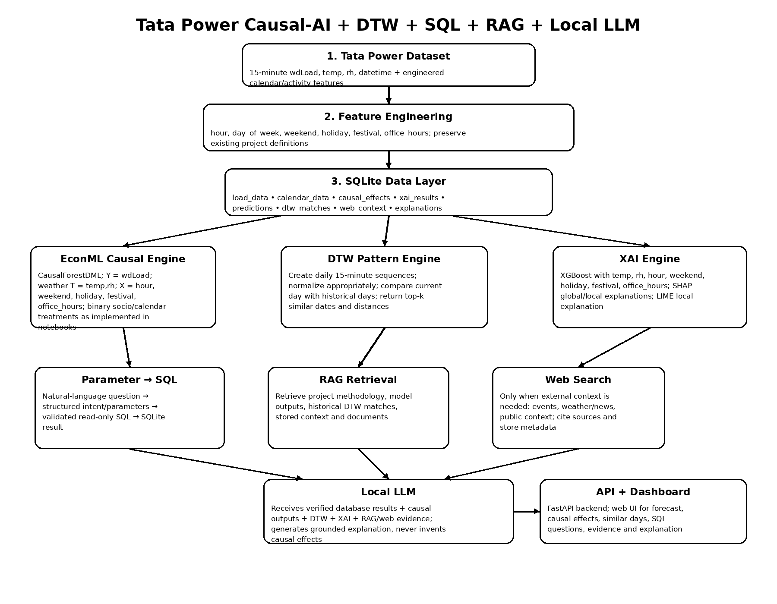
Figure 1. Target architecture. The existing EconML and XAI work remains the analytical core; the new components provide storage, historical pattern matching, retrieval, external context, and grounded natural-language interaction.

1. Purpose
This document is an implementation brief for extending the existing Tata Power electricity-load project. The implementation must build on the supplied Jupyter notebooks rather than replacing their causal/XAI methodology. The immediate additions are: (1) DTW historical pattern matching, (2) SQLite storage, (3) a safe parameter-to-SQL pipeline, (4) optional web-search context retrieval, and (5) local LLM deployment. The final system should explain load behavior using verified analytical outputs and retrieved evidence.

2. Source notebooks and existing methodology
Use the supplied notebooks as the reference implementation for the current analytical layer:
- sociowinter_v2(2).ipynb — Winter 2024 causal + socio/calendar effects + XAI.
- sociowinter(1).ipynb — earlier Winter implementation and treatment-support checks.
- autumnsocio_v2(1).ipynb — Autumn causal + socio/calendar effects + XGBoost/SHAP/LIME + LLM-oriented explanation code.
- autumnsocio.ipynb — earlier Autumn causal implementation.
- socioSummer_with_LLM_v2(1).ipynb — Summer weather causal effects, confidence intervals, socio/calendar effects, HTE-by-hour, and XGBoost/SHAP/LIME/LLM-oriented components.

3. Existing model contract — DO NOT silently change
The supplied notebooks establish the following implementation contract:
Component | Existing definition | Implementation instruction
Outcome | Y = df['wdLoad'].values | Keep wdLoad as the load outcome.
Weather treatments | T = ['temp','rh'] | Keep temperature and RH as continuous weather treatments for the weather causal model.
Weather adjustment variables | ['hour','weekend','holiday','festival','office_hours'] | Preserve these as the existing adjustment set for the weather causal model unless a deliberate research change is documented.
Causal estimator | EconML CausalForestDML | Reuse the existing estimator settings from notebooks as the baseline.
Weather effects | const_marginal_effect(X), mean by treatment | Store effect estimates and confidence intervals in SQLite.
Socio/calendar effects | Binary treatment helper with treatment-specific controls | Keep the one-treatment-at-a-time structure used by the supplied notebooks.
HTE | Effects grouped by hour | Store hourly treatment effects so the UI/LLM can explain time-of-day variation.
XAI model | XGBoost features: temp, rh, hour, weekend, holiday, festival, office_hours | Preserve these features for the baseline XAI model.
XAI methods | SHAP + LIME | Store global importance and local explanation records.

4. Target data flow
Raw/processed CSV data → feature engineering → SQLite → analytical services (EconML/XAI/DTW) → retrieval layer → local LLM. Web search is an optional external-context branch. The LLM is a synthesis layer, not a causal estimator.

5. SQLite database design
Table | Suggested columns | Purpose
load_data | id, datetime, wdLoad, temp, rh, hour, day_of_week, weekend, holiday, festival, office_hours, lag_load_15min, lag_load_prev_day, season, year | Canonical structured observations.
causal_effects | id, run_id, season, treatment, effect_type, effect_value, ci_lower, ci_upper, hour, created_at | Persist EconML estimates and uncertainty.
xai_results | id, run_id, model_type, feature, importance, observation_time, shap_value, lime_weight, prediction, created_at | Persist SHAP/LIME outputs.
predictions | id, run_id, datetime, actual_load, predicted_load, residual, model_name, created_at | Persist forecast/evaluation outputs.
dtw_matches | id, query_date, historical_date, season, distance, rank, sequence_type, created_at | Persist historical similar-day results.
documents | id, title, source, content, metadata_json, created_at | RAG source material.
web_context | id, query, title, url, snippet, source_date, retrieved_at | External search evidence.
explanations | id, query, answer, evidence_json, created_at | Auditable LLM responses.
Use SQLite for the prototype/local deployment. Create indexes on datetime, date/season/year, treatment, and query_date. Use parameterized SQL everywhere. Do not allow the LLM to execute arbitrary write SQL.

6. DTW implementation
Implement DTW as a separate service. The default comparison unit should be a complete day represented by 96 fifteen-minute observations. Create a daily sequence from wdLoad. For each query date, compare it with eligible historical dates and return top-k lowest-distance matches. Support filters such as season, holiday/festival state, and year so the comparison can be made context-aware.
- Baseline sequence: normalized daily wdLoad curve.
- Optional multivariate extension: load + temp + RH, with explicit scaling/weights. Do not mix binary calendar variables into a distance metric without documenting the weighting.
- Exclude the query day itself and prevent future leakage when the system is operating in historical/validation mode.
- Persist distance, rank, query date, historical date, season and sequence type in dtw_matches.
- DTW identifies similarity, not causality. Never label a DTW match as causal evidence.

7. Parameter-to-SQL pipeline
Implement a controlled pipeline:
- User question → intent extraction.
- Intent extraction → validated structured parameters (metric, variable, date range, season, holiday/festival/weekend state, grouping).
- Parameters → SQL generated from predefined templates/query builders.
- SQL → read-only SQLite execution.
- Result → structured JSON returned to the LLM/UI.
- Do not permit arbitrary SQL, INSERT/UPDATE/DELETE/DROP/ALTER, filesystem commands, or shell execution through the LLM.
Example: 'What was the average load during summer festival days in 2025?' should resolve to metric=AVG, variable=wdLoad, season=Summer, festival=1, year=2025, then execute a predefined parameterized SELECT.

8. Web-search integration
Web search is an external-context tool, not a replacement for the project database. Trigger it only when the question requires information outside the stored dataset, for example an event/festival description, external weather context, public reports, or other dated contextual information.
- Record query, title, URL, snippet, source date when available, and retrieval time.
- Prefer authoritative sources for factual context.
- Pass only relevant retrieved snippets/metadata to the LLM.
- Do not use web results to override measured Tata Power data or EconML estimates.

9. Local LLM deployment
Use a local model server such as Ollama (or another local inference server available in the development environment). Keep the model behind a small LLM service abstraction so the model can be changed without changing the rest of the application.
The LLM should receive a structured evidence packet containing:
- Current observation and database aggregates.
- EconML effect estimates and confidence intervals.
- HTE-by-hour values when relevant.
- Prediction and residual information when available.
- SHAP/LIME explanation values.
- Top DTW similar dates and distances.
- RAG retrieved documents.
- Web-search context with source metadata.
The system prompt must explicitly require the model to distinguish observed facts, model estimates, historical similarity, and external context. It must not invent an effect when no EconML estimate exists.

10. RAG layer
Start with a lightweight local RAG implementation. Index project methodology, model definitions, stored historical context, and selected analytical summaries. For the prototype, SQLite can store document metadata/content; a vector index can be added if needed. Retrieval should return source IDs and text so the final answer is auditable.

11. Backend/API structure
Recommended modular structure:
- backend/app.py — API entry point.
- backend/db.py — SQLite connection/schema/query helpers.
- backend/services/causal.py — wrapper around existing EconML models/results.
- backend/services/xai.py — SHAP/LIME/XGBoost results.
- backend/services/dtw.py — daily sequence creation and DTW matching.
- backend/services/sql_agent.py — intent extraction + safe query builder.
- backend/services/rag.py — document retrieval.
- backend/services/web_search.py — external search adapter.
- backend/services/llm.py — local LLM adapter.
- backend/services/explainer.py — evidence aggregation and final explanation.
- frontend/ — dashboard/chat interface.
- scripts/ingest.py — CSV → SQLite ingestion.
- scripts/run_analysis.py — execute/store existing analytical outputs.

12. API endpoints
Endpoint | Purpose | Output
/api/query | Natural-language analytical question | answer + SQL + data + evidence
/api/dtw/{date} | Find similar historical days | top-k matches
/api/causal | Retrieve causal effects | effects + CI + HTE
/api/xai | Retrieve SHAP/LIME explanations | feature contributions
/api/prediction | Retrieve prediction/evaluation | actual + predicted + metrics
/api/explain | Generate evidence-grounded explanation | structured explanation
/api/health | Service status | component health

13. Example end-to-end query
User: 'Why was load high on this festival day?'
- 1. Resolve date/current context from SQLite.
- 2. Query load, weather and calendar state.
- 3. Retrieve relevant EconML treatment effects.
- 4. Retrieve HTE at the relevant hours.
- 5. Run DTW against eligible historical days.
- 6. Retrieve relevant RAG documents.
- 7. If external context is required, perform web search.
- 8. Build evidence JSON.
- 9. Local LLM synthesizes the answer with explicit source/evidence categories.
- 10. Store the explanation and evidence IDs for reproducibility.

14. Implementation phases for the coming days
Day | Workstream | Deliverables
Day 1 | SQLite + ingestion | Create schema, ingest seasonal CSVs, indexes, validation queries.
Day 2 | DTW | Implement daily 96-point sequences, normalization, top-k historical matching, persistence and tests.
Day 3 | Parameter → SQL | Build intent schema, safe query templates, validation, API endpoint and test questions.
Day 4 | RAG + web search | Add document retrieval and external-search adapter with source metadata.
Day 5 | Local LLM | Deploy local model server, evidence-packet prompt, explanation endpoint.
Day 6 | Integration | Connect DTW + EconML + XAI + SQL + RAG + web + LLM; build dashboard/chat.
Day 7 | Testing + research outputs | Leakage checks, causal-label safeguards, reproducibility, screenshots, architecture/results documentation.

15. Testing and research safeguards
- Verify SQLite row counts against source CSVs.
- Verify timezone handling: existing datetime values are timezone-aware IST; do not blindly apply utc=True/tz_convert again.
- Prevent DTW leakage: historical comparisons must respect the chosen validation period.
- Keep 2024 as the existing development/causal/XAI reference and 2025 as the existing validation/testing cycle unless the research protocol is intentionally changed.
- Do not treat DTW similarity as causality.
- Do not treat SHAP/LIME as causal effects.
- Do not allow the LLM to generate unsupported numerical causal claims.
- Store model run IDs, timestamps and source dataset identifiers for reproducibility.

16. Definition of done
- CSV data is queryable from SQLite.
- DTW returns reproducible top-k similar historical days.
- Natural-language questions produce validated read-only SQL and correct database results.
- EconML/XAI outputs from the existing notebooks are available through the application without changing their baseline definitions.
- RAG retrieves relevant project evidence.
- Web search can be invoked for external context and source metadata is retained.
- Local LLM produces explanations from a structured evidence packet.
- UI shows answer, supporting data, causal estimates, similar historical days, and retrieved evidence.
- An end-to-end 'why did load change?' query works without manually running notebooks.

17. Instruction to Gemini / Antigravity
Implement this system incrementally inside the existing project. First inspect the repository and the supplied notebooks. Reuse existing functions and outputs where practical; do not rewrite the EconML/XAI methodology merely to fit the new architecture. Create modular services with tests. Ask for confirmation only when a destructive or irreversible change is required. Do not hard-code machine-specific paths from the notebooks. Replace them with configurable paths/environment variables. Do not expose unrestricted SQL execution or shell execution to the LLM. Every analytical result returned to the LLM must be structured and traceable to a database record, model run, DTW match, RAG document, or web source. At each phase, run tests and report what was implemented, what remains, and how to reproduce it.

18. Suggested final user experience
The dashboard should provide:
- Current load and recent load curve.
- Weather and calendar state.
- Predicted vs actual load.
- EconML causal-effect cards.
- Hour-wise heterogeneous treatment effects.
- SHAP/LIME explanation panel.
- DTW 'similar historical days' panel.
- Natural-language analytics box powered by parameter-to-SQL.
- Evidence-grounded explanation generated by the local LLM.
- External-context sources when web search was used.

End of implementation specification.

19. Revised LLM Explanation Contract — REQUIRED
The local LLM must not produce a technical dump of ATE, HTE, SHAP, LIME, DTW, SQL, or RAG results. Its primary user-facing output is a concise, evidence-grounded natural-language paragraph explaining why the observed electricity load was above or below the expected level and which factors had the strongest estimated influence.

19.1 Required explanation objective
For questions such as “Why was load unusually high on 15 Oct 2025 at 3 PM?”, the system must retrieve the observed load, expected/predicted load, weather, calendar state, relevant causal estimates, hour-specific heterogeneous treatment effects, prediction explanations, and historical DTW matches. The LLM then synthesizes these results into one concise paragraph. The LLM is an explanation and synthesis layer; it must not calculate causal effects, infer missing numerical values, or replace the analytical models.

19.2 Evidence hierarchy
- Observed database values establish what actually happened: load, weather, calendar conditions, previous load, and prediction/residual where available.
- EconML ATE provides the estimated average causal effect for the relevant treatment and population/season under the specified model assumptions.
- HTE provides the estimated treatment effect under the relevant condition, especially the current hour. Use it to describe whether an effect is stronger or weaker at the current time than the broader seasonal/overall estimate.
- SHAP/LIME describe model-prediction contributions. They are prediction explanations, not causal effects.
- DTW identifies historical days with similar load trajectories. It is supporting historical-pattern evidence only and must never be described as proof of causation.
- RAG supplies project methodology and stored contextual evidence.
- Web search supplies external context only when required; it must not override measured Tata Power data or model outputs.

19.3 Explanation generation logic
- Determine the observation date/time and retrieve actual and expected/predicted load.
- Retrieve weather and calendar conditions.
- Retrieve relevant EconML ATEs and confidence intervals.
- Retrieve HTE values for the current hour or relevant time period.
- Retrieve SHAP/LIME contributions when available.
- Retrieve top-k DTW similar historical days and distances.
- Retrieve RAG and web context only when relevant.
- Identify factors supported by the available evidence as the main contributors. Do not equate the largest raw number across incompatible measures with the strongest cause.
- Generate one concise paragraph focused on why load was above/below expected and which factors had the strongest estimated influence.
- Store the explanation with evidence IDs/JSON for reproducibility.

19.4 Required language style
- Prefer “mainly associated with”, “contributed to”, “estimated influence”, “estimated effect”, and “is consistent with historical patterns”.
- Use “under the specified causal model” when discussing causal results.
- Never describe DTW similarity as causal evidence.
- Never describe SHAP/LIME values as causal effects.
- Do not claim causation solely from a large SHAP value or correlation.
- If required evidence is unavailable, state that the available evidence is insufficient.
- Keep the final explanation concise: normally one paragraph of approximately 3–5 sentences.

19.5 Target output examples
“The electricity load was higher than expected mainly because of the elevated temperature, with festival activity providing the second-largest estimated contribution. Office-hour demand also contributed to the increase, while humidity had a comparatively smaller effect. The hour-specific causal estimates show that the influence of temperature and the festival condition was stronger at the current time than their overall seasonal averages. Similar load patterns were also observed on previous festival days, suggesting that the current demand profile is consistent with historical patterns under comparable conditions.”
“The increase in electricity load was primarily associated with the unusually high temperature during this period. The causal analysis shows that temperature had the largest estimated influence among the considered factors, with its effect being particularly strong during the current hour. Humidity and calendar-related factors had comparatively smaller estimated effects. The current load profile also resembles historical days with similar weather conditions, supporting the observation that weather was an important contributor to the elevated demand.”
“The elevated load was mainly associated with the calendar and activity conditions of the day. The causal analysis indicates that the festival and office-hour conditions had the strongest estimated effects, while temperature and humidity made smaller contributions. The current hour also corresponds to a period where the estimated treatment effects are relatively stronger, and DTW identified similar load trajectories on previous days with comparable calendar conditions.”

19.6 LLM system prompt requirements
- Use only the supplied evidence packet. Never invent numerical values, causal effects, dates, or historical matches.
- Do not perform causal inference yourself. Treat EconML outputs as the source of causal estimates.
- Treat ATE as an overall/average estimated effect and HTE as condition/hour-specific estimated effect.
- Treat SHAP/LIME as prediction explanations, not causal evidence.
- Treat DTW as historical similarity, not causality.
- Distinguish observed facts, model estimates, prediction explanations, historical similarity, RAG evidence, and external web context.
- Answer the user’s question with one concise paragraph focused on the main supported factors and their estimated influence.
- Do not list technical components merely for the sake of listing them. Mention a component only when its evidence materially supports the explanation.
- If evidence conflicts, describe the conflict rather than choosing an unsupported interpretation.
- If evidence is insufficient, explicitly say so.

19.7 UI behavior
The dashboard should show the concise AI-generated explanation prominently. Technical evidence remains available through expandable cards or panels so the user can inspect the basis of the explanation.
- AI Load Explanation — one concise paragraph.
- View Causal Effects — ATE and confidence intervals.
- View HTE — hour/condition-specific effects.
- View SHAP/LIME — prediction contributions.
- View Similar Days — DTW matches and distances.
- View Sources — RAG and web evidence when used.

20. Revised end-to-end explanation flow
- User asks: “Why was load unusually high on 15 Oct 2025 at 3 PM?”
- Parameter-to-SQL resolves the date/time and retrieves the observation from SQLite.
- Retrieve prediction/residual information and weather/calendar state.
- EconML returns relevant ATE and HTE evidence.
- XAI returns SHAP/LIME prediction contributions where available.
- DTW returns similar historical days without leakage.
- RAG retrieves project methodology/context; web search is used only if external context is needed.
- Build an evidence packet with explicit source types.
- The local LLM synthesizes the evidence into a concise 3–5 sentence explanation focused on why load was above/below expected and which factors had the strongest supported estimated influence.
- Store the answer and evidence references for reproducibility.

21. Revised definition of done
- The system answers “why did load change?” questions with a concise evidence-grounded paragraph rather than a raw technical dump.
- ATE and HTE are available as structured evidence but are never calculated by the LLM.
- The explanation distinguishes causal estimates from SHAP/LIME prediction contributions and DTW historical similarity.
- The explanation identifies the main supported factors without inventing causal claims.
- The final paragraph is based on observed load deviation plus relevant causal, HTE, XAI, and historical evidence.
- Technical evidence remains inspectable in the dashboard through separate panels.
- Every explanation is traceable to database records, model runs, DTW matches, RAG documents, and/or web sources.
- Every explanation stores its evidence packet and generated text for reproducibility.

