SKILLINFYTECH
Internship Project Report

Sales Dashboard Analysis
An End-to-End Business Intelligence Solution

Project Title | Sales Dashboard Analysis
Domain | Data Analytics & Business Intelligence
Technology Stack | Python, MySQL, SQL, Power BI
Dataset | Superstore Sales Dataset
Dashboard Pages | 3 Interactive Pages

1. Introduction

In today's data-driven business environment, organizations generate vast volumes of transactional and operational data. The ability to extract actionable insights from this data is a critical competitive advantage. Business Intelligence (BI) and data visualization tools have become indispensable in transforming raw, unstructured data into clear, interactive dashboards that enable informed decision-making at every level of an organization.
This project — Sales Dashboard Analysis — represents a comprehensive, end-to-end data analytics solution developed during the SkillinfyTech internship program. The project utilizes the globally recognized Superstore Sales Dataset and applies a complete data pipeline: from raw data collection and Python-based cleansing, through structured database management in MySQL, to sophisticated business intelligence visualization using Microsoft Power BI.
The resulting deliverable is a three-page interactive Power BI dashboard that enables business stakeholders to monitor sales performance, understand customer behavior, analyze product profitability, and assess regional market dynamics — all through visually intuitive and filterable reports.

2. Project Objective

The primary objective of this project is to design and develop an end-to-end Sales Dashboard Analysis system that:
- Transforms raw sales data into meaningful, actionable business insights.
- Demonstrates proficiency in data cleaning and processing using Python (Pandas, NumPy).
- Applies structured query language (SQL) for in-depth business analysis through 50+ queries.
- Develops a relational data store using MySQL Server and MySQL Workbench.
- Creates a professional, interactive, three-page Power BI dashboard for executive reporting.
- Enables filtering and drill-down capabilities across Year, Segment, Region, and Category.
- Presents key KPIs including Total Sales, Total Profit, Total Customers, and Total Orders.

3. Tools & Technologies

The following tools and technologies were employed throughout the project lifecycle:

Category | Tool / Library | Purpose
Programming Language | Python 3.x | Core scripting for data processing and automation
Data Processing | Pandas | Data manipulation, cleaning, and transformation
Numerical Computing | NumPy | Array operations and numerical validation
Database Server | MySQL Server | Relational database for structured data storage
Database IDE | MySQL Workbench | Database design, SQL execution, and administration
Query Language | SQL | 50+ business analysis queries across the dataset
Visualization | Power BI Desktop | Interactive dashboard development and reporting

4. Dataset Overview

The Superstore Sales Dataset is a widely used benchmark dataset in the field of business intelligence and data analytics. It simulates the sales records of a retail superstore operating across multiple regions of the United States. The dataset encompasses transactional records spanning multiple years and contains rich dimensions for analysis.

Attribute | Description
Time Period | 2014 to 2017 (four fiscal years)
Total Orders | Approximately 5,009 orders
Unique Customers | 793 distinct customers
Total Sales Revenue | Approximately $2.30 Million
Total Profit | Approximately $286,400
Regions Covered | West, East, Central, South
Customer Segments | Consumer, Corporate, Home Office
Product Categories | Technology, Furniture, Office Supplies
Shipping Modes | Standard Class, Second Class, First Class, Same Day

5. Project Methodology

The project followed a systematic, multi-phase methodology ensuring data quality, analytical depth, and professional visualization standards. The end-to-end workflow is outlined below:

Phase | Activity | Details
1 | Dataset Collection | Sourced the Superstore Sales Dataset containing multi-year transactional records
2 | Data Cleaning | Used Python (Pandas, NumPy) to handle missing values, remove duplicates, and standardize fields
3 | Data Validation | Verified data integrity, data types, and value ranges across all columns
4 | Date Format Conversion | Standardized date fields to MySQL-compatible formats (YYYY-MM-DD)
5 | Export Clean Dataset | Exported the cleaned dataset as a CSV file ready for database import
6 | MySQL Import | Imported the cleaned dataset into MySQL Server using MySQL Workbench
7 | Database Creation | Designed relational schema and created the production database
8 | SQL Business Analysis | Executed 50+ SQL queries to analyze sales, profit, customers, and regional trends
9 | Power BI Integration | Connected MySQL data source to Power BI Desktop for visualization
10 | Dashboard Development | Built 3-page interactive dashboard with slicers, KPI cards, charts, and maps

6. Dashboard Analysis

The Power BI dashboard is structured across three dedicated pages, each addressing a distinct analytical domain. All pages include cross-filter slicers for Year, Segment, Region, and Category to support dynamic, drill-down exploration by business users.

6.1 Page 1 – Executive Sales Dashboard
The Executive Sales Dashboard serves as the primary landing page for senior management and decision-makers. It provides a consolidated, high-level view of overall business performance through KPI metrics and trend analysis.

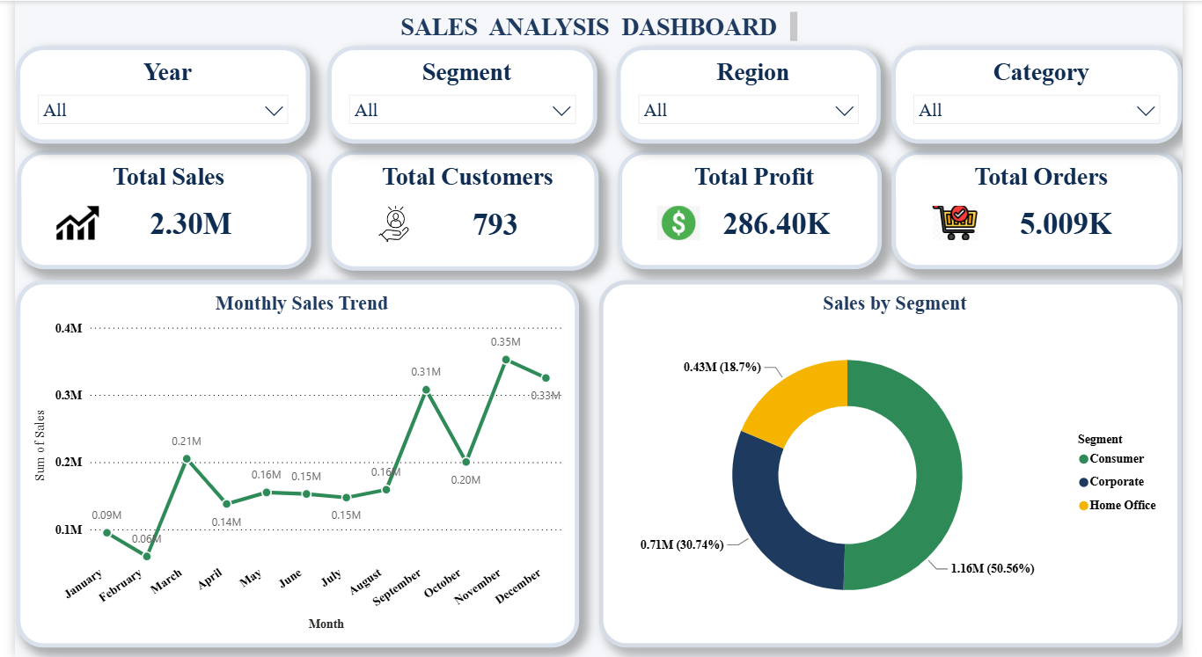
Figure 1: Page 1 – Executive Sales Dashboard (Power BI)

KPI Summary Cards
Four KPI cards are prominently displayed at the top of the dashboard, each communicating a critical business metric at a glance:
- Total Sales: $2.30 Million — representing the aggregate revenue generated across all years, regions, and segments.
- Total Customers: 793 — the count of unique customers served, indicating market reach.
- Total Profit: $286.40K — the net profit figure, essential for profitability assessment.
- Total Orders: 5.009K — the total volume of orders processed, reflecting operational scale.

Monthly Sales Trend (Line Chart)
A line chart visualizes the monthly distribution of sales revenue throughout the year. Key observations include a sales trough in February ($0.06M), a gradual recovery and mid-year stabilization between April and August (ranging $0.14M–$0.16M), and a sharp Q4 acceleration peaking in November at $0.35M — consistent with seasonal retail demand patterns. December records $0.33M, confirming sustained year-end momentum. This visual enables management to identify seasonality, plan inventory, and allocate marketing budgets accordingly.

Sales by Segment (Donut Chart)
A donut chart breaks down total sales by customer segment. The Consumer segment dominates with $1.16M (50.56% of total sales), followed by Corporate at $0.71M (30.74%), and Home Office at $0.43M (18.70%). This segmentation guides targeted sales strategies, helping the organization prioritize consumer-facing campaigns while nurturing corporate account growth.

Slicer Filters
Four interactive slicers — Year, Segment, Region, and Category — allow users to dynamically filter all visuals on the page. This interactivity ensures that management can isolate specific business contexts without requiring separate reports.

6.2 Page 2 – Product & Customer Insights
This page provides a granular view of product performance, customer distribution, and category-level profitability. It supports product managers and sales teams in identifying top performers and areas requiring strategic attention.

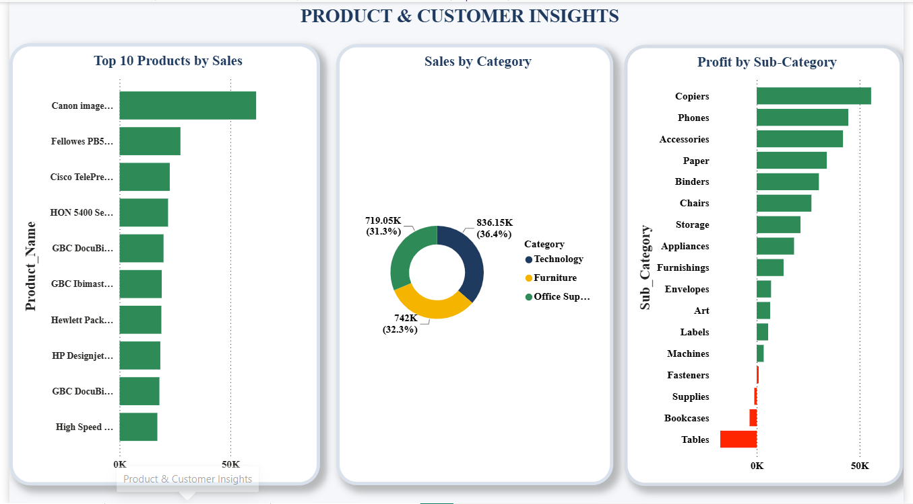
Figure 2: Page 2 – Product & Customer Insights (Power BI)

Top 10 Products by Sales (Horizontal Bar Chart)
A ranked horizontal bar chart displays the ten highest-revenue products. Canon imageCLASS leads significantly beyond the $50K mark, followed by Fellowes PB500 Electric Punch, Cisco TelePresence, and HON 5400 Series office furniture. The remaining products cluster between the $20K–$35K range. This visual empowers procurement and merchandising teams to focus on stocking and promoting high-value products while reviewing underperforming SKUs.

Sales by Category (Donut Chart)
A donut chart illustrates the revenue contribution of the three product categories. Technology leads with $836.15K (36.4%), followed by Office Supplies at $742K (32.3%) and Furniture at $719.05K (31.3%). The near-equal distribution across categories signals a balanced product portfolio, though Technology's marginal lead suggests continued investment priority in tech accessories and devices.

Profit by Sub-Category (Horizontal Bar Chart)
This chart reveals the profit contribution of individual product sub-categories. Copiers emerge as the highest-profit sub-category, followed by Phones and Accessories. Paper, Binders, Chairs, and Storage also contribute positively. Critically, Tables appear as the only sub-category with a significant negative profit (shown in red), indicating a loss-making product line likely affected by excessive discounting or high procurement costs. Bookcases and Supplies also show marginal negative returns. This insight is invaluable for product portfolio rationalization decisions.

6.3 Page 3 – Regional & Profit Analysis
The third dashboard page offers a geographic and temporal perspective on sales performance, combining map-based state-level analysis, regional comparisons, shipping mode distribution, year-over-year growth trends, and the relationship between discount levels and profitability.

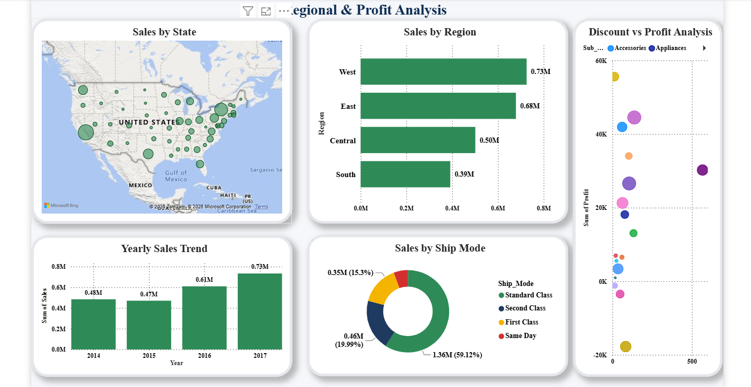
Figure 3: Page 3 – Regional & Profit Analysis (Power BI)

Sales by State (Map Visualization)
A bubble map of the United States plots sales volume by state, with bubble size proportional to revenue. California emerges as the largest sales contributor (visible as the dominant West Coast bubble), followed by New York and Texas. The Eastern Seaboard shows a cluster of high-activity states. This geographic view helps regional managers identify market saturation and pinpoint expansion opportunities in underperforming states.

Sales by Region (Horizontal Bar Chart)
The four U.S. sales regions are compared by revenue: West leads at $0.73M, followed by East ($0.68M), Central ($0.50M), and South ($0.39M). The West and East regions together account for the majority of total revenue, suggesting stronger market presence and customer density in coastal areas. The South and Central regions present growth opportunities.

Yearly Sales Trend (Bar Chart)
A year-on-year bar chart traces sales growth from 2014 to 2017. Sales grew from $0.48M in 2014, dipped slightly to $0.47M in 2015, recovered to $0.61M in 2016, and reached a peak of $0.73M in 2017. This consistent upward trajectory (with the 2015 plateau being modest) demonstrates healthy business growth, a trend that management can leverage for forward-looking revenue projections.

Sales by Ship Mode (Donut Chart)
The donut chart shows that Standard Class shipping dominates at $1.36M (59.12%), followed by Second Class at $0.46M (19.99%), First Class at $0.35M (15.3%), and Same Day at a minor share. Standard Class preference indicates cost-conscious customer behavior, while the growing use of First Class and Same Day signals an opportunity to offer premium shipping programs for high-margin customers.

Discount vs Profit Analysis (Scatter Chart)
A scatter plot maps the relationship between discount levels and profit across sub-categories. Most profitable sub-categories (Accessories, Appliances, Phones) cluster at lower discount levels with profits exceeding $20K. Tables, positioned at higher discount ranges, show negative profit — confirming that deep discounting on furniture products is eroding margins. This analysis is a critical input for pricing and discount policy reform.

7. Key Business Insights

The dashboard analysis yields the following actionable business insights:

# | Insight Area | Finding & Recommendation
1 | Seasonal Sales Patterns | Sales peak in Q4 (Nov–Dec). Increase marketing spend and inventory from September onwards to capitalize on seasonal demand.
2 | Consumer Segment Dominance | Consumers contribute over 50% of revenue. Loyalty programs and personalized offers can enhance retention and lifetime value.
3 | Technology Category Leadership | Technology leads by revenue at 36.4%. Expanding the technology product range and targeted B2B outreach can drive incremental growth.
4 | Loss-Making Sub-Categories | Tables and Bookcases generate negative profit. A review of procurement costs, pricing strategies, and discount policies is recommended.
5 | Discounting Erodes Margins | High discounts on Furniture sub-categories correlate directly with negative profit. Discount caps and tiered pricing models should be enforced.
6 | West Region Outperformance | The West region leads in revenue. Strategies applied there (product mix, channel distribution) should be replicated in the South.
7 | Year-on-Year Growth | Consistent growth from 2014 to 2017 (CAGR ~14.9%) indicates organizational health. The 2015 plateau warrants investigation into market conditions of that period.
8 | Copiers as Profit Driver | Copiers represent the highest profit sub-category. Strategic upselling and cross-selling of copier accessories can further maximize profitability.

8. Conclusion

The Sales Dashboard Analysis project successfully demonstrates an end-to-end business intelligence pipeline, integrating Python-based data processing, MySQL database management, and Power BI visualization. By transforming the raw Superstore Sales Dataset into a three-page interactive dashboard, the project delivers a professional-grade analytical tool that empowers business stakeholders to make data-driven decisions with confidence and clarity.
The Executive Dashboard provides leadership with an at-a-glance performance overview; the Product & Customer Insights page supports product strategy and portfolio management; and the Regional & Profit Analysis page enables geographic targeting and discount policy optimization. Together, these dashboards cover the full analytical spectrum required for modern retail operations management.
Key outcomes of the project include the identification of seasonal sales peaks, profitable and loss-making product lines, regional performance disparities, and the damaging effect of excessive discounting — all of which translate into concrete, actionable recommendations for business improvement.
This project reinforces the importance of clean data pipelines, structured SQL analysis, and effective visualization in delivering real business value — skills that form the foundation of a career in data analytics and business intelligence.

Report prepared as part of the SkillinfyTech Internship Program | Domain: Data Analytics & Business Intelligence

