**Name :** Yadav Vishal Tahsildar

**Roll No :** 69 **Batch :** I6 **Class :** TEIT2 **Sub :** Ip Lab

**Experiment No : 05 Aim :** Define Arrow Function

# Theory :

Function in any programming language is the basic building block to create and combine the related bits of code. Every programming language provides certain kinds of practices to write any function. The arrow function syntax is one of the most used and efficient ones to create a function in JavaScript.

How to create arrow function: To write the arrow function, simply create any variable it can be const, let, or var but always do prefer with const to avoid

unnecessary problems. And then do assign the function code to the variable that’s it. So from now, you can call that function by writing the parenthesis in front of that variable. With arrow function syntax, we consider function as an object and assign the definition to some variable. Following are the syntax of the arrow function:

const myFunction = (param1, param2,

.... paramN) => { // function code }

const myFunction = (param) => { // function code } or

const myFunction = param => { // function code } const myFunction = param => { return param*param }

or

const myFunction = param => param*param

# Code :

<html>

<body>

<script>

var logStuff = (arg1, arg2, ...moreArgs) => {

// Logs arg1 console.log(arg1); document.write(arg1); document.write('<br>')

// Logs arg2 console.log(arg2); document.write(arg2); document.write('<br>');

// Logs an array of any other arguments you pass in after arg2 console.log(moreArgs);

document.write(moreArgs); document.write('<br>');

};

// In this example... arg1 = 'Mango'

arg2 = 'Apple'

moreArgs = ['chiku', 'banana', 'pineapple', 'delicious'] logStuff('Mango', 'Apple','chiku', 'banana', 'pineapple', 'delicious');

document.write(logStuff(arg1,arg2, ...moreArgs))

</script>

</body>

</html>

**Output :**

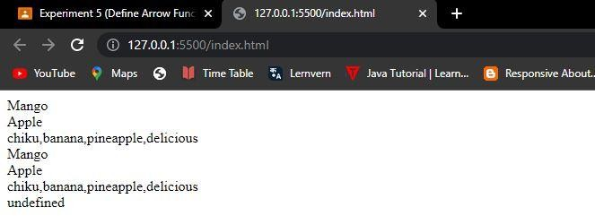

**Conclusion :** Therefore we have successfully implemented Arrow function in javascript