Computer vision is a field of artificial intelligence (AI) focused on enabling machines to interpret and understand visual data from the world, such as images and videos. It involves acquiring, processing, and analyzing images to perform tasks like object detection, image classification, facial recognition, and scene reconstruction

Image Transformation: It involves the transformation of image data in order to retrieve information from the image or preprocess the image for further usage. Like Image Translation, Reflection, Rotation, Scaling, Cropping, Shearing in x-axis, Shearing in y-axis

Some operations commonly used in computer vision based on a Deep Learning perspective include:
- Convolution: Convolution in computer vision is an operation in which a learnable kernel is “convolved” with the image. In other words—the kernel is slided across the image pixel by pixel, and an element-wise multiplication is performed between the kernel and the image at every pixel group.
- Pooling: Pooling is an operation used to reduce the dimensions of an image by performing operations at a pixel level. A pooling kernel slides across the image, and only one pixel from the corresponding pixel group is selected for further processing, thus reducing the image size., eg., Max Pooling, Average Pooling.
- Non-Linear Activations: Non-Linear activations introduce non-linearity to the neural network, thereby allowing the stacking of multiple convolutions and pooling blocks to increase model depth.
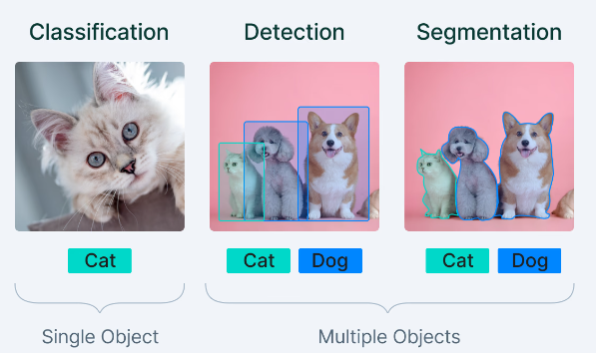

What is Sobel Edge Detection

Sobel Edge detection is one of the successful approaches adopted in the field of image processing and computer vision to detect edges in an image. This is done through a derivation in which the gradient of the image intensity is derived for each pixel, and hence, provides a determination of direction as well as the rate of change in the direction. Masks of the Sobel operator are two 3x3 convolutions one serves to detect a change in the horizontal direction and the other in the vertical one. When these gradients are added together, high-intensity values are observed at specific parts of the image, specifically edges.

Features of Sobel Edge detection

- Directional Sensitivity:Sobel edge detection is good for edge detection because it uses two different kernels thus it can detect edges in both the horizontal and vertical phases.
- Noise Reduction: The operator incorporates smoothing or blurring such as the Gaussian blur that helps in removing noise hence the operator is less sensitive to minor changes in the images.
- Gradient Magnitude Calculation: It calculates the gradient computed per pixel which aids in enhancing edges, through quantizing the amount of intensification.
- Simple Implementation:Due to these features, the Sobel operator is easy to implement, and it can work in real-time software systems.
- Edge Orientation: Besides, the edges are not only detected but also give information about the orientation of the edges which is very useful for the next levels of image processing.

What is Canny Edge Detection

Canny Edge Detection is a set of several procedures to find almost all the edges that could be potentially present in the image in a very precise manner. Developed by John F. Canny in 1986, the algorithm aims to achieve optimal edge detection by addressing three key criteria: A very important criterion is low error rate, meaning that the edge detected by an algorithm must be as close to the actual edge as possible; low localization meaning the distance between the actual and detected edge; and low response meaning reducing the chance of multiple responses to a single edge. It includes several stages, starting from smoothing using a Gaussian filter, then computing the gradients, thinning the responses via a method called non-maximum suppression, and lastly hysteresis thresholding to connect the edges properly and eliminate the weak ones.

Features of Canny Edge Detection

- Noise Reduction: Many techniques are applied here; one of which is the Gaussian filter to filter out noise from the image which is very important when it comes to edge detection.
- Gradient Calculation: Calculates the image gradient which indicates how intense the edges in the image are as well as in what direction they lie.
- Non-Maximum Suppression: Increases the edge contrast by squeezing its thickness down to a pixel width that makes edge localization more precise.
- Double Thresholding: Uses two thresholds, high and low to eliminate ambiguity, in that it detects strong edges and weak edges within an image improving on the algorithm’s robustness.
- Edge Tracking by Hysteresis: Accumulates edges by deriving a path between every edge and the next edge, thus maintaining proper and seamless continuity of edges between high and low threshold levels.

