Name: Ameya Chaudhary
D15A

09

EXPERIMENT NO.11

AIM : To use google Lighthouse PWA Analysis Tool to test the PWA functioning.

THEORY :

Google Lighthouse is an open-source tool developed by Google that helps developers improve the quality and performance of web pages and web applications. It is commonly used to audit and analyze various aspects of a website, including performance, accessibility, best practices, SEO (Search Engine Optimization), and Progressive Web App (PWA) functionality. Here's a breakdown of what Google Lighthouse is and its key features:

1. Audit Capabilities:

-Google Lighthouse can perform audits on different aspects of a web page or web application.

-It evaluates performance metrics such as load time, page speed, and resource optimization.
-It checks accessibility standards to ensure that websites are usable by people with disabilities.
-It assesses best practices to identify areas where coding standards can be improved. -It analyzes SEO factors to help improve search engine rankings.

-It examines PWA features to verify if a web app meets the criteria for being considered a Progressive Web App.

2. Scoring System:

-Lighthouse provides a scoring system for each audit category, ranging from 0 to 100. - Higher scores indicate better performance, accessibility, best practices, SEO, and PWA compliance.
-The scores are accompanied by detailed information and recommendations for improving each aspect.

3. Detailed Reports:

-After running an audit, Lighthouse generates a detailed report that includes scores, metrics, and recommendations.
-The report highlights areas of concern and provides actionable insights to optimize web pages and web apps.

  - Integration with DevTools:

- Lighthouse is integrated into Chrome DevTools, making it easily accessible for developers.

- It can be launched directly from DevTools to audit a specific web page or web

app.

  - Open-Source and Extensible:

- Lighthouse is an open-source tool, allowing developers to contribute to its development and customize its functionality.

- It supports plugins and extensions, enabling additional capabilities and integrations.

  - Focus on Performance Optimization:

- One of Lighthouse's primary focuses is on performance optimization, helping developers identify and address issues that impact page load times and user experience.

Steps :

To use Google Lighthouse to test the Progressive Web App (PWA) functioning, follow these steps:

  - Open Chrome DevTools:

- Open Google Chrome browser.

- Go to the website you want to test as a PWA.

- Right-click on the page and select "Inspect" or press `Ctrl+Shift+I` (Windows/Linux) or `Cmd+Option+I` (Mac) to open Chrome DevTools.


- Navigate to the Lighthouse Tab:

  - In Chrome DevTools, click on the "Lighthouse" tab at the top of the DevTools panel.
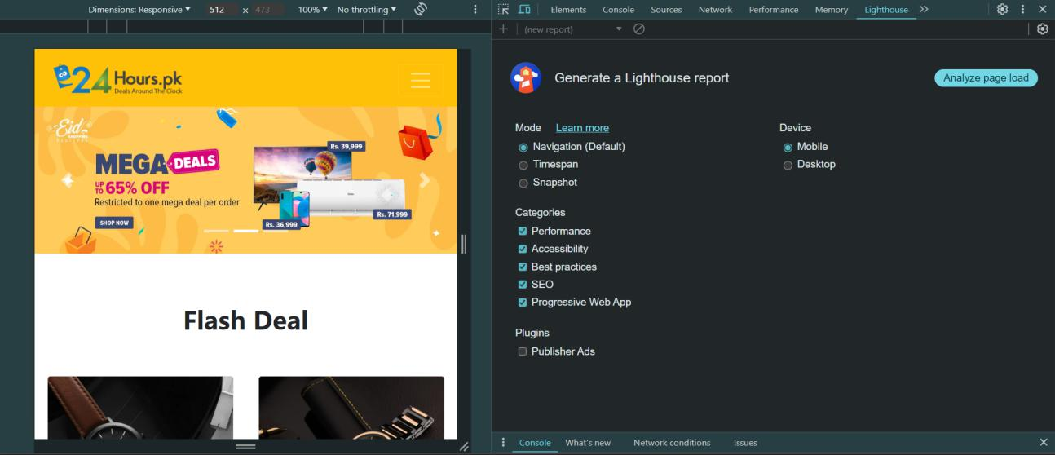

- Run the Lighthouse Audit:

  - Click on the "Generate report" button to start the audit process.

-
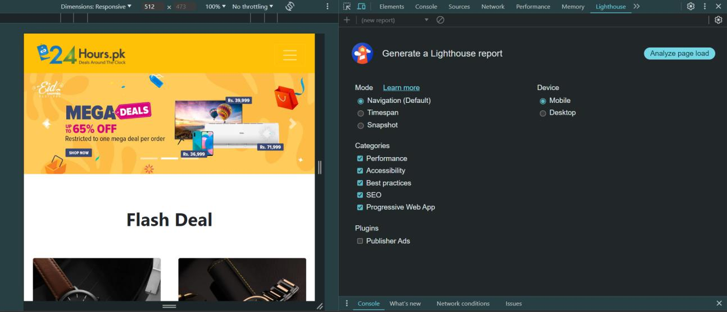

You can choose to audit for Performance, Accessibility, Best Practices, SEO, and Progressive Web App (PWA) functionality. Make sure to select the "Progressive Web App" checkbox.
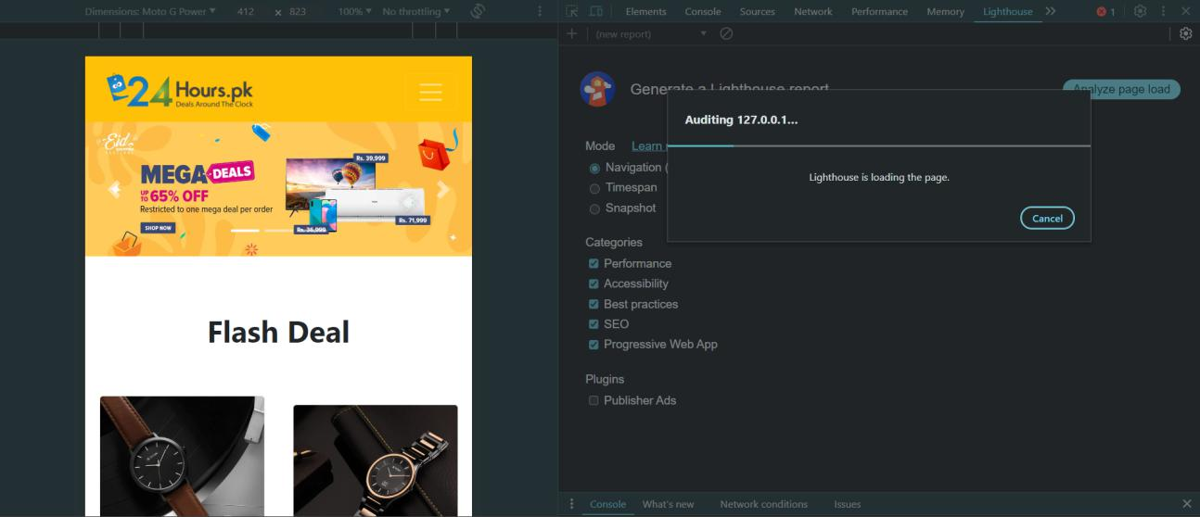

4. View the Audit Results:

-After the audit is complete, Lighthouse will display a report with scores and detailed information for each category.

-In the PWA section, you can check if your website meets the PWA criteria, such as having a service worker, being responsive on different devices, having a valid manifest file, etc.

-Lighthouse will provide suggestions for improvements and optimizations to enhance your PWA functionality.
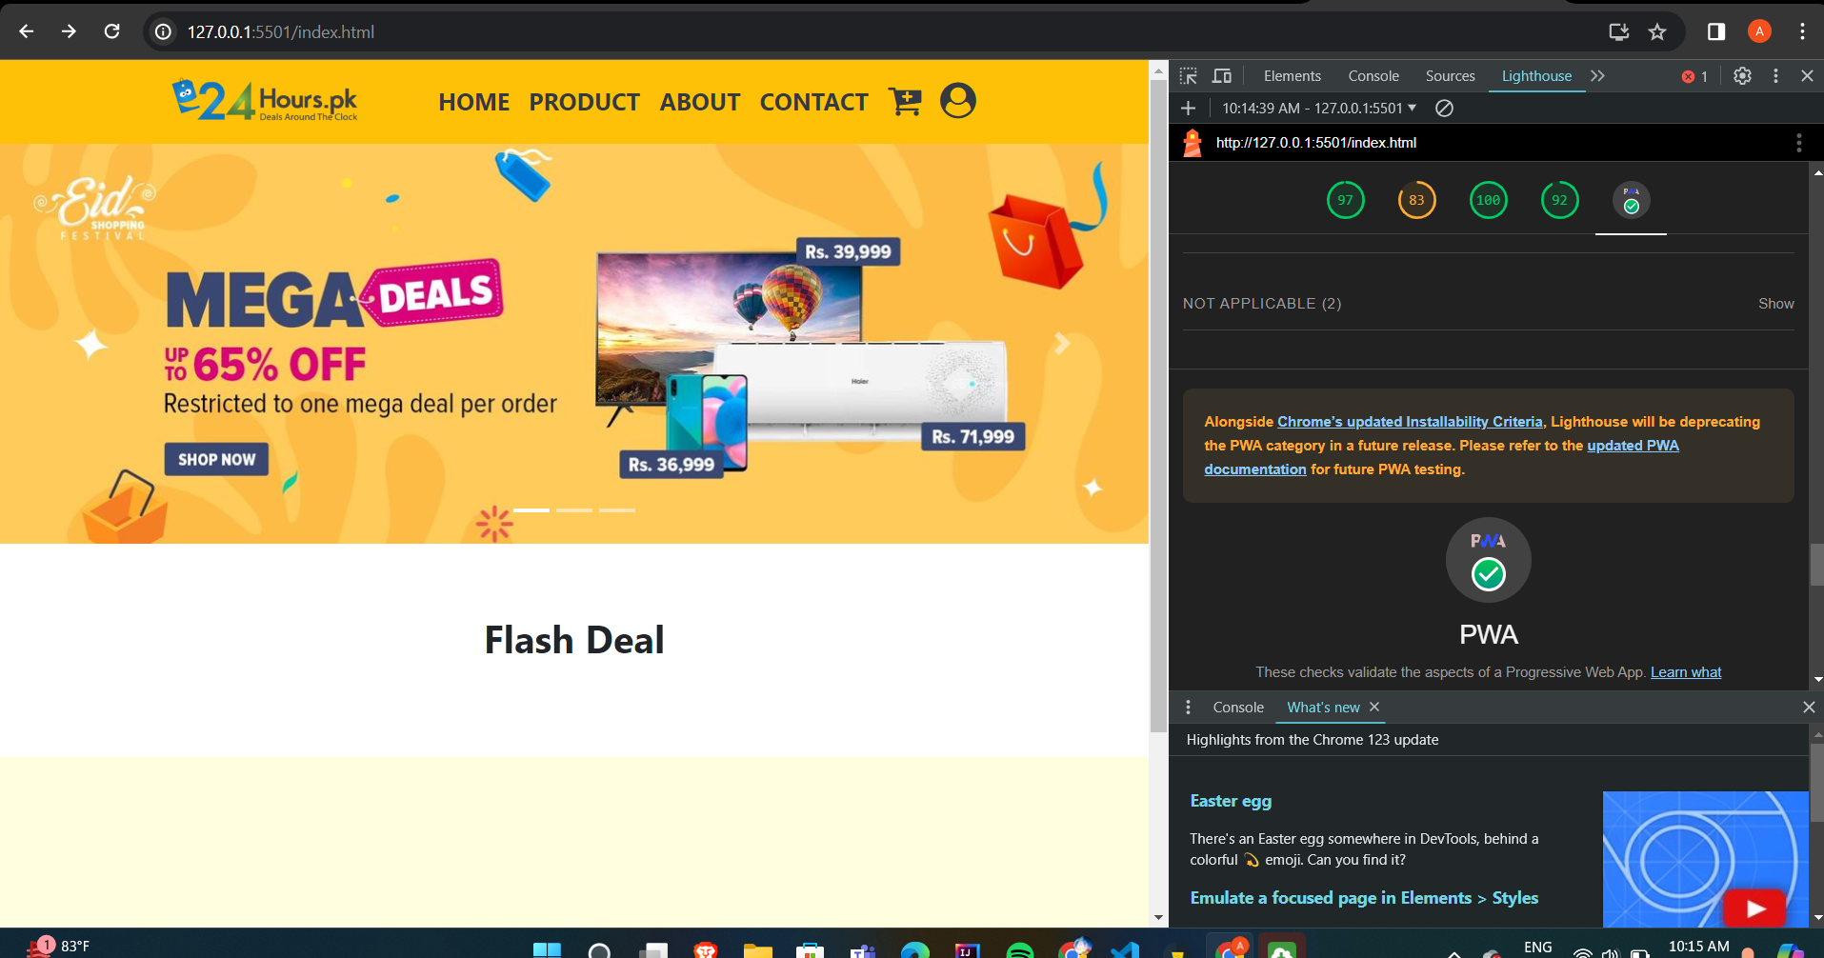

-

CONCLUSION : Hence we have understood the working of Google Lighthouse PWA analysis tool, and used Google Lighthouse tool to test and analyze the performance statistics of our E-commerce Progressive web application.

