ABSTRACT
Keeping updated with the upcoming technology is the key to success in any business in today’s era. Similarly, getting the business recognized over World Wide Web is as important as the more traditional way of doing business.
Normally, a business website works for enhancement of any business, this website also gives user the mobility to have a wider approach towards their clients. The online shopping of products in bulk also gives the visitors a brief idea about the products according to their rates.
Once the order is placed, the whole data is directly stored into database. With the help of this data, the admin can get the products ready and send the shipment to the address mentioned by the customer.
Therefore, an online website is used in faster communication and getting a better improvement in the sales, hence to enhance their business.

OBJECTIVES
The objective of this product is to provide the user information related to the commodities being manufactured and sold by the company. The website works as a medium of faster communication between the customer and the owners. The user is easily able to browse through the catalogue of the products. Accordingly, the customer can select a desired product and order it right through the website.
Since product is hosted on a server, not much human intervention is needed and the product can be accessed round the clock. According to the customer’s desire, products are selected and a quotation of the amount to be paid is generated. This way the company executives are able to contact the customer for the payment method to be followed and the delivery process that has to be undertaken.
Thus the product makes sure that the tedious task of browsing and ordering products from the catalogue is made easier with the help of technology.

List of Figures
Figure No. | Figure Name. | Page No.
4.1.1 | Iterative enhancement model……………………………..................... | 16
4.2.1 | Use Case Diagram………………………………………..................... | 19
4.3 | Architecture Diagram…………………………………….................... | 19
4.4.1 | E R Diagram……………………………………………...................... | 20
4.4.2 | Data Flow Diagram…………………………………………………. | 21
5.1 | Work Breakdown Structure…………………………………………. | 26
5.2 | Gantt Chart…………………………………………………………. | 26
5.3 | Pert Chart……………………………………………........................... | 27
5.4 | Timeline…………………………………………….............................. | 28

List of Tables
Table No. | Table Name. | Page No.
1.5.1 | Software Requirements……………………………………………… | 7
1.5.2 | Hardware Requirements……………………………………………... | 8
4.4.3 | Database Schema……………………………………………............... | 22
4.4.3.1 | Contact Table……………………………………………..................... | 22
4.4.3.2 | Customer Details Table……………………………………………... | 23
4.4.3.3 | Order Table……………………………………………........................ | 23
4.4.3.4 | Order Detail Table……………………………………………............ | 23
4.4.3.5 | Product Details Table……………………………………………....... | 24
5.8.2 | Test Cases……………………………………………........................... | 35

- INTRODUCTION
In looking over to the challenges faced by the entrepreneurs in their more like traditional approach towards the business, one most certain solution can be recognized to improve it is the approach towards e-Business. Overall, the answer that firms have faced most of the challenges identified in the past, and that this represents the latest iteration of these challenges.
A turn towards Internet based technologies generated a new status quo in the business world. E business enables an enterprise to spread it wings to the global customer. To extend the sales platform to a futuristic dimension, business houses have incorporated software that can run on platforms offered by the World Wide Web. E business has now penetrated into customer goods and other production and service based industries.
This approach towards modernizing the business by taking it to a new level will surely help the business owners grow their business in a considerably satisfying amount.

1.1 Problem Definition
The typical traditional approach towards the business has left the business’s growth stuck at a stage. Knowledge of marketing, launch of any new products, updates for clients and customers, special offers and discounts on goods have no medium to share than conducting meetings. This can be time consuming, as well as costly in terms of annual budget.
The e Business concept is more reliable in such scenarios that even one person can manage multiple things once they have taught.
1.2 Scope
Following are some points which relate to the scope of the project:-
- Break and Mortar firms are the key candidates for e Business.
- Geographical independence (Globalization).
- Expansion of market place.
- Flexible inventory according to the number of orders and the supplies.
- Gathering new customers, and clients.
- Obtain new orders from new customers.
- Enhancement of business.
- Since everything is automated, the track on orders can be kept.
1.3 About existing system
In the past many years, people have made fortunes in business management, marketing and many still do today. Today they live their lives, and enjoy a freedom that most people only dream about. Usually, it was only a small number of people went on to become the top money earners in any company. “Generally it was the individuals who already had marketing, business and managing skills and knew how to put them into action.” This left the majority of distributors / associates out in the cold, failing to achieve any measurable level of success.
But today there are more resources than ever before to help you become successful. The challenge today is to choose the company, product range, delivery system, user friendly operation system and above all the business plan.
1.4 Proposed System
The proposed system which we have developed thus takes into account all the drawbacks of the current system and develops over its benefits. The developed system fulfills all the above mentioned parameters with the most innovative and powerful compensation plan which is called Mirror Reflection Genealogy Plan. This business plan helps a very ordinary person to achieve very extra ordinary success in network marketing business. The characteristics of this plan are – very easy to join, very easy to recruit, very easy to achieve higher levels, very easy to earn instant income and the most important point is that it’s an everlasting business plan.

1.5 System Requirements
1.5.1 Software Requirements
Table 1.1 Software requirements
 | Developer Side
OS | 32-bit Microsoft Windows 7 SP1
Front End:m | Platform: HTML, CSS, JavaScript
Back End: | D/B used : MYSQL Server Management Studio
1.5.2 Hardware Requirements
Table 1.2 Hardware Requirements
Developer Side | User Side
CPU: Intel Core 2 Duo T6400 (2.9 GHz)  Memory: 1GB DDR3  Free Disk Space: 100 MB | CPU: P4 1 GHz, recommended P4 1 GHz+  Memory: 512 MB, recommended 1 GB  Active Internet Connection

- LITERATURE SURVEY
The Print-N-Coat Organization was established in the year 1978. We are a force to reckon with in the field in manufacturing form many Years. Serving the needs of diverse industries. We continuously diversify to meet new horizons and challenges with competence and dynamism. We responded by expanding our product line Our Plant is having all the machinery to manufacture all products
Neeta Inks (Manufactures of Products like printing inks offset inks & Decorative Paint)
These innovations have been made in the formulation of Offset or “paste” inks over years, keeping pace with the evolutions that have marked the Graphic Industry.
PNC Paints
PNC Paints is a leading industrial paint and decorative paint manufacturing company based in The Decorative paint products include exterior wall finishes, interior wall & wood finishes and enamels. Its innovative and eco-friendly product range includes decorative paints, Marine coatings, Industrial coatings, automotive coatings and fine chemicals.
Mayuri Packers & Printers
(Corrugated Boxes and BOPP Self Adhesive Tapes)
PNC Group is manufacturing corrugated boxes since from 2005. Serving the needs of diverse industries, our Wax coated Paper & Laminated Paper.Manufacturing flexible packaging & BOPP Self-adhesive tape. BOPP tapes ideal Usage for sealing all types of export Cartons.
Megha Industries (Manufacturer of Corrugated Boxes)
Corrugated paper board containers are extensively used in the packaging of industrial as well as consumer goods Corrugated box design is the process of matching design factors for corrugated fibreboard boxes with the functional physical, processing and end-use requirements. Packaging engineers work to meet the performance requirements of a box while controlling total costs throughout the system. Serving the needs of diverse industries, our Wax coated Paper, Laminated
Ajantha Chemproducts
We are a force to reckon with in the field of Grape guard paper since 15 years. We responded by expanding our product line to slow release and fast realize grape guard.
Grape Guard Paper (SO2 Release Paper) It is use to increase life of grapes while transportation. Grapes are harvested in the months of January – March when the ambient temperature varies from 25 –32^0 C with a relative humidity of 40-80 per cent shapes and sizes, ventilated CFB boxes. For packing in CFB boxes, prepare a layer of paper shreds as cushioning at the bottom of the polythene bag, placed in the CFB box.
Grape guard is a sheet of paper available in 2 forms.
(I) quick release or with a layer of sodium bisulphite coated on one side of the paper
(II) the slow release (SR) has the coating as QR with small white pouches with granules of sodium bisulphite packed in it. When the grapes are packed in polythene bags, they are held at low temperature.

- SOFTWARE REQUIREMENT SPECIFICATION AND DESIGN
3.1 Introduction
The Software Requirements Specification is designed to document and describe the agreement between the customer and the developer regarding the specification of the software product requested. Its primary purpose is to provide a clear and descriptive “statement of user requirements” that can be used as a reference in further development of the software system. This document is broken into a number of sections used to logically separate the software requirements into easily referenced parts.
This Software Requirements Specification aims to describe the Functionality, External Interfaces, Attributes and Design Constraints imposed on Implementation of the software system described throughout the rest of the document. Throughout the description of the software system, the language and terminology used should unambiguous and consistent throughout the document.
3.1.1 Purpose
Defining and describing the functions and specifications of the business website is the primary goal of this Software Requirements Specification (SRS). This Software Requirements Specification illustrates, in clear terms, the system’s primary uses and required functionality as specified by our customer. The intended audience of this document is the existing and new clients and customers of the company.

3.1.2 Definitions
Barcode | A unique identifier assigned to single items
Button | A user interface element that allows a User to click and inform the system to take an action
Checkbox | A user interface element that allows a User to inform the system that he/she selected a particular item
CRUD | Create, Retrieve, Update, Delete
Inventory | An object that holds items available for purchase by the Customer
Item | An individual entity in the inventory which has several descriptive attributes:
SRS | Software Requirements Specification
Stock | The quantity of any particular item the inventory has on hand
Transaction | The information related to a customer's purchase that is logged
User | The person who operate the software product.

3.1.3 System Overview
This Software Requirements Specification document is divided in to mainly three subsections. The first section includes explanations of the Purpose, Scope and Organization of the document. The first section also handles the description of project specific words, acronyms and abbreviations that will be used in the document. The second section of the document is separated into the following two different sections, each detailing specific details of system uses and their corresponding actions: Product Perspective, Product Functions, user Characteristics Apportioning of Requirements. The third section is an enumerated listing of all of the requirements described for this system.

3.2 Overall Description
This section includes details about what is and is not expected of the system in addition to which cases are intentionally unsupported and assumptions that will be used in the creation of the system.

3.2.1 Product Perspective
PNC Group’s website supports a number of functions for both the consumer and business management. The website must be available to anyone using the internet. As stated by the customer, there are no hardware or software requirements beyond these including, but not limited to, memory or specific software packages that need to be utilized nor software packages that need not be utilized.

3.2.1 Product Functions
PNC website will provide a number of functions; each is listed below.
• Maintain data associated with the inventory.
• A product has a title, unique Id and price.
• The inventory also keep track of the stock/quantity of each product.
• Maintain records for many customers.
• No membership is required.
• Show a listing of available products.
• Allow customers and managers to log in and out of the system.
• Checkout is available to each and every customer.
• The discount is specified by the manager at the time of the promotion’s creation or most recent update/edit.
• Allow manager to specify a stop-order for any specific order.
• Allow manager to update stock quantities.
• Allow manager to change any product's price.
• Allow manager to view transaction logs.

3.2.2 User Characteristics
The typical user is simply anyone that has access to the Internet and a web browser on the computer. It is assumed that the user is familiar enough with a computer to operate the browser, keyboard and mouse and is capable of browsing to, from and within simple websites.

- PROJECT ANALYSIS AND DESIGN
4.1 Methodologies Adapted
SDLC, Software Development Life Cycle is a process used by software industry to design, develop and test high quality software. SDLC aims to produce high quality software that meets or exceeds customer expectations, reaches completion within times and cost estimates. The software development life cycle (SDLC) is a framework defining tasks performed at each step in the software development process.
SDLC is a process followed for a software project, within a software organization. It consists of a detailed plan describing how to develop, maintain, replace and alter or enhance specific software. The life cycle defines a methodology for improving the quality of software and the overall development process.
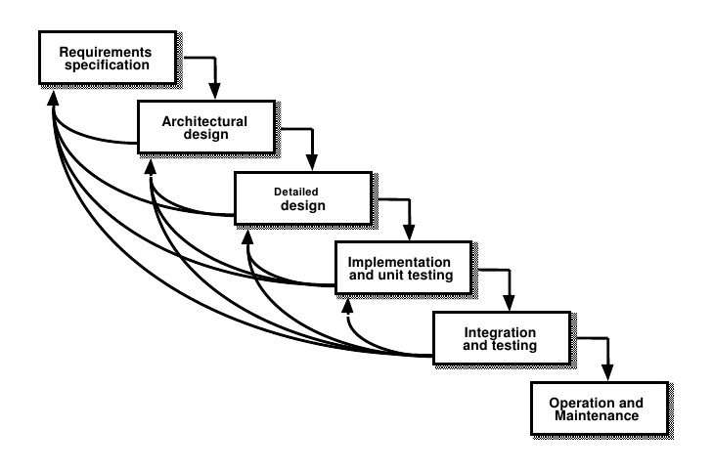
Figure 4.1 SDLC
    - DETAILED LIFE CYCLE OF THE PROJECT
A typical Software Development life cycle consists of the following stages:

Stage 1: Planning and Requirement Analysis
Requirement analysis is the most important and fundamental stage in SDLC. For the project the requirements were taken by the professors and accordingly the planning was done and modules were decided. The technology to be used was decided in this phase.

Stage 2: Defining Requirements
Once the requirement analysis is done the next step is to clearly define and document the product requirements and get them approved from the mentor. This is done through Software Requirement Specification document which consists of all the product requirements to be designed and developed during the project life cycle.

Stage 3: Designing the product architecture
SRS is the reference for product architects to come out with the best architecture for the product to be developed. Based on the requirements specified in SRS the design approach for the product architecture is proposed. In design approach the architectural modules is defined.
Stage 4: Building or Developing the Product
In this stage of SDLC the actual development starts and the product is built. The programming code is generated as per DDS during this stage. Developers have to follow the coding guidelines defined by their organization and programming tools like compilers, interpreters, debuggers etc. are used to generate the code. The programming language is chosen with respect to the type of software being developed.

Stage 5: Testing the Product
This stage is usually a subset of all the stages as in the modern SDLC models, the testing activities are mostly involved in all the stages of SDLC. However this stage refers to the testing only stage of the product where products defects are reported, tracked, fixed and retested, until the product reaches the quality standards defined in the SRS.

Stage 6: Deployment in the Market and Maintenance
Once the product is tested and ready to be deployed it is released formally in the appropriate market.

4.2 Modules

4.2 UML Diagram

4.2.1 Use Case Diagram

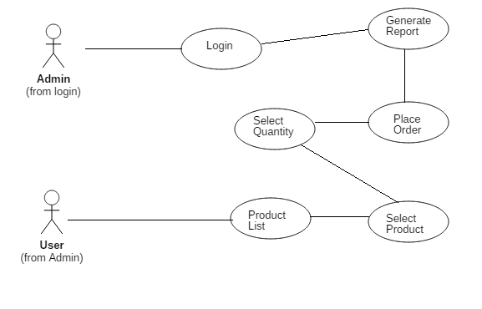

4.3 Architectural Design

Place Order
PNC Website

Database

Data retrieved by admin

  - Database Schema/ Design

4.4.1 E-R Diagram

ORDER NOW

PRODUCT TYPE
QUANTITY
PRODUCT DETAILS

ADDRESS
NAME

CUSTOMER DETAILS

CONTACT NO
EMAIL ID
PAYMENT

AMOUNT
COD

PRODUCT TYPE

QUANTITY

4.4.2 Data Flow Diagram
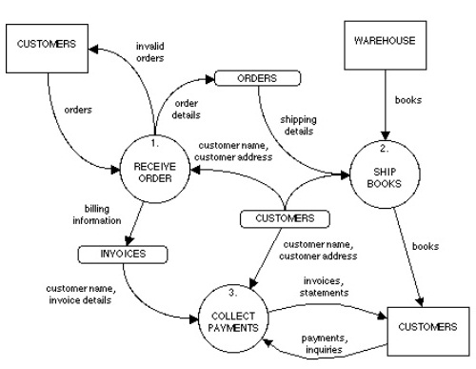

4.4.3 Database Schema Design

A database is the collection of interrelated data stored with the minimum number of redundancy to serve many applications. The primary objectives are fast response time to the enquiry, more information, and control of redundancy, clarity of use, accuracy and fast recovery. The organization of data in a database aims to achieve three major objectives viz., data integration, data recovery, data independence. During the design of the database at most care has been taken to keep up the objectives of the database design.
Following tables are been used in this project:
4.4.3.1 Contact Table
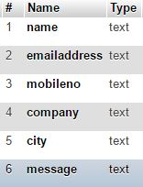

4.4.3.2 Customer Details Table
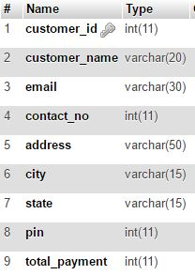
4.4.3.3 Order Table
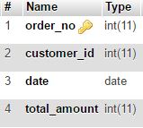
4.4.3.4 Order Details Table
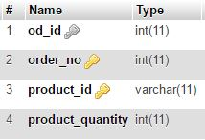

4.4.3.5 Product Details Table
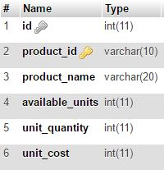

Software Requirement Specification [SRS] & Design
Introduction
The Print-N-Coat Organization was established in the year 1978. We are a force to reckon with in the field in manufacturing form many Years. Serving the needs of diverse industries. We continuously diversify to meet new horizons and challenges with competence and dynamism. We responded by expanding our product line Our Plant is having all the machinery to manufacture all products.
The Website must give an idea about online notifications, messages sent by visitors and online orders made by them. A tentative rate card is given in the website according to the lists of products from different industries and the order should be finalized with the same rates.
The Contact Page should give a valid chance for the visitor to send the message directly to the business owners, so that they can get back in contact with the other party. This will be beneficiary in growing their business on a great scale. Similarly, the Order Page should allow the visitor to place their order online with an ease. The data entered by the visitors will be stored in a database linked with the website owner of the website will be able to see the data in the admin panel.
Performance requirements
The system must is interactive and the delays involved is also less .So in every action-response of the system, there are no immediate delays. In case of opening windows forms, of popping error messages and saving the settings or sessions there is delay much below 2 seconds, In case of opening databases, sorting questions and evaluation there are no delays and the operation is performed in less than 2 seconds for opening ,sorting, computing, posting > 95% of the files.

Safety:
Information transmission is securely transmitted to database without any changes in the information.

5. Project Implementation & Testing
5.1 Work Break Down Structure

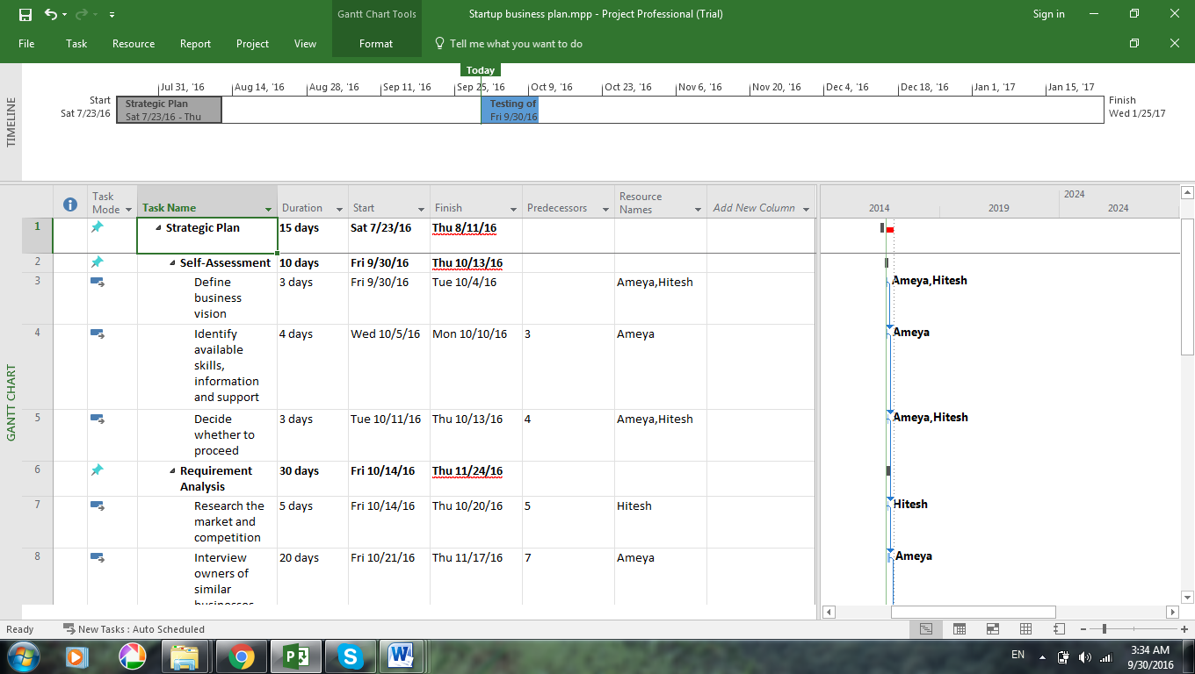

5.2 Gantt Chart

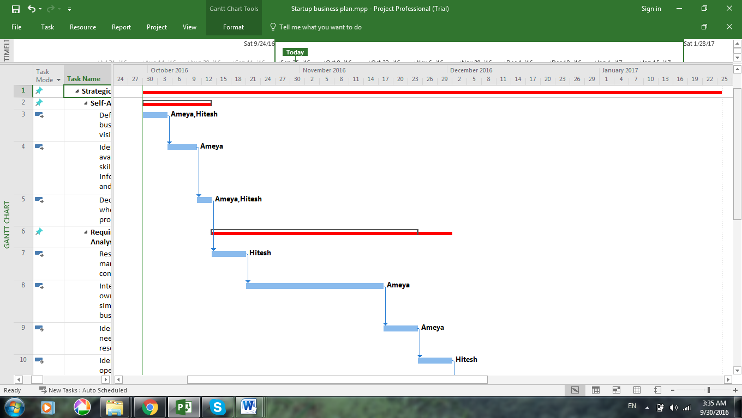

5.3 Pert Chart and PERT Table

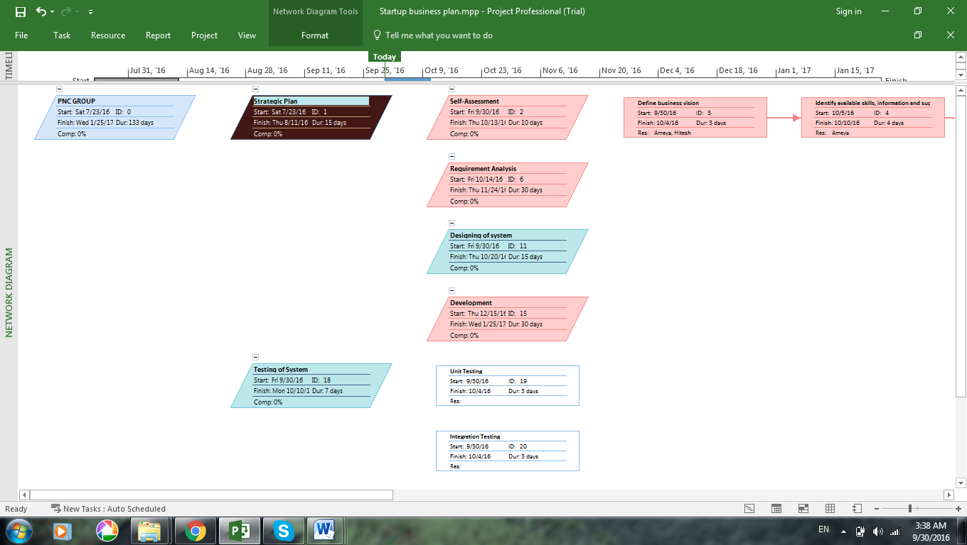

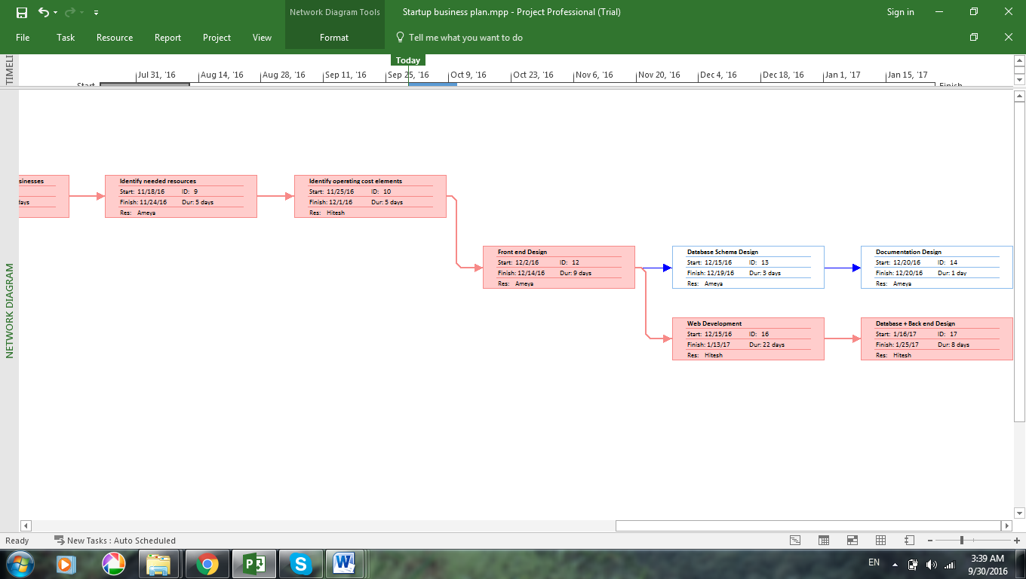

5.4 Time Line

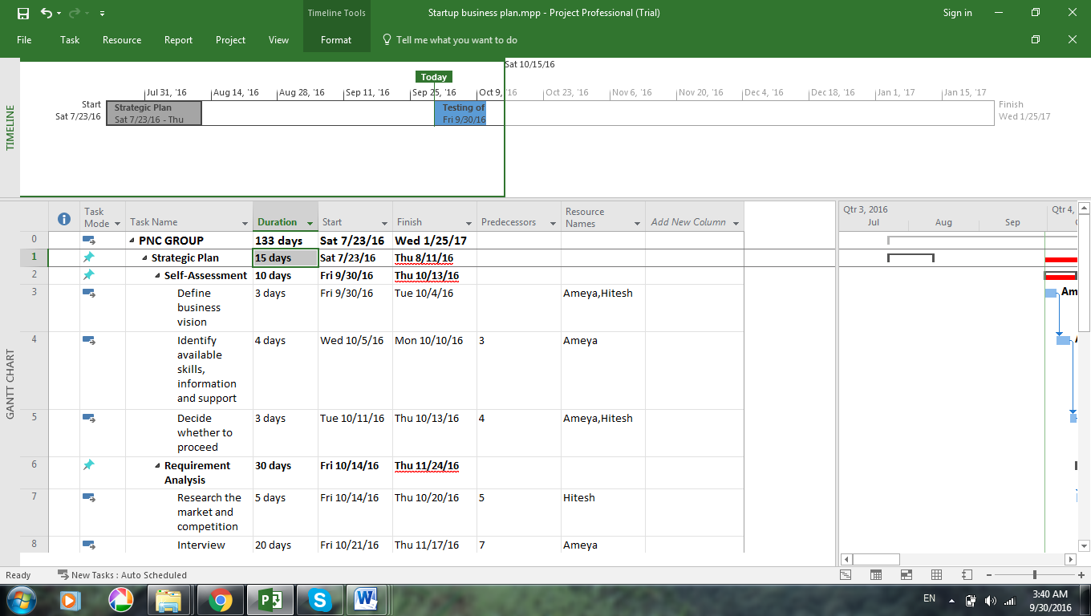

5.5 Snapshot of UI & Reports
Homepage:

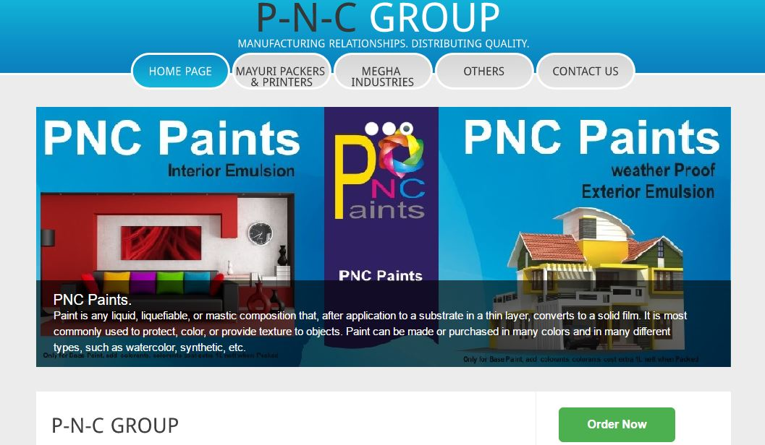

Order Details

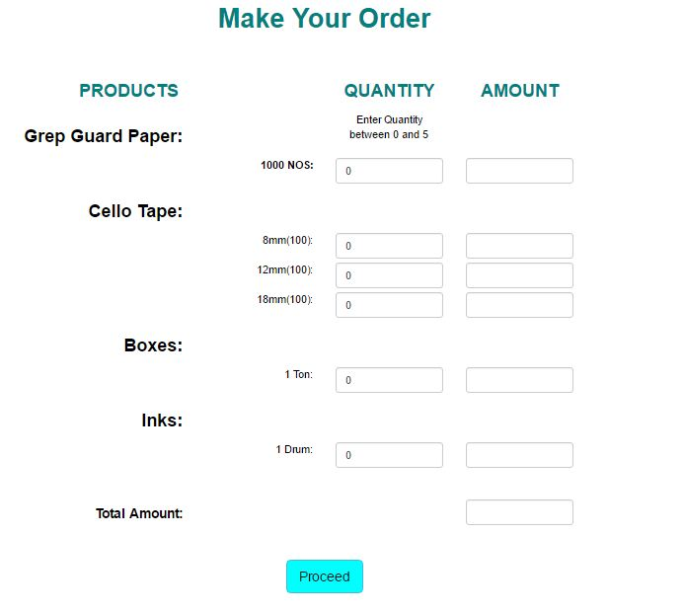

Customer Details

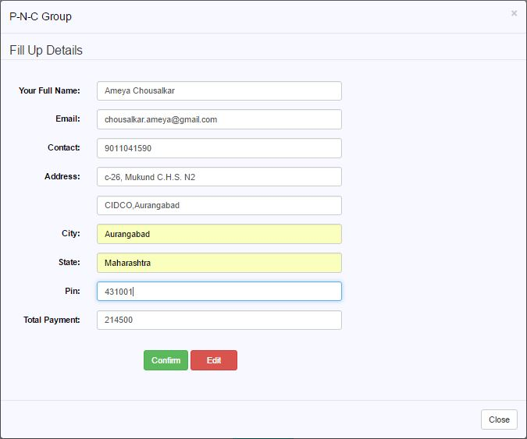

Billing Details

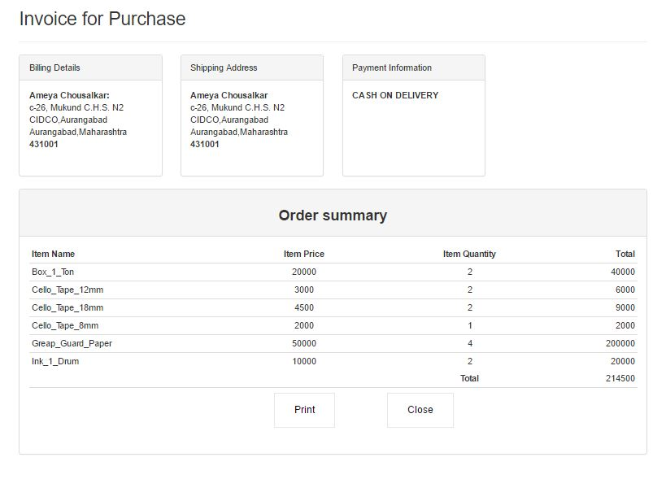

5.8 Test cases & Report

5.8.1 Types of Testing

White Box Testing
White-box testing (also known as clear box testing, glass box testing, transparent box testing, and structural testing) is a method of testing software that tests internal structures or workings of an application, as opposed to its functionality (i.e. black-box testing). In white-box testing an internal perspective of the system, as well as programming skills, are used to design test cases. The tester chooses inputs to exercise paths through the code and determine the appropriate outputs. This is analogous to testing nodes in a circuit, e.g. in-circuit testing (ICT). White-box testing can be applied at the unit, integration and system levels of the software testing process. Although traditional testers tended to think of white-box testing as being done at the unit level, it is used for integration and system testing more frequently today. It can test paths within a unit, paths between units during integration, and between subsystems during a system–level test. Though this method of test design can uncover many errors or problems, it has the potential to miss unimplemented parts of the specification or missing requirements.

Black Box Testing
Black-box testing is a method of software testing that examines the functionality of an application without peering into its internal structures or workings. This method of test can be applied to virtually every level of software testing: unit, integration, system and acceptance. It typically comprises most if not all higher level testing, but can also dominate unit testing as well.

5.8.2 Test Cases

Test Cases | Test Description | Test Data | Expected Result | Actual Result | Remark
T101 | Enter Name | 0-9 | Invalid Name | Invalid Name | Success
T102 | Enter Name | A-Z/a-z | Message Sent | Message Sent | Success
T103 | Enter Name | Special Symbols | Invalid Name | Invalid Name | Success
T104 | Enter Name | (Blank) | Name is Required | Name is Required | Success
T105 | Enter Email | 0-9@0-9.0-9 | Invalid Email | Invalid Email | Success
T106 | Enter Email | a-z@0-9.0-9 | Invalid Email | Invalid Email | Success
T107 | Enter Email | 0-9@a-z.0-9 | Invalid Email | Invalid Email | Success
T108 | Enter Email | 0-9@A-Z.0-9 | Invalid Email | Invalid Email | Success
T109 | Enter Email | 0-9@a-z.com | Message Sent | Message Sent | Success
T110 | Enter Email | (Blank) | Email is Required | Email Required | Success
T111 | Enter Mobile No | a-z | Invalid Number | Invalid Number | Success
T112 | Enter Mobile No | 0-9 | Message Sent | Message Sent | Success
T113 | Enter Mobile No | Special Symbols | Invalid Number | Invalid Number | Success
T114 | Enter Mobile No | (Blank) | No. is Required | No. is Required | Success
T115 | Enter Company | (Blank) | Message Sent | Message Sent | Success
T116 | Enter Company | 0-9 | Message Sent | Message Sent | Success
T117 | Enter Company | A-Z/a-z | Message Sent | Message Sent | Success
T118 | Enter Company | Special Symbols | Message Sent | Message Sent | Success
T119 | Enter City | (Blank) | Message Sent | Message Sent | Success
T120 | Enter City | 0-9 | Invalid City | Invalid City | Success
T121 | Enter City | A-Z/a-z | Message Sent | Message Sent | Success
T122 | Enter City | Special Symbols | Invalid City | Invalid City | Success
T123 | Your Message | (Blank) | Message Sent | Message Sent | Success
T124 | Your Message | 0-9 | Message Sent | Message Sent | Success
T125 | Your Message | A-Z/a-z | Message Sent | Message Sent | Success

6. System Maintenance & Evaluation
6.1 Maintenance
Maintenance is an enigma of the system development. It holds the software industry captive. Analysts spend more time in maintaining programs than coding them. Software maintenance denotes any changes made to the software product after it has been delivered to the customer. Most products need maintenance due to the wear and tear of the product. Software Maintenance can be divided into following types:
Corrective Maintenance
It is necessary to rectify the bugs observed while the system is in use. This project needs this maintenance for any removing flaws that can arise while summarizing the data or for correcting the logical bugs that might have been left unchecked as they appear only in real time.
Adaptive Maintenance
Software might need this type of maintenance when the customers need the product to run on new platforms, on new operating systems, or when they need the product to interface with new hardware or software. This project provides this type of maintenance for adapting to the new Browser and Server Configurations that may be required in future. It also involves upgrading the kernel at server site.

Perfective Maintenance
Software product might need maintenance to support the new features that users want it to support, to change different functionalities of the system according to the customer demands, or to enhance the performance of the system. This project needs this maintenance for removing the short falls of its current version.
Software Maintenance is essential as initial stages of any software developed are always unstable. Over the time it achieves stability as bugs are fixed and faults are removed to make the system accurate.
6.2 Evaluation
Modern information systems have become increasingly complex because of networking, distributed computing, distributed and heterogeneous databases, and the need to store large quantities of data. When these systems fail, significant breakdowns may ensue.
A system can fail in following two major ways
Functional failure
It occurs when the system fails to generate the correct results for a set of inputs. For example, if an information system fails to retrieve records that match a set of specified constraints.
Performance failure
It occurs when the system operates correctly but fails to deliver the results in a timely fashion. For example, if an information system takes a longer time than users are willing to wait for the records they requested, the system is said to fail performance-wise even though it may eventually retrieve the correct set of records.
Therefore, in designing system it is necessary to guarantee that the end product will display neither functional nor performance failure. It is then necessary to predict the performance of computer systems when they are under design and development, as well as to predict the impact of changes in configurations of existing systems.

7. Future Enhancements
Scope for future enhancement is very high as this is a small scale industry for now and the business owners intend to grow their business in the near future. As the business grows, the frequency of their online visitors will also grow simultaneously. As in near future, the website will have to be updated with new products and vendors. The owners have also advised their vendors to advertise their products under the same website for different businesses in the same area.

8. Conclusion
The P-N-C GROUP will be useful for people who want of manufacturing products. The site enables to browse through detail information about the products. Through this website you can order your BOPP tape with the brand name you want and there is a contact page through which you can contact our company for any query. Thus basically P-N-C Group acts as a platform for their growth in industrial area and spread it wide our company slogan “MANUFACTURING RELATIONSHIP. DISTRIBUTING QUALITY”. Our website has more or less achieved our goals and thus we have successfully implemented the work plan according to the plan with great effort and team work.

9. Bibliography
Following are the references taken to develop the product.
http://www.cse.msu.edu/~chengb/RE-491/Papers/SRS-BECS-2007.pdf
https://www.google.co.in
http://www.w3schools.com/html/default.asp
http://www.w3schools.com/w3css/default.asp
http://www.w3schools.com/bootstrap/default.asp
http://www.w3schools.com/js/default.asp
http://stackoverflow.com/
https://www.tutorialspoint.com/
https://en.wikipedia.org/wiki/Electronic_business
https://www.edx.org/

