Documentation
- PR Reviewer Tools Comparison: Link
- AI Powered Code Reviewer (Research paper): Link [not effective]
- Maitrey Document Google colab : Link
- GitHub Free API: Link
- GitLab Docs: Link
- Codium AI (PR Reviewer):
GitHub Link: https://github.com/qodo-ai/pr-agent
Docs: https://qodo-merge-docs.qodo.ai/
Workflow: 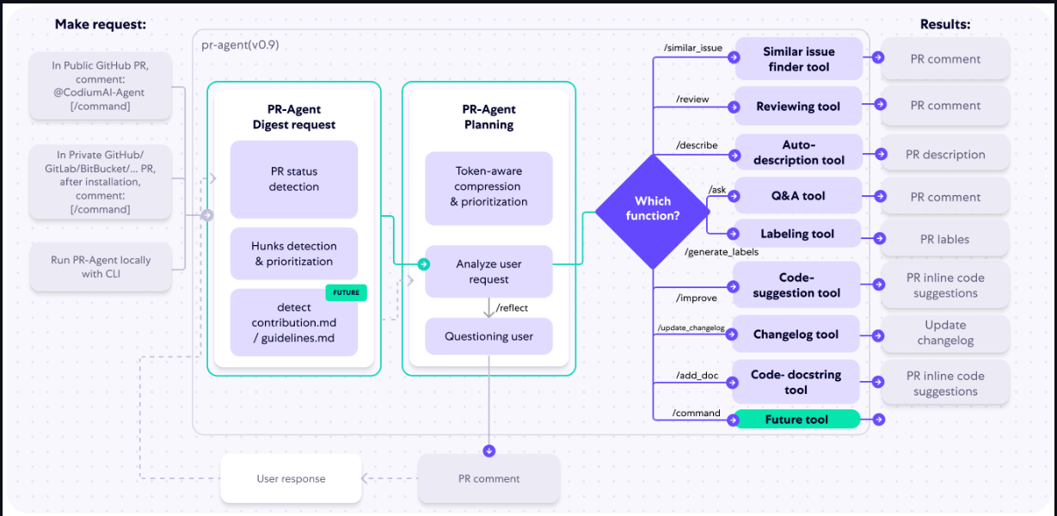

Implementation started by Amey and created basic react applications and used authentication of GitHub where we can see GitHub activity and Gemini response of PR review on generic answer

Version: 0.1
- It takes multiple custom rule files from user and on basic of that custom rule and generic rule of coding it provides feedback.
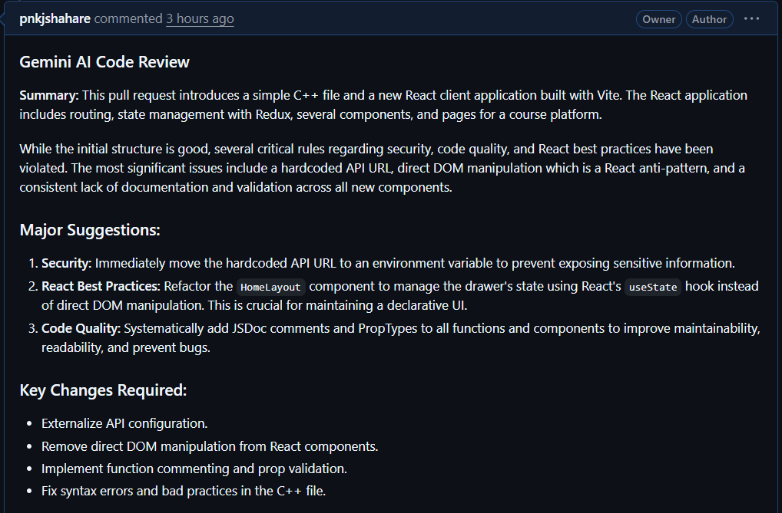

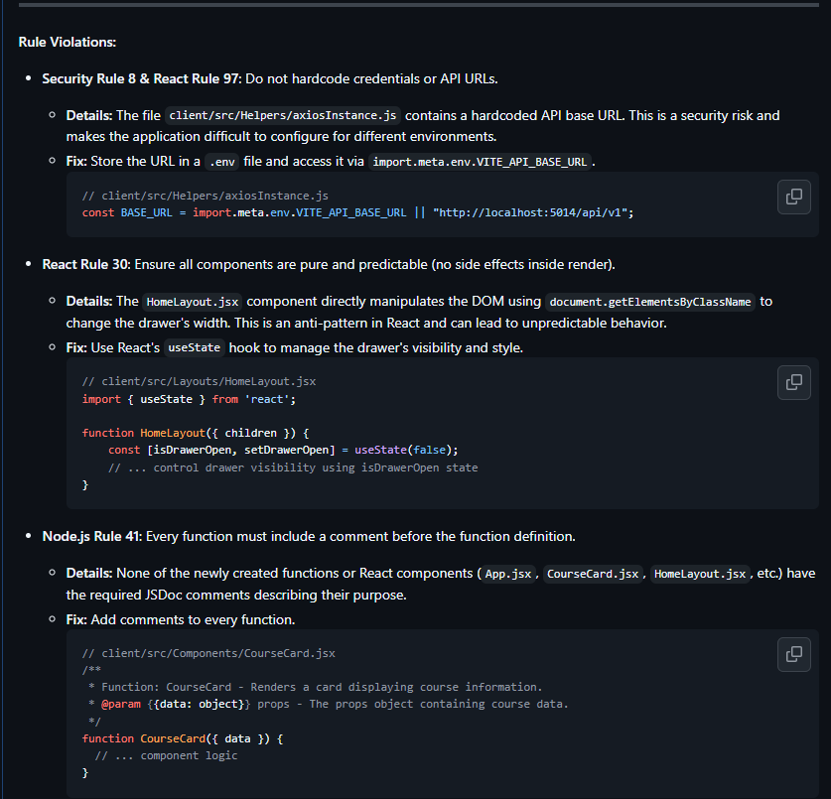

Vs Code Extension: Developer Friendly Reviewer before commit

Git Commit Hook → Node.js Script → Gemini API → VS Code Extension (Display Results)
VS Code API for extension : Link
Code Ant Extension: Link

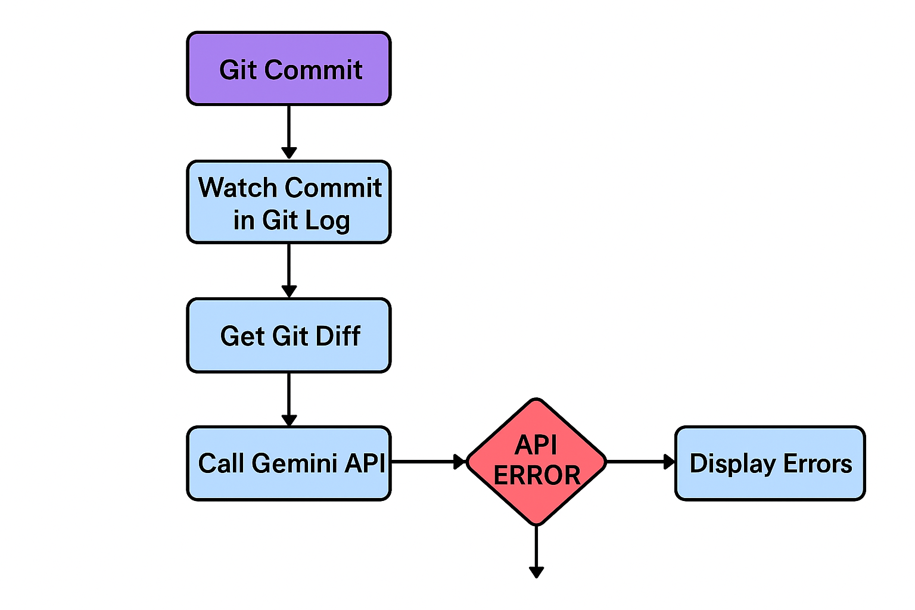

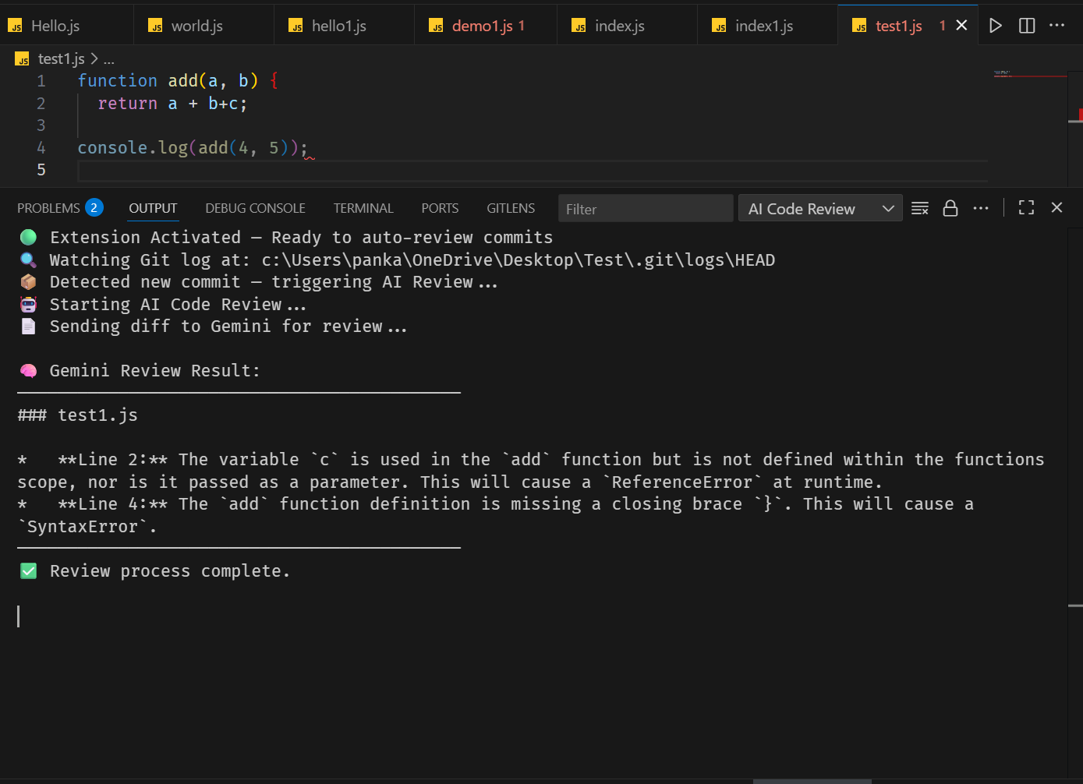
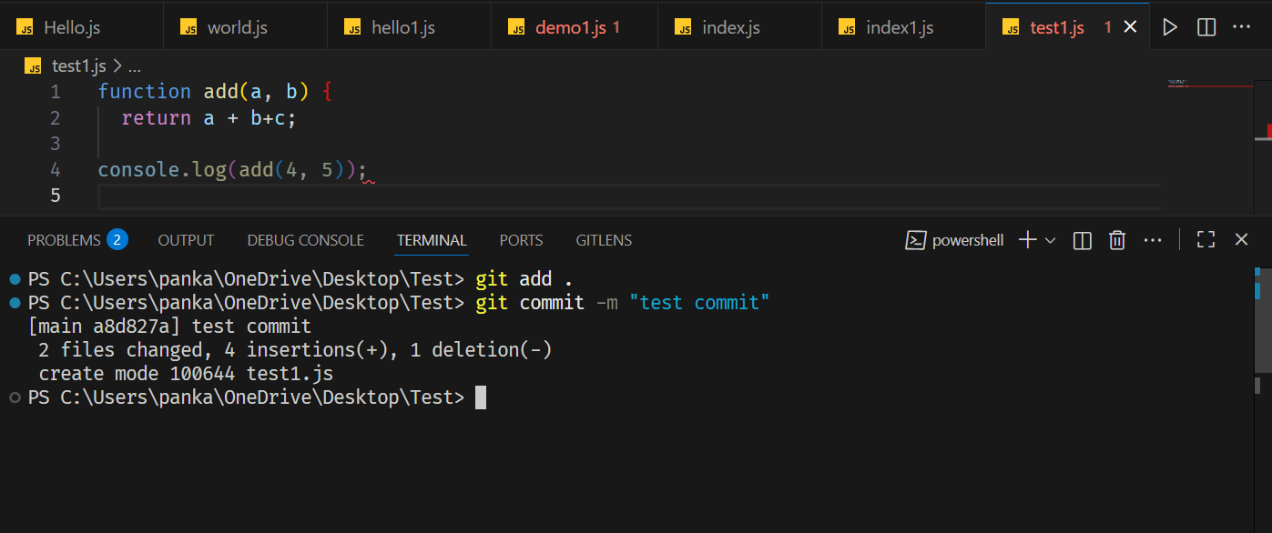

Eclipse Plugin:
  - How To create Plugin official Docs: Link
  - Eclipse Article: Link
  - YouTube Video: Link Link

- Install tools
  - Install Eclipse IDE for RCP and RAP (or add PDE to existing Eclipse).
  - Restart Eclipse.
- Create plugin project
  - File → New → Project… → Plug-in Project
  - Enter project name (e.g., com.example.helloplugin) → Finish.
- Configure manifest
  - Open META-INF/MANIFEST.MF.
  - Set Bundle-SymbolicName, Bundle-Version, and required bundles (e.g., org.eclipse.ui).
- Define extensions (plugin.xml)
- Open plugin.xml → Extensions tab.
- Add extension points (e.g., org.eclipse.ui.commands, org.eclipse.ui.handlers, org.eclipse.ui.menus).
- Add a command
  - In plugin.xml add a command with an id and name (e.g., com.example.helloCommand).
- Add a handler
  - Add org.eclipse.ui.handlers extension mapping command → handler class.
  - Create handler Java class extending AbstractHandler.
- Implement handler logic (small example)
  - In execute(...), get shell via PlatformUI.getWorkbench().getActiveWorkbenchWindow().getShell() and show MessageDialog.openInformation(...).
- Add UI contribution (menu/button)
  - Add org.eclipse.ui.menus entry.
  - Use locationURI (e.g., menu:help) and include your command.
- Run plugin for testing
  - Right-click project → Run As → Eclipse Application.
  - New runtime Eclipse opens → test menu/command.
- Debug if needed
- Put breakpoints in handler → Debug As → Eclipse Application.
- Export plugin
- File → Export → Plug-in Development → Deployable plug-ins and fragments
- Choose destination .jar or directory.
- Install into other Eclipse instances
- Place exported JAR into ECLIPSE_HOME/dropins/ (or install via update site).
- Quick tips
- Use small, testable steps (create command → handler → menu).
- Keep dependencies minimal in MANIFEST.MF.
- Use the PDE runtime to iterate fast.

Coding Standard Rule (C++): https://isocpp.org/wiki/faq/coding-standards
Coding Standard Rule (Java): https://www.oracle.com/docs/tech/java/codeconventions.pdf
Coding Standard Rule (.NET) : https://learn.microsoft.com/enus/dotnet/csharp/fundamentals/coding-style/coding-conventions
Coding Standard Rule (Python): https://peps.python.org/pep-0008/

